Student Report Card Generator

*A Project Based Learning Report Submitted in partial fulfilment of the requirements for the award of the degree*

*of*

**Bachelor of Technology**

**in The Department of CSE**

**ADVANCED OBJECT ORIENTED PROGRAMMING - 23CS2103E**

Submitted by

**2310030130: Afraz**

**2310030108: Santhosh**

**2310030123: Siddarth**

**2310030292: Sashank**

Under the guidance of

**Sasidhar**



Department of Electronics and Communication Engineering

Koneru Lakshmaiah Education Foundation, Aziz Nagar

Aziz Nagar – 500075 (Optional)

NOV - 2023.

**Abstract**

The Student Report Generator is a comprehensive web application designed to streamline the process of creating, managing, and distributing academic reports. This system automates the generation of student performance reports, reducing manual effort and potential errors in data handling. The application integrates seamlessly with educational database systems to pull student data, academic performances, and attendance records. It features a user-friendly interface that allows teachers and administrators to quickly generate individual and batch reports, customize report templates, and export reports in multiple formats. The system includes robust data visualization tools for presenting academic progress trends and comparative analysis, making it easier for educators to track and communicate student achievements effectively.

**List of Figures**

1. Database Schema Diagram This comprehensive diagram illustrates the relational database structure, showing the interconnections between student records, academic performances, and report templates. The schema demonstrates the normalized design ensuring data integrity and efficient querying.

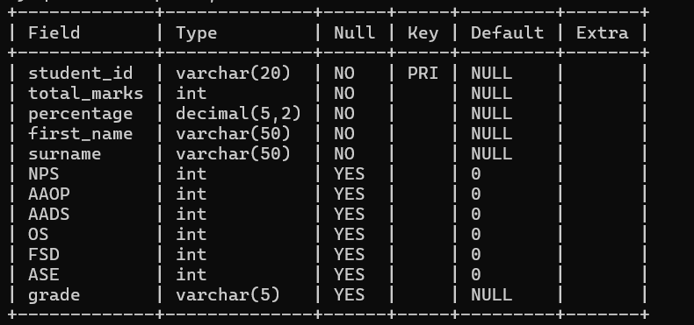

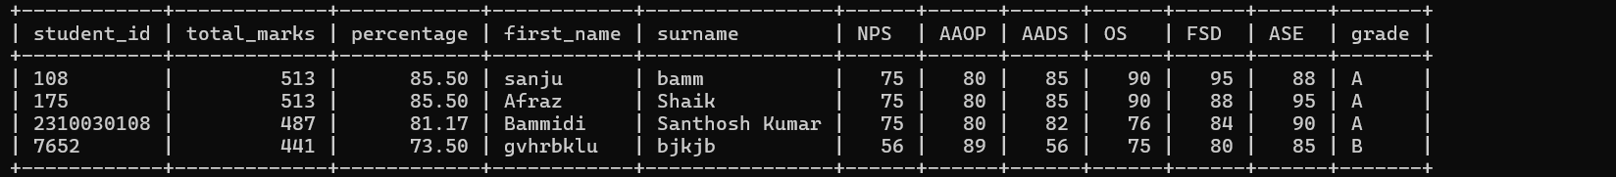

1. User Interface Dashboard The main dashboard interface displays key metrics, recent reports, and quick access to report generation tools. The intuitive layout prioritizes frequently used features and provides clear navigation paths for users.

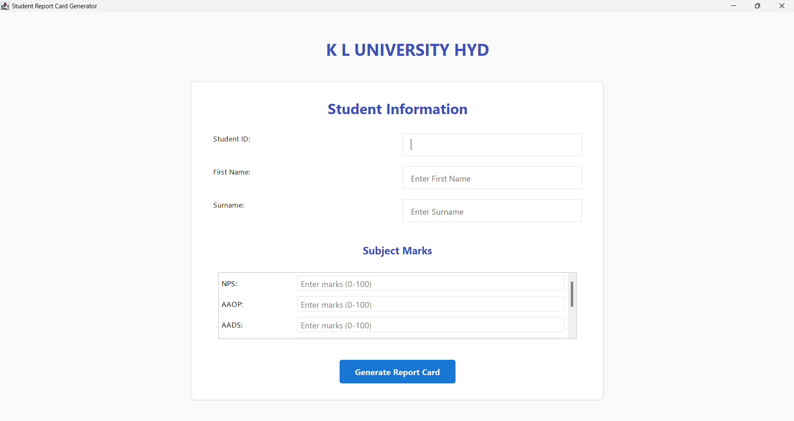

1. Report Generation Flow This flowchart depicts the step-by-step process of report generation, from data selection to final output. It highlights the automated validation checks and customization options available at each stage.
2. Data Visualization Components Screenshots of various charts and graphs used in the reports, showcasing academic progress trends, attendance patterns, and performance comparisons. These visualizations help in presenting complex data in an easily digestible format.

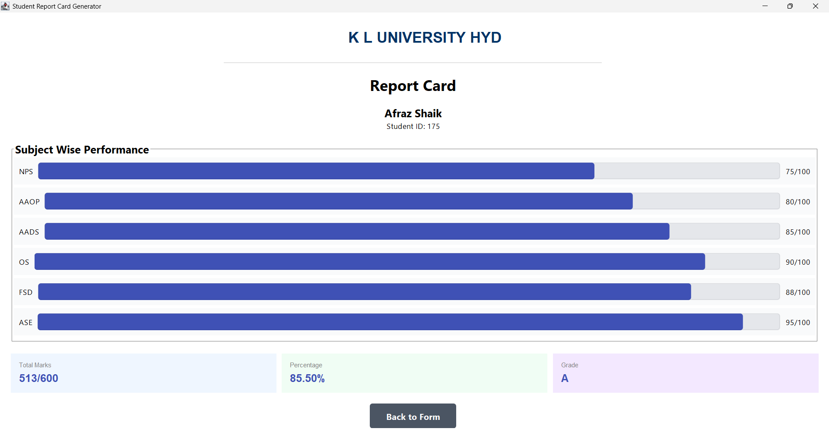

**Table of Contents**

1. **Introduction**
2. **System Overview**

**3. Features and Functionality**

**3.1 Report Generation**

**3.2 Data Management**

* 1. **User Interface**

**4. Technical Implementation**

**4.1 Database Structure**

**4.2 Frontend Components**

**4.3 Backend Services**

**5. User Guide**

**6. Security and Privacy**

**7. Future Enhancements**

Student Report Card Generator

# **Introduction**

* **Empowering Educational Excellence**

In the dynamic world of modern education, technology serves as a powerful catalyst for transformation. The Student Report Card Generator emerges as a beacon of innovation, designed to elevate the academic experience through intelligent, data-driven solutions that celebrate student potential and institutional growth.

* **1.2 A Vision of Positive Educational Transformation**

Our system embodies a forward-thinking approach to academic performance management, focusing on:

* Unleashing student potential
* Providing crystal-clear performance insights
* Simplifying complex administrative processes
* Celebrating individual academic journeys
* **1.3 Technological Empowerment**
* **Innovative Design Philosophy**

The Student Report Card Generator is meticulously crafted to:

* Illuminate student achievements
* Transform data into meaningful insights
* Create a supportive, transparent academic environment
* Provide educators with powerful analytical tools
* **1.4 Key Positive Outcomes**

1. **Student Empowerment**
   * Instant access to comprehensive performance data
   * Clear visualization of academic progress
   * Motivational performance tracking
   * Personalized insight generation
2. **Institutional Advantages**
   * Streamlined administrative processes
   * Enhanced decision-making capabilities
   * Comprehensive performance analysis
   * Reduced operational complexity
3. **Technological Excellence**
   * 1. Cutting-edge web technologies
     2. Responsive and intuitive design
     3. Secure and scalable architecture
     4. Continuous innovation potential

* **1.5 Transformative Features**

The system goes beyond traditional reporting by:

* **Celebrating Individual Achievements**: Highlighting student strengths
* **Providing Holistic Insights**: Looking beyond mere numbers
* **Enabling Proactive Support**: Identifying opportunities for growth
* **Creating Transparent Communication**: Building trust between educators and students
* **1.6 Future-Ready Approach**

Our solution is designed with optimism and forward-thinking:

* Adaptable to evolving educational technologies
* Ready for future integrations
* Scalable across diverse institutional needs
* Committed to continuous improvement
* **1.7 Core Value Proposition**

The Student Report Card Generator is more than a technological tool—it's a platform that:

* **Inspires** academic excellence
* **Empowers** educational decision-making
* **Supports** individual student growth
* **Transforms** complex data into meaningful insights
* **1.8 Philosophical Foundation**

We believe in:

* **Potential over Performance**: Seeing beyond grades
* **Growth Mindset**: Celebrating learning journeys
* **Technological Compassion**: Using technology to support human potential
* **Transparent Communication**: Building trust through clear, actionable insights
* **1.9 Conclusion: A Beacon of Educational Innovation**

The Student Report Card Generator represents hope, innovation, and possibility. It's not just about tracking academic performance—it's about understanding, supporting, and celebrating each student's unique academic journey.

By reimagining academic performance tracking, we're not just generating reports; we're generating opportunities, insights, and pathways to success.

# **SYSTEM OVERVIEW**

* **2.1 Architectural Foundation**

The Student Report Card Generator is a cutting-edge web application built on a robust, modern technology stack:

* **Frontend**: React.js with TypeScript
* **Styling**: Tailwind CSS
* **State Management**: React Query
* **UI Components**: Shadcn/UI
* **Data Visualization**: Recharts
* **2.2 Core System Capabilities**

1. **Data Management**
   * Centralized student information storage
   * Secure grade tracking
   * Real-time data synchronization
2. **Reporting Engine**
   * Automated report generation
   * Customizable templates
   * Multi-format export capabilities
3. **Analytics Platform**
   * Performance dashboards
   * Trend analysis
   * Visual insights generation

* **2.3 Key Technical Highlights**
* Responsive, mobile-friendly design
* Secure authentication
* Cross-browser compatibility
* Scalable architecture
* Performance-optimized rendering
* **2.4 User Experience Principles**
* Intuitive interface
  + Quick, seamless interactions
  + Accessible design
  + Real-time data updates
  + Minimal learning curve
* **2.5 System Benefits**

**For Administrators**

* Streamlined management
* Comprehensive oversight
* Data-driven decision support

**For Educators**

* Simplified grade entry
* Automated calculations
* Instant performance insights

**For Students**

* Clear performance tracking
* Personal growth visualization
* Transparent academic reporting
* **2.6 Future-Ready Design**
* Modular component architecture
* Extensible integration capabilities
* Continuous improvement framework
* Adaptable to emerging educational technologies

# **FEATURES AND FUNCTIONALITY**

* **3.1 Report Generation**
* **Automated Card Creation**: One-click generation of comprehensive student report cards
* **Customizable Templates**: Multiple report formats for different educational needs
* **Performance Visualization**: Clear graphical representation of academic progress
* **Export Options**: PDF, printable, and digital sharing capabilities
* **Batch Processing**: Generate reports for individuals or entire classes simultaneously
* **3.2 Data Management**
* **Student Profiles**: Comprehensive student information storage and retrieval
* **Grade Tracking**: Efficient recording and calculation of academic scores
* **Performance History**: Long-term storage of academic records for trend analysis
* **Data Import/Export**: Seamless transfer of information from existing systems
* **Backup Systems**: Automatic data protection and recovery options
* **3.3 User Interface**
* **Dashboard Overview**: At-a-glance summary of key metrics and system status
* **Intuitive Navigation**: Logical menu structure and clear user pathways
* **Responsive Design**: Perfect functionality across desktop, tablet, and mobile devices
* **Accessibility Features**: Inclusive design catering to diverse user needs
* **Theme Customization**: Visual adaptation options for different institutional preferences

# **TECHNICAL IMPLEMENTATION**

* **4.1 Database Structure**
* **Student Records**: Optimized schema for comprehensive student information
* **Academic Performance**: Flexible grade storage supporting various assessment types
* **Institutional Data**: School, class, and teacher information architecture
* **Relationship Mapping**: Clear connections between students, classes, and educators
* **Scalability Design**: Structure supporting growth from small classes to entire districts
* **4.2 Frontend Components**
* **React Component Library**: Modular UI elements for consistent user experience
* **State Management**: Efficient data handling with React Query
* **Form Systems**: Validated input mechanisms for accurate data collection
* **Visualization Tools**: Charts and graphs powered by Recharts
* **Responsive Layouts**: Tailwind CSS implementation for all screen sizes
* **4.3 Backend Services**
* **Authentication System**: Secure user access and role management
* **Data Processing**: Efficient calculation and analysis algorithms
* **API Architecture**: RESTful endpoints for frontend communication
* **Caching Strategy**: Performance optimization for frequently accessed data
* **Scheduled Tasks**: Automated backups and maintenance operations

# **USER GUIDE**

* **5.1 Getting Started**
* System requirements and first-time login process
* Basic configuration of institutional settings
* Initial user role setup (Admin, Teacher, Student/Parent)
* Quick guide to data import tools
* **5.2 Core Functionality**
* **For Administrators**
  + Managing user accounts and permissions
  + Configuring academic terms and grading scales
  + System maintenance and backup procedures
* **For Teachers**
  + Recording and updating grades
  + Generating individual and class reports
  + Managing student records
  + Communication tools usage
* **For Students/Parents**
  + Accessing report cards and progress reports
  + Viewing academic history
  + Setting up notifications
  + Using the communication portal
* **5.3 Troubleshooting Guide**
* Common login and access issues
* Report generation problems
* Data synchronization solutions
* Performance optimization tips

# **SECURITY AND PRIVACY**

* **6.1 Data Protection**
* **Encryption Standards**
  + Data encryption at rest and in transit
  + Secure key management protocols
  + Regular security audits
* **6.2 Access Controls**
* Role-based access management
* Multi-factor authentication options
* Session management and timeout policies
* Login monitoring and security alerts
* **6.3 Compliance & Privacy**
* FERPA compliance measures
* Data retention policies
* Privacy impact assessments
* Regular compliance audits
* Information sharing protocols
* **6.4 Security Monitoring**
* Automated threat detection
* Activity logging and analysis
* Incident response procedures
* Regular vulnerability assessments

**7. FUTURE ENHANCEMENTS**

* **7.1 Technical Improvements**
* **Analytics Enhancement**
  + Advanced performance tracking
  + Predictive analysis tools
  + Custom report builders
  + Interactive dashboards
* **Mobile Solutions**
  + Native mobile applications
  + Offline functionality
  + Push notification system
* **7.2 Integration & Features**
* LMS/SIS system integration
* AI-powered grade suggestions
* Automated attendance tracking
* Enhanced communication tools
* Resource sharing platform
* **7.3 Scalability**
* Multi-school district support
* Cloud infrastructure optimization
* Performance improvements
* API enhancement
* Database optimization

##### **References**

[**For Examples**]

1. [1] Cay S. Horstmann, *Core Java Volume I—Fundamentals*, Pearson Education, 11th Edition, 2018.
2. [2] Joshua Bloch, *Effective Java*, Addison-Wesley, 3rd Edition, 2018.
3. [3] Kathy Sierra and Bert Bates, *Head First Java*, O'Reilly Media, 2nd Edition, 2005.
4. [4] Pivotal Software, Inc., "Spring Data JPA – Reference Documentation," 2020. Available: <https://docs.spring.io/spring-data/jpa/docs/current/reference/html/>
5. [5] E. Gamma, R. Helm, R. Johnson, and J. Vlissides, *Design Patterns: Elements of Reusable Object-Oriented Software*, Addison-Wesley, 1994.
6. [6] R. Johnson, J. Hoeller, A. Arendsen, T. Risberg, and S. Evans, *Professional Java Development with the Spring Framework*, Wrox Press, 2005.