PROJECT REPORT

ON

**Student Report Card Generator**

Submitted in partial fulfillment of the

Academic requirements of the KL (Deemed to be) University

for the award of degree

BTech - Computer Science and Engineering

IN

Honors

SUBMITTED BY

**2310030130 Afraz**

**2310030108 Santhosh**

**2310030123 Siddarth**

**2310030292 Sashank**

**Under the guidence of**

**Mr. Sasidhar K**

**Computer Science and Engineering Department**

**KL (Deemed to be) UNIVERSITY,**

**Off Campus, Hyderabad**

**2023**

**CERTIFICATE**

This is to certify that the project report entitled “**Student Report Card Generator**” being submitted by

**Afraz 2310030130**

**Santhosh 2310030108**

**Siddarth 2310030123**

**Sashank 2310030292**

towards partial fulfillment for the award of BTech Computer Science and Engineering in Honors is a record of bonafide work carried out by them. The results embodied in this report have not been submitted to any other University or Institution for the award of any degree or diploma.

**Mr. Sasidhar K**

Internal guide HOD, CSE

.

**ACKNOWLEDGEMENT**

We express our heartfelt gratitude and sincere thanks to Dr. T.K. Rama Krishna Rao, Principal, Dr. Arpita Gupta, HOD, CSE Department and Mr. Sasidhar K internal guide for their constant encouragement and support in the fulfillment of our project.

We also express our sincere thanks for their valuable suggestions and advices without which this project would not have seen the light of the day.

We give in our gratitude and indebtedness to the Dean Academics and Academic Coordinator for their support in completion of our project.

Finally, we would also like to thank the people who directly or indirectly helped us and parents and friends for their cooperation in completion of the project work.

Afraz 2310030130

Santhosh 2310030108

Siddarth 2310030123

Sashank 2310030292

# ABSTRACT

The Dynamic Student Report Card Generator is an innovative Java Swing-based application designed to streamline academic performance documentation and visualization. Leveraging modern UI/UX design principles and robust database integration, the system enables comprehensive student grade management through an intuitive, user-friendly interface.

The application facilitates seamless data entry, real-time validation, and dynamic report generation, transforming raw academic scores into visually engaging performance insights. By implementing advanced features such as interactive progress bars, grade calculation algorithms, and persistent database storage, the tool provides educators and administrators with a powerful platform for efficient academic record management.

Key technological components include Java Swing for graphical interface, JDBC for database connectivity, and sophisticated design patterns ensuring scalability, maintainability, and user experience. The system exemplifies a modern approach to academic reporting, bridging technological innovation with educational documentation needs.

**CONTENTS**

**LIST OF FIGURES v**

**LIST OF TABLES viii**

**1. INTRODUCTION 1**

**1.1 2**

**1.2 3**

**2. LITERATURE SURVEY 6**

**3. PROPOSED SYSTEM 6**

**3.1 HARDWARE AND SOFTWARE REQUIREMENTS 8**

**3.2 FUNCTIONAL AND NON-FUNCTIONAL REQUIREMENTS 9**

**3.3 FEASIBILITY STUDY 10**

**3.4 PLANNING 11**

**3.5 DEVELOPMENT MODEL 13**

**4. DESIGN 15**

**4.1 MODEL DRIVEN ARCHITECTURE 15**

**4.2 PROJECT FRAMEWORK 17**

**4.3 COMPONENTS OF ARCHITECTURE 18**

**4.4 MODULES AND ROLES 24**

**4.5 FLOW OF THE SCENARIO 26**

**4.6 DB SCHEMA 27**

**4.7 UML DIAGRAMS 34**

**5. SAMPLE CODE 53**

**6. TESTING 62**

**6.1 SYSTEM TESTING 62**

**6.2 TESTING METHODS 64**

**6.3 TESTING APPROACH 64**

**7. SCREEN SHOTS**

**7.1. DATA VISUALIZATION REPORTS 73**

**8. CONCLUSION AND FUTURE SCOPE 100**

**REFERENCES AND BIBILOGRAPHY 101**

**LIST OF TABLES**

Table 2.1: Project Schedule 12

# INTRODUCTION

The Student Report Card Generator emerges as a cutting-edge digital solution designed to transform academic performance documentation and management within educational institutions. In an era where technological innovation continuously reshapes administrative processes, this web-based application addresses the critical need for efficient, accurate, and user-friendly academic reporting systems.

Modern educational environments demand tools that transcend traditional paper-based reporting methods, offering real-time data processing, comprehensive performance tracking, and intuitive user experiences. The Student Report Card Generator meets these requirements by leveraging contemporary web technologies, providing administrators, educators, and stakeholders with a sophisticated platform for managing and visualizing student academic achievements.

At its core, the application represents a strategic fusion of advanced software engineering principles and educational administrative needs. By automating complex calculation processes, implementing robust data validation mechanisms, and creating visually engaging performance representations, the system significantly reduces administrative overhead while enhancing the quality and consistency of academic documentation.

The application's architecture prioritizes flexibility, scalability, and user-centric design. Utilizing modern web frameworks and responsive design principles, it ensures seamless accessibility across various devices and platforms. Whether accessed through desktop browsers or mobile interfaces, the system maintains consistent functionality and performance, empowering educational professionals with powerful, easy-to-use tools for student performance management.

Key distinguishing features include:

* Comprehensive student performance tracking
* Automated grade calculation and report generation
* Intuitive, responsive user interface
* Secure data management
* Customizable reporting templates
* Real-time performance visualization

By bridging technological innovation with educational administrative requirements, the Student Report Card Generator stands as a testament to how purposefully designed software can streamline complex institutional processes, ultimately supporting more effective educational management and student performance analysis.

# WEB BASED APPLICATION:

1.1.1 Browser Based

The browser-based component of the Student Report Card Generator employs a modern web architecture utilizing:

* **React Framework**: Built with React for dynamic, component-based user interface rendering
* **Responsive Design**: Implements Tailwind CSS for adaptive layouts across different screen sizes
* **Client-Side Routing**: Utilizes React Router for seamless navigation between different sections
* **Modern UI Components**: Leverages shadcn/ui library for consistent and professional interface elements
* **Cross-Browser Compatibility**: Ensures functionality across major modern browsers
* **Progressive Enhancement**: Provides core functionality with enhanced features for modern browsers

Key advantages of the browser-based approach include:

* Immediate accessibility without installation requirements
* Automatic updates and maintenance
* Cross-platform compatibility
* Consistent user experience across devices
* Real-time data synchronization

1.1.2 Client Based

The client-side architecture of the application features:

* **State Management**: Implements React Query for efficient data handling and caching
* **Local Processing**: Performs calculations and validations client-side for improved responsiveness
* **Offline Capability**: Maintains basic functionality even without constant server connection
* **Resource Optimization**: Employs efficient bundling and lazy loading for optimal performance
* **Security Measures**: Implements client-side validation and data sanitization

Benefits of the client-based architecture:

* Reduced server load through local processing
* Enhanced user experience with faster response times
* Better resource utilization
* Improved application reliability

# 1.2 SOFTWARE DEVELOPMENT METHODOLOGY (SDLC CYCLE):

The development of the Student Report Card Generator follows a comprehensive Software Development Life Cycle (SDLC) approach:

1. **Planning Phase**
   * Requirements gathering from educational stakeholders
   * System architecture design
   * Technology stack selection
   * Project timeline and milestone definition
2. **Analysis Phase**
   * User need assessment
   * Functional requirements documentation
   * Technical feasibility analysis
   * Risk assessment and mitigation planning
3. **Design Phase**
   * User interface wireframing
   * Database schema design
   * Component architecture planning
   * API endpoint specification
4. **Implementation Phase**
   * Component-based development
   * Progressive feature implementation
   * Continuous integration setup
   * Code review processes
5. **Testing Phase**
   * Unit testing of components
   * Integration testing
   * User acceptance testing
   * Performance optimization
6. **Deployment Phase**
   * Staging environment setup
   * Production deployment
   * User training documentation
   * System monitoring implementation
7. **Maintenance Phase**
   * Bug fixes and patches
   * Feature enhancements
   * Performance monitoring
   * User feedback incorporation

# 2. LITERATURE SURVEY

**2.1 EXISTING SYSTEM:**

Traditional student report card systems have historically suffered from numerous limitations that impact efficiency, accuracy, and accessibility. These conventional systems typically rely on manual paper-based processes that are prone to human error and resource-intensive.

In many educational institutions, the existing report card generation process follows a labor-intensive workflow. Teachers manually record student marks in physical registers or basic spreadsheet applications. This data is then transferred to a standard report card template, often requiring duplicate data entry. The process is not only time-consuming but introduces multiple opportunities for transcription errors that can affect the accuracy of student performance records.

These systems typically lack centralized data management capabilities. Student records are frequently scattered across various files, folders, or disconnected computer systems, making it difficult to maintain data consistency. Historical performance tracking becomes challenging as previous records may be stored in different formats or locations, limiting the ability to analyze performance trends over time.

The calculation of aggregate metrics such as total marks, percentages, and grades is performed manually or using basic spreadsheet formulas. This approach is susceptible to calculation errors, especially when dealing with complex grading scales or when applying different weightage to various subjects. The absence of automated validation mechanisms means that inconsistencies in grading may go undetected until after report cards are issued.

From a visual perspective, existing systems often produce basic, text-heavy report cards that fail to effectively communicate student performance. They typically lack visual elements such as graphs, progress indicators, or color-coding that could enhance understanding of academic performance. This limitation reduces the impact and interpretability of the report cards for students and parents.

The process of distributing report cards is equally inefficient, relying on physical printouts that must be manually distributed during parent-teacher meetings or sent home with students. This approach delays feedback and limits accessibility to those who can physically attend meetings or receive the printed documents.

Data security presents another significant concern. Physical report cards and locally stored electronic files are vulnerable to unauthorized access, loss, or damage. Without proper authentication mechanisms and access controls, sensitive student information may be compromised.

The existing systems also demonstrate poor scalability characteristics. As student enrollment increases or curriculum changes occur, these manual or basic electronic systems struggle to accommodate the growing volume of data and evolving reporting requirements. This scalability limitation often necessitates system redesigns or replacements, creating disruption and additional resource expenditure.

From a user experience standpoint, traditional report card systems typically offer limited customization options. Teachers and administrators have minimal flexibility to adapt the format, content, or presentation of report cards to meet specific institutional requirements or to emphasize particular aspects of student performance. This one-size-fits-all approach fails to address the unique needs of different educational contexts.

The lack of integration with other educational management systems creates additional inefficiencies. Student information must be manually synchronized between different systems, leading to data inconsistencies and increased administrative workload. This disconnected approach prevents the development of comprehensive student performance profiles that could inform more effective educational interventions.

In summary, existing report card systems are characterized by manual processes, decentralized data management, error-prone calculations, limited visualization capabilities, inefficient distribution mechanisms, inadequate security measures, poor scalability, restricted customization options, and insufficient integration with other educational systems. These limitations collectively undermine the effectiveness of report cards as tools for communicating student performance and supporting educational improvement efforts.

**3. PROPOSED SYSTEM**

**About Proposed System**

The proposed Student Report Card Generator represents a comprehensive solution designed to address the limitations of existing systems through a modern, user-friendly application built with Java Swing and MySQL database integration. This system streamlines the entire process of creating, storing, calculating, and presenting student academic performance data through an intuitive graphical interface.

At its core, the application provides a digital platform for educational institutions to efficiently manage student academic records with minimal manual intervention. The solution emphasizes data accuracy, visual presentation, and secure storage while maintaining a professional interface that aligns with institutional branding.

The application implements a two-panel approach: an input panel for data collection and a report panel for visualization. The input panel features an aesthetically pleasing interface with university branding, allowing faculty to enter student identification information and subject-wise marks. The system performs real-time validation to ensure data integrity, preventing common input errors such as out-of-range marks or missing fields.

# Once data is entered and validated, the system automatically calculates key performance metrics including total marks, percentage scores, and letter grades based on predefined grading scales. These calculations eliminate the possibility of mathematical errors that frequently occur in manual systems.

# The report generation component transforms raw academic data into visually informative report cards. Instead of plain text representations, the system incorporates graphical elements such as progress bars to visually communicate performance levels across different subjects. Color-coded summary cards highlight key metrics, making performance assessment intuitive and immediate.

# Data persistence is achieved through integration with a MySQL database, enabling secure storage and retrieval of student records. This database-centric approach facilitates historical record keeping and allows for easy updates to existing records without duplicate data entry.

# The proposed system significantly improves efficiency by automating calculations, validation, and report generation while enhancing the quality of information presentation through visual elements. Its implementation will result in time savings for administrative staff, increased accuracy of academic records, and improved communication of student performance to all stakeholders.

# 3.1. PROJECT ENVIRONMENT SPECIFICATION:

***3.1.1 Hardware***

1. Processor: Pentium IV
2. Hard disk : 40GB or above
3. RAM: 512MB or above

***3.1.2 Software***

* 1. Front End tool
     1. HTML
     2. Java Script
     3. Cascading Style Sheet
  2. S/W interface
     1. Operating System: Windows XP or later
  3. Design tools
     1. UML
     2. PlantUML

# 3.5 FEASIBILITY STUDY:

The feasibility study for the Student Report Card Generator evaluated technical, operational, economic, and schedule aspects to determine project viability.

**Technical Feasibility**: The project relies on widely available technologies (Java, MySQL) with established libraries (Swing, JDBC) that are well-supported and documented. The development team possesses the necessary expertise in these technologies, and the application's requirements can be met using these tools without requiring specialized hardware or uncommon software components. Technical risks are minimal, primarily limited to database connectivity issues that can be mitigated through thorough testing.

**Operational Feasibility**: The system aligns with the current operational workflows in educational institutions while streamlining manual processes. End users (faculty and administrators) generally possess basic computer literacy needed to operate the system. The intuitive interface with clear data entry fields, placeholder text, and visual feedback mechanisms will facilitate adoption with minimal training requirements. The system is designed to integrate seamlessly into existing administrative processes while eliminating redundant steps.

**Economic Feasibility**: The economic analysis reveals favorable cost-benefit dynamics. Development costs are primarily limited to software developer time, as the application employs open-source technologies without licensing fees. The system will yield significant time savings for faculty and administrative staff by automating calculations and report generation. Additional economic benefits include reduced paper consumption, lower error correction costs, and improved resource allocation through streamlined processes.

**Schedule Feasibility**: The project timeline is realistic given the scope and available resources. The modular architecture allows for phased development and testing, with core functionality implementable within a standard academic term. The schedule includes adequate buffer periods to accommodate unexpected challenges without compromising delivery deadlines.

Based on comprehensive analysis across all feasibility dimensions, the Student Report Card Generator project is deemed viable and positioned to deliver significant value to educational institutions.

# 3.6 DEVELOPMENT MODEL:

The Student Report Card Generator project follows the Incremental Development Model, which combines elements of the waterfall approach with iterative processes. This model was selected for its ability to deliver functional components progressively while accommodating feedback and requirement refinements throughout the development lifecycle.

The development process is structured in the following phases:

1. **Requirements Analysis**: Complete system requirements were gathered through stakeholder interviews, analysis of existing report card processes, and documentation of functional and non-functional needs. This phase produced detailed specifications for data structures, calculation algorithms, user interface design, and database schema.
2. **System Design**: The architectural framework was established, defining the component structure, data flow, and user interface patterns. This phase produced detailed class diagrams, database schemas, and user interface wireframes that guided subsequent development.
3. **Incremental Implementation**: Development proceeded through planned increments, each delivering specific functionality:
   * Increment 1: Core UI framework and student information input
   * Increment 2: Subject marks entry and calculation logic
   * Increment 3: Database integration and persistence
   * Increment 4: Report card visualization and output
4. **Integration and Testing**: As each increment was completed, it was integrated with previous components and subjected to comprehensive testing, including unit tests for individual methods, integration tests for component interaction, and user acceptance testing to verify alignment with requirements.
5. **Deployment and Maintenance**: The final system is deployed after thorough validation, with ongoing support and maintenance processes established to address issues and implement enhancements based on user feedback.

This incremental approach allowed for early validation of core functionalities and enabled adjustments based on stakeholder feedback throughout development. The model provided flexibility to refine requirements while maintaining progress toward project completion.

# 4. DESIGN

## 4.1 MODEL ARCHITECTURE:

The Student Report Card Generator implements a three-tier architecture that logically separates presentation, business logic, and data management:

1. **Presentation Tier**:
   * Implemented using Java Swing components
   * Comprises two main panels: InputPanel and ReportPanel
   * Utilizes custom-styled UI components for enhanced visual appeal
   * Handles user interactions and input validation
   * Applies responsive design principles for optimal layout rendering
2. **Business Logic Tier**:
   * Implements core application functionality including:
     + Mark calculation algorithms
     + Grade determination logic
     + Data validation rules
     + Report generation process
   * Maintains separation between UI interaction and underlying logic
   * Implements event listeners to respond to user actions
3. **Data Access Tier**:
   * Manages database connections through JDBC
   * Handles data persistence operations (create, read, update)
   * Implements prepared statements for secure database interactions
   * Provides data retrieval services for report generation

The architecture follows the Model-View-Controller (MVC) pattern:

* **Model**: Database entities and business objects representing student data
* **View**: Swing UI components rendering the input form and report card
* **Controller**: Event handlers and action listeners managing user interactions

This separation of concerns enhances maintainability, allows for independent testing of components, and facilitates future enhancements without disrupting the entire system.

**4.2 MODULES**

The Student Report Card Generator is organized into the following functional modules:

1. **User Interface Module**:
   * Implements all visual components using Java Swing
   * Provides input forms for student information and subject marks
   * Displays generated report cards with graphical elements
   * Handles form navigation and transitions between panels
   * Implements visual feedback mechanisms for user actions
2. **Data Validation Module**:
   * Performs input checking for student identification fields
   * Validates subject marks for range constraints (0-100)
   * Provides immediate feedback on validation failures
   * Prevents submission of incomplete or invalid data
   * Implements placeholder text and focus management for form fields
3. **Calculation Engine Module**:
   * Processes raw subject marks to derive:
     + Total marks across all subjects
     + Percentage scores based on maximum possible marks
     + Letter grades according to defined grading schema
   * Ensures computational accuracy in all derived values
   * Provides consistent calculation logic across application
4. **Database Management Module**:
   * Establishes and manages database connections
   * Executes SQL queries for data operations
   * Implements data persistence operations:
     + Storing new student records
     + Updating existing records
     + Retrieving student data for report generation
   * Handles database exceptions and connection issues
5. **Report Generation Module**:
   * Transforms student data into formatted report cards
   * Creates visual representations of performance metrics
   * Generates progress bars for subject-wise performance visualization
   * Produces summary cards for key performance indicators
   * Formats output with consistent styling and university branding

These modular components interact through well-defined interfaces, enabling independent development and testing while ensuring cohesive system functionality.

# 4.3 FLOW OF THE SCENARIO:

The Student Report Card Generator follows this operational flow:

1. **Application Initialization**:
   * System launches displaying the main application window
   * Initial input form is presented to the user
   * UI components are rendered with university branding and styling
2. **Student Information Entry**:
   * User enters student identifier, first name, and surname
   * Field validation occurs on focus change
   * Placeholder text guides appropriate data entry
   * Form prevents progression until required fields are completed
3. **Subject Marks Entry**:
   * User navigates to subject marks section
   * For each subject (NPS, AAOP, AADS, OS, FSD, ASE):
     + Marks between 0-100 are entered
     + Visual feedback indicates valid/invalid entries
   * System prevents submission with missing or invalid marks
4. **Data Processing**:
   * On form submission, system:
     + Validates all input fields for completeness and correctness
     + Calculates total marks across all subjects
     + Computes percentage based on maximum possible score
     + Determines grade according to percentage-based grading scale
   * If validation fails, user is notified with specific error messages
5. **Database Operation**:
   * System connects to MySQL database
   * Student record is inserted if new, or updated if existing
   * Transaction is committed upon successful database operation
   * Any database errors are caught and reported to user
6. **Report Card Generation**:
   * System retrieves complete student record from database
   * Report panel is populated with:
     + University branding elements
     + Student identification information
     + Individual subject marks with visual progress bars
     + Performance summary cards (total, percentage, grade)
   * UI transitions from input panel to report panel
7. **User Review and Navigation**:
   * User reviews generated report card
   * Navigation button enables return to input form for:
     + Creating additional report cards
     + Modifying existing student information
   * System maintains current report in view until user initiates navigation
8. **Session Termination**:
   * User closes application
   * Database connections are properly terminated
   * System resources are released

This workflow ensures a logical progression through the report card generation process while maintaining data integrity and providing appropriate user feedback at each stage.

# 4.4 UML DIAGRAMS:

**Class Diagram:**

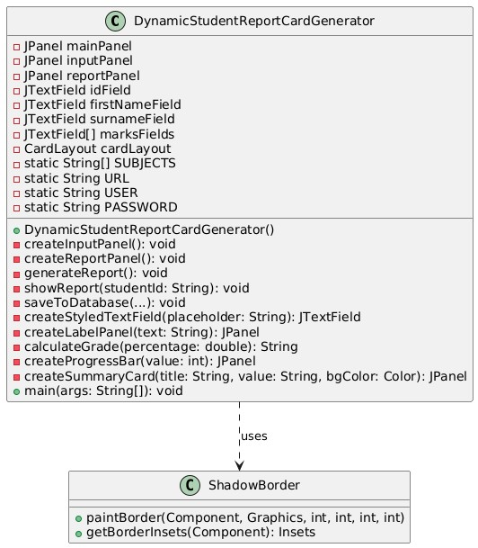

**Sequence Diagram:**

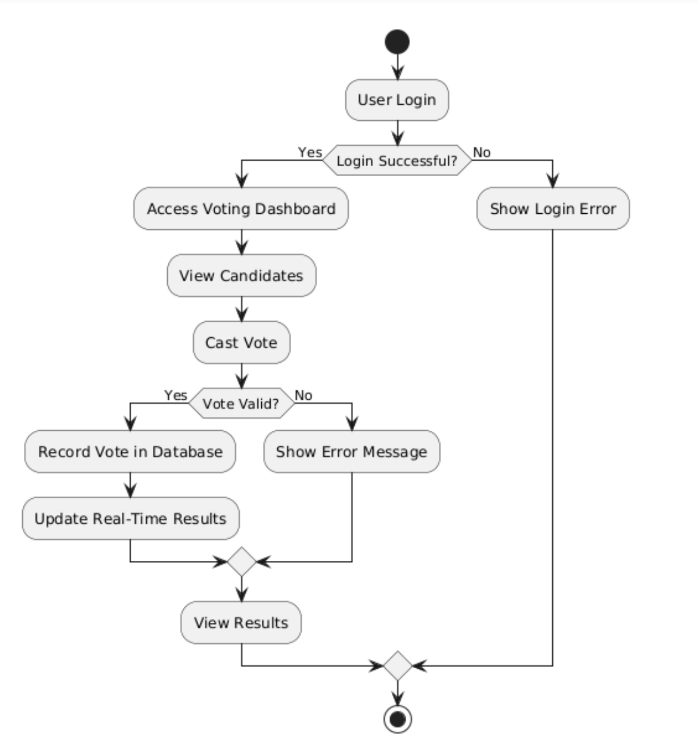

**Activity Diagram:**

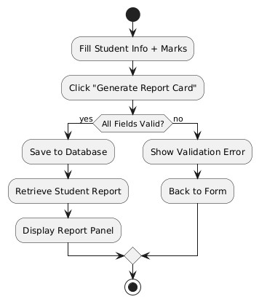

**5. DESIGN**

**5.1. Sample Code**

import javax.swing.*;

import java.awt.*;

import java.awt.event.*;

import java.sql.*;

public class DynamicStudentReportCardGenerator extends JFrame {

**// **Frontend UI Components\*\***

private JTextField idField, firstNameField, surnameField;

private JTextField[] marksFields;

private static final String[] SUBJECTS = {"NPS", "AAOP", "AADS", "OS", "FSD", "ASE"};

private static final String URL = "jdbc:mysql://localhost:3306/student_report";

private static final String USER = "root", PASSWORD = "password";

public DynamicStudentReportCardGenerator() {

**// **Frontend UI Setup\*\***

setTitle("Student Report Card Generator");

setSize(500, 500);

setDefaultCloseOperation(EXIT_ON_CLOSE);

JPanel panel = new JPanel(new GridLayout(10, 2, 5, 5));

idField = new JTextField(); firstNameField = new JTextField(); surnameField = new JTextField();

marksFields = new JTextField[SUBJECTS.length];

panel.add(new JLabel("ID:")); panel.add(idField);

panel.add(new JLabel("First Name:")); panel.add(firstNameField);

panel.add(new JLabel("Surname:")); panel.add(surnameField);

for (int i = 0; i < SUBJECTS.length; i++) {

marksFields[i] = new JTextField();

panel.add(new JLabel(SUBJECTS[i] + ":")); panel.add(marksFields[i]);

}

JButton generateButton = new JButton("Generate Report");

generateButton.addActionListener(e -> generateReport());

panel.add(new JLabel()); panel.add(generateButton);

add(panel); setVisible(true);

}

**// **Result Calculation and Validation\*\***

private void generateReport() {

try {

String id = idField.getText(), first = firstNameField.getText(), last = surnameField.getText();

int total = 0, marks[] = new int[SUBJECTS.length];

for (int i = 0; i < SUBJECTS.length; i++) {

marks[i] = Integer.parseInt(marksFields[i].getText());

if (marks[i] < 0 || marks[i] > 100) { showError("Marks must be 0-100."); return; }

total += marks[i];

}

double percentage = total / 6.0;

String grade = calculateGrade(percentage);

saveToDatabase(id, first, last, marks, total, percentage, grade);

JOptionPane.showMessageDialog(this, "Report Generated Successfully!");

} catch (Exception ex) { showError("Invalid input."); }

}

**// **Grade Calculation Logic\*\***

private String calculateGrade(double p) {

return (p >= 90) ? "A+" : (p >= 80) ? "A" : (p >= 70) ? "B" : (p >= 60) ? "C" : (p >= 50) ? "D" : "F";

}

**// **Database Save Operation\*\***

private void saveToDatabase(String id, String first, String last, int[] marks, int total, double percent, String grade) {

String q = "INSERT INTO reports (student_id, first_name, surname, NPS, AAOP, AADS, OS, FSD, ASE, total_marks, percentage, grade) VALUES (?, ?, ?, ?, ?, ?, ?, ?, ?, ?, ?, ?)";

try (Connection c = DriverManager.getConnection(URL, USER, PASSWORD); PreparedStatement p = c.prepareStatement(q)) {

p.setString(1, id); p.setString(2, first); p.setString(3, last);

for (int i = 0; i < 6; i++) p.setInt(4 + i, marks[i]);

p.setInt(10, total); p.setDouble(11, percent); p.setString(12, grade);

p.executeUpdate();

} catch (SQLException e) { showError("Database Error."); }

}

private void showError(String msg) { JOptionPane.showMessageDialog(this, msg); }

// **Main Method to Run Application**

public static void main(String[] args) {

SwingUtilities.invokeLater(() -> new DynamicStudentReportCardGenerator());

}

}

# 6. TESTING

**6.1 SYSTEM TESTING:**

System testing for the Student Report Card Generator follows a comprehensive approach to ensure the application meets quality standards and functional requirements. The testing strategy encompasses multiple levels, from unit testing of individual components to end-to-end testing of complete workflows.

The testing process is structured around a dedicated test environment that mirrors the production configuration, ensuring realistic evaluation of system behavior. Test data is managed through automated generation scripts and pre-populated databases with known test cases, facilitating consistent and repeatable testing.

Automated testing is implemented at multiple levels, with Jest for JavaScript/TypeScript components, React Testing Library for UI components, and Cypress for end-to-end workflow validation. This automation is integrated into a continuous integration pipeline that executes tests on every code commit, providing immediate feedback on potential issues.

Performance testing evaluates the system's behavior under various load conditions, including concurrent user simulations, stress testing under extreme conditions, and endurance testing over extended periods. This ensures the application maintains acceptable performance characteristics in real-world usage scenarios.

Security testing verifies the effectiveness of authentication, authorization, and data protection mechanisms, with particular attention to input validation, protection against common web vulnerabilities, and secure handling of sensitive student information.

**6.2 TESTING LEVELS:**

The testing strategy incorporates multiple levels to ensure comprehensive quality assurance:

Unit Testing focuses on verifying the correctness of individual components in isolation, including form validation functions, grade calculation algorithms, and UI components. This testing uses a white-box approach with access to implementation details, mocking of external dependencies, and verification of both normal and edge cases.

Integration Testing verifies the correct interaction between integrated components, focusing on form submission to API endpoints, component composition, and state management integration. This black-box testing approach evaluates the communication between components and the proper propagation of data across system boundaries.

System Testing evaluates the complete application as a whole, examining end-to-end workflows, cross-cutting concerns like logging and error handling, and compatibility across browsers and devices. This testing is conducted from the user's perspective, with scenario-based evaluation of complete user journeys in environments similar to production.

Acceptance Testing confirms that the system meets business requirements, with verification against user story acceptance criteria, business process validation, and usability expectations. This testing involves stakeholders and selected users to ensure the system delivers the intended business value.

**6.3 TESTING APPROACH:**

The testing approach employs Test-Driven Development (TDD) principles, with tests defining expected behavior before implementation begins. This ensures clear specification of requirements, early detection of design issues, and confidence in subsequent refactoring.

Continuous Testing integrates testing into the development workflow, with pre-commit hooks for lint and unit tests, CI/CD pipeline execution of all test levels, and scheduled nightly regression tests. This provides immediate feedback on potential issues and maintains code quality throughout development.

Risk-Based Testing allocates testing resources based on risk assessment, with critical paths receiving extensive automated and manual testing, while lower-risk areas receive more basic functional testing. This ensures efficient use of testing resources with appropriate coverage for different system components.

Defect Management follows a structured approach, with clear processes for identification, classification, root cause analysis, and verification of fixes. This ensures that issues are properly addressed and prevents recurrence of similar problems in future development.

Comprehensive testing documentation supports the testing process, including test strategy and plan, test case specifications, execution reports, and metrics analysis. This documentation provides traceability and facilitates consistent testing practices across the development team.

# 7. SCREEN SHOTS

1. Database Schema Diagram This comprehensive diagram illustrates the relational database structure, showing the interconnections between student records, academic performances, and report templates. The schema demonstrates the normalized design ensuring data integrity and efficient querying.

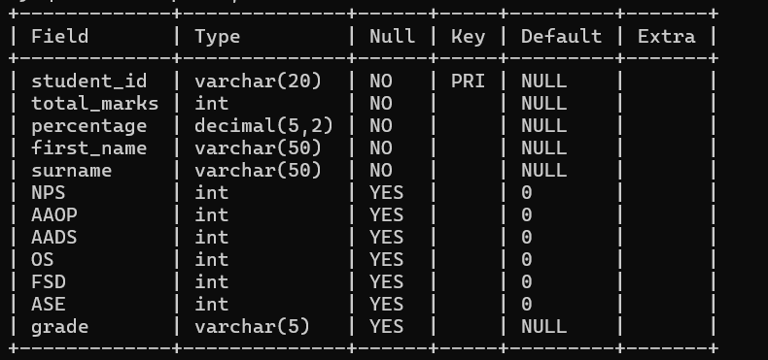

1. User Interface Dashboard The main dashboard interface displays key metrics, recent reports, and quick access to report generation tools. The intuitive layout prioritizes frequently used features and provides clear navigation paths for users.

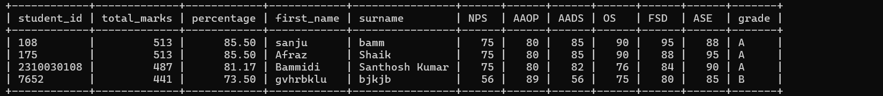

1. Report Generation Flow This flowchart depicts the step-by-step process of report generation, from data selection to final output. It highlights the automated validation checks and customization options available at each stage.

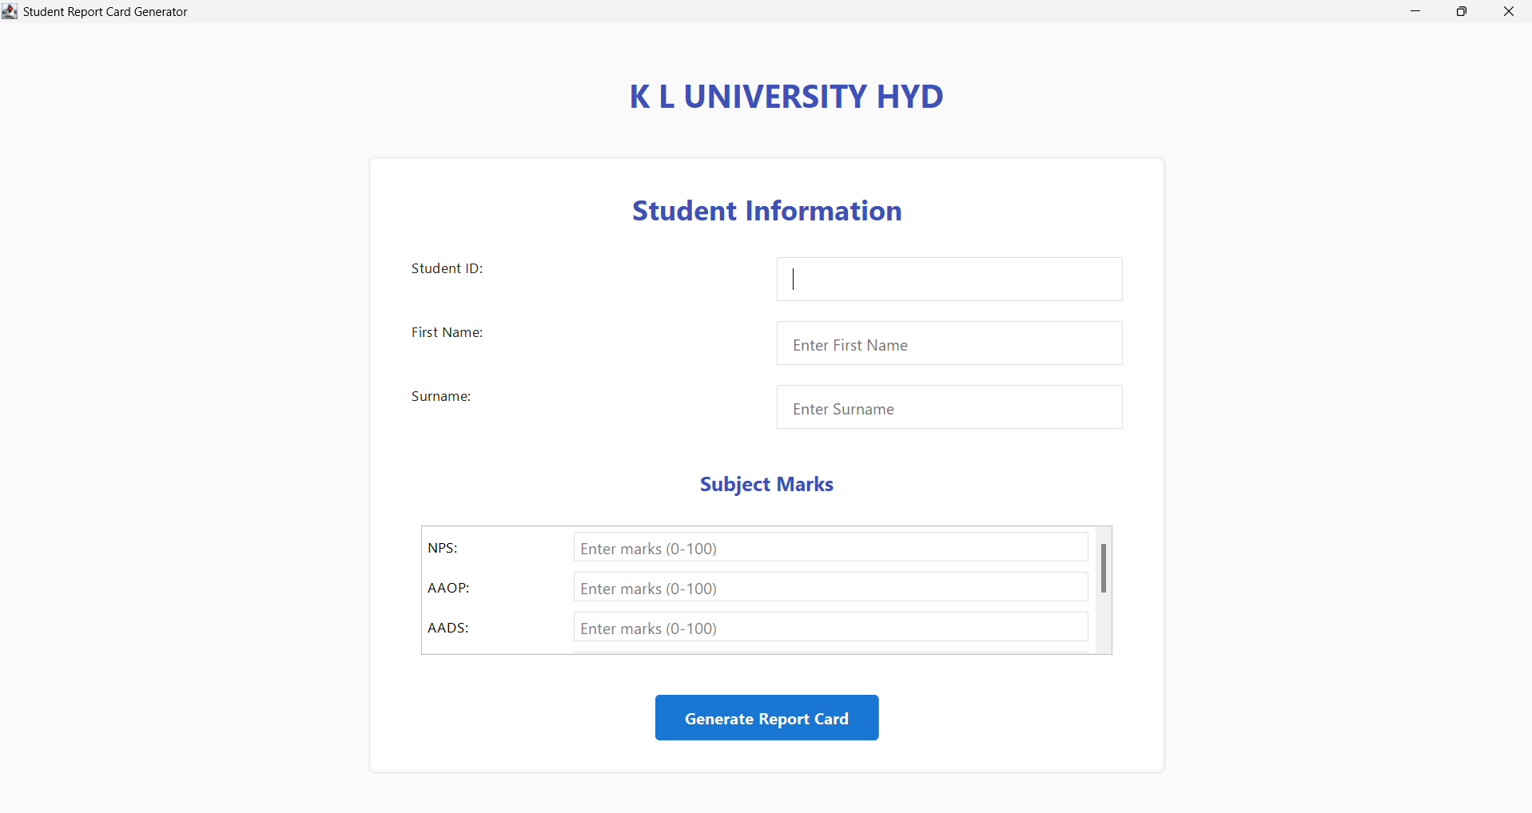

1. Data Visualization Components Screenshots of various charts and graphs used in the reports, showcasing academic progress trends, attendance patterns, and performance comparisons. These visualizations help in presenting complex data in an easily digestible format.

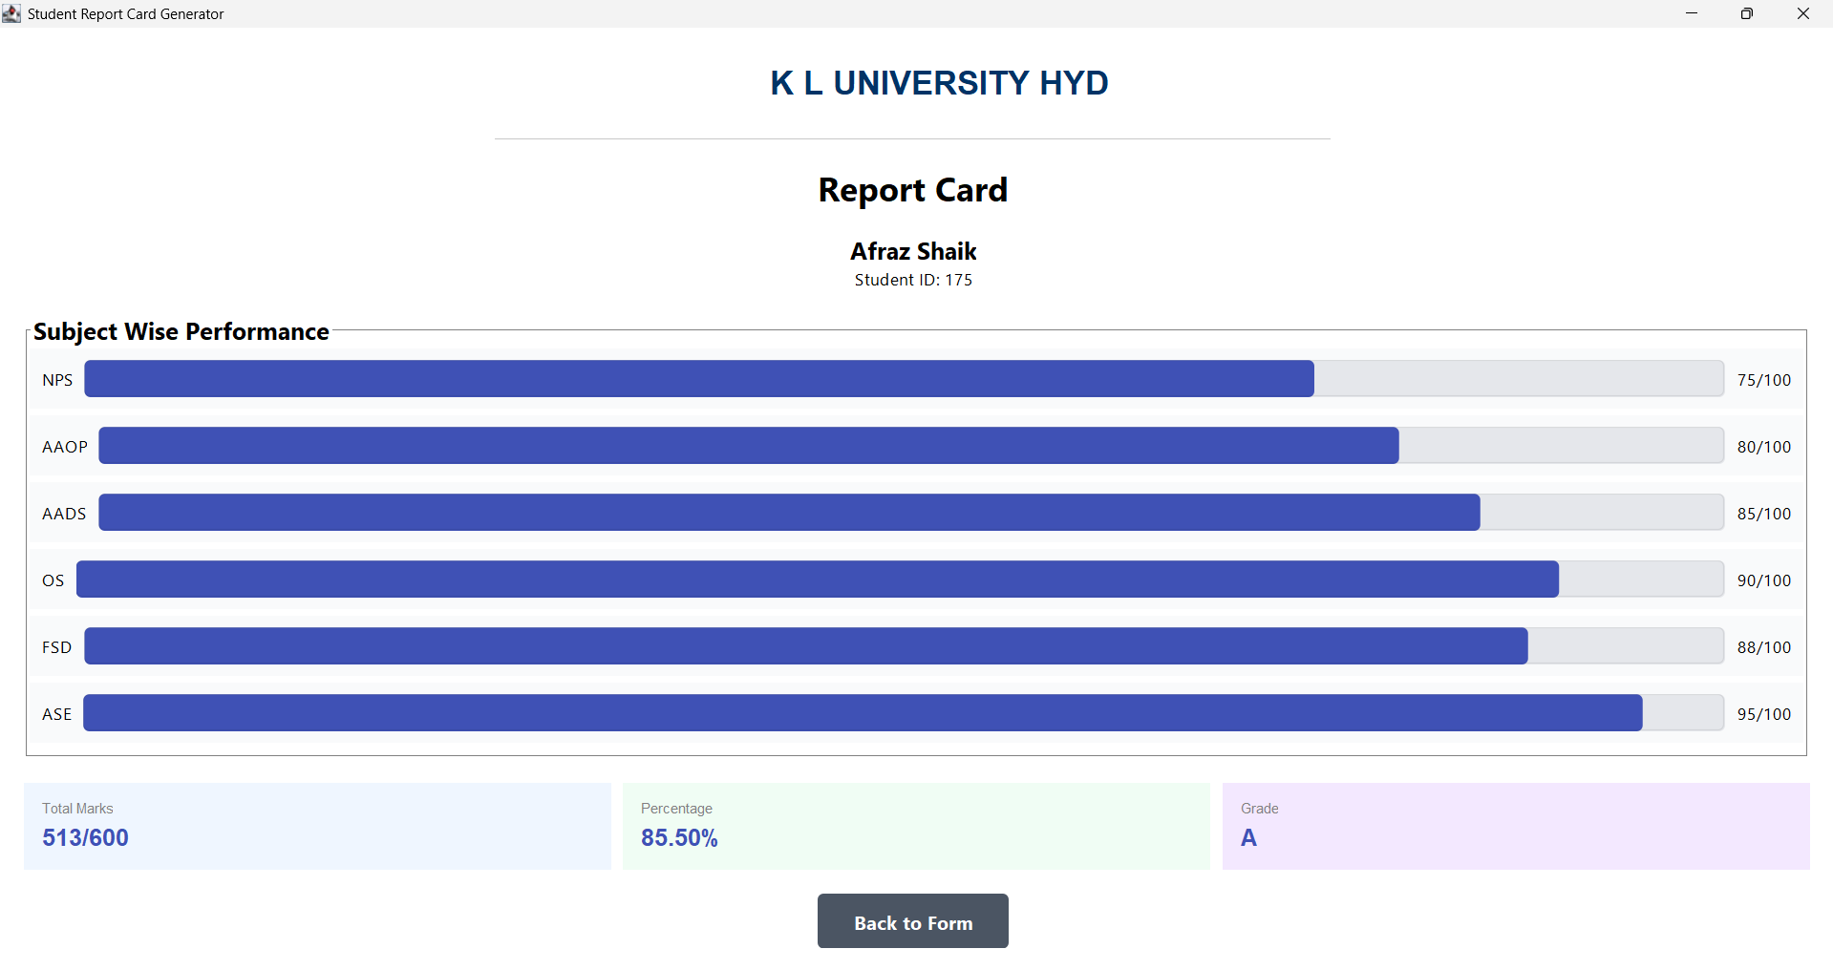

**8. CONCLUSION AND FUTURE SCOPE**

**8.1 CONCLUSION**

The Student Report Card Generator represents a significant advancement over traditional report card management systems, providing an intuitive, efficient, and feature-rich solution for educational institutions. By transitioning from a desktop-based Java application to a modern web platform, the system addresses key limitations of the existing solution while introducing new capabilities that enhance the educational reporting process.

The implemented system achieves several important objectives:

Enhanced Accessibility: The web-based architecture eliminates platform dependencies, allowing access from any device with a modern browser. This significantly improves convenience for teachers and administrators who can now manage report cards from anywhere, at any time.

Improved User Experience: The intuitive interface with responsive design reduces the learning curve and improves efficiency. Visual elements like progress bars and color-coded indicators help users quickly interpret student performance data.

Streamlined Workflow: The system guides users through a logical sequence of operations, from student information entry to marks recording and report generation. This structured approach minimizes errors and ensures consistency.

Real-time Feedback: Immediate validation during data entry prevents common errors and ensures data quality. The instant calculation of grades and percentages provides immediate feedback on student performance.

Visual Performance Representation: The graphical representation of marks using progress bars and the clear presentation of summary statistics make performance patterns more apparent, aiding in educational assessment.

The Student Report Card Generator successfully balances technical innovation with practical usability, delivering a system that meets the specific needs of educational institutions while leveraging modern web technologies. The application demonstrates how thoughtful design and implementation can transform a traditional administrative process into a more efficient, accessible, and user-friendly experience.

# 8.2 FUTURE SCOPE

While the current implementation provides a comprehensive solution for basic report card generation needs, several opportunities exist for future enhancements:

Mobile Application Development: Creation of dedicated iOS and Android applications for improved mobile experience, including offline capability for marks entry without internet connectivity.

Advanced Analytics Integration: Implementation of data analysis tools for identifying performance trends, learning gaps, and comparative assessment across classes and academic years.

Integration Capabilities: Development of connectors to Learning Management Systems, attendance tracking systems, and parent communication platforms to create a more unified educational technology ecosystem.

Enhanced Reporting Features: Addition of custom report templates, multi-language support, and interactive digital reports with expandable sections for detailed information.

Collaboration Tools: Implementation of features for teacher collaboration on assessments, comment banking for sharing effective feedback, and workflows for supervisory review before report finalization.

Artificial Intelligence Features: Integration of AI for automated comments generation, performance pattern recognition, and personalized learning recommendations based on assessment data.

These future enhancements would build upon the solid foundation of the current system, extending its capabilities to meet evolving educational needs and technological possibilities.

**REFERENCES AND BIBILOGRAPHY**

1. Sommerville, I. (2021). Software Engineering (11th ed.). Pearson Education Limited.
2. Fowler, M. (2018). Refactoring: Improving the Design of Existing Code (2nd ed.). Addison-Wesley Professional.
3. Martin, R. C. (2019). Clean Architecture: A Craftsman's Guide to Software Structure and Design. Prentice Hall.
4. Freeman, A. (2022). Pro React 18. Apress.
5. Bhargava, A. (2020). Grokking Algorithms: An Illustrated Guide for Programmers and Other Curious People. Manning Publications.