System Requirements Specification (SRS) –

AestheticAM

**1. Introduction**

**2. Functional Requirements**

**2.1 Seller/ admin/ Admin Module**

**2.2 Buyer Module**

**2.3 message acknoeledgement Module**

**2.4 Use Case Diagram.........................................................................................................................**

1. **Introduction**

This document explains the system requirements and scope for developing AestheticAM – An Online Store System.

AestheticAM System can be divide into four main parts; Seller/ admin part, Buyer part, Admin part and, the Acknowledgement part.

1. **Functional Requirements**

The said system has been divided into three modules which are divided into several processes, described as below,

|  |  |  |
| --- | --- | --- |
| **No** | **BRS requirement ID** | **Description** |
| **2.1** | **Seller/ admin/ Admin Module** | |
| **2.1.1** | **F1** | **Login process** |
| **2.1.2** | **F2** | **Publish product for sale** |
| **2.1.3** | **F3** | **Delete product** |
| **2.1.4** | **F4** | **Add new category for sale** |
| **2.1.5** | **F5** | **Delete existing category** |
| **2.1.6** | **F6** | **Maintain user information** |
| **2.1.7** | **F7** | **Disable unwanted user account** |
| **2.1.8** | **F8** | **Maintain website** |
| **2.2** | **Buyer Module** | |
| **2.2.1** | **F9** | **Account Creation Process** |
| **2.2.2** | **F10** | **Login Process** |
| **2.2.3** | **F11** | **Forgot Password Process** |
| **2.2.4** | **F12** | **Change Password Process** |
| **2.2.5** | **F13** | **Update Account Process** |
| **2.2.6** | **F14** | **Search Product** |
| **2.2.7** | **F15** | **Buy Products** |
| **2.2.8** | **F16** | **Payment Process** |
| **2.2.9** | **F17** | **Cancel Order** |
| **2.3 Message Acknowledgement Module** | | |
| **2.3.1** | **F18** | **Sends Message on successful purchase** |

* 1. **Seller/ admin/ Admin Module**
     1. **Login Process**

Administrator should be responsible for following activities,

To begin using the system, admin must first log-in with his credentials as part of authentication.

The user authentication demands UserID and Password. The UserID and the Password should be checked in three ways.

* The UserID and the Password should exist and must be correct.

If The UserID and the Password does not match to what the admin has been provided with, the Admin authentication cannot be provided.

* The User Type linked to the UserID should be "Admin".

When the User Type is "Admin", user can be placed on “Admin Home”.

The Admin account should be alive for as long as decided by the Admin.

Only when these checks are successfully completed, Admin can be placed on respective pages.

The “Admin Home” provides some items described as below.

* A trigger to logout
* A trigger to update Account
* A trigger to Change Password
* A trigger to Search Product
* A trigger to Publish Product for sale
* A trigger to Update Product Information
* A trigger to Delete Product
* A trigger to Update the website
  + 1. **Publish product for sale**

Publish products requirements are described as below.

* Product category
* Price
* Product name
* Quantity
* Photos
  + 1. **Delete Product**

After Publishing if Seller/ admin wants to remove some products, then he can delete the product.

* + 1. **Add New Category for Sale**
    2. **Delete Existing Category**
    3. **Maintain User Information**

Admin should able to track all,

* Registered user of the website.
  + 1. **Enable/ Disable User**

Admin should be able to manage all the accounts with following activities,

* Enable accounts
* Disable accounts
  + 1. **Update Website**

→ Admin can make changes to the website UI.

* 1. **Buyer Module**
     1. **Account Creation Process**

AestheticAM System does not need to create the account for using system but compels to create the account before buying the product. So, AestheticAM System should provide the function which makes buyer creates new account.

When buyer creates new account, the function demands four information described as below.

* Login information
* Contact Details
* Payment information
* Security Question Information

Login information

The Login information consists of some items described as below,

* UserID

The UserID should be unique. If the UserID correspond with not case-sensitive to other which is previously registered, the UserID should not be registered as an account.

* Password

The Password has constrains which makes the Password consists of more than or equal 8 and less than or equal 16 characteristics including characters described as below,

* Numeric figure (at least one)
* Capital alphabet (A-Z) (at least one)
* Small alphabet (a-z) (at least one)
* Special character (#, $, %, &, etc.) (at least one)

The Password is masked by dummy characters. The re-entering Password is demanded.

The Password must be encrypted in AestheticAM System.

* First Name
* Last Name
* E-mail address

All items are compulsory demanded.

Contact Details

The Contact Detail consists of some items described as below.

* Permanent Address

Permanent Address should be filled, only the state should be selected from options.

* Contact Phone number

All items are compulsory demanded.

* + 1. **Login Process**

AestheticAM System always compels buyer’s authentication before using itself except when a new account is successfully created.

The user authentication demands UserID and Password.

* The UserID and the Password should be existed and correct.

If, the UserID and the Password are not equal to what the user has registered, the user authentication cannot be provided.

The buyer account should alive for as long as the duration decided by Admin.

Only when the checks are successfully completed, buyer can be placed on respected page.

The “Buyers Home” provides some items described as below.

* A trigger to logout
* A trigger to update Account
* A trigger to Change Password
* A trigger to Search Product
  + 1. **Forgot Password Process**

When Buyer lost their Password, the recovery method should be provided by AestheticAM system.

The recovery method is described as below,

* First, Buyer enters their UserID for AestheticAM System.
* Next, AestheticAM System demands the Answer which has been registered since when the Account was created.
* Only when the Answer is correct, Buyer get the new password by E-mail which also has been registered since when the Account was created.
* The new password is automatically generated by AestheticAM System.

Of course, the new password should consist of more than or equal 8 and less than or equal 16 characteristics including at least a numeric figure, a capital alphabet, a small alphabet, and a special character.

As a consequence, The Buyer could get the user authentication using the new password.

* Then, the Buyer had better change the new password manually.

If the Answer is not correct, otherwise, the correct Answer is demanded for Buyer again.

* In that case, Of course, Buyer couldn’t get the new password.
  + 1. **Change Password Process**

When Buyer wants to change their Password, the measure should be provided by AestheticAM System.

Therefore, AestheticAM System should provide the function which is available after getting the Buyer authentication.

The function demands the current password and the new password.

* Of course, the new password should consist of more than or equal 8 and less than or equal 16 characteristics including at least a numeric figure, a capital alphabet, a small alphabet, and a special character.
* The current password and the new password are masked by using dummy characters.
* The new password is demanded to enter twice to avoid a typing error.

Only when the current password is correct, Buyer could change their Password.

When the current password is changed into new password, AestheticAM System compels Buyer authentication again.

* + 1. **Update Account Process**

AestheticAM System should provide the function which makes the account updated for buyer.

The information buyer could update is described below,

* Login information
* User information
* Security Question Information

Login information

The updatable items as described below,

* First Name
* Last Name
* E-mail address

All items are compulsory demanded, but updating is optional.

The User information

The updatable items as described below,

* User Name
* User Phone No
* E-mail address
* Permanent address

All items are compulsory demanded, but updating is optional.

The Security Question information

The updatable items as described below,

* Selected Question
* Answer

All items are compulsory demanded, but updating is optional.

* + 1. **Search Product**

Search conditions are described as below,

* Product category
* Price range

As the result of searching Requirements, buyer could see the list of products which are available for sale and below information about the product,

* Product name
* Price
* Quantity
* Photos
  + 1. **Buy Product**

To buy the product followings are the condition,

* Product category
* Price range
* Product Quantity
* Product Name
  + 1. **Payment Process**

In payback process system following are the conditions,

* If somehow order is not fulfil.
* If buyer is not satisfied with product.
  + 1. **Cancel Order**

Before paying Buyer can cancel the order in following condition

* If the product does not fulfil the requirement.
* If price goes out of his budget.
  1. **Message Acknowledgement Module**

The acknowledgement is to be sent under the following conditions:

1. After completion of successful registration.
2. After every successful transaction,
   1. To buyer when the successfully buy the product
   2. To seller/ admin after they successfully sell the product
3. As of now the messages are being sent via email, but in future we can include mobile SMS.
   1. **Use Case Diagram**
4. **Seller/ admin/ Admin:**

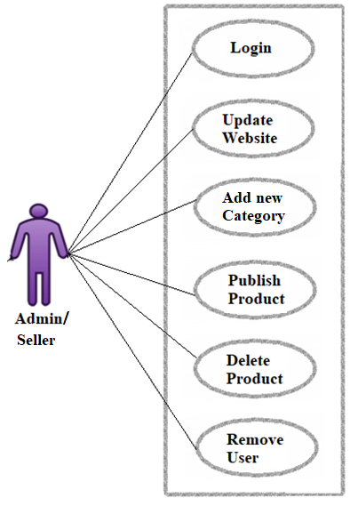

*fig.: Seller/ admin use case diagram*

Seller/ admin/ Admin can handle following use cases:

* Login
* Add new category
* Add new product
* Delete existing category
* Delete existing product
* Delete unwanted user account
* Update Website

1. **Buyer:**

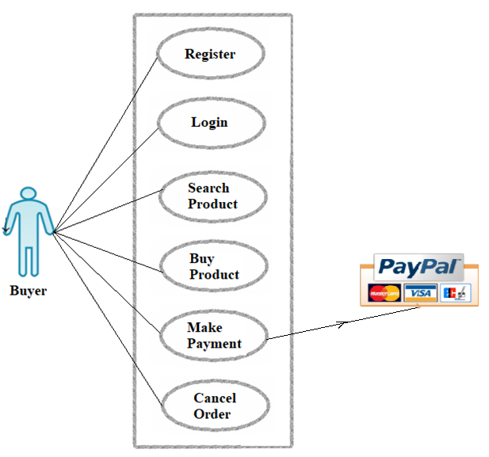

*fig.: Buyer use case diagram*

Buyer can handle following use cases:

* Register
* Login
* Search Product
* Buy Product
* Make Payment
* Cancel Order