**Blood Bank Management System**

**Name:** Sayyed Swaleha Sameer **STD:** T.Y.B.Sc.Cs {A1} **Roll No.:** 04

**Name:** Khan Afreen Mubarak **STD:** T.Y.B.Sc.Cs {A1} **Roll No.:** 08

* **Introduction:**
  + Blood Bank Management System is web-based system that is designed to store, process, retrieve & analyse blood related information.
  + This project is designed to handle the daily transactions of blood bank & search the details when required.
  + Through this application any person who is interested in donating the blood can register himself. Moreover, if any general consumer wants to make request blood online, he can also take the help of this site. Admin is the main authority who can do CRUD operations on blood details.
* **Problem Definition:**

Despite advances in technology, nowadays, most

blood bank systems are running in manual system. As such,

there is a prevalent problem in the availability of needed blood

types. For instance, when a person needs a certain type of blood

and this type is not available in the hospital, family members

send messages through social media to those who can donate to

them and this process takes longer than the life of the patient to

the most dangerous. In addition, it seems that there is lack of

proper documentation about blood donors and its medical

history. This may lead to blood bag contamination and may

affect the blood transfusion safety. Generally, this study aims

to determine how the use of online bank management system

enhance blood transfusion safety. Subsequently, this study

seeks to answer the following specific problems:

1. What is the level of perception among blood bank’s stakeholders on manual- based system?

2. What is the level of perception among blood bank’s stakeholders on online blood bank management system?

3. H0: Is there no significant difference in the level of perception among stakeholders between manual-based and online-based blood bank system?

H1: Is there a significant difference in the level of perception among stakeholders between manual-based and online-based blood bank system?

* **Existing Systems:**

Searching for blood donors can take place through blood bank centres or by toll free numbers. So far it is a time taken process because there is a lot of manual work. It is a waste to go to blood bank if the blood of particular group is not available & most of the time user has to wait in queue.

* + - Tracking the database was complicated when the details are maintained manually.
    - It is time consuming and space consuming scarcity of rare blood.
    - Unavailability of blood during emergency.
* **Proposed System:**

* + With the increasing of population of & revolution of the new technologies, Blood Bank Management System plays an important role in the blood bank as blood is necessity to everyone.
  + This proposed system of the Blood Bank Management System is a webbased system intends to simplify & automate the process of searching for blood in case of emergency & maintain the records of blood donors, patients & blood stocks in the bank.
  + In case of emergency, we don’t have time to spend going here & there, we can use technical way to search the blood by using the new Blood Bank Management System.
  + This Blood Bank Management System will provide the information about the Donation camps.
  + **Centralized System:**  A centralized community blood bank with computerized supply chain & distribution system.
  + **Web-Portal:** Web portal for donor to register view blood availability & provide donation information.
  + Medical history & medical checkup of the donor will be checked & done by our expertise doctors by appointing them.
* **Scope of the System:**

* + **Data Management:** Storing, processing, retrieving & analysing data about blood bank administration.
  + **Inventory Management:** Supervising blood inventory management.
  + **Donor Records:** Maintaining donor records.
  + **Blood Supply & Demand:** Facilitating coordination between blood supply & demand.
  + **Voluntary Blood Donation:** Encouraging voluntary blood donation.
  + The Blood Bank Management System will help in managing various blood bank operations effectively. The major goal of Blood Bank Management System is to keep the track of blood, donor, blood groups, blood banks & stock information.
* **Feasibility study:**

A feasibility study for a blood donation management system tailored to a single blood bank focuses on evaluating the practicality of implementing a streamlined solution for managing donor and donation data. The system will track donor information, monitor blood donation history, and ensure efficient management of blood inventory. It will also handle donor eligibility checks, collection of blood, and the storage and tracking of blood units to ensure safety and minimize wastage. The study will assess the technological requirements for the system, including database management, user-friendly interfaces, and secure data storage. It will evaluate the financial costs of development and maintenance, as well as the benefits, such as improved blood stock management, enhanced donor retention, and compliance with regulatory standards. The system’s impact on operational efficiency and the ability to quickly access donor and blood unit data for distribution would also be key factors in determining its feasibility for the blood bank.

* **Data Dictionary:**

**List of relations**

|  |  |  |  |
| --- | --- | --- | --- |
| **Schema** | **Name** | **Type** | **Owner** |
| **public** | **bloodstock** | **table** | **postgres** |
| **public** | **donors** | **table** | **postgres** |
| **Public** | **enquiry** | **table** | **postgres** |
| **public** | **request** | **table** | **postgres** |
| **public** | **users** | **table** | **postgres** |
| **(5 rows)** |  |  |  |

**Table "public.bloodstock"**

|  |  |  |  |  |
| --- | --- | --- | --- | --- |
| **Column** | **Type** | **Collation** | **Nullable** | **Default** |
| **id** | **integer** |  | **not null** | **nextval('bloodstock_id_seq'::regclass)** |
| **blood_group** | **Character varying(10)** |  | **not null** |  |
| **units_available** | **integer** |  | **not null** |  |

**Table "public.donors"**

|  |  |  |  |  |
| --- | --- | --- | --- | --- |
| **Column** | **Type** | **Collation** | **Nullable** | **Default** |
| **id** | **integer** |  | **not null** | **nextval('donors_id_seq'::regclass)** |
| **name** | **character varying(100)** |  | **not null** |  |
| **gender** | **character varying(10)** |  | **not null** |  |
| **age** | **integer** |  | **not null** |  |
| **blood_group** | **character varying(3)** |  | **not null** |  |
| **medical_disorder** | **text** |  |  |  |
| **email** | **character varying(100)** |  | **not null** |  |
| **phone** | **character varying(15)** |  | **not null** |  |
| **isapproved** | **character varying(10)** |  | **not null** | **'pending'::character varying** |

**Table "public.enquiry"**

|  |  |  |  |  |
| --- | --- | --- | --- | --- |
| **Column** | **Type** | **Collation** | **Nullable** | **Default** |
| **id** | **integer** |  | **not null** | **nextval('enquiry_id_seq'::regclass)** |
| **name** | **character varying(50)** |  |  |  |
| **email** | **character varying(100)** |  |  |  |
| **message** | **text** |  |  |  |

**Table "public.request"**

|  |  |  |  |  |
| --- | --- | --- | --- | --- |
| **Column** | **Type** | **Collation** | **Nullable** | **Default** |
| **id** | **integer** |  | **not null** | **nextval('request_id_seq'::regclass)** |
| **patient_name** | **character varying(50)** |  | **not null** |  |
| **email** | **character varying(100)** |  | **not null** |  |
| **blood_group** | **character varying(5)** |  | **not null** |  |
| **quantity** | **integer** |  | **not null** |  |
| **price** | **integer** |  | **not null** |  |
| **message** | **text** |  | **not null** |  |
| **created_at** | **timestamp without time zone** |  |  | **CURRENT_TIMESTAMP** |
| **isapproved** | **character varying(20)** |  |  |  |

**Table "public.users"**

|  |  |  |  |  |
| --- | --- | --- | --- | --- |
| **Column** | **Type** | **Collation** | **Nullable** | **Default** |
| **id** | **integer** |  | **not null** | **nextval('users_id_seq'::regclass)** |
| **first_name** | **character varying(50)** |  | **not null** |  |
| **last_name** | **character varying(50)** |  | **not null** |  |
| **email** | **character varying(100)** |  | **not null** |  |
| **created_at** | **timestamp without time zone** |  |  | **CURRENT_TIMESTAMP** |
| **password** | **character varying(20)** |  |  |  |

* **System Design:**

**ER Diagram**

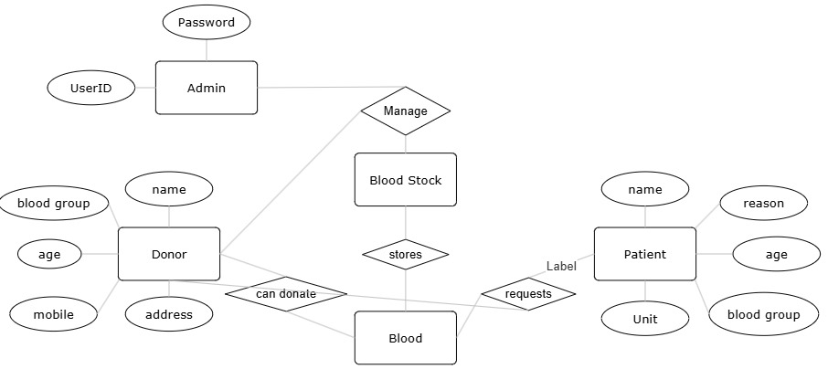

**Class Diagram**

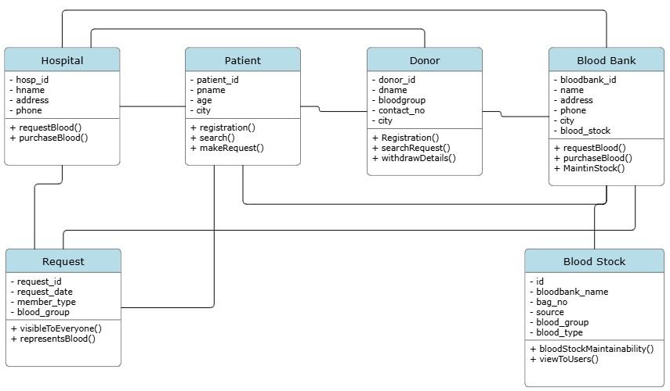

**Sequence Diagram**

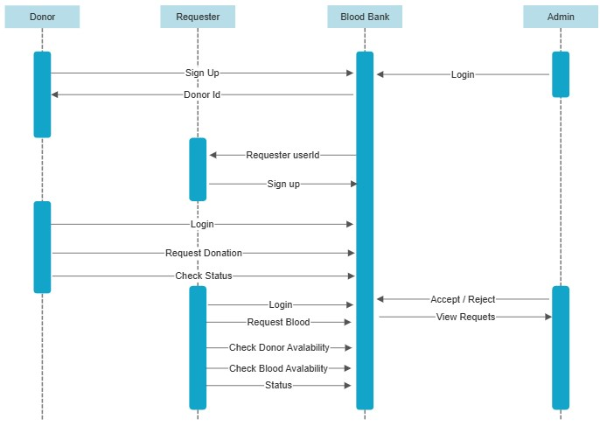

**Usecase Diagram**

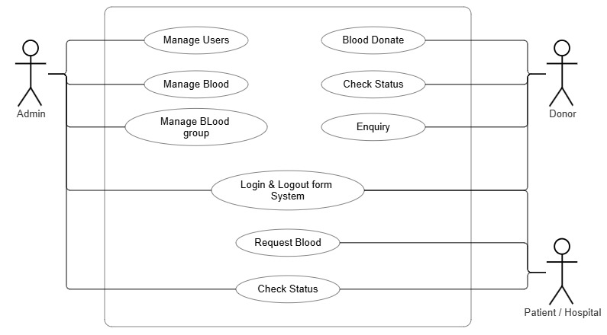

**Activity Diagram**

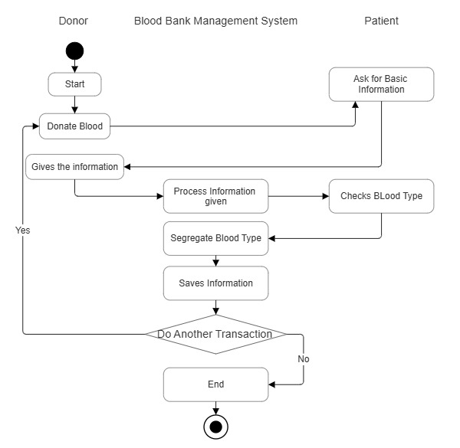

**Component Diagram**

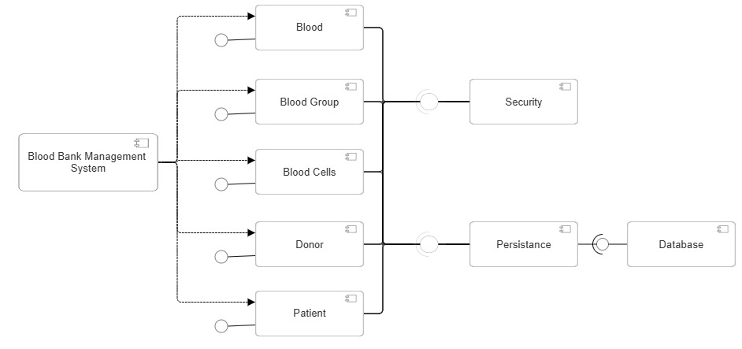

**Collaboration Diagram**

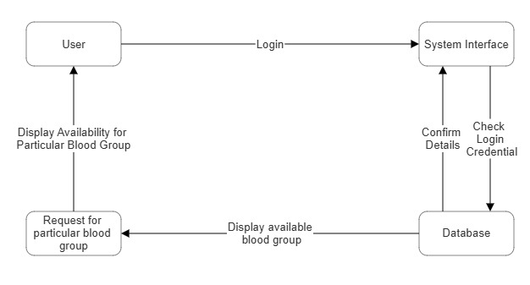

**State Chart Diagram** 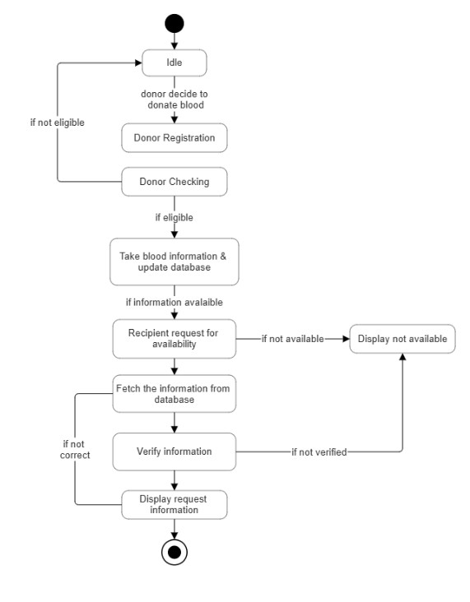

**Deployment Diagram**

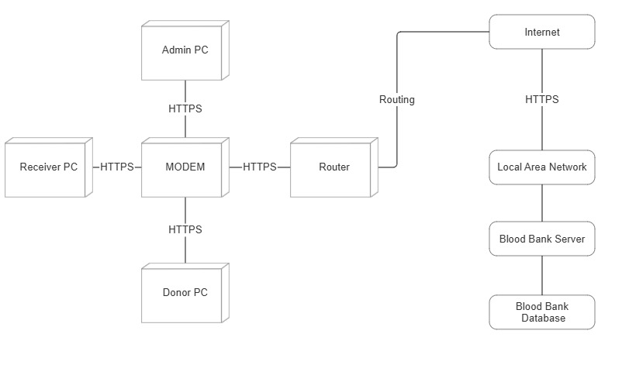

* **Design of Input & Output Screens:**

|  |
| --- |
|  |

**Home Page**

|  |
| --- |
|  |

**Login Form**

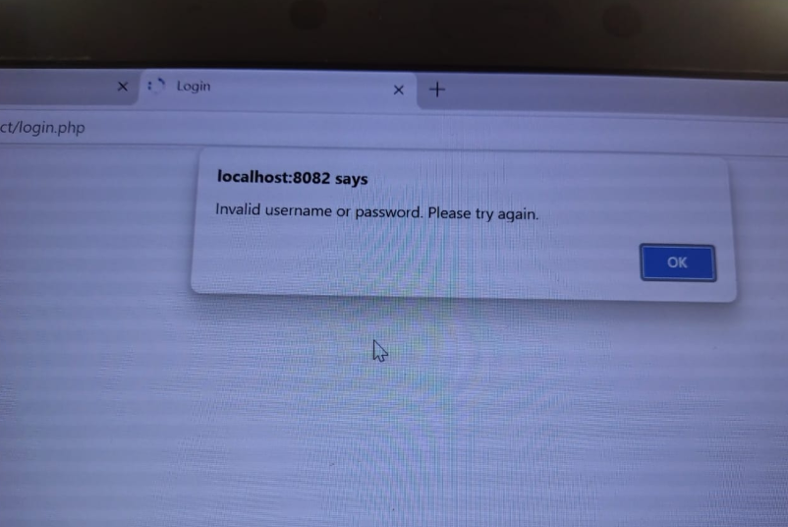

**Validation**

|  |
| --- |
|  |

**Profile Page**

|  |
| --- |
|  |

**Donor Status**

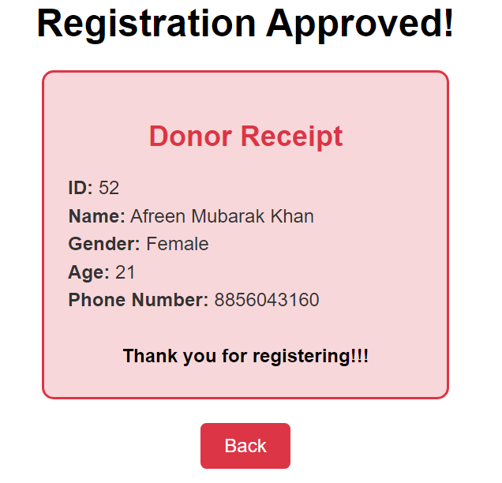

**Token Generation**

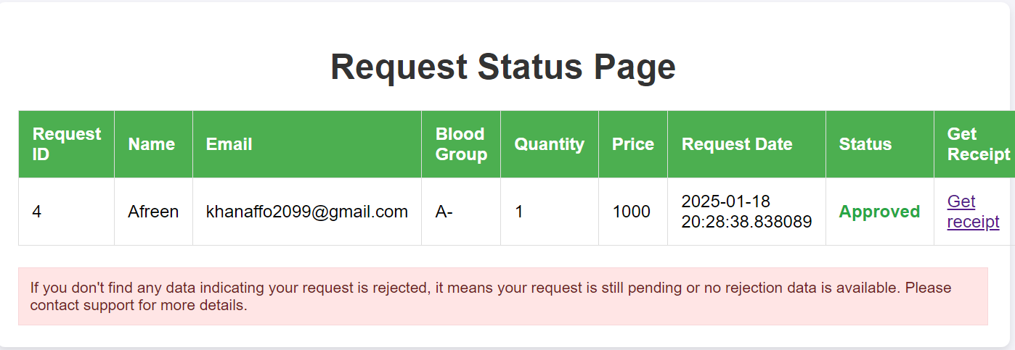

**Patient Request Status**

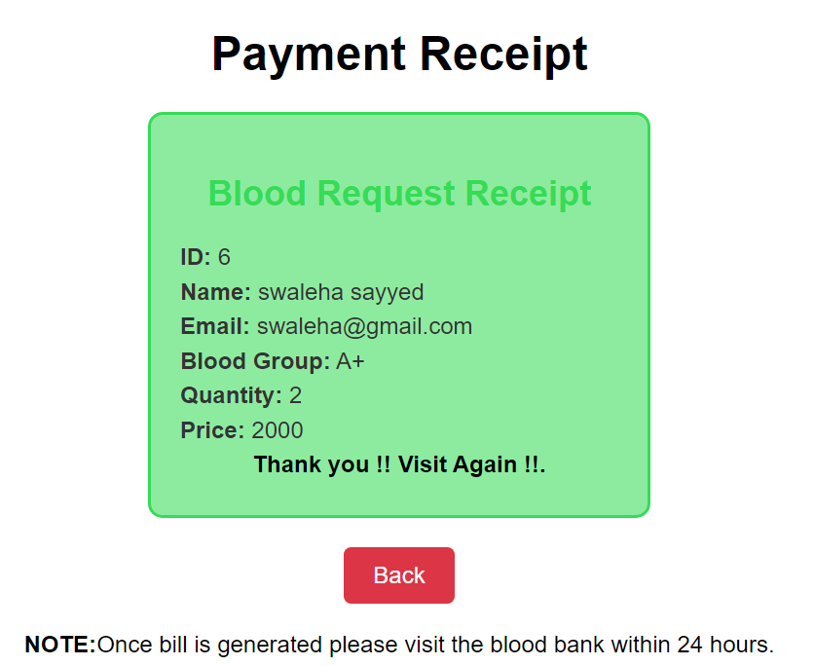

**Bill Generation**

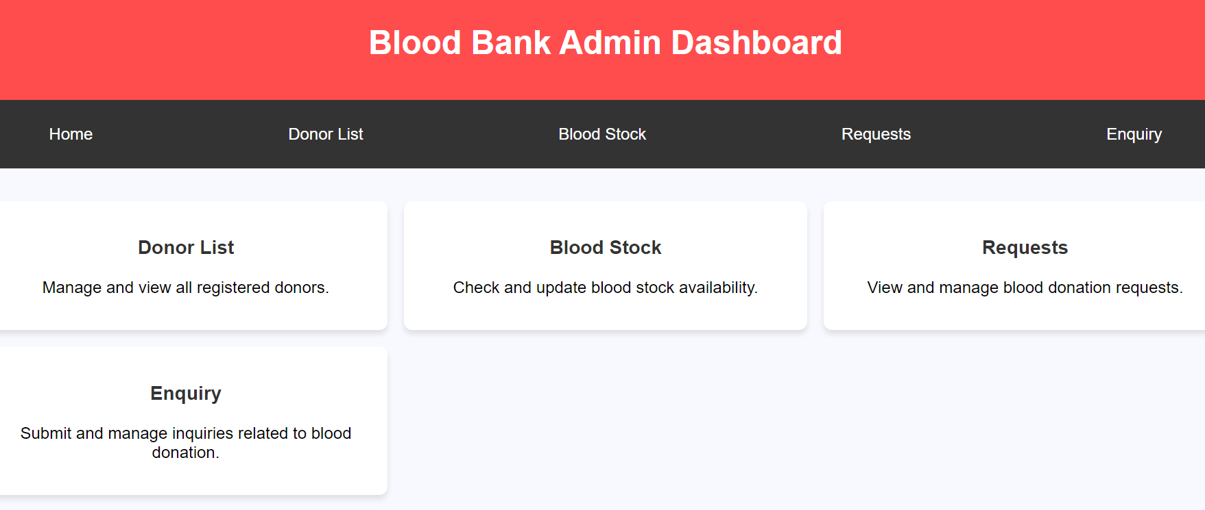

**Admin Dashboard**

* **Report:**

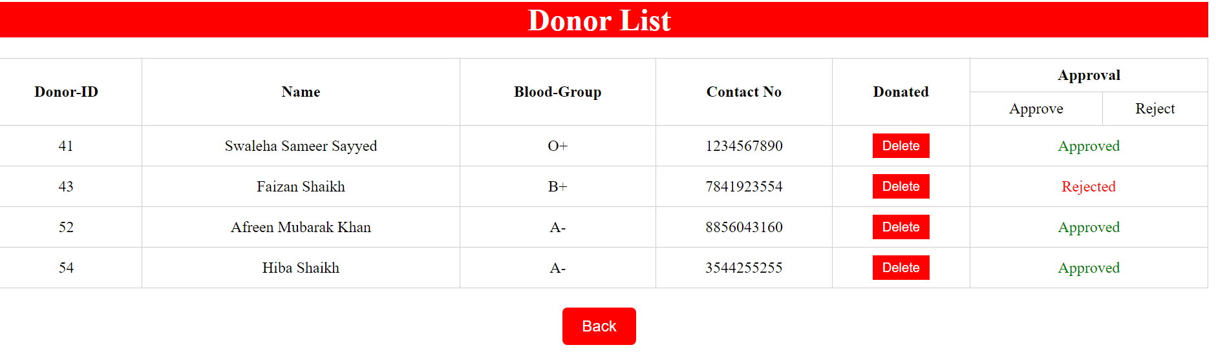

**Donor List**

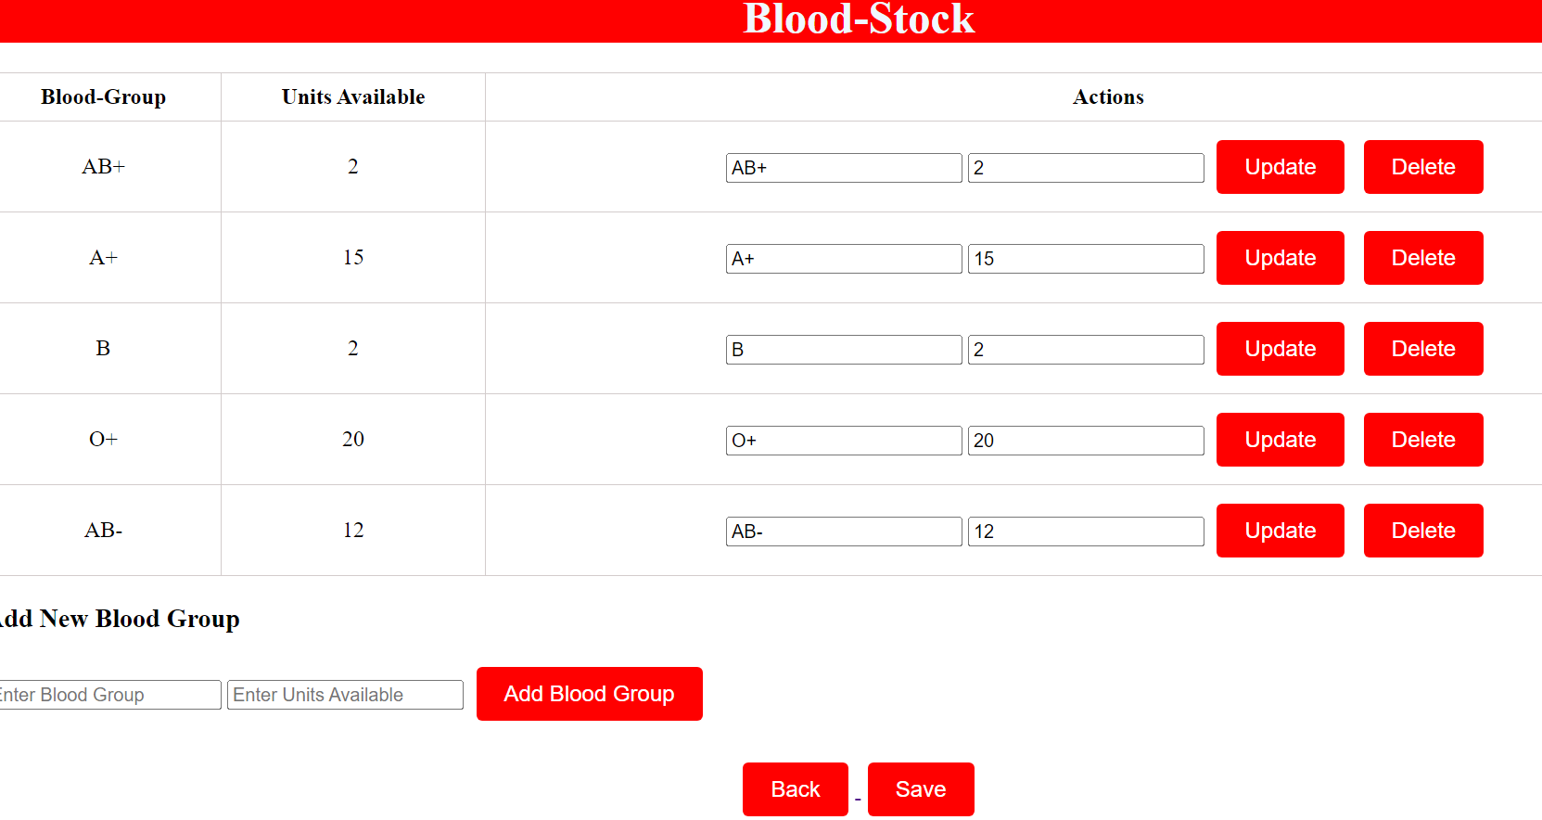

**Blood- Stock**

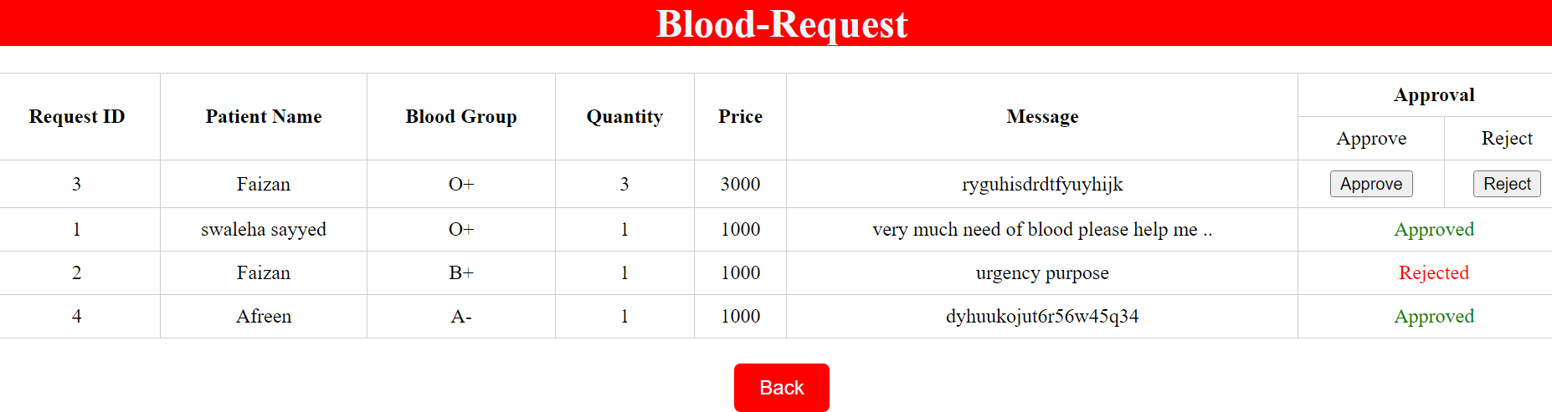

**Blood-Request**

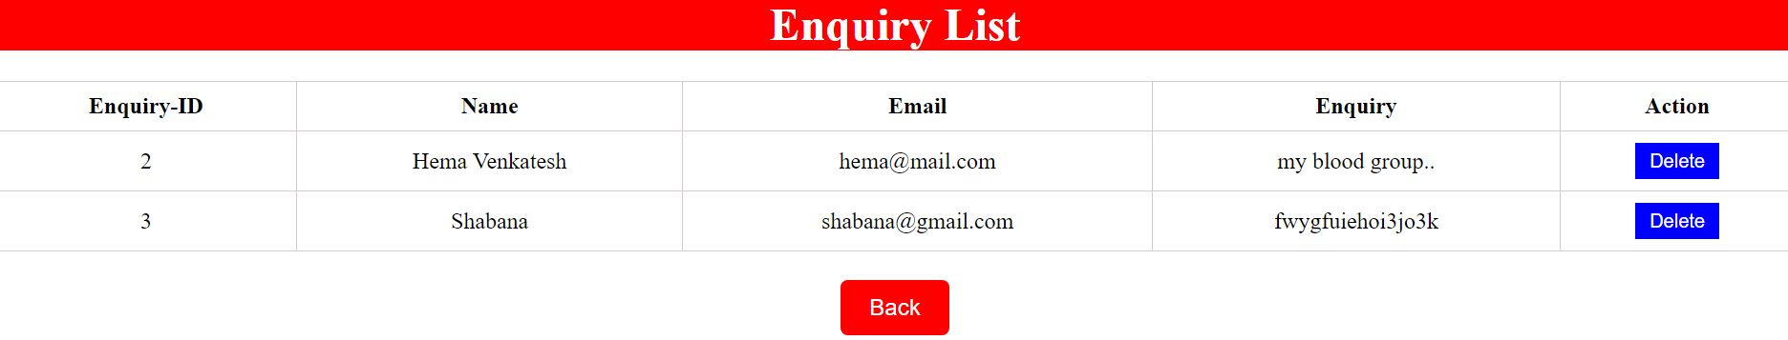

**Enquiry List**

* **Conclusion:**

The purpose of these literature reviews was to collect information on how an

information system helped the management of blood banks. Based on the reviews, it was found

out that web-based blood bank systems provide convenience, efficiency and security to the

system users and hospitals compared to the manual systems. It was found out that manual

systems have many disadvantages that disappoint and dissatisfy users. Indeed, online blood

bank applications make work easy, and ensures fast retrieval of data when needed.

* **Future enhancement:**

1. *Admin Page Enhancements*

* *Search Functionality*: Add search options to easily find specific donors or requests.
* *Basic Reports*: Display a list of donations and requests with basic details (e.g., blood type, quantity).

2. *Registration Page Enhancements*

* *Confirmation Message*: After registration, show a clear message confirming that the registration was successful.
* *Editable Profile*: Allow users to update their personal details (name, contact info, etc.) after registration.

3. *Home Page Enhancements*

* *Upcoming Donation Events*: Display upcoming blood donation drives or events.
* *Basic Blood Needs Info*: Show a simple message about the need for different blood types (e.g., "We need Type A+ blood urgently").

4. *Patient Request Page Enhancements*

* *Status Update*: Allow patients to see if their request is "pending," "approved," or "completed."
* *Basic Filter*: Let patients select blood type and urgency to simplify requests.

5. *Donor Registration Page Enhancements*

* *Eligibility Check*: Include a simple question (like "Are you above 18 years old?") to confirm donor eligibility.
* *Donation Center Info*: Include a section to choose the nearest donation center (simple dropdown list or selection).

6. *Enquiry Page Enhancements*

* *Simple Contact Form*: Allow users to send questions or feedback through a basic contact form.
* *FAQ Section*: Add a simple FAQ section to answer common questions about blood donation.

*General Enhancements*

* *Mobile-friendly Design*: Make sure the pages are responsive, so users can access them easily from smartphones.
* *User-friendly Interface*: Ensure the design is simple, with easy navigation to make it user-friendly.

These enhancements keep the system basic, while improving functionality and user experience!

* **Bibliography:**

1. **Kumar, R., & Gupta, M. (2016).** "Blood Donation System." *International Journal of Computer Science and Information Technology*, 7(5), 89-94.

- This paper outlines a basic blood donation system, including the key features and components involved in managing donors and blood inventory.

2. **Patel, S., & Sharma, N. (2015).** "Design and Implementation of Blood Donation System Using PHP and MySQL." *International Journal of Advanced Research in Computer Science and Software Engineering*, 5(4), 12-15.

- Discusses a basic web-based system for blood donation management, covering front-end design and database integration using PHP and MySQL.

3. **Singh, V., & Kumar, A. (2017).** "Blood Bank Management System: A Review." *International Journal of Emerging Trends in Science and Technology*, 4(1), 56-60.

- This article provides an overview of blood bank management systems, including the challenges and solutions in designing systems for blood donation and storage.

4. **Chaudhary, N., & Agarwal, R. (2018).** "Online Blood Donation System." *Journal of Computer Science and Applications*, 9(6), 45-49.

- Introduces a simple online platform for blood donation registration, helping users find available blood and donate easily.

5. **Patel, P., & Desai, V. (2014).** "Blood Donation System Using Web Technologies." *International Journal of Computer Science and Mobile Computing*, 3(9), 93-96.

Explains a basic blood donation system that uses web technologies to connect donors and recipients.