Software Requirements Specification

for

Supply Chain System

Version 1.0 approved

Prepared by HoangF

VietIS

July 1, 2018

Table of Contents

Table of Contents ii

Revision History ii

1. Introduction 1

1.1 Purpose 1

1.2 Document Conventions 1

1.3 Product Scope 1

2. Overall Description 2

2.1 Context Diagram 2

2.2 Class Diagram 2

2.3 Usecase Diagram 2

3. Busness Rules 3

4. Function Requirements 4

4.1 Get History 4

4.2 Login 4

4.3 View Balance 4

4.4 Sell Products 4

5. Nonfunctional Requirements 4

5.1 Performance Requirements 4

5.2 Safety Requirements 5

5.3 Security Requirements 5

5.4 Software Quality Attributes 5

5.5 Business Rules 5

6. Other Requirements 5

Appendix A: Glossary 5

Appendix B: Analysis Models 5

Appendix C: To Be Determined List 6

Revision History

|  |  |  |  |
| --- | --- | --- | --- |
| **Name** | **Date** | **Reason For Changes** | **Version** |
| Init | July 1, 2018 | Start write document | 1.0 |
|  |  |  |  |

1. **Introduction**
   1. Purpose

This system have 2 side: end-user side and provider side. Each side have a special application. In end-user side is Client App. This app have only on function to search history of transfer product. In the other side is Supply Ap. This app allow sell product and send transfer to network. After all of that, it can print bill. All information about price is secure and not up to network.

* 1. Document Conventions

|  |  |
| --- | --- |
| Name | Convention |
| Sypply Chain System | SCS |

* 1. Product Scope

This product help people know the history of transfer product. End-user or provider can trust in product is legal and trustworthy. User can use smart phone installed this app to search information about product with a puctire of code id.

1. **Overall Description**
   1. Context Diagram

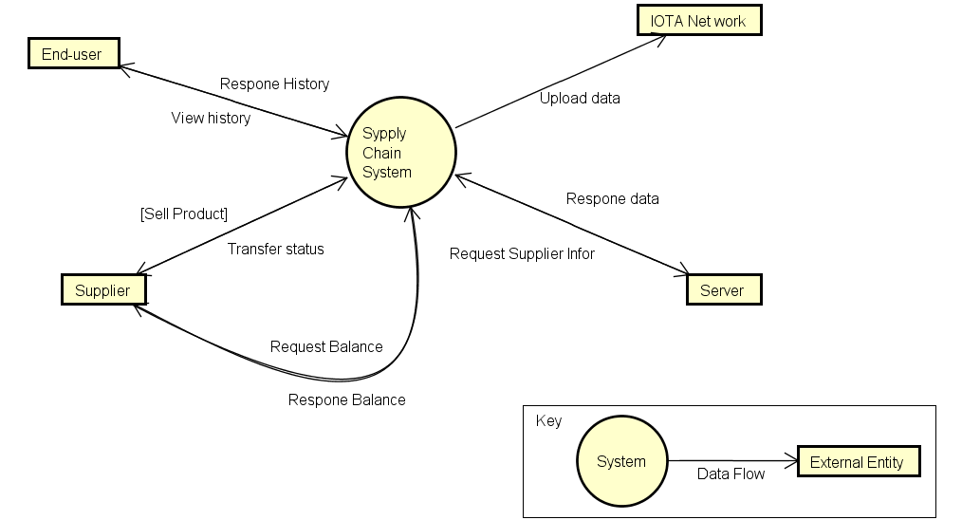

* 1. Class Diagram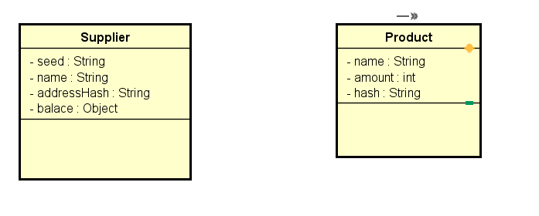
  2. Use-Case Diagram 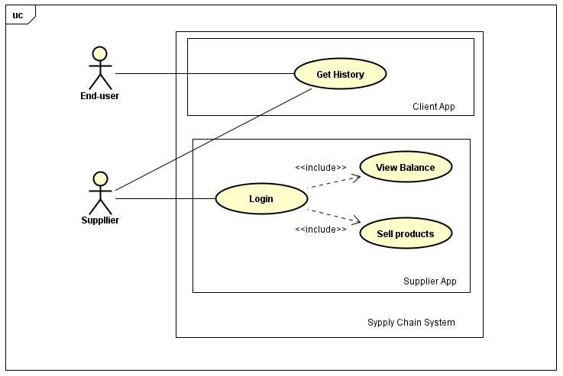

1. **Business Rules**
2. Supplier must login before do anything
3. Supplier must sign up with “server” – manager of SCS
4. Supplier can sell many products of many different kind in one Transfer
5. Supplier must sell product via SCS
6. Product must be attached new hash after transfer
7. **Functional Requirement**
   1. Get History
      1. Usecase Diagram

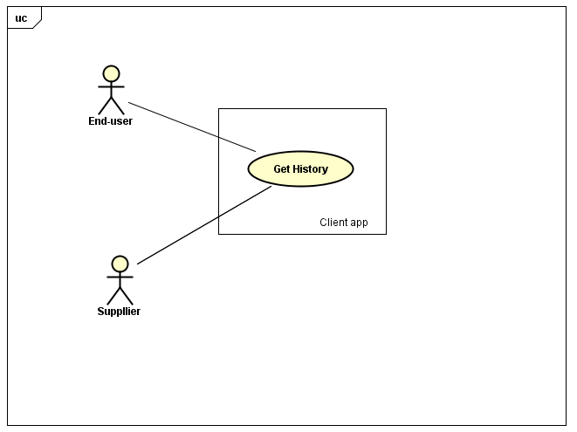

* + 1. Sequence Diagram

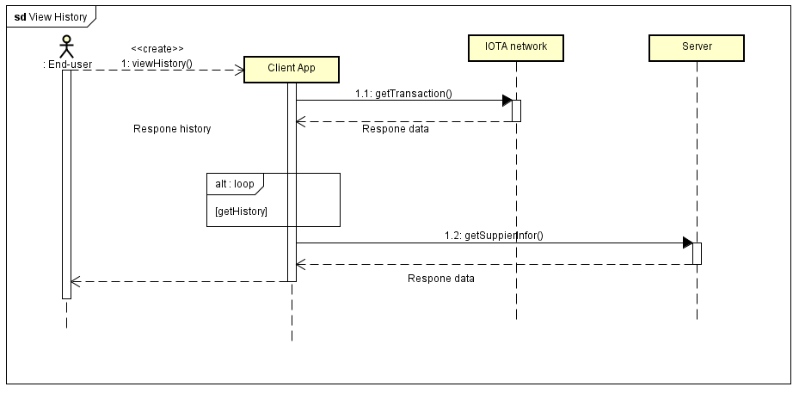

* + 1. Usecase
  1. Login
     1. Usecase Diagram

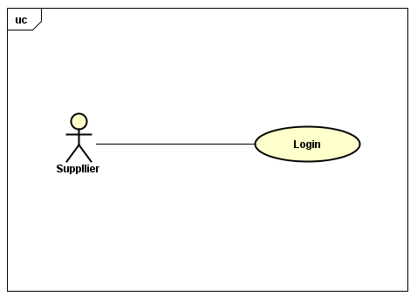

* + 1. Sequence Diagram

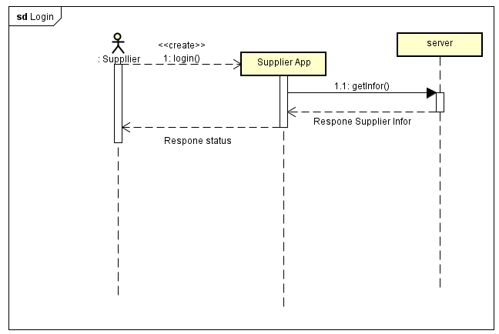

* + 1. Usecase
  1. View Lance
     1. Usecase Diagram

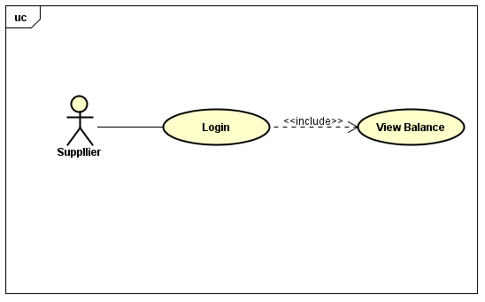

* + 1. Sequence Diagram

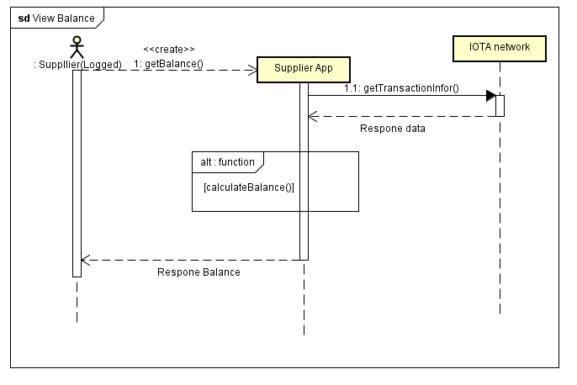

* + 1. Usecase
  1. Sell Products
     1. Usecase Diagram

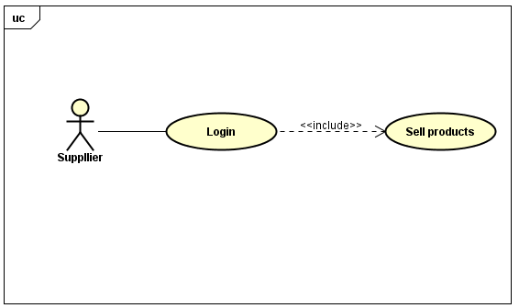

* + 1. Sequence Diagram

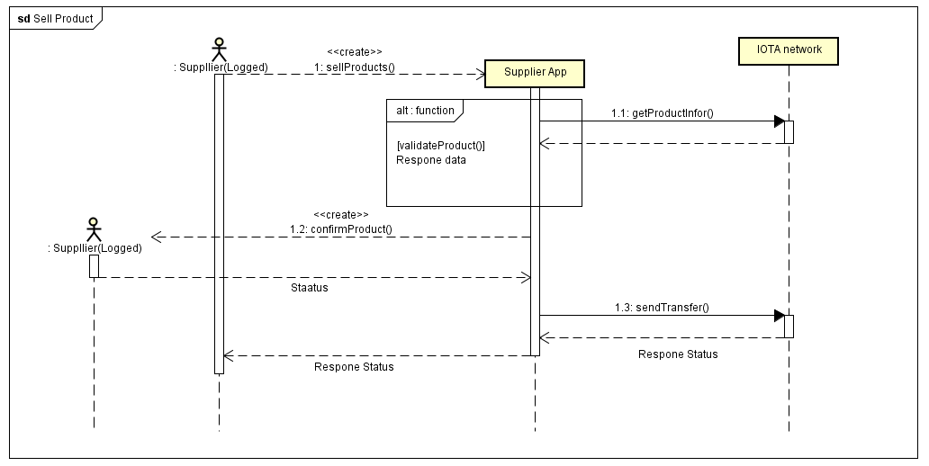

* + 1. Usecase

1. **NonFunctional Requirement**