Matthew Donnelly

Daniel Bjorklund

Lab#2 report: team 2

1a. A simple program which slowly allows the motor to build its speed up to protected the gears. We accomplished this by creating a program which will increment the speed slowly by incrementing by a certain value, until the desired value was reached. This program was run as its own task; we also had another task running which displayed the values on robot’s screen.

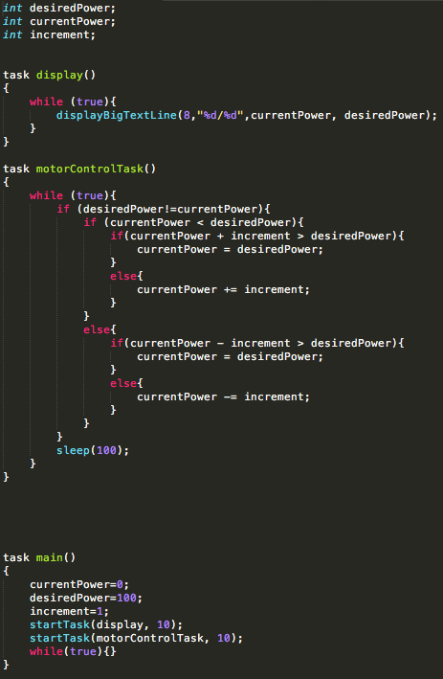

1b. We applied the same concept as 1a, but this time we added the actual motor control. We had multiple tasks which allowed the display and motors to actually run at the same time. We also had tasks which assigned a random value to the desired power. The other tasks revolved around setting the new motor speed based off those values. We also had two more tasks which carried out the slew rate algorithm.

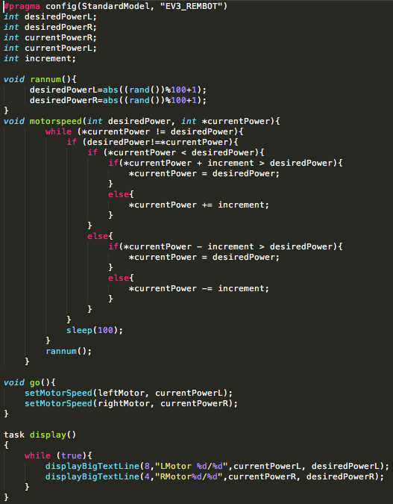

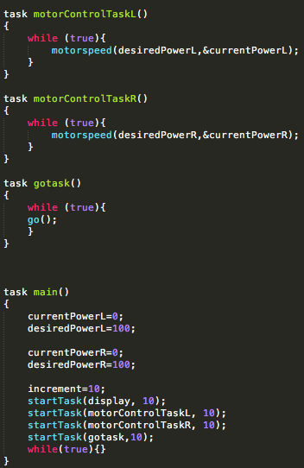

2a. The program was divided into two parts. The first was to keep track of where the ball was, and to play the sound when it hit the wall and change the velocity. The second part was to draw the ball on the screen and move it around using the velocity. The other programs left just did some “housekeeping” work, such as choosing the random velocity. These programs only need one task named “Main” which called other functions.

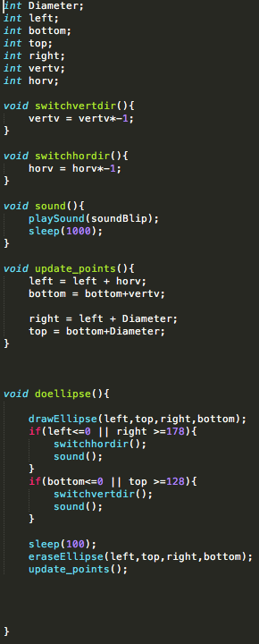

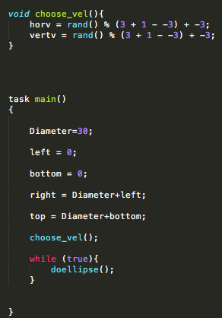

2b. We combined our slew rate control with our bouncing ball program with a few minor changes. We basically made the ball program into its own task and modified what it does when it hits the wall (hint: it changes the motor speed).

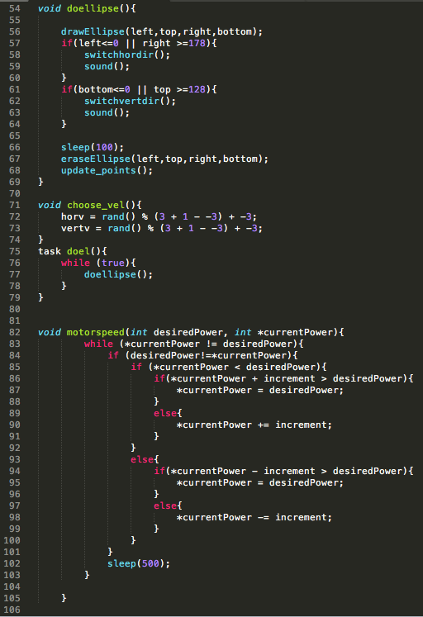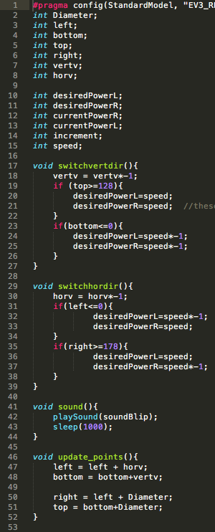

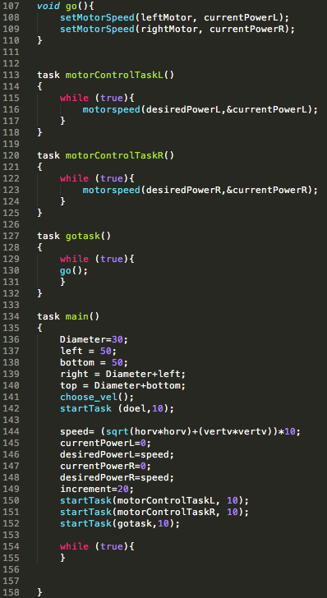

3. We created a standalone task which would measure the distance traveled by each wheel. Once we tested it and it passed our test, we literally copied and pasted the entire task into Q1 and Q2 code. We then added the different display options for each, running on their own tasks.

Q1 (changes around lines 49 and 78)

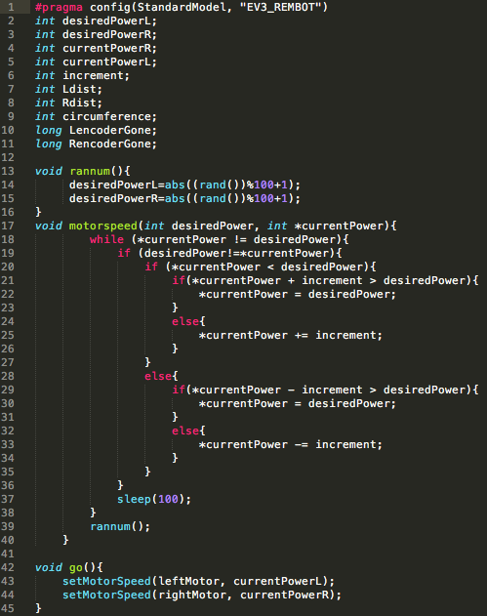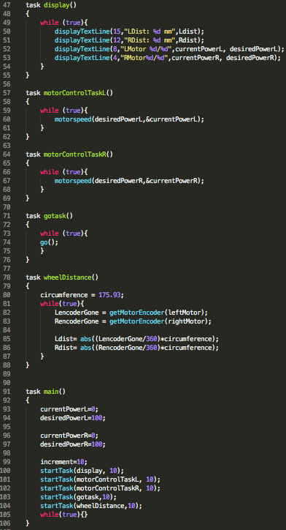

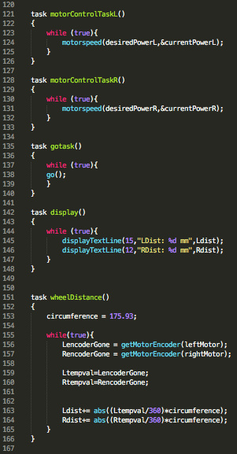Q2 (changes lines 142-266)

