Matthew Donnelly

Daniel Bjorklund

CSC375

Lab 5 report: team 2

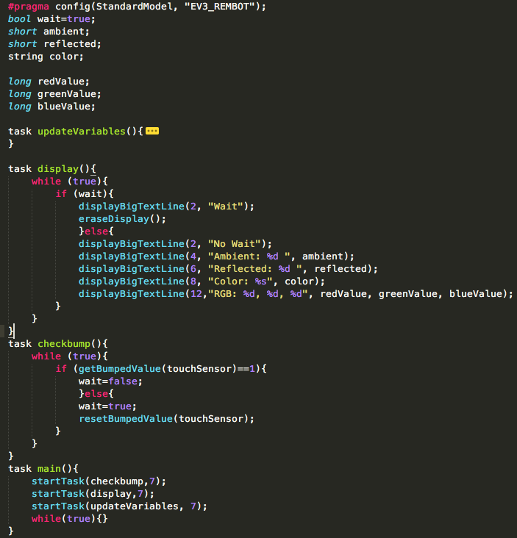1A. This program is all together very simple. We have a task for display that checks whether it should be displaying (checks based off bump), if not it flashes “wait” on the screen. Otherwise it displays the required values. The values are updated in a separate task that simply calls the methods that return the required information and storing the result in variables. The only oddity is getColorName, which we must translate to a string through use of a switch statement. In the below screenshot the updateVariables task is condensed and shown in another screenshot.

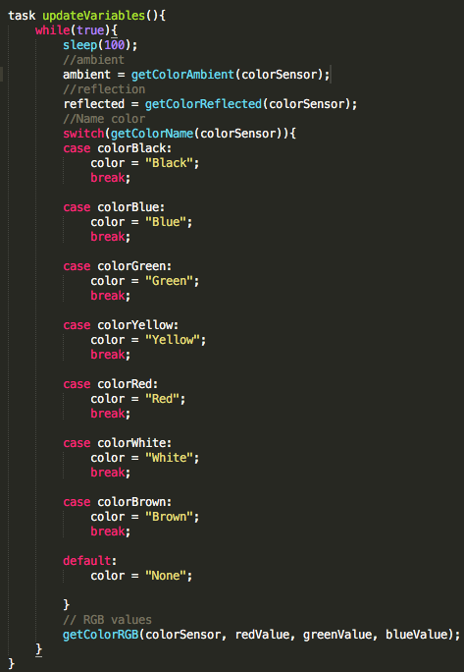

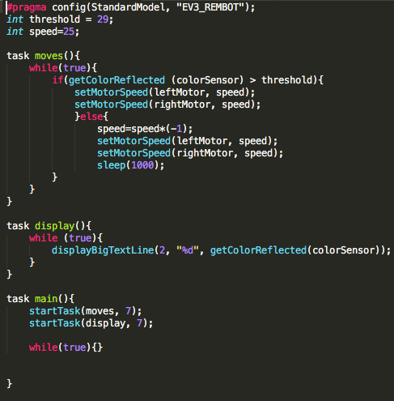1B. This one only has a display for debugging purposes, to help us assess what to use for a threshold. Move runs constantly, checking whether the color sensor detects the black tape. If it does it changes the direction of the motors and sleeps for a second (to let the robot get away from the black tape). Really nothing groundbreaking here.

3A. This question has no surprises. We have a task the updates the variables by storing the values returned by the various method calls. And then a separate task displays them.

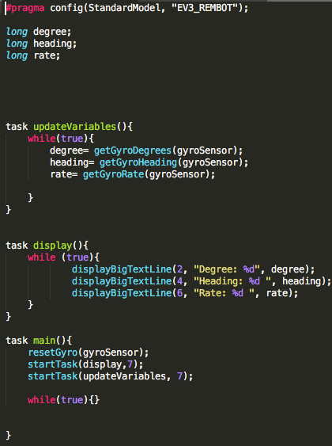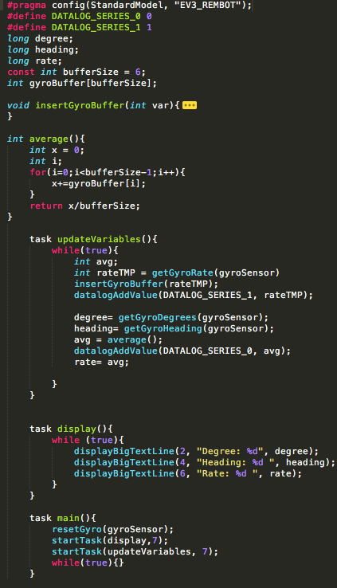3B. The insertGryoBuffer is straight from the lab handout and is not shown in the screenshot. The average just sums the array and divides it by the number of elements. The display task once again just displays the different required values. But updateVariables adds values to the different datalog series as well as inserts to the moving average and averages the array. We noticed that with our current bufferSize of 6 that the average was not too different from the actual measured value. The peaks/troughs were more compressed than the raw but not by a massive amount. I imagine if we tested with a larger buffer that the compression of the moving average would be larger.