Lab6 : InfoGAN

0516069 翁英傑

1. Introduction

Train a generative adversarial network to learn to generate mnist digits.

1. Experiment setups
2. Adversarial loss :





Simultaneously minimize both loss function for generator and discriminator, we can generate well image.

1. Maximizing mutual information:

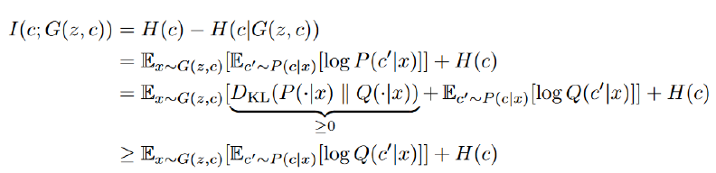

Mutual information is the entropy between the class predicted by a Q network from an image generated from the generator with a class condition and that condition class used in generator.

1. How you generate fixed noise and images:



1. Which loss function of generator you used:



1. Discussion

In my experiment, I’ve encounter a situation so called mode collapse, which is usually referred to a problem that generator outputs are identical. It may be caused by the distribution of true data to be multi-peaks, and that the generator is only able to produce sub-group of the true data. And this may be triggered in a seemingly random fashion.

1. Results of testing

Fixed Condition (same digit different style)

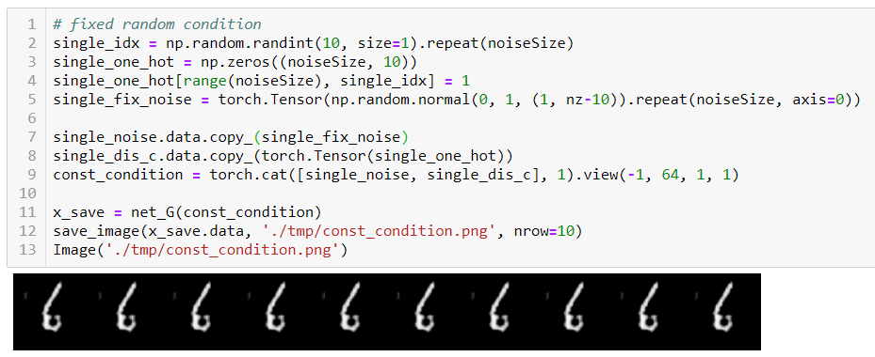

Fixed meaningless noise ( different digit same style)

