AUTOMATED CLOUD RESOURCE MANAGEMENT
Complete Project Flow and Technical Architecture
1. Project Objective
The Automated Cloud Resource Management project automates the lifecycle of a cloud resource request inside ServiceNow. The system provides a structured workflow in which a user submits a cloud resource request, the request is validated, approval is obtained from an authorized approver, and an external REST API is triggered only after the request reaches the approved state. The response from the external service is then recorded through ServiceNow logging and surfaced through monitoring.
User creates cloud resource request
↓
Request validation
↓
Manager approval
↙ ↘
Rejected Approved
↓ ↓
Status = Status =
Rejected Approved
↓
REST API triggered
↓
External provisioning
simulation
↓
Logging & monitoring
Important: The current REST integration uses httpbin.org as a simulated external provisioning endpoint. It demonstrates the REST integration and authorization flow but does not actually create an AWS EC2 instance.
2. Phase 1 — Application & Data Model
The first phase established the ServiceNow application and the data model required to store cloud resource requests. The application was created with the name Automated Cloud Resource Management.
Application Scope: x_2062699_automa_0
Main Table: Cloud Resource Request
Technical Table: x_2062699_automa_0_cloud_resource_request
Important fields:
- Number
- Requested By
- Resource Type
- AWS Region
- Environment
- Instance Type
- Business Justification
- Status
- Rejection Reason
- Cloud Resource
- Provisioned At
Example request:
Number: CR0001012
Requested By: Shaik Afridi
Resource Type: EC2
AWS Region: ap-south-1
Environment: Production
Instance Type: t2.micro
Status: Pending Approval

3. Phase 2 — Approval & Provisioning Workflow
The main Flow Designer workflow was created to manage the approval and subsequent provisioning lifecycle. When a cloud resource request is created, the flow sends the request for approval. Based on the approval decision, the request follows either the rejected path or the approved path.
Cloud Resource Request Created
↓
Ask For Approval
↓
Approval decision
↙ ↘
Approved Rejected
↓ ↓
Provisioning Status =
↓ Rejected
Create/Update
Cloud Resource
↓
Update Request
Status = Provisioned
The approval action uses the request record and sends it to the configured approver. The current project configuration uses System Administrator as the approver.
4. Phase 3 — Scripting & Form Logic
The third phase introduced server-side and client-side scripting to improve validation, data retrieval, duplicate prevention, automatic naming, and user interaction on the request form.
4.1 Business Rule — Prevent Duplicate Requests
A Business Rule checks whether a similar request already exists before allowing a new request to proceed. The comparison is based on Requested By, Resource Type, and Environment. If an existing request matches all three values, the new request is blocked. Otherwise, the request is allowed.
Requested By + Resource Type + Environment
↓
Existing match?
↙ ↘
Yes No
↓ ↓
Request blocked Request allowed
4.2 Script Include — CloudResourceUtils
The CloudResourceUtils Script Include is used to generate a meaningful cloud resource name from the resource type and request number.
Resource Type + Request Number
Example: EC2-CR0001012
4.3 Script Include — CloudUserAjax
CloudUserAjax provides server-side user information to the client through GlideAjax. It retrieves the selected user's email address from the sys_user table and returns it to the client-side script.
User selects Requested By
↓
Client Script
↓
GlideAjax
↓
CloudUserAjax
↓
sys_user table
↓
User email returned
↓
Displayed on form
4.4 Client Script — Fetch Requester Email
Whenever the Requested By field changes, the Client Script initiates a GlideAjax call to CloudUserAjax. The user's email address is retrieved from the sys_user table and displayed on the request form.
4.5 Client Script — Production Warning
A client-side warning is displayed whenever the Environment field is set to Production. This provides immediate feedback to the requester that production resources require additional approval.
Warning: Production resources require strict manager approval.
5. Phase 4 — REST API Integration
The fourth phase connected ServiceNow to an external REST endpoint. A REST Message named Cloud Resource Provisioning API was configured to send request information to the external endpoint.
Endpoint: https://httpbin.org/post
HTTP Method: POST
Content Type: application/json
Example JSON payload:
{
"number": "${number}",
"resource_type": "${resource_type}"
}
Additional request information is also mapped in the Business Rule before the REST call is executed. The endpoint receives the request as an HTTP POST and returns an HTTP response that can be processed by ServiceNow.
6. Phase 5 — Approval-Based Provisioning
The provisioning API is intentionally not triggered merely because a request exists. The automation is authorization-driven: the REST API is executed only after the request has been approved. This ensures that provisioning follows the configured approval process.
Request Created
↓
Pending Approval
↓
Manager/System Administrator approves
↓
Status becomes Approved
↓
Business Rule detects status change
↓
REST API executes
↓
HTTP response received
For the tested request CR0001012, the approval was completed and the REST API returned HTTP 200. Therefore, the tested authorization chain was:
Request
↓
Approval
↓
Approved status
↓
Provisioning Business Rule
↓
REST API
7. Phase 6 — Security & ACLs
Security controls were implemented using application roles and table/field-level Access Control Lists (ACLs). The purpose of these controls is to prevent ordinary requesters from bypassing the approval process by directly modifying the approval status.
Roles created:
- x_2062699_automa_0.user
- x_2062699_automa_0.manager_approver
Status field ACL:
- Table: Cloud Resource Request
- Field: Status
- Operation: Write
- Required role: x_2062699_automa_0.manager_approver
Normal requester
↓
Can view Status
↓
Cannot directly modify approval Status
Manager/Approver
↓
Can modify Status
This security configuration ensures that status changes associated with approval are restricted to authorized users.
8. Phase 7 — Monitoring, Logging & Error Handling
The REST Business Rule contains error-handling logic around the external API call. The system evaluates the HTTP response and records successful and failed calls using ServiceNow system logging.
REST API call
↓
Try
↓
HTTP response
↙ ↘
Success Error
↓ ↓
gs.info() gs.error()
Successful response example:
HTTP Status: 200
Provisioning API triggered for CR0001012.
HTTP Status: 200
For failed requests, the system records relevant diagnostic information such as the HTTP status, response body, and error message using gs.error(). This supports troubleshooting and operational monitoring.
9. Phase 8 — Dashboard & Monitoring
A Cloud Resource Management Dashboard was created to provide administrators with a visual overview of the cloud resource request lifecycle. The dashboard contains a visualization grouped by request Status.
The monitored statuses include:
- Approved
- Provisioned
- Pending Approval
- Rejected
This dashboard provides an administrator with a quick view of the current state and distribution of cloud resource requests.
10. Phase 9 — Final Testing & Deployment Package
The final phase focused on end-to-end validation, security testing, and packaging the application changes for deployment.
End-to-end testing sequence:
Create Request
↓
Approval
↓
Approved
↓
REST API
↓
HTTP 200
↓
System Logs
↓
Dashboard
Security testing:
The Status field ACL was tested using a non-admin/requester context to verify that an ordinary requester could not directly modify the approval status.
Update Set:
- Name: Cloud Resource Management - Phase 8
- State: Complete
The completed Update Set was exported as an XML package for deployment to another ServiceNow instance.

11. Complete Technical Architecture
The following architecture summarizes the complete technical implementation, including the user interface, client-side processing, server-side validation, approval workflow, REST integration, external simulation endpoint, logging, and monitoring.
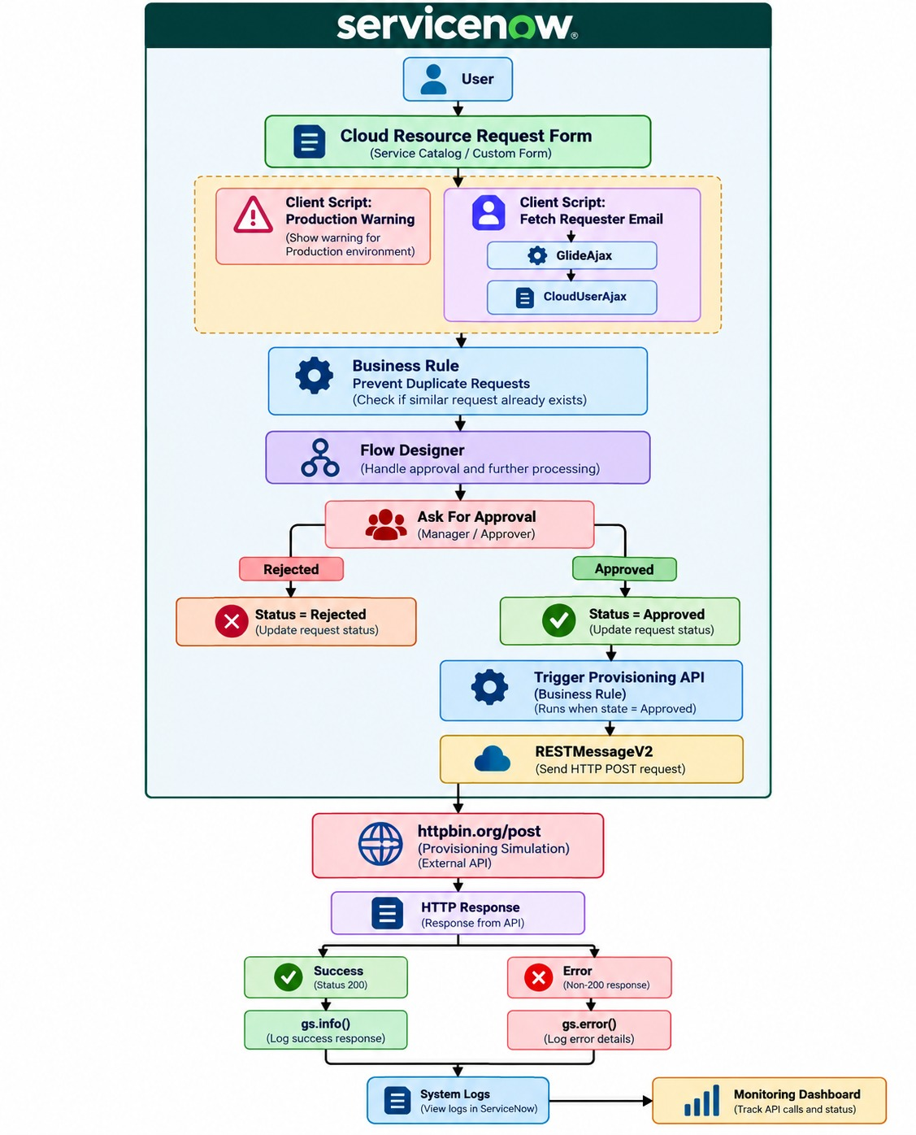
12. Project Summary
The Automated Cloud Resource Management project demonstrates an end-to-end ServiceNow workflow for managing cloud resource requests. It combines a custom application and data model, client-side scripting, server-side Business Rules and Script Includes, GlideAjax, Flow Designer approvals, RESTMessageV2 integration, security through roles and ACLs, error handling, system logging, and dashboard-based monitoring.
The implementation demonstrates how ServiceNow can act as an orchestration layer between users, approval processes, and external cloud services. In the current implementation, httpbin.org is used as a safe external simulation endpoint. A production implementation could replace this endpoint with an authorized cloud provisioning service or API while retaining the same approval, security, logging, and monitoring architecture.

