INVESTIGATION REPORT
Windows Security Logs
- SUMMARY
This investigation analyzed Windows Security Event IDs 4624 (Successful Logon), 4672 (Special Privileges Assigned to New Logon), and 4798 (User Group Membership Enumeration) to assess authentication and privilege-related activities. Timeline reconstruction showed that successful logon events were followed by privilege assignment and user group membership enumeration, which is consistent with normal Windows authentication behavior. No evidence of unauthorized access, privilege abuse, or malicious account enumeration was identified during the analysis period. Overall, the observed activities were assessed as Likely Normal, while continued event correlation and security monitoring are recommended to improve visibility and support early detection of anomalous behavior.

- OBJECTIVE
Windows Security Event Logs (.evtx) were collected from the local Event Viewer and analyzed throughout this investigation.

- ENVIRONMENT
System Operasi : Windows 11 Pro
Device : DESKTOP-OH1MQ57
Log Source : Local Event viewer
Investigation Date : 13 July 2026
Analyst : Afrijal

- DATA COLLECTION
Data are collected from local event viewer, exported security, System, and Windows defender logs as .evtx and storage in /data/raw.
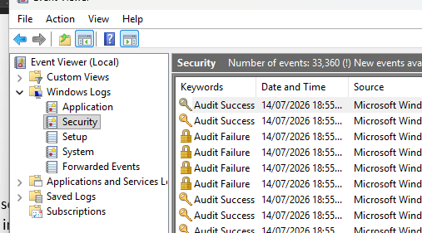

- INVESTIGATION METHODOLOGY
  - Evidence Collection
  - Event Filtering
  - Event Correlation
  - Timeline Reconstruction
  - Findings Validation
  - Reporting

- EVENT ANALYSIS
EVENT ID | DESCRIPTION | OBSERVATION | ASSESSMENT
5379 | Credential Manager Accessed | Repeated multiple times throughout the analysis period. | Need verification
5061 | Cryptographic Operation Performed | Recorded 174 occurrences during the analysis period. | Needs Verification
4624 | Successful Logon | Multiple successful logon events were observed during the analysis period. | Expected Behavior
4672 | Privileged Logon Detected | Observed following successful logon events. | Expected Behavior
4798 | User Group Membership Queried | Repeated multiple times throughout the analysis period. | Needs Verification
5058 | Key File Operation | Recorded 61 occurrences during the analysis period. | Needs Verification
5059 | Key Migration Operation | Recorded 41 occurrences during the analysis period. | Needs Verification
Summary

- 5379 – Credential Manager Accessed
Item | Details
Purpose | Records access to Windows Credential Manager.
Observation | The event appeared repeatedly during the investigation period.
Assessment | The events suggest that Windows or installed applications accessed Credential Manager. Additional verification is required to determine whether the access originated from legitimate system processes.

ITEM | DETAILS
Purpose | Records cryptographic operations performed by Windows.
Observation | The event occurred multiple times throughout the analysis period.
Assessment | The observed operations may represent expected cryptographic activity. Further verification is required to determine whether the operations were legitimate.
- 5061 – cryptograph operated

- 4624 – Logon
Item | Details
Purpose | Records successful user authentication.
Observation | A total of 838 successful logon events were recorded during the analysis period.
Assessment | The observed activity appears consistent with expected Windows authentication behavior. Due to the high event volume, manual verification of every log was impractical. Representative sampling and automated analysis are recommended to validate account names, devices, and logon types.

Item | Details
Purpose | Records privileged access assigned after successful authentication.
Observation | 831 events were observed, most occurring immediately after Event ID 4624.
Assessment | The sequence is consistent with normal Windows authentication. Verification of the originating account, device, and authentication context is recommended to confirm legitimate privileged access.
- 4672 – Special Logon

Item | Details
Purpose | Records enumeration of a user's local group memberships.
Observation | The event occurred repeatedly during the analysis period.
Assessment | This activity is commonly generated by legitimate Windows authentication and administrative processes. However, correlation with authentication, process creation, and privilege-related events is required to distinguish normal administration from potential reconnaissance.
- 4798 - User Group Membership Queried

Item | Details
Purpose | Records operations performed on cryptographic key files.
Observation | 64 events were recorded, often occurring near Event IDs 5061 and 5059.
Assessment | The investigation could not determine a consistent execution sequence or whether the event initiated or resulted from other cryptographic operations.
- 5058 – Key file operation

- 5059 – Key Migration Operation
ITEM | DETAILS
Purpose | Records cryptographic key migration activities.
Observation | 41 events were observed, frequently appearing near Event IDs 5058 and 5061.
Assessment | The available logs do not provide sufficient evidence to establish a consistent execution order or direct relationship between the cryptographic events.

- TIMELINE RECONSTRUCTION
  - 13/07/2026
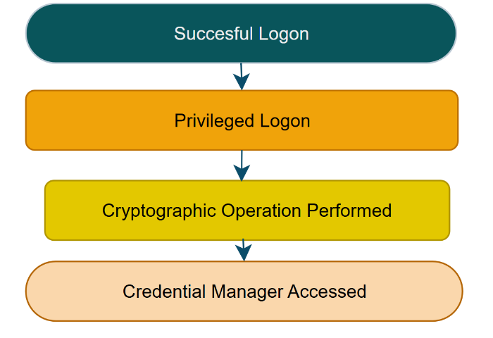
A successful user logon (Event ID 4624) was followed by a privileged logon (4672), indicating that administrative privileges were assigned after authentication. Shortly afterward, cryptographic operations (5061) and multiple Credential Manager access events (5379) were recorded. This sequence is consistent with normal Windows authentication and credential management activities, with no immediate indicators of malicious behavior.

  - 11/07/2026
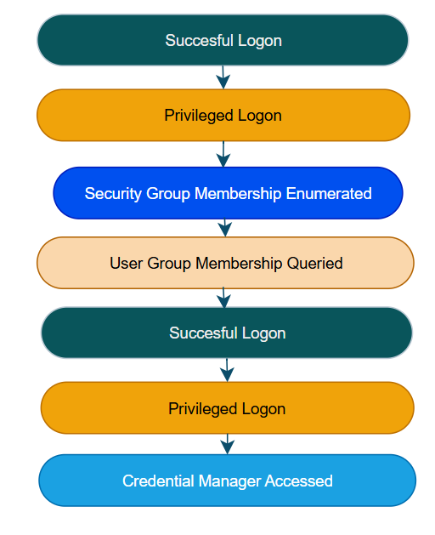
The timeline begins with a successful user logon (Event ID 4624), followed immediately by a privileged logon event (4672), indicating that administrative privileges were assigned after authentication. Shortly afterward, multiple Security Group Membership Enumeration events (4799) and a User Group Membership Query event (4798) were recorded, suggesting that the system retrieved group membership information for the logged-on user. A subsequent successful logon was then observed, followed by repeated Credential Manager access events (5379). Overall, the sequence is consistent with normal Windows authentication and authorization processes, with no immediate indicators of malicious activity identified during the investigation.
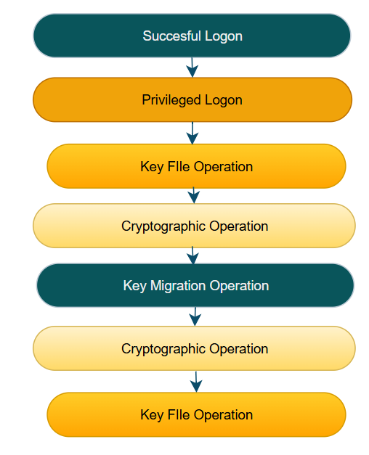
  - 13/07/2026
Following a successful authentication sequence (Event IDs 4624 and 4672), multiple cryptographic events (5058, 5059, and 5061) were recorded within the same second. Due to identical timestamps, the exact execution order could not be determined. However, the events indicate active cryptographic key management immediately after authentication

- FINDINGS
  - Finding 1 – Normal Authentication activity
    - Evidence
      - Multiple Event ID 4624 and 4672 were observed
      - The events occurred in a consistent authentication sequence.
Timestamp | Account Name | Logon Type | Workstation | Source IP
13/07/2026 14:45:41 | DESKTOP-OH1MQ57$ | 5 | DESKTOP-OH1MQ57 | -
10/07/2026 13:19:37 | DESKTOP-OH1MQ57$ | 5 | DESKTOP-OH1MQ57 | -
13/07/2026 09:14:13 | DESKTOP-OH1MQ57$ | 5 | DESKTOP-OH1MQ57 | -
10/07/2026 12:05:05 | DESKTOP-OH1MQ57$ | 5 | DESKTOP-OH1MQ57 | -
10/07/2026 14:38:01 | DESKTOP-OH1MQ57$ | 5 | DESKTOP-OH1MQ57 | -
11/07/2026 09:23:44 | DESKTOP-OH1MQ57$ | 5 | DESKTOP-OH1MQ57 | -
11/07/2026 08:18:17 | DESKTOP-OH1MQ57$ | 5 | DESKTOP-OH1MQ57 | -
12/07/2026 08:53:42 | DESKTOP-OH1MQ57$ | 5 | DESKTOP-OH1MQ57 | -

Note :
Due to the high volume of authentication events (838 Event ID 4624 entries), a representative sampling approach was used instead of analyzing every individual event. Samples were selected randomly from the filtered log to validate authentication patterns, including account name, logon type, workstation, timestamp, and source network information. The sampled events consistently showed Logon Type 5 (Service Logon) originating from the local workstation (DESKTOP-OH1MQ57) with no source network address, indicating expected service authentication behavior during the analysis period.

    - Conclusion
The Authentication activity is consistent with normal Windows logon behaviour. No Abnormal logon pattern was identified.

    - Status
Confirmed – Expected Behaviour

  - Finding 2 – Privileged logon Activity
    - Evidence
      - Event ID 4672 consistently occurred immedately after successful logon events (4624)
      - Representative samples identified the account as DESKTOP-OH1MW57$
      - All Sampled events used Logon Type 5 (Service Logon).
      - No unexpected account names or abnormal authentication patterns were observed
    - Conclusion
Event ID 4672 was consistently associated with the DESKTOP-OH1MQ57$ service account using Logon Type 5 (Service Logon). This behavior is consistent with normal Windows service authentication and does not indicate unauthorized privileged access during the analyzed period.
    - Status
Confirmed - Expected Behaviour

  - Finding 3 – Credential Manager Access
- Evidence
- Event ID 5379 occurred repeatedly throughout the analysis period.
- Credential Manager access appeared after successful authentication events.
- No abnormal authentication sequence or suspicious account activity was observed.
- Conclusion
Credential Manager access is consistent with normal Windows credential management processes and shows no evidence of unauthorized credential access.
- Status
Likely Normal

  - Finding 4 – User Group Membership Enumeration
- Evidence
- Event ID 4798 was recorded repeatedly during the analysis period.
- Timeline reconstruction shows that the events occurred shortly after user authentication
- Conclusion
Event ID 4798 records the enumeration of a user's local group memberships. This activity is commonly generated by legitimate Windows authentication and account management processes. The reviewed events do not independently indicate malicious behavior. However, because Event ID 4798 provides limited context, correlation with related authentication, process creation, and privilege management events is required to determine whether the activity represents legitimate administration or potential reconnaissance.
- Status
Likely Normal

  - Finding 5 – Cryptographic Key Management Activities
- Evidence
- Event ID 5061 recorded 174 occurrences.
- Event ID 5058 recorded 64 occurences.
- Event ID 5059 recorded 41 occurrences.
- Several event sequences showed 5058 -> 5061 -> 5059, while Event ID 5061 also appeared independently in other authentication sequences.
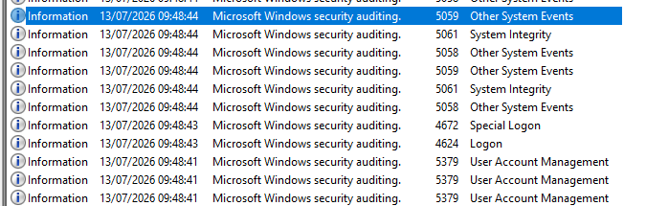
- No single execution pattern was consistently observed across all cryptographic events.
- Conclusion
The analyzed logs indicate recurring cryptographic key management activities involving Event IDs 5058, 5061, and 5059. Although several events occurred in close temporal proximity, the investigation did not identify a consistent execution sequence or a direct causal relationship between them. Additional verification of the initiating process, provider name, and operational context is recommended to determine the purpose of each cryptographic operation.
- Status
Needs Verification

- RECOMMENDATION
  - Enable Continuous Security Monitoring
Continuously monitor Windows Security events related to authentication (4624), privileged logons (4672), and account enumeration (4798) to identify abnormal activities.
  - Implement Event Correlation
Correlate authentication, privilege assignment, process creation, and account management events to improve detection accuracy and reduce false positives.
  - Review Privileged Account Usage
Periodically review privileged account activities and ensure administrative privileges are assigned only to authorized users following the principle of least privilege.
  - Establish Baselin Behaviour
Develop baseline patterns for normal logon and administrative activities to facilitate the detection of anomalous authentication or privilege-related events.
  - Maintain Centralized Log Collection
Forward Windows Security logs to a centralized logging or SIEM platform to support long-term retention, investigation, and threat detection.

