Exercise-2

1. Create a .log file



1. Create a log/ folder



1. Create/Edit .gitignore



Content added to .gitignore:

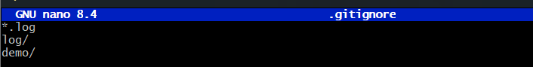

1. Confirm .gitignore content

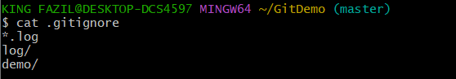

1. Untracking previously tracked files

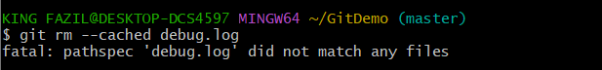 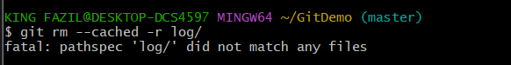

1. Stage and commit .gitignore

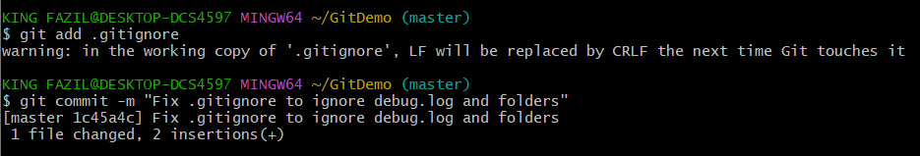

1. Check status

