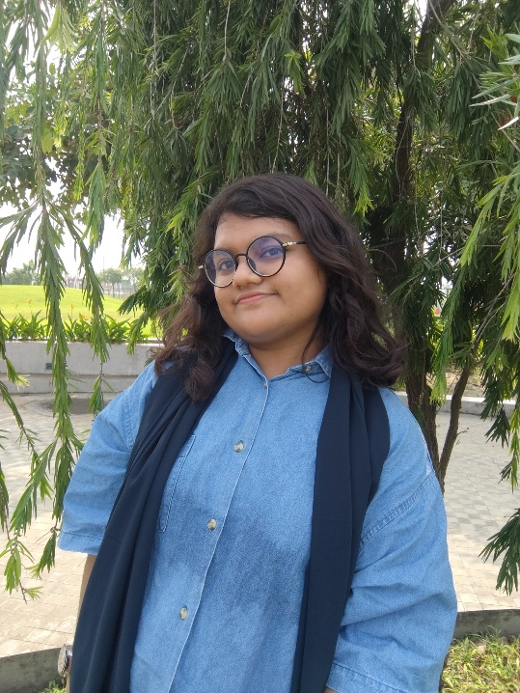Afrin Ahmed

 [2022-2-60-012@std.ewubd.edu](mailto:2022-2-60-012@std.ewubd.edu)

 01795156078

 Kazi Reazuddin road, Lalbagh, Dhaka

 01/11/2000

# Profile

# Passionate and committed student of Computer Science and Engineering (CSE), with a strong interest in using technology to address practical issues. I am eager to contribute new ideas and collaborate with mentors and peers in both academic and professional contexts. I am always looking for ways to increase my understanding of and proficiency with new technologies.

# Skills

* MS Office (Word, PowerPoint, Excel)
* Programming (C/C++, Java, Python, SQL)
* Canva
* Teaching

# Languages

Bengali (Mother tongue)

English (Fluent in speaking and writing)

Hindi

# Education

BSC in CSE, East West University (2022 - Running)

Student ID: 2022-2-60-012

CGPA: 3.70 out of 4.00

Earned Credits: 93

HSC, Agrani School and College (2017- 2019)

Group: Science

Result: 4.17 out of 5 Board: Dhaka

SSC, Agrani School and College (2015 - 2017)

Group: Science

Result: 4.82 out of 5

Board: Dhaka

# Personal Quality

Empathetic and approachable team player, Attention to detail, Punctuality, Sincere and Eager to learn.

# Awards

* Medha Lalon Fund Scholarship