# Cyber Security-Edge Program

|  |
| --- |
| Name: Afrin Faria  ID: 2111270  Batch: B11 |

# **14. 9 November, 2024**

System hacking

Ethical hacking/security assessment

Network infras - IP based

Web app+API

Mobile app

Wireless network

**Web application penetration testing**

**Security:**

1. Authentication and authorization
2. Input validation
3. TLS/SSL
4. Secure coding practices
5. Keeping updated
6. Least privilege
7. firewall

 Crawling: <http://testphp.vulnweb.com/>

Alada alada page ache  then test

Owasp testing guideline

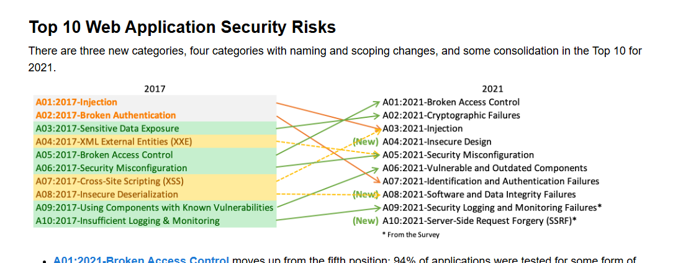

<https://www.sans.org/top25-software-errors/>

Bug bounty:

Bug crowd

Synack

Hacker one

Yogasha

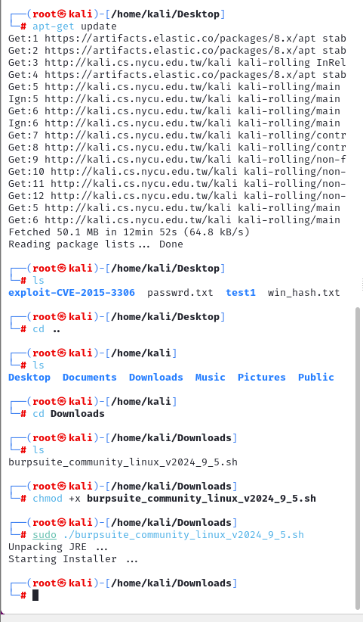

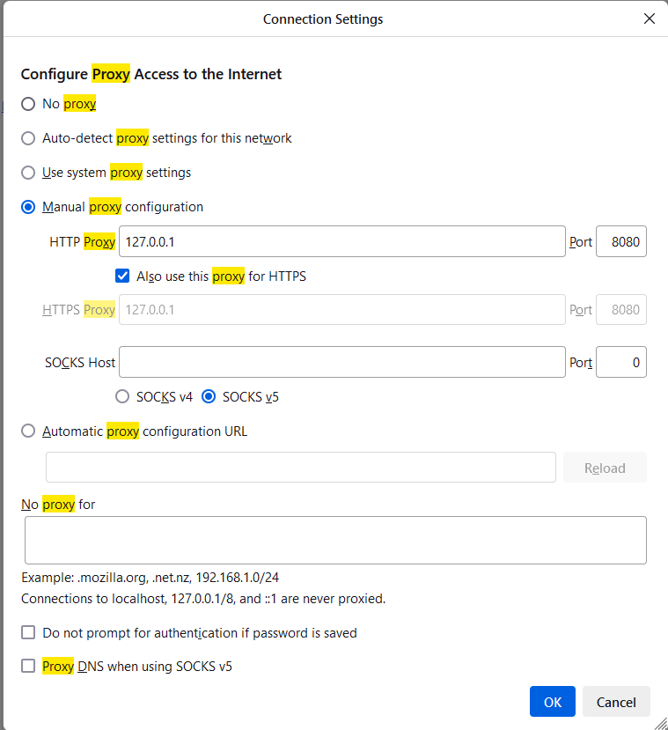

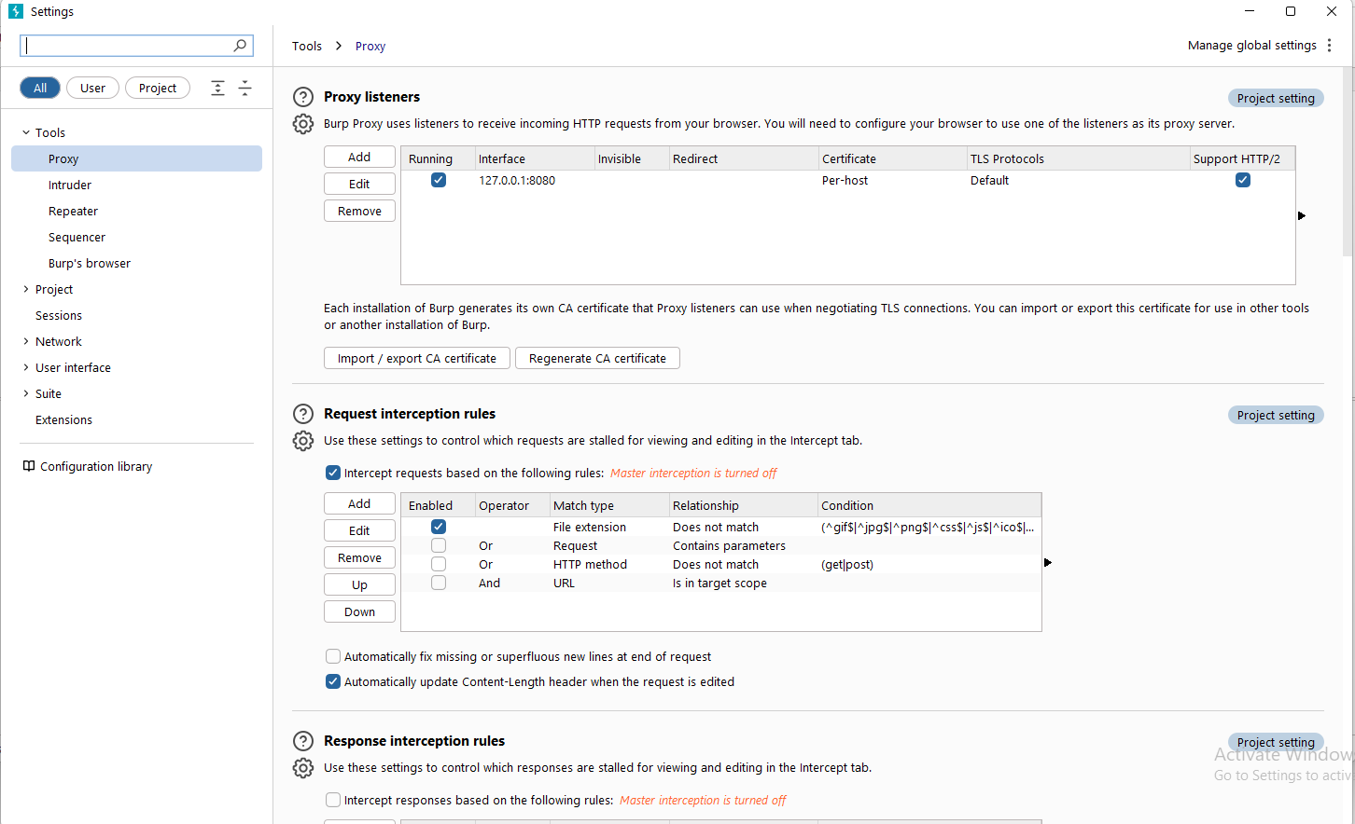

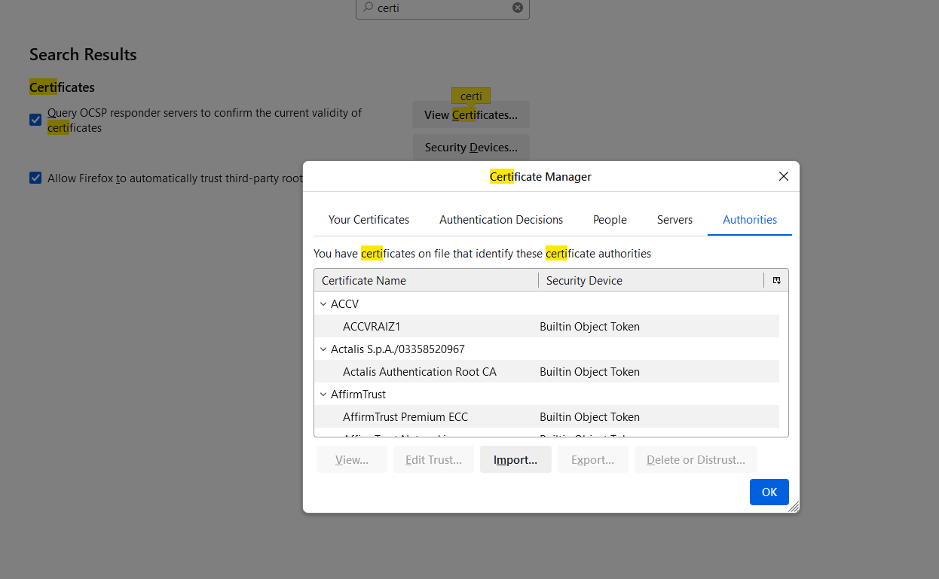

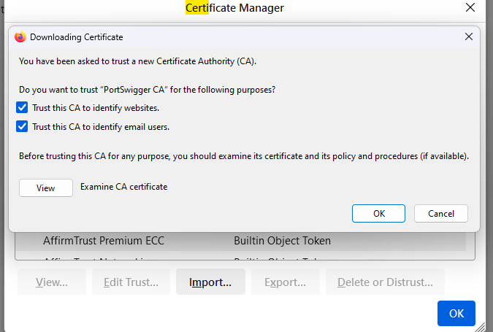

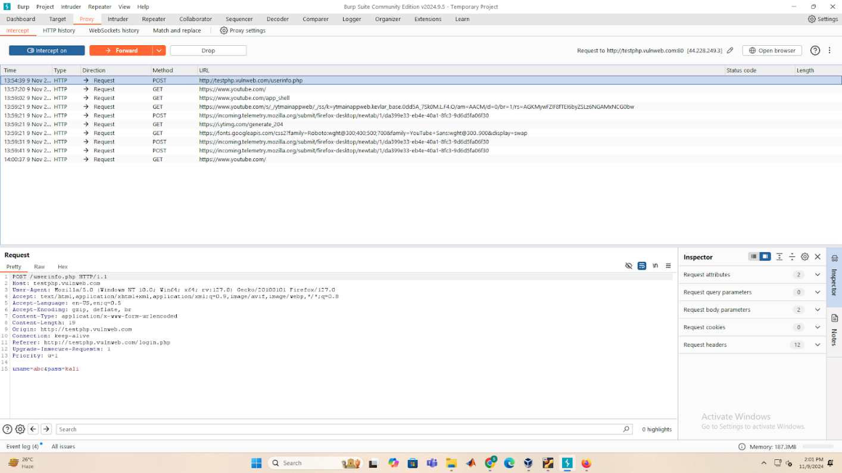

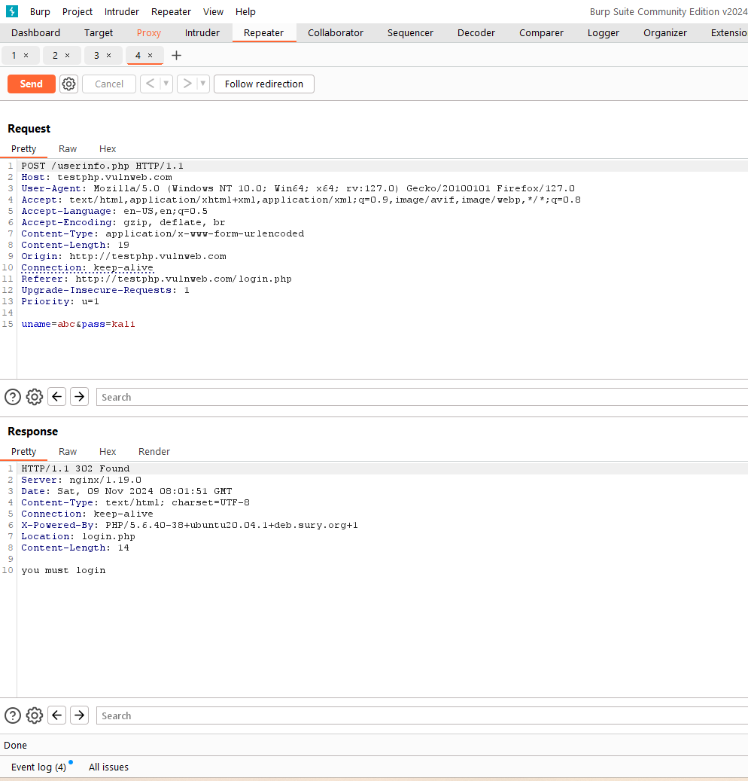



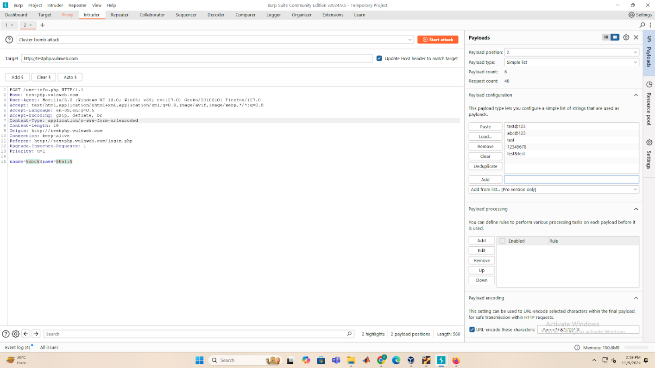

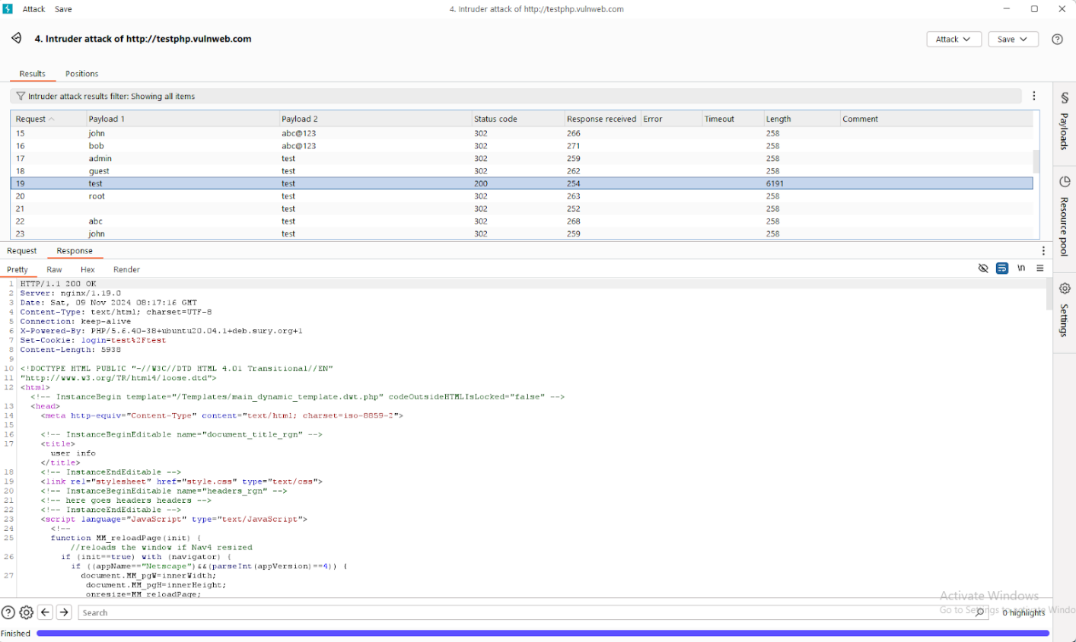

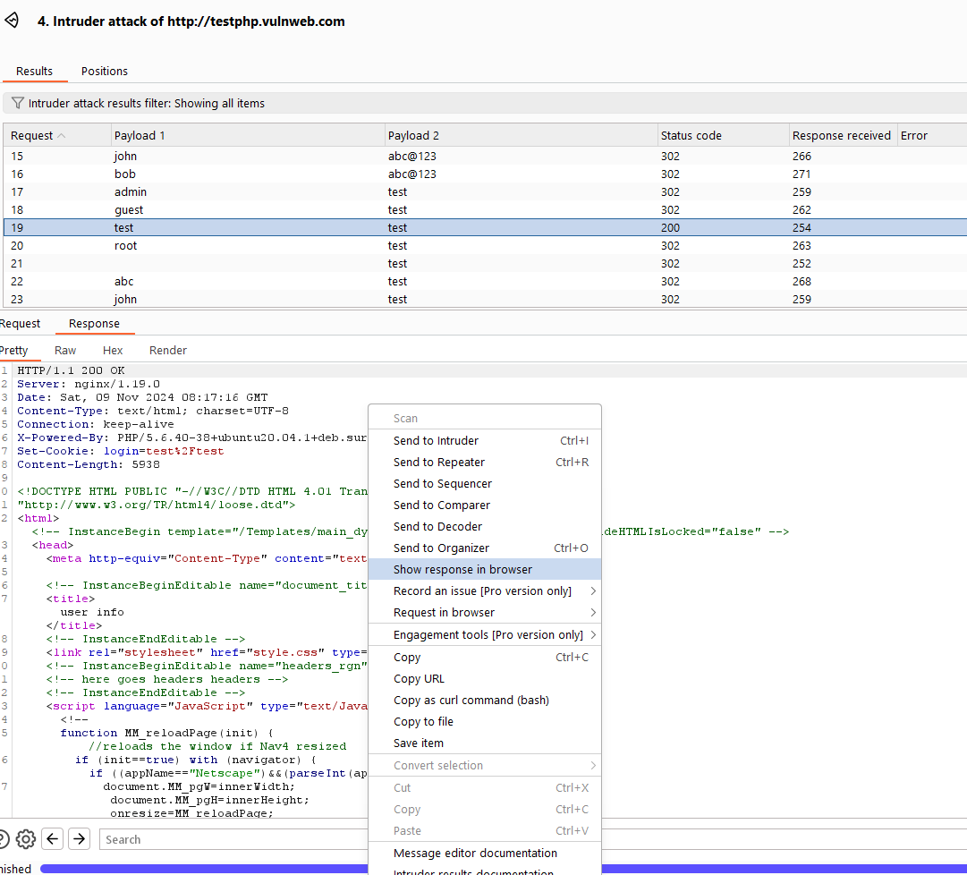

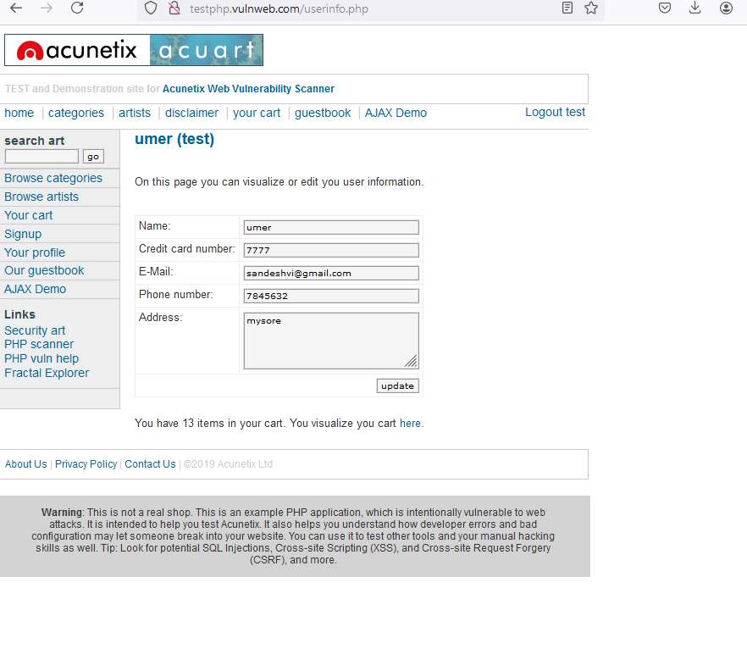

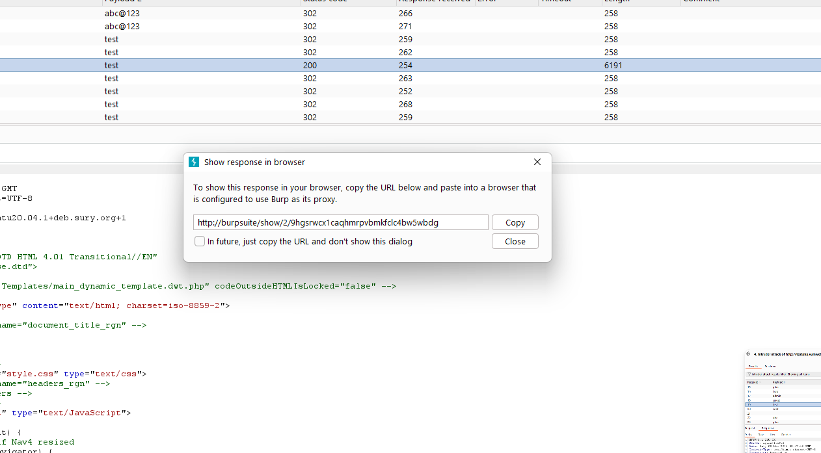

broken access control

<https://juice-shop.herokuapp.com/#/>

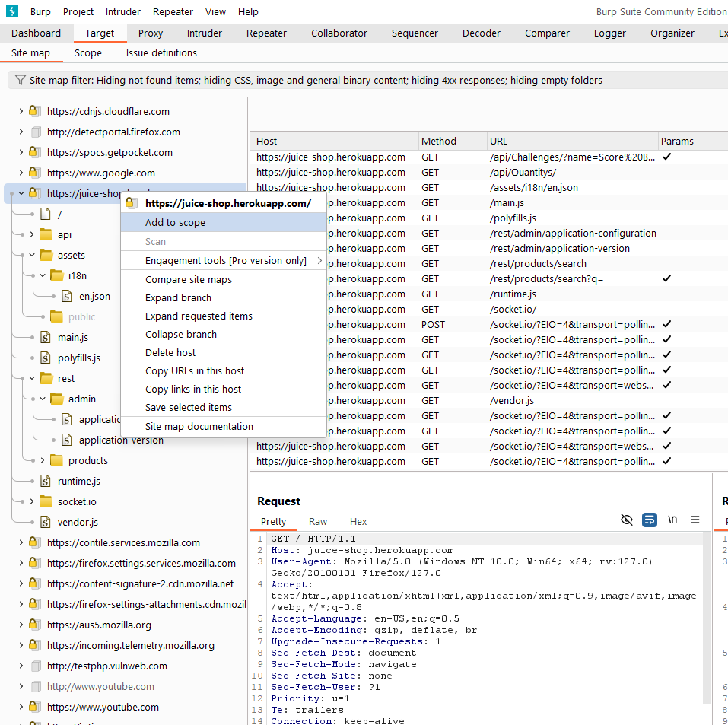

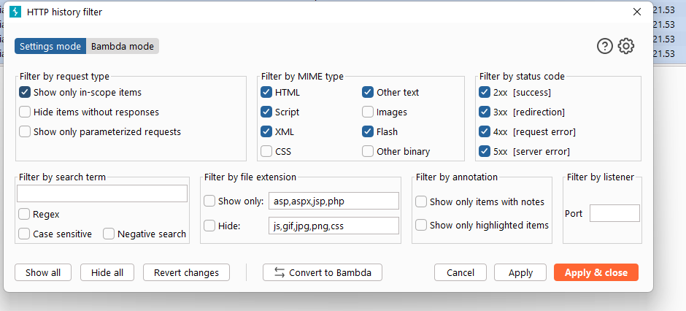

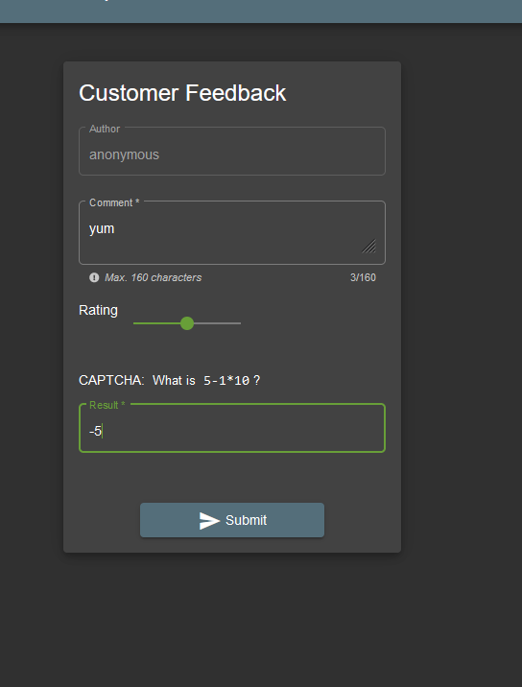

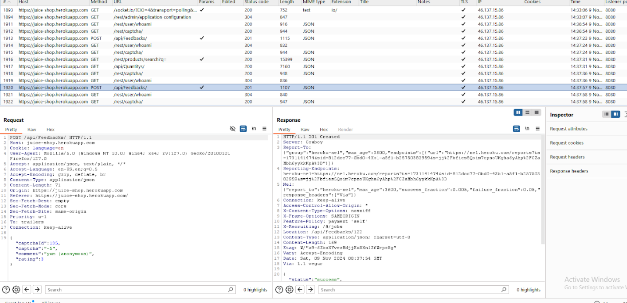

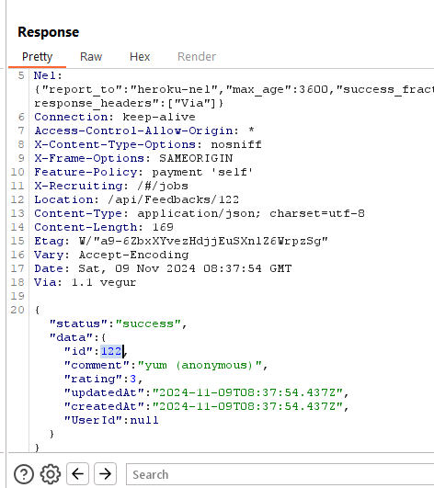

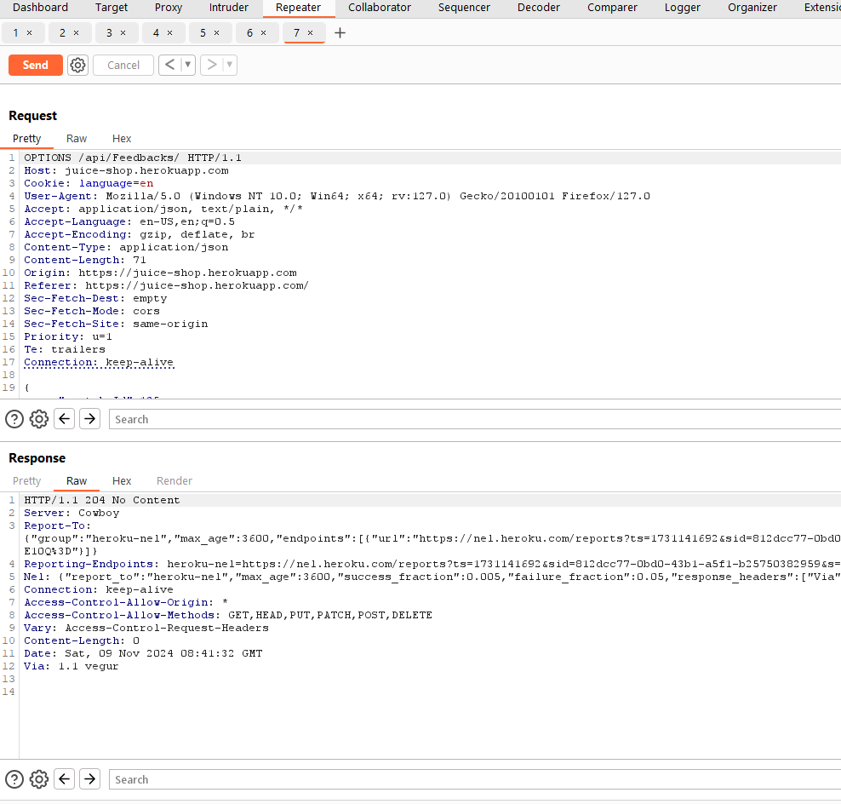

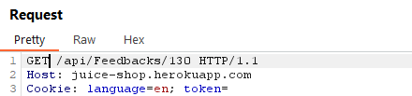  
You can use GET, DELETE, POST

 SQL INJECTION:

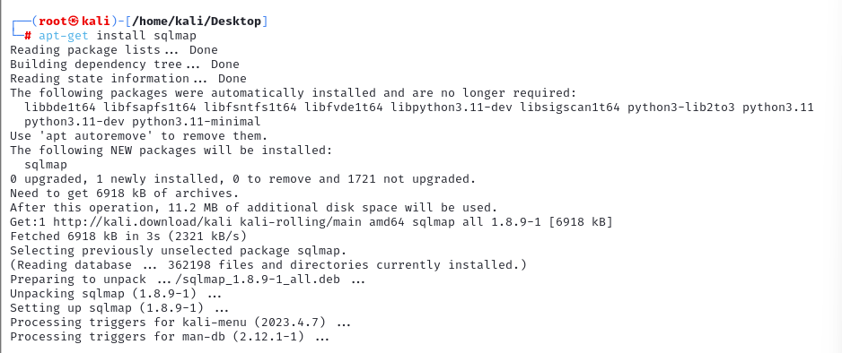

 sqlmap -u http://testphp.vulnweb.com/artists.php?artist=1 --dbs --batch

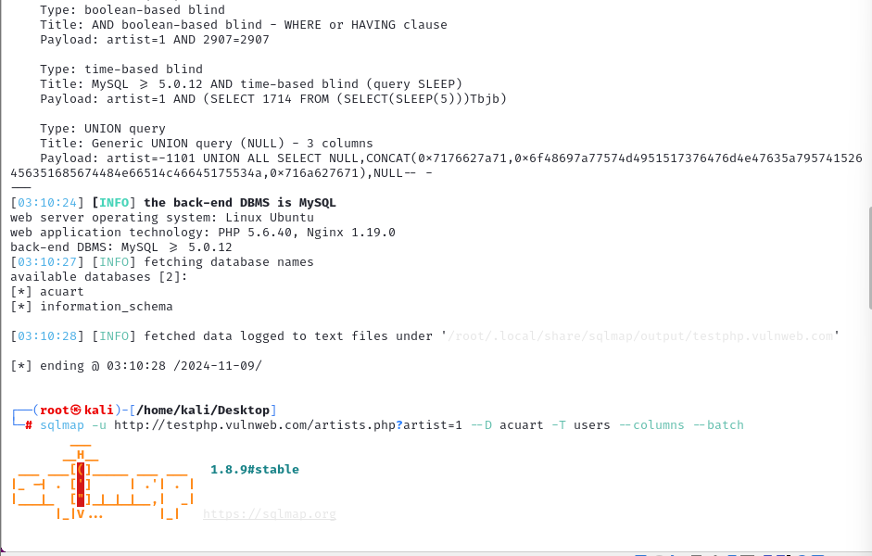

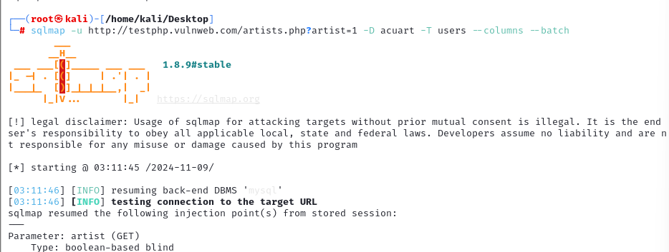

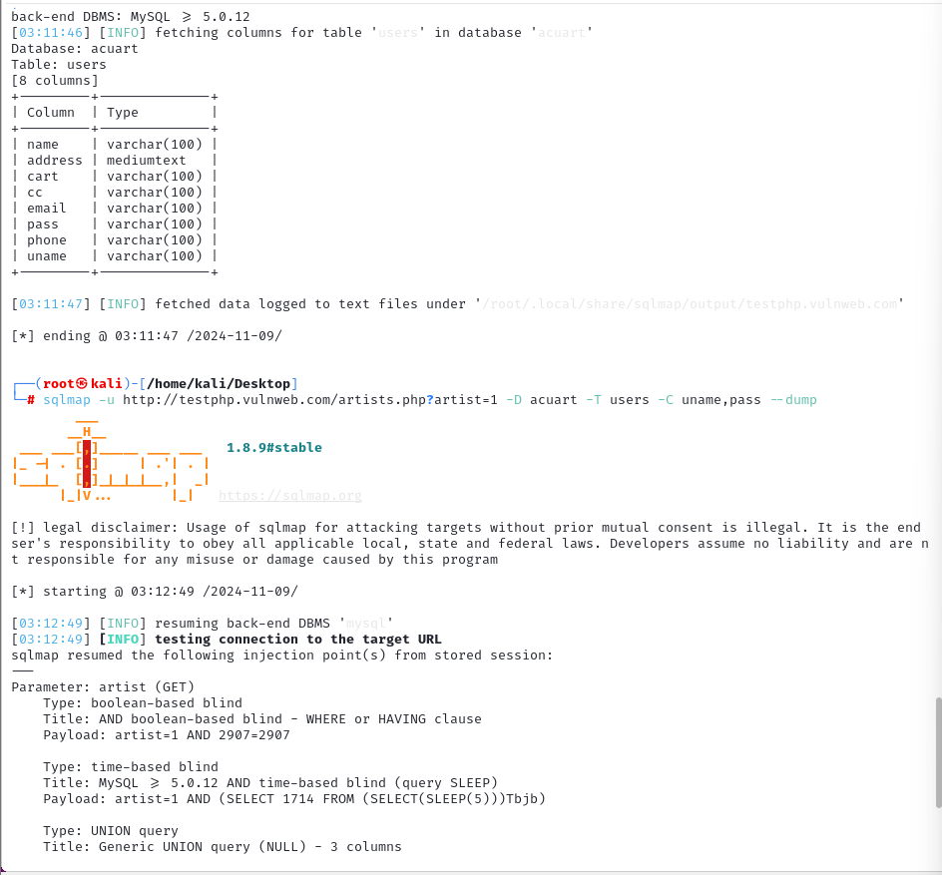  
   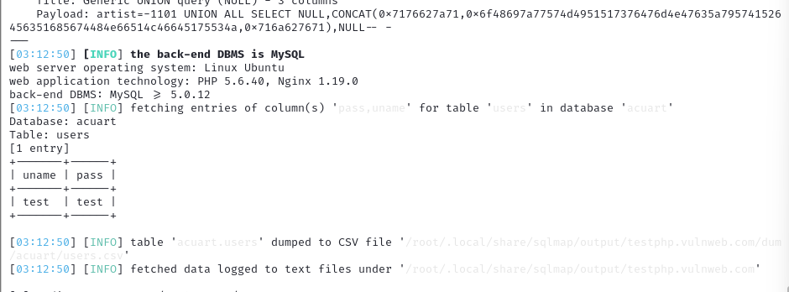

|  |
| --- |
| **14. 9 November, 2024** System hacking  Ethical hacking/security assessment  Network infras - IP based  Web app+API  Mobile app  Wireless network  **Web application penetration testing**  **Security:**   1. Authentication and authorization 2. Input validation 3. TLS/SSL 4. Secure coding practices 5. Keeping updated 6. Least privilege 7. firewall    Crawling: <http://testphp.vulnweb.com/>  Alada alada page ache  then test  Owasp testing guideline  https://lh7-rt.googleusercontent.com/docsz/AD_4nXd_W6DYmUCyQQE0mVKbQps4z9lXg2mWmh-ObzRu-9nKpQ2t9eI4jEQgdkheSxR6Ho7uFLdLikLJPVRP5pgqu1VP8-t1Xl7O-UdJ4cTEW-HYhyfm1pbcCQyD6WFlkaxH5d9KLEtkDhzPHfOBa36A_1oy82Y?key=Vk71agtBjgu2Ts9zXFwT4Q  <https://www.sans.org/top25-software-errors/>  Bug bounty:  Bug crowd  Synack  Hacker one  Yogasha  https://lh7-rt.googleusercontent.com/docsz/AD_4nXfnNDRsZYebhWNzx1fEsR3OJOe5jzjOXaR_IEultTqGVzVngHaPQpsiCnXR8lyMJFzX2oP8Q3U4ssbiE3yD5T3tqjL8YAbD4wFtbczz0T00rp7ZVnERGn4MoqeLuJVnNIKIfXze6xk8_YOjQLT7MBpZMrk?key=Vk71agtBjgu2Ts9zXFwT4Q  https://lh7-rt.googleusercontent.com/docsz/AD_4nXeYmXZJq3N4wGLihomspSVogO3yYLGb3uKSKGQ2MKKfcqKDvjoQ9CCcw7WIBD1zn7-i7fus5J7zetm0llhPZ7xo3SAtA-ZkUME9u-aZ9-meboa29qJVBhcVZVDUf1XD63ngOcotgd4HeuvUUSzrHdDb5VQ?key=Vk71agtBjgu2Ts9zXFwT4Q  https://lh7-rt.googleusercontent.com/docsz/AD_4nXf3ecWM6gqZ_M6LzyFmTZW7sW515s087yp4gQcwfglupHPDNr1wt9OKO6R7HSkNyO1XPCURhivIFirF2h0KwRM4hPwArpxWAuyCj9sE3Qct4vza58waZMERF-KlocM8h6YcyP7o15BOIe6zhiEy4z8ybBQ?key=Vk71agtBjgu2Ts9zXFwT4Q  https://lh7-rt.googleusercontent.com/docsz/AD_4nXcgBm_RippaShyHqwpDfyp5sYxVut2_N9CdJ5Eic4GdXNMKlpnOKKCs6E-8naZefvPismVHEHkzrdG1dkWO8rNVus4QJmPrMmuNSpvYqguGacaM9WOqCPEjhyfMhPMvj3HujaBfkOAtbyPfyJW3krvoJkp7?key=Vk71agtBjgu2Ts9zXFwT4Q  https://lh7-rt.googleusercontent.com/docsz/AD_4nXdOqiD0brPgBfCwXy7OAv3nH-8jrk7t1E3QVSd89kDWcK-13Pv2XLfp-lMbjN9bbmHJ1juFmoRnnCQkTFxvk1t8fnB6OSklS43HXlHZlVmP_uTOeF6IcDLB4dQNKjX501OmLFYRsOjEoUkij3InWw-hpWnE?key=Vk71agtBjgu2Ts9zXFwT4Q  https://lh7-rt.googleusercontent.com/docsz/AD_4nXd0XYk_j-Xk6_3QUmh1P1dBx4uX5pQ_-qFJ5DcCWnBOB8PJE0XWIuvA0qyodQqhgchIeWI4nKhc5G2ZkpjaHCTnLSys0fAu0o1f974_kZLnbmmlfhWUuo4VYqdZjZ80zuDMFEV4kxljCdRfhXijuVQoLWc7?key=Vk71agtBjgu2Ts9zXFwT4Q  https://lh7-rt.googleusercontent.com/docsz/AD_4nXe-gMX34zJ8GwkKMR_BEPZJIREI1Ydq79eHOnN1mY9wAKz1odCPYV9LHtHBrayEhp_x52KFuCj0rjQgJ_hmpiL92qOIeROdb4DKFFTyBOpezhWYsis4l1SE_DFr60gOpRGpCYetzCqdmS9EVNH0PCW7-W1G?key=Vk71agtBjgu2Ts9zXFwT4Q  https://lh7-rt.googleusercontent.com/docsz/AD_4nXeFNvBM3DL7CfbbkmVznCJ7m04sPIPL3EOZtUD_Ff4qup32hOeXFy-1LTuJ7Rt7qJDr1wcaacQBWCCb_SZ1neDHiVYAexJdt_CafxiuKJSFpt-mJo22wXmSoWo_zJ7iwwPWmd771ywXN5F0h11s89su1A?key=Vk71agtBjgu2Ts9zXFwT4Q    https://lh7-rt.googleusercontent.com/docsz/AD_4nXcevLVZiiHahG1UpFpAuMiqIAYsW-MkjgptgiCxcoeS1ZWiDJanOrISnTC8DHLqlypiTsnjT64C3nmjMeboo10KNS1NJ-OjeC9kLh7wnMbDJXIGVTx-eD8cIy9gIKLkjQxKB117eA-C_aX5OyHFLL3NQ5Sl?key=Vk71agtBjgu2Ts9zXFwT4Q  https://lh7-rt.googleusercontent.com/docsz/AD_4nXccKQ4dV8t8ou4_6d3CXzVTgIjWH1LJcndLqxFS1axNbd2ZTHh9xajDVFQvvmXIg-T0jxhlf36IRE1zwBymqax7Sg04c6wh1oEICgxI5Gp_Q7PB0tvSNGFtB0RmDWdX7AwCldD6h4dd9JrHh0OpEbv46p4?key=Vk71agtBjgu2Ts9zXFwT4Q  https://lh7-rt.googleusercontent.com/docsz/AD_4nXdiq0Pa6xShPH-14rVE5rJS_jMumwFS3yCpHi2w4fRsQvhDJG9j4S58xDQVyH443YuNXDWX5K3k8-A1lU3_1NYjP0VdMeKsPYR9KiXwz-EvXz5XAKLyyyMNKaGd5FfPuysIE6ljgmvD2DxUxAo8WMQzGTM?key=Vk71agtBjgu2Ts9zXFwT4Q  https://lh7-rt.googleusercontent.com/docsz/AD_4nXfVu3RktwMjbxNVKJzDHHpw1wMhLvILtrqdXnLZddqFmeMt98teCmyZKGOvVU1OSqqLVyZ1Nta_M-HtVimzPDKJ5GFJAfJSI5fC_NBsLVJ6PSTS9kZqK04L-PBT3_1aUXijM6TopbvCt6fXN9mz0fSgcA?key=Vk71agtBjgu2Ts9zXFwT4Q    https://lh7-rt.googleusercontent.com/docsz/AD_4nXd01Io4GduFEWzOq92aZF3mzQBtm1kZ9qKTCp4sXOC4T4BGDETI_HdSwsHlAYBeoaS0EpqwrD6NhOON1X0fTycfKk5Q9Uy9C8E8NKYLYCgQMAVHlez_1lPLd52x9tSQ9iA9jtn86oNAIVrOGZshOfDJOVfX?key=Vk71agtBjgu2Ts9zXFwT4Q  broken access control  <https://juice-shop.herokuapp.com/#/>  https://lh7-rt.googleusercontent.com/docsz/AD_4nXdWxF59iKPAb5PZDiF6DiVbFceB2-TOQeFPgFhUtKJQwbsL_Xvj5JqikUMjXGtKuUBjO6Q4TvcImjMKQ5VWVgfq9eowPdTrP8_W-r0sEbPWtlpy5ttQQnIt8dlRlf2rrIoi6vpLtFBkfeETHeTXFfro9J4A?key=Vk71agtBjgu2Ts9zXFwT4Q  https://lh7-rt.googleusercontent.com/docsz/AD_4nXddEot-pEFBmvRIzKvX-SwCCEMCRZ-7dDpeftYLWnGqQcmZq7TIc8onAB77f6AX2cPYiMml5hmNQfnEm165-wrgEttg8SjS5DKBjxyhWG9_IKTeTf7DBDFk2FoeAmBkChYxUAD2HeLngga7KWZEFvZsC6bg?key=Vk71agtBjgu2Ts9zXFwT4Q  https://lh7-rt.googleusercontent.com/docsz/AD_4nXefSqcNRV-7QT5YKEwkPLsOvT4hhqnlwOyd8BEjrkG36sEnGMJG5RUHBxw250VO7hVr3rurx87DG2uR_aMlOrMpl2Z4tzSGdxL-sCjAhJe6LXSYQ61gQNGRoBY1F-YFD9RTVT3OV8OxcZKwQ6dnStowgJGj?key=Vk71agtBjgu2Ts9zXFwT4Q  https://lh7-rt.googleusercontent.com/docsz/AD_4nXeNL0meHvOrFcFE5VFusfP8QlqVUfo_BI7Nwz4VkbvhODpoWuxNfdpH83eA190DjV7-7z6roDzvVU6ipBlVeJR3HtOTOQBjpWPacm_gZp-EV5DnFeV26DurjIDO2sPFXCHIcjJgeytfhmNkyTU4FwDsHy_f?key=Vk71agtBjgu2Ts9zXFwT4Q  https://lh7-rt.googleusercontent.com/docsz/AD_4nXfd79541VZHUTRMl0n33vY_YjJKfX45Kn7s-4XQQG16HwtqYCUbSwG7tAY_Y3_SZpbdJpsaNfutjKNNUR6P7ggJTPqcACC4NkntYUn22IMpahMBTOegjpgVjAZ6VARvkkv-ePZncpNVz1p6k_TIP1D8mjdM?key=Vk71agtBjgu2Ts9zXFwT4Q  https://lh7-rt.googleusercontent.com/docsz/AD_4nXdjcf-5h-DXG8WXEXnRR5-VCXh8p66RjXZxN1-088nrRY34oQ_WhgAYqnQmlHFgA5vPLRat8cP7EtLtmW3kHvh7jGLIOW2_mfQfq6C3k0ff-x9Ivuu88Q_IFFkrRzMCByRWex8JqWaLTOXQ9PVPh_f_zhI?key=Vk71agtBjgu2Ts9zXFwT4Q  https://lh7-rt.googleusercontent.com/docsz/AD_4nXfV_4b0CGjcYZ8tA2ph3-n8EANKc56h0UOJZTJYjgiVFjxZyrx_G8253c3Wnsc8t7epSs8ZBLMxnL3fMjcabxePAbNM9iei7G1rRrrLl1H6APYKr3xohSqmq6GI9GqTwxTWm2YTBAR5IyHc4ruGcKoHeMLT?key=Vk71agtBjgu2Ts9zXFwT4Q You can use GET, DELETE, POST   SQL INJECTION:  https://lh7-rt.googleusercontent.com/docsz/AD_4nXdjfGsibOPB_elJ7tPwAN1HSzbdr3LWpkhe06jYYc1RkzSLcegQ0aEFRZjHBoWF8MFWuXB8ip8IqX2BPFPWl0uVFo_06bwxkNag-kPxVjeaKrJotQaqwFrigTR2UPwYwohpV4KmDVXK16ZZHdbKkTBAVG8e?key=Vk71agtBjgu2Ts9zXFwT4Q   sqlmap -u http://testphp.vulnweb.com/artists.php?artist=1 --dbs --batch  https://lh7-rt.googleusercontent.com/docsz/AD_4nXe0eh7ksayWg_AqL18rR90aKiraO_ZTY7gSRAxNr4xbXHHoJHaAWf2ZtgaV3TQODcxmL_KTo3vfbksC-YgjKS9MIFRPzeET9BbrxyHqAd_bweCBObr3TCv0-F6JC0o_lX7oDuKgn0RSK8ILBhA885pgMSk8?key=Vk71agtBjgu2Ts9zXFwT4Q  https://lh7-rt.googleusercontent.com/docsz/AD_4nXcXZFCDy9rwLLOdJFIYXePlgaq2B08MuhR_G0HnsIn9vB2I-K95EY5v_-Snd0e5c32Bvqauv-qMlPTnYWmrrQ5sCg7fqHbj9RRDSnCSfpmlPK3xvovBegC_Y9SX6W1IZTbxecnJQ2bFkQyL_J4G_6p7vrZj?key=Vk71agtBjgu2Ts9zXFwT4Q  https://lh7-rt.googleusercontent.com/docsz/AD_4nXeT3-CsSudhLv5ci9eqkffGCAI0JpEJYccGuxygOfzU4tu4dUIMtj_ddZ5rTxDX8ez-oBEcIMzdGiABPHLJXtfuZZ88YXd_z7ApdL3X0QzFbaMPDl4oIn0Ril1HNRKgARyFDCFnTssMpa1BvK7Hlc2I2lYL?key=Vk71agtBjgu2Ts9zXFwT4Q    https://lh7-rt.googleusercontent.com/docsz/AD_4nXev0UAz8mkgG6gRIxQViCUc2E3Vm7E9wCXPnyqZeODjELcbf1BgPo1oqmdMqEHlG4b9Nr7DG6eSp_relSib8_yXP63j7cD4bqhiti6aZSQBE60vDojQ71NMbFlHi_NnWBUpJmk1XjqoMweQzUlUQOyeMSqs?key=Vk71agtBjgu2Ts9zXFwT4Q |