CREATE CHATBOT IN PYTHON

**Phase 3 Submission DocumentProjectTitle :**Creatingchatbot

Phase3:DevelopmentPart1

**Topic:**Startbuildingachatbotby preparingtheenvironmentand implementing basic user interactions.

Creating Chatbot

**Introduction:**

Building a chatbot using a specific dataset involves several steps,including setting up the environment and implementing basic userinteractions. In this example, we will demonstrate how to create achatbotusingadatasetobtainedfromKaggle.We'llutilizePythonandlibrariessuchasChatterBottofacilitatethis process.

By following the steps in this example, you'll learn how to set up theenvironment,loadandpreprocesstheKaggledataset,andimplementbasic user interactions with your chatbot. While our chatbot'scapabilities will be confined to the dialogues present in the dataset,this project serves as a foundation for understanding how to leverageexternaldatasets forchatbottraining.

GivenDataset:

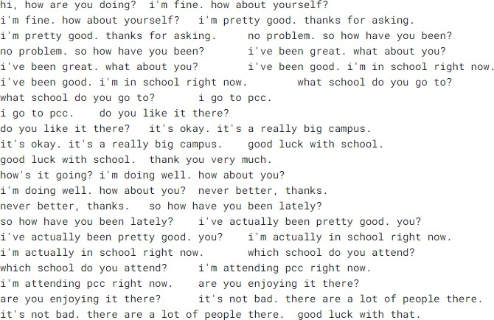

To build a chatbot using the dataset from Kaggle, you can followthesesteps:

1. DownloadandPreparetheDataset:

Download the dataset from Kaggle(http[s://www.k](http://www.kaggle.com/datasets/grafstor/simple-dialogs-for-)agg[le.co](http://www.kaggle.com/datasets/grafstor/simple-dialogs-for-)m[/datasets/grafstor/simple-dialogs-for-](http://www.kaggle.com/datasets/grafstor/simple-dialogs-for-)chatbot).

1. InstallDependencies:

Install the necessary Python libraries for working with data andbuildingachatbot.We'll usepandas,ChatterBot,andChatterBot'snaturallanguageprocessing library,spacy.

pipinstallpandas

pipinstallchatterbot

**pip installchatterbot_corpus**

**pip install flask**

1. CreateaPythonScript:

CreateaPythonscript,e.g.,chatbot_with_dataset.py.

1. Implementthe chatbot:

Program:

importpandasaspd

fromchatterbotimportChatBot

from chatterbot.trainers import ListTrainerdata=pd.read_csv('dialogues.csv')chatbot=ChatBot('MyBot')

trainer = ListTrainer(chatbot)dialogs = data['User'] + data['Bot']trainer.train(dialogs.tolist())conversation_history=[]

defchat_with_bot():

print("Hello!I'myourchatbot.Youcanstartaconversation,ortype'exit'toquit.")

whileTrue:

user_input=input("You:")

if user_input.lower() == 'exit':print("Bot: Goodbye!")break

elif user_input.lower() == 'history':print("Bot: Conversation History")forentryinconversation_history:

print(entry)

elif user_input.lower() == 'clear history':conversation_history.clea()

print("Bot: Conversation history )

else:

response=chatbot.get_response(user_input)

conversation_history.append(f"You: {user_input}")conversation_history.append(f"Bot:{response}")

print("Bot:",response)

chat_with_bot()

1. Runthe Chatbot:

Run the Python script by executing python chatbot_with_dataset.py interminal orIDE.

SampleOutput:

Hello! I'myourchatbot. Youcanstart

aconversation,ortype'exit'toquit**.**

**You:**hi,howareyoudoing?

**Bot:**i’m fine how about yourself ?

**You:**What'stheweatherlike

today?

**Bot:** I'mnotsureabout theweather. I'mjust achatbot.

**You:**history

**Bot:**ConversationHistory

**You:**hi,howareyoudoing?

**Bot:**i’m fine how about yourself ?

You**:**What'stheweatherliketoday?

**Bot:** I'mnotsureabout theweather. I'mjust achatbot.

**You:**clearhistory

**Bot:**Conversationhistory cleared.

**You:** exit

**Bot:** Goodbye!

keytasks involvedin creatinga chatbot:

* 1. DefinePurposeandUse Case:

Determine the specific purpose and use case for your chatbot.Considerwhetheritwillprovidecustomersupport,answerfrequentlyaskedquestions,assistwithtasks,orengageincasualconversations.

* 1. SelectaPlatform:

Decideon theplatformwhereyourchatbotwillbedeployed.Thiscould be a website, messaging apps (e.g., Facebook Messenger,WhatsApp),oracustomapplication.

* 1. Choose the Technology Stack:

Select the technologies and tools you'll use to build thechatbot,includingprogramminglanguages,libraries,andframeworks.CommonchoicesincludePython,JavaScript,Node.js,andmachinelearninglibrarieslikeTensorFloworPyTorch.

* 1. DataCollectionandPreprocessing:

Collect and preprocess data for training your chatbot. This mayinvolvegatheringconversationdatasets,cleaningandformattingthedata,and extracting relevantinformation.

* 1. Trainthe Chatbot:

Train your chatbot using appropriate datasets. This training caninvolve supervised learning, reinforcement learning, or rule-basedapproaches,dependingon thecomplexityofyourchatbot.

* 1. Natural LanguageProcessing(NLP):

Implement Natural Language Processing techniques to enable thechatbot to understand and generate human-like text. This may includetasks like tokenization, entity recognition, sentiment analysis, andintentdetection.

Conclusion:

Building a chatbot is an exciting and complex endeavor with thepotential to revolutionize various industries and enhance userexperiences. In this process, we've explored the fundamental steps andconsiderationsinvolved increatinga chatbot