**1. ifconfig :** stands for "**interface configuration**." It is used to view and change the configuration of the network interfaces on your system.

[AfrinZamanRima@webminal.org ~]$ifconfig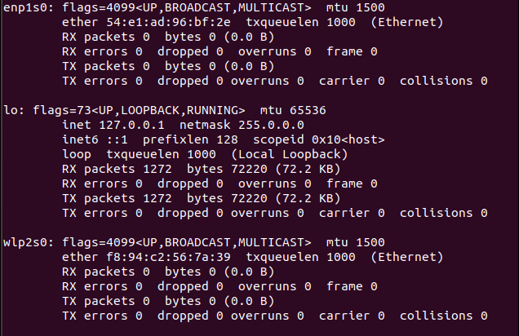

**ifconfig -a:** Displays the configuration of all interfaces, both active and inactive.

[AfrinZamanRima@webminal.org ~]$ifconfig -a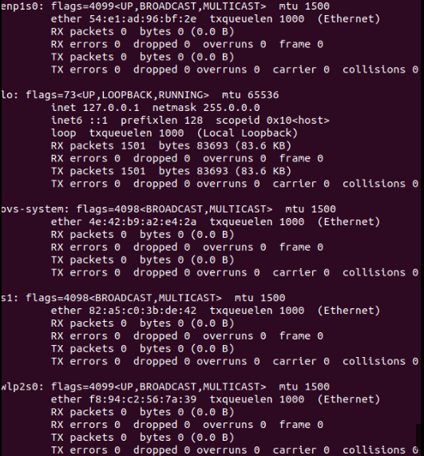

**Create Virtual Network:**

**We will be using CLI(sudo mn command) to manage our virtual network. The default topology includes two hosts (h1,h2), OpenFlow Switch(s1) and OpenFlow controller(c0).**

[AfrinZamanRima@webminal.org ~]$sudo mn

[sudo] password for AfrinZamanRima

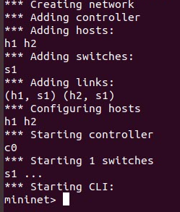

**This command launches a simple 2 host, 1 controller, 1 switch topology. The following diagram outlines the topology.**

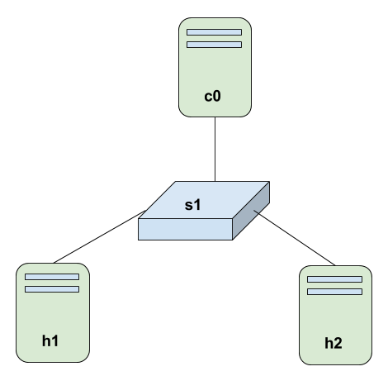

**Help command:** Run the help option to view the list of commands available:

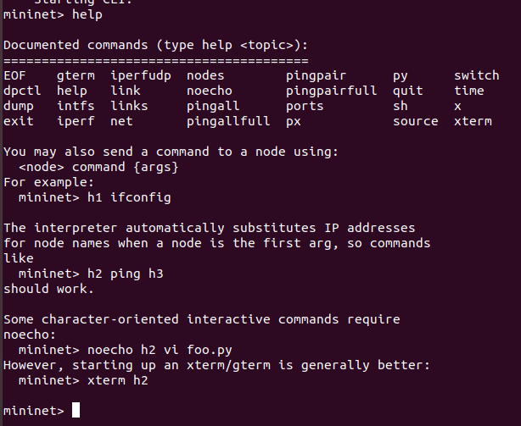

**nodes command:** Shows the nodes we created with the simple Mininet command:

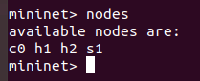

**net command:** This command shows the links of all nodes

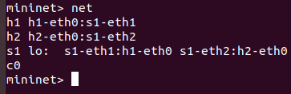

dump command: which displays summary information about all devices:

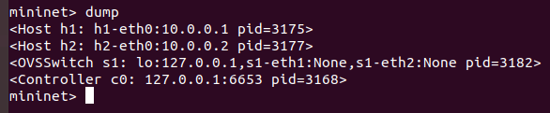h1 ifconfig -a: This command will display the IP address, broadcast address and MAC address of the host h1. The command h2 ifconfig -a are also as the command

h1 ifconfig -a.

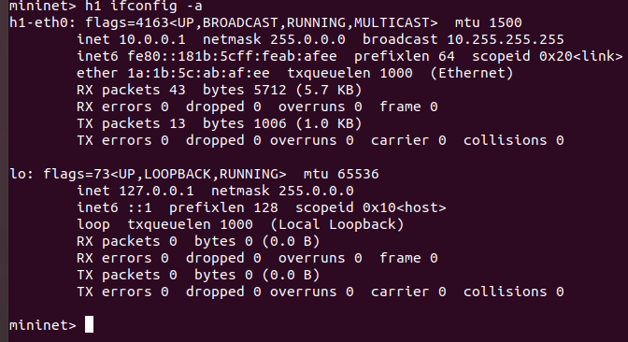

Ping command: We can test connectivity between the host by using ping command.

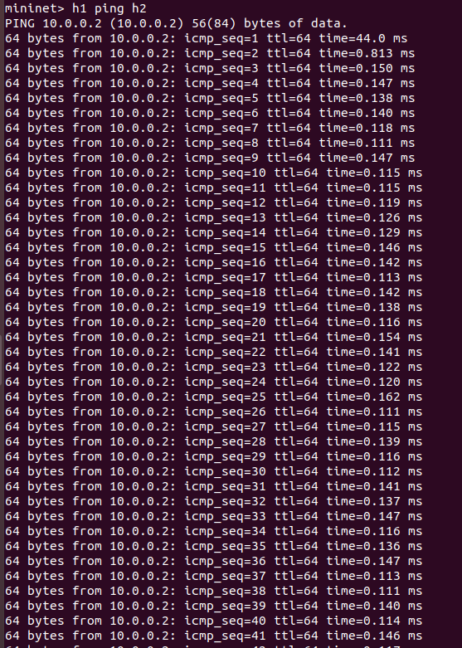

Pingall command: This command will make each host in the network ping every other host in the network. In the network that we have, **h1** will ping **h2**, and **h2** will ping **h1.**

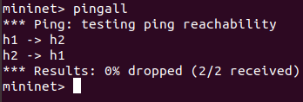

create topology : topo=single,4 that means controller , switch is one and host are 4 like h1,h2,h3,h4

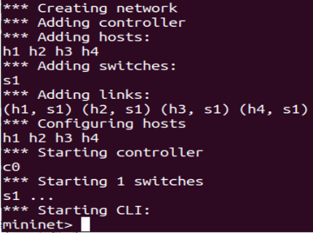

sudo mn -x command :

one node one new corresponding terminal.

exit command:

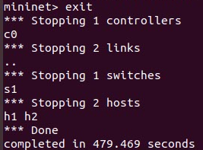

### **cleanup command:** If Mininet crashes for some reason, clean it up:

### [AfrinZamanRima@webminal.org ~]$sudo mn -c