**SILENT SPEECH RECOGNIZATION - AUTOMATIC LIPREADING MODULE**

**GENERAL DESCRIPTION**

The proposed project aims to develop an advanced lipreading model that can effectively convert lip movements into text, benefiting individuals with hearing impairments and situations where audio information is compromised. The proposed solution to the challenge of "Silent Speech Recognition: Automatic LipReading Model using 3D CNN and GRU" aims to create an advanced system that can recognize speech from lip movements without requiring audible audio input. This technology has various potential applications, such as aiding individuals with speech impairments, enhancing speech recognition in noisy environments, and enabling silent communication in sensitive situations like security and surveillance.

The advanced lipreading model can be integrated into assistive devices for individuals with hearing impairments, providing them with a more effective means of communication.

This model's successful implementation addresses the challenge of converting lip movements into text accurately and reliably. It offers a practical and valuable solution for individuals with diverse applications in scenarios where audio information may be limited or compromised.

**NOVELTY/UNIQUENESS**

The uniqueness of the proposed solution lies in the combination of 3D Convolutional Neural Networks (CNN) and Gated Recurrent Units (GRU) for silent speech recognition. While both 3D CNNs and GRUs have been used individually for various tasks, the integration of these two architectures specifically for lip reading presents a novel approach to tackle the challenge.

3D CNNs are capable of capturing spatial and temporal patterns in video data. By applying 3D CNNs to lip video frames, the model can effectively learn complex spatiotemporal features, which are crucial for accurate lip reading.

While speech recognition has been a well-researched area, the focus on silent speech recognition using only lip movements makes this solution unique. It caters to specific use cases where audio input might not be available or practical.

**BUSINESS IMPACT**

Integrating this technology into consumer businesses that implement this silent speech recognition technology can gain a competitive advantage in industries where speech recognition is essential, such as communication devices, security, and customer service.

products, such as smartphones or voice assistants, can enhance user experience, particularly for individuals with speech impairments or in noisy environments.

Companies can explore new revenue streams by offering silent speech recognition as a service or licensing the technology to other businesses.

**SOCIAL IMPACT**

The solution can significantly improve accessibility for individuals with speech impairments, granting them a new means of communication and promoting inclusivity in society.

In sensitive situations, such as law enforcement or military operations, the technology can enable silent communication, potentially improving safety and security

**TECHNOLOGY ARCHITECTURE**

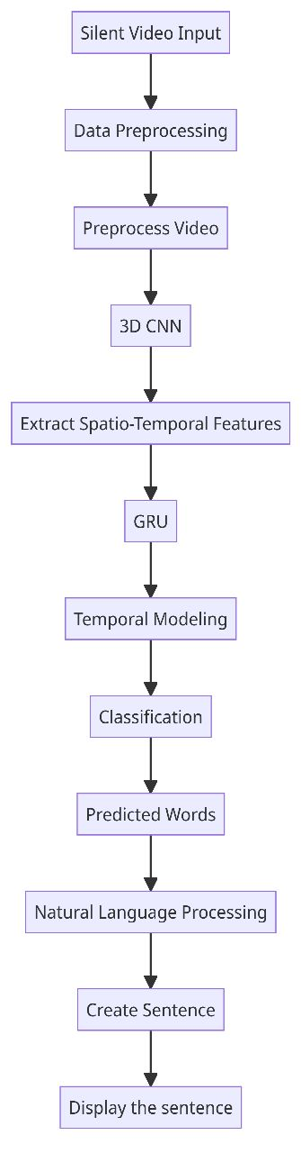

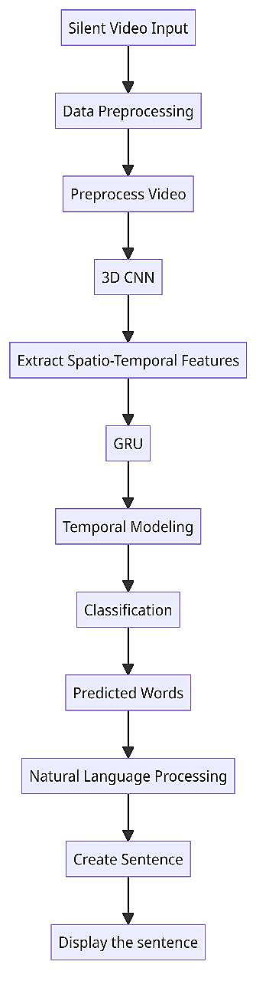

3D Convolutional Neural Networks (CNNs) are well-known for their ability to extract spatial features from 2D images. However, lip reading involves analyzing temporal dynamics as well.

By extending CNNs to 3D, the model can capture both spatial and temporal characteristics from sequential frames of lip movements. This allows the model to comprehend the dynamic nature of lip motion over time, which is crucial for accurate lip reading.

Gated Recurrent Units (GRUs are a type of recurrent neural network (RNN) that are particularly effective in capturing long-term dependencies in sequential data. Lip movements are inherently sequential in nature, and by employing GRUs, the model can effectively learn and utilize the temporal dynamics present in the lip movement sequences. This helps the model understand the context and patterns in spoken language, which is vital for accurate transcription.

By combining 3D CNNs and GRUs, the model can jointly leverage both spatial and temporal information from lip movements, leading to improved accuracy and robustness in lip reading tasks. This architecture enables the system to better understand spoken language even in scenarios where audio information is unavailable or unreliable.

Data Collection and Preprocessing:

Collect a diverse dataset of video recordings containing speakers with varying lip movements and speech patterns. Use computer vision techniques and libraries like OpenCV for lip region extraction and normalization.We are using "LRW-500" Dataset for tarining the model.

Feature Extraction with 3D CNN:

Apply 3D Convolutional Neural Networks (CNN) to the preprocessed lip video frames. Technologies: Deep learning frameworks like TensorFlow or PyTorch for implementing 3D CNN architecture.

Sequence Modeling with GRU:

Utilize Gated Recurrent Units (GRU) or other recurrent neural network architectures to model sequential dependencies between lip movements. Technologies: TensorFlow or PyTorch for implementing GRU-based models. We have used Inception_v4 architecture for a machine learning model, which seems to be designed for a specific task, possibly image classification. This architecture is constructed using TensorFlow.

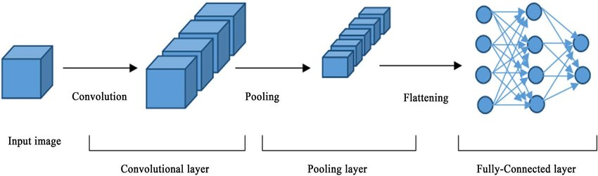

Model Integration:

Combine the outputs of the 3D CNN and GRU into a unified model that predicts spoken words or phrases from the lip movements.

Training and Optimization:

Train the model on the prepared dataset using appropriate loss functions and optimization techniques. Fine-tune hyperparameters to achieve optimal performance.

Evaluation and Testing:

Evaluate the model's performance on a separate test dataset using metrics like accuracy, precision,recall, and F1-score.

Deployment:

Deploying the trained model as an application or integrating it into existing systems for silent speech recognition.

Web servers (Flask) for deploying the application, or integration with existing platforms.

**SCOPE**

The project's scope includes the development of deep learning models, data preprocessing, model training, and evaluation. Optional modules like real-time implementation, user interface development, and privacy considerations can be included based on specific project requirements and use cases. It's essential to plan each module's tasks, set clear objectives, allocate appropriate resources, and establish milestones to ensure a smooth and successful implementation of the project. Additionally, continuous testing and validation at each stage will be critical to ensuring the model's accuracy, reliability, and overall effectiveness.

**REFERENCES**

1.Dataset link : https://www.robots.ox.ac.uk/~vgg/data/lip_reading/lrw1.html

2.https://ieeexplore.ieee.org/abstract/document/9001505/references#references

3.https://ieeexplore.ieee.org/document/9042439