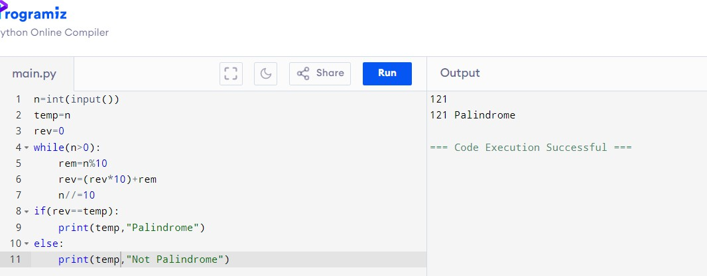PALINDROMEOR NOT:

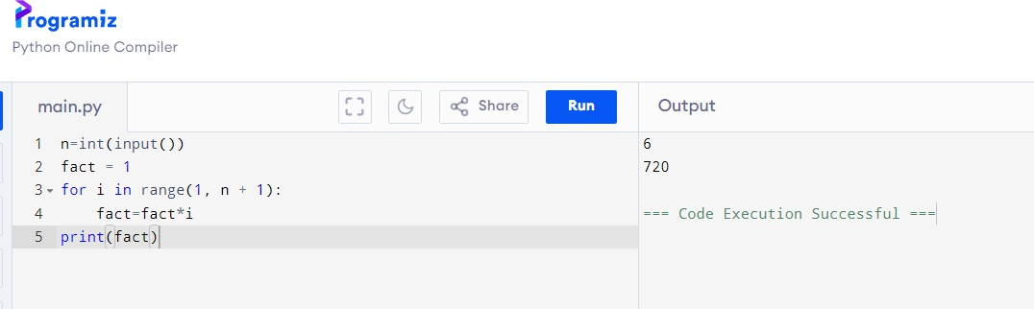FACTORIAL:

PRIMEORNOT:

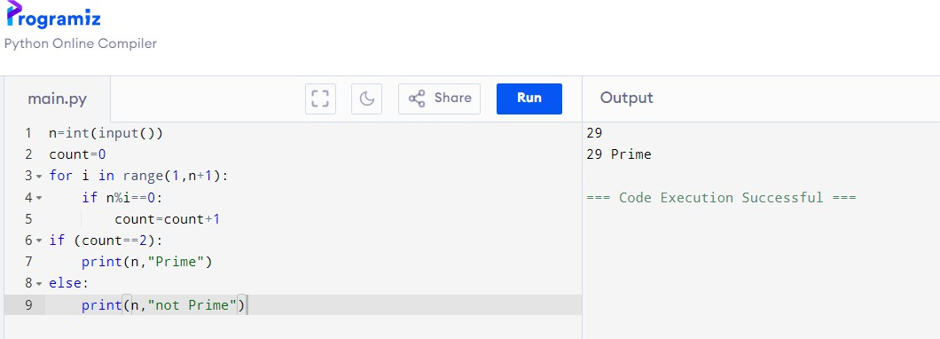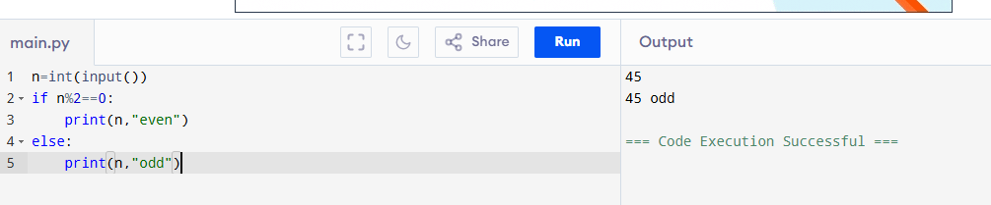EVENORODD:

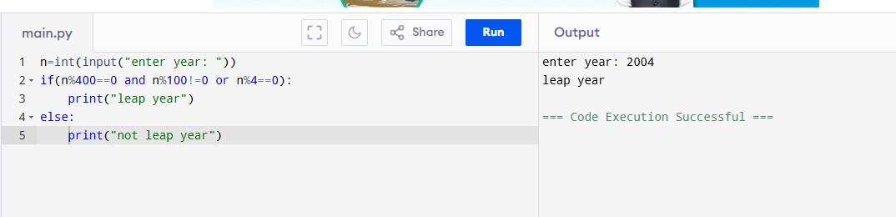LEAPYEARORNOT:

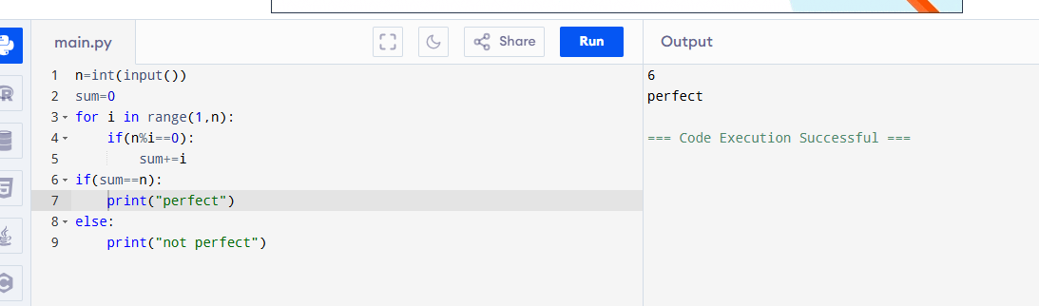PERFECTORNOT: