**PROGRAM TO PRINT SUM OF INDIVIDUAL DIGITS IN A GIVEN NUMBER:**

n=int(input()) Sum=0 While(n>0):

Rem=n%10 Sum=sum+rem n=n//10

Print(sum)

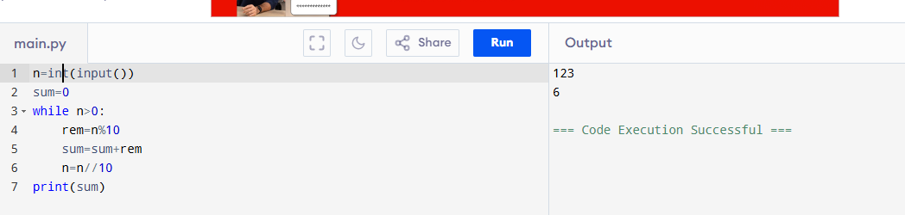**OUTPUT:**

**PROGRAM TO PRINT ALL THE PRIME NUMBERS IN A GIVEN RANGE:**

n=int(input()) m=int(input())

for num in range(n,m+1): if num>1:

for i in range(2,num): if num%i==0:

break else:

print(num,end=" ")

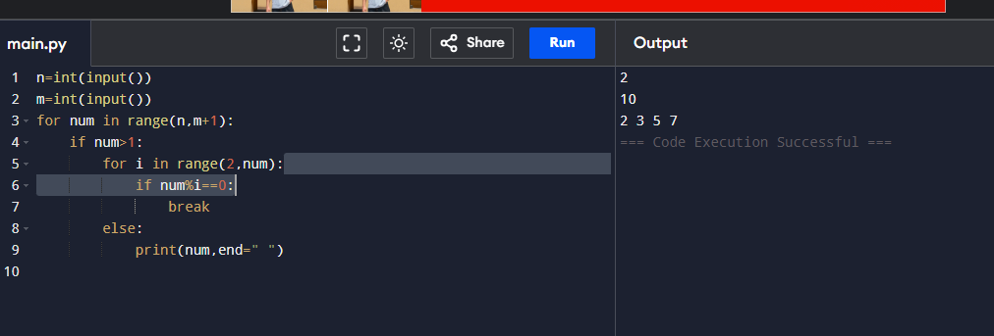**OUTPUT:**