2.Displayed manual page using mkdir -p second

3. (didn’t do this one)

4.Displayed id and groups using id command

5. Displayed name of current directory using pwd command.

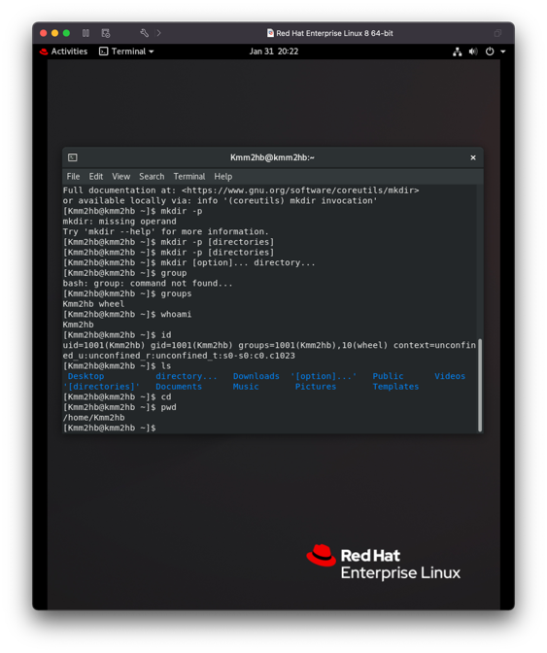

7.Switched back to home directory using cd ~

8.Switched to efi directory 9. Switched to parent director using cd

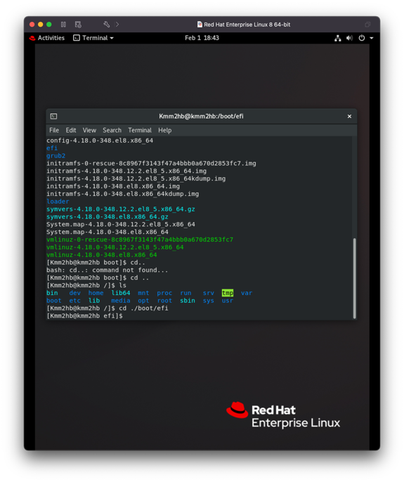

10.I ended up in the /boot 11.Used ls command to see in the directory

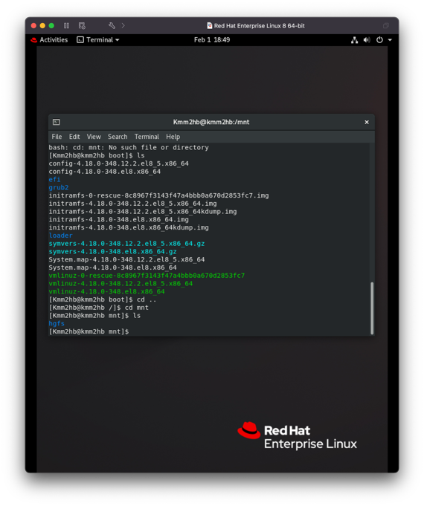

12.Used the ls -a command to display all hidden files 13.used ls -lh to display sizes

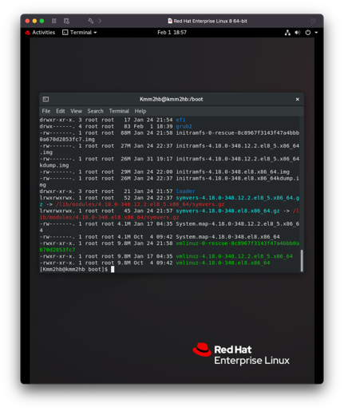

14.Created new directory in kmm2hb

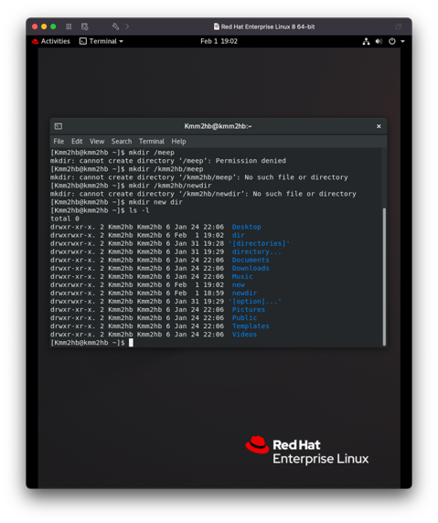

15. created dir1/2/3 inside of eachother.

16. Accidentally made those directories inside of my newdir already. The code I would use to move them inside the directory is mv Dir1 newdir (same pic as 15)

17. used touch command to create 3 files

18.Moved file1 to newdir using mv file1 newdir

19. Renamed file1 to file4 using mv file1.txt file4.txt

20.used rm -r newdir to delect directory and all things contained in it.