IT 3850 Computer System Administration  
Spring 2022

**Laboratory # 4 - Dynamic Host Configuration Protocol - DHCP**

*Dr. Ronny Bazan (Contact: bazanantequerar@umsystem.edu)*



1. **Objectives**
2. Explain how the DHCP process works.
3. Customize DHCP configuration:
   * Lease time, gateway and DNS
   * Assign a fixed network configuration to DHCP clients.
4. Identify DHCP-related files.
5. Install and configure Microsoft Windows 10.
6. Configure Microsoft Windows 10 VM as a DHCP client.
7. **Material Required**

A RHEL VM and one Microsoft Windows 10 VM.

1. **Activity**
2. **Go through the DHCP material posted on Canvas.**
3. Besides having a RHEL VM connected to VMnet2 or ‘Private to my Mac’ (for MacOS users) you will need an additional Microsoft Windows 10 VM also connected to the same private network virtual switch, configured as shown in the below network topology.

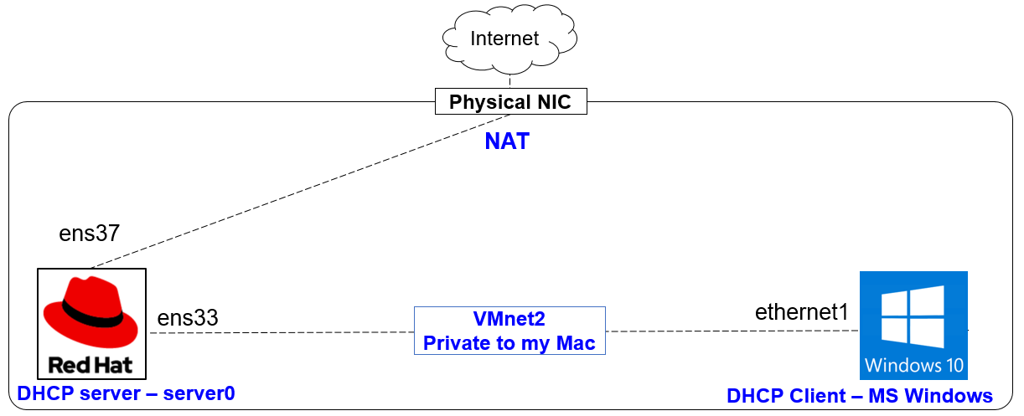

1. **Review Questions**

**\*Important*. For each question where you are required for a screenshot, include the screenshot that clearly demonstrates you completed that step successfully.** Include any commands you executed for each step as well, if applicable**. All the screenshots for this lab and future labs must include your pawprint in the command prompt or have other information visible that identifies you (i.e. type/draw your pawprint).** This is to ensure that you are submitting your own work.

Answer the following questions and perform the following tasks. Construct your report in a document to submit on Canvas. Make sure to read the directions and the rubric carefully!

1. (Fill in the blank) See this article about Daemons: <https://wiki.debian.org/Daemon> The systemctl command belongs to the _________ daemon management system, and the service command belongs to the _________ daemon management system.
2. After finishing the Microsoft Windows installation process, and connecting the network adapter to VMnet2 or ‘Private to my Mac’ (for MacOS users), notice the Windows VM is obtaining an IP address in the range of 169.254.0.1 through 169.254.255.254. However the DHCP server is turned off, and the network adapter in VMware Workstation/Fusion is not connected to NAT. Why is the Windows system obtaining an IP address if there is no DHCP server available for it?
3. Using the **4**th subnet of the 192.168.100.0/27. Configure a DHCP server on your server0 RHEL system with only one Microsoft Windows (aka DHCP client).
   * Assign the **first valid IP** to the network adapter **connected to your VMnet2** or ‘Private to my Mac’ on your RHEL server0. (Break down this subnet into network ID, first valid IP, last valid IP, and broadcast components to help with this)
   * Assign the **8.8.4.4 IP as a DNS server** for all the DHCP clients.
   * Assign the **second** **valid IP** as a **gateway** for all the DHCP clients.
   * Assign the **last valid IP to your Microsoft Windows DHCP client** (use the **client MAC address** to assign the IP).

Submit:

1. A screenshot of the **server** executing the command ifconfig with the correct IP address
2. A screenshot of the **client** executing the command route –n (linux) or c:/> route PRINT (windows) with the correct **gateway** output
3. A screenshot of the **client** executing the command cat /etc/resolv.conf (linux) or c:/> ipconfig /all (windows) with the correct **DNS** output
4. A screenshot of the **server** executing showing the content of /var/log/messages with the **correct DHCP communication process from the client** (i.e. DHCP messages type: DHCPDiscover, DHCPOffer, DHCPRequest, DHCPAck).
5. Once you finalize configuring the DHCP server on RHEL, the Windows system gets an IP address from there. The Windows system can ping to the DHCP server successfully. However, the DHCP server cannot ping to the windows VM. Inquire about the reason or reasons why this communication is not possible. Provide an explanation and the steps you follow on your Windows VM to solve the problem. Include a screenshot showing RHEL pinging Windows. (Tip: Firewall).
6. Our MS Windows VM obtained network configuration from the RHEL DHCP server. How can we obtain information from MS Windows VM about the RHEL DHCP server’s IP address? Include a screenshot showing this information obtained through MS Windows (Tip: use the cmd or show graphically).
7. How can we guarantee that after rebooting our RHEL server0 with the DHCP service installed on it, the DHCP service will continue to be enabled? Show the command to be used.