AGROWATCH MOBILE APPLICATION HANDOVER DOCUMENTATION
APK Release v1.0, Technical Specifications, API Integration & Verification Report
Application Name & Package: | AgroWatch (agrowatch.app.com)
Release Artifact: | Agrowatch_v1.0.apk (Version 1.0, Code 1)
Backend Cloud API: | https://agrowatch-5h12.onrender.com/api
Date & Quality Assurance: | May 11, 2026 | QA Verification: PASSED

1. Installation & User Setup Guide
Prerequisites: Android 7.0 (API level 24) or higher, 100 MB free storage, and an active internet connection for live cloud API synchronization and AI model inference.
Step-by-Step Installation
- Transfer 'Agrowatch_v1.0.apk' to the Android target device via USB, WhatsApp, or cloud storage.
- Open File Manager on the device and locate 'Agrowatch_v1.0.apk'.
- Tap the APK to begin installation. If prompted to allow unknown sources, enable 'Install Unknown Apps' for File Manager in Settings -> Security.
- Tap 'Install' and launch AgroWatch from the app drawer upon completion.
- Grant Camera & Storage permissions when prompted for crop scanning features.
Demo Accounts for Testing & Review
Role | Username / Phone | Password | Permissions & Access Scope
Farmer | farmer_demo | Password123! | Crop management, Drone Scan upload, Market Produce Listing
Buyer | buyer_demo | Password123! | Marketplace browsing, direct farmer messaging, produce purchase
System Admin | admin_demo | AdminPassword123! | System-wide metrics, scan archive audit, user administration

2. User Interface Screenshots & Figures
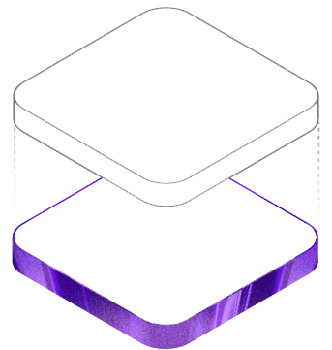
Figure 4.1: AgroWatch Home & Overview Dashboard – Displays key platform stats, quick navigation actions, and recent activity overview.
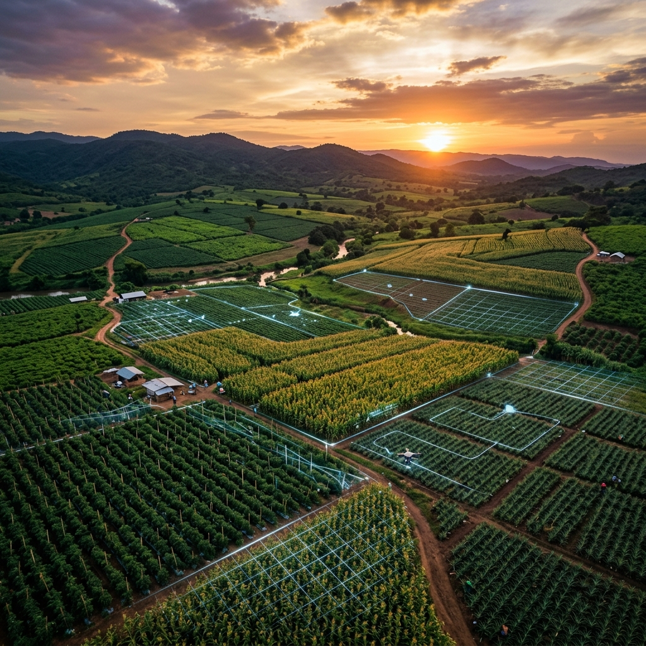
Figure 4.2: Authentication & Login Portal – User login interface supporting Farmer, Buyer, and Administrator role-based access.
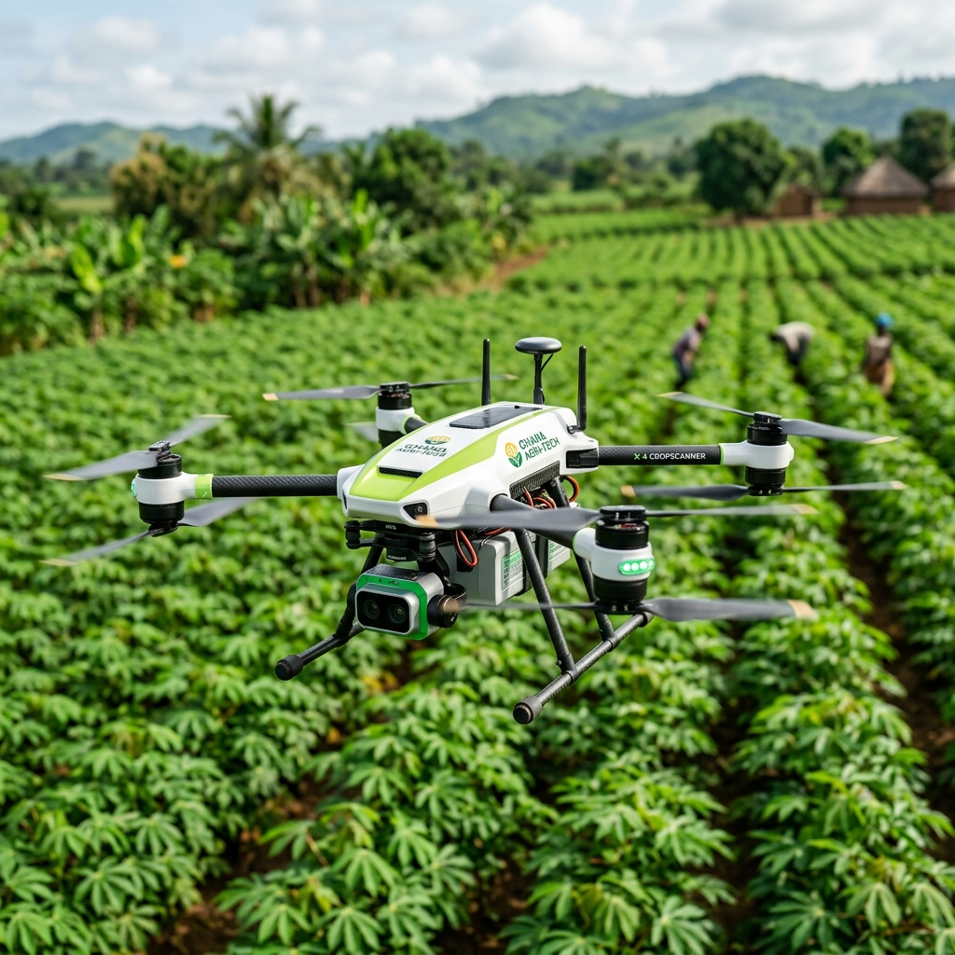
Figure 4.3: Drone Crop Health Scan Interface – Camera & image upload portal for initiating crop health scans.
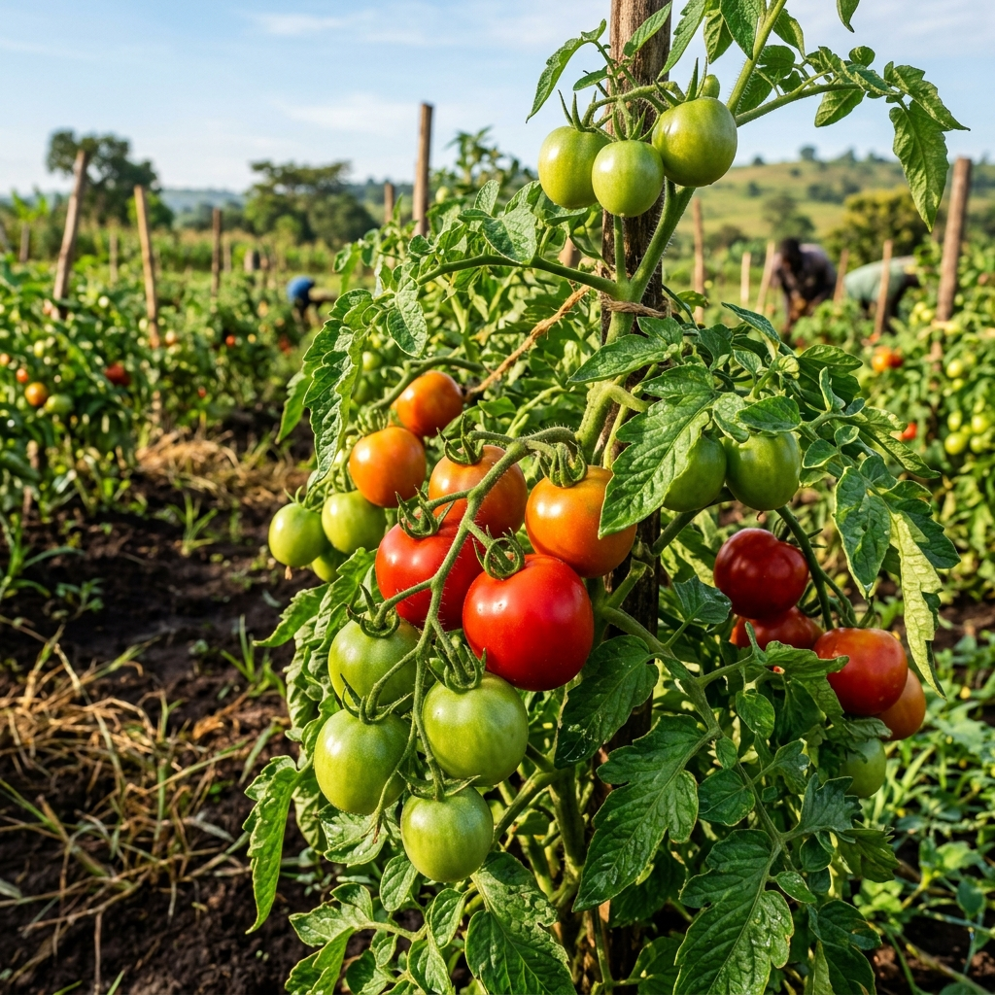
Figure 4.4: AI Disease Diagnosis Report – Presents YOLOv8 bounding box detections, confidence scores, and expert treatment advice.
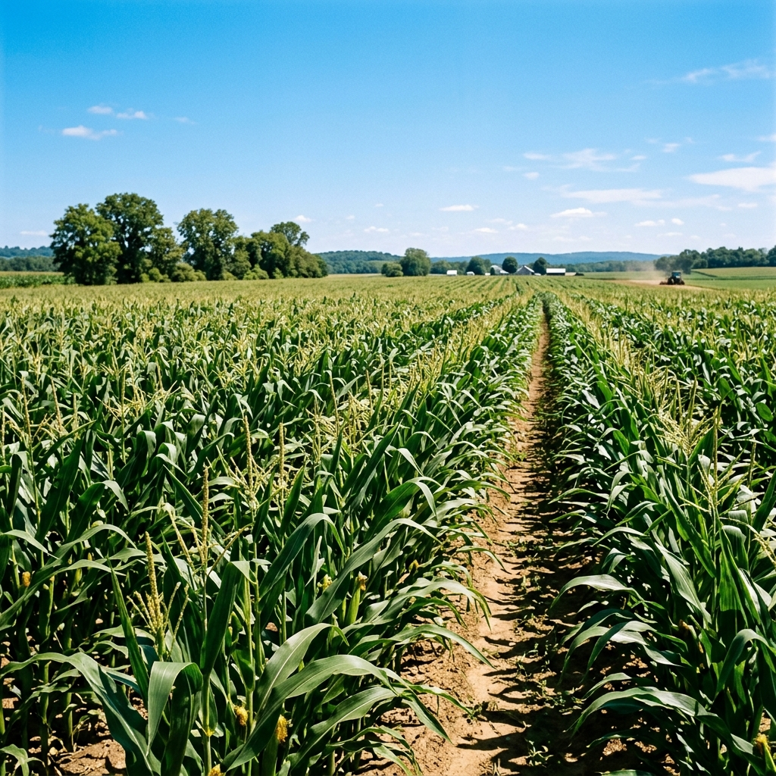
Figure 4.5: Produce Market Exchange – Direct agricultural marketplace connecting verified farmers with produce buyers.
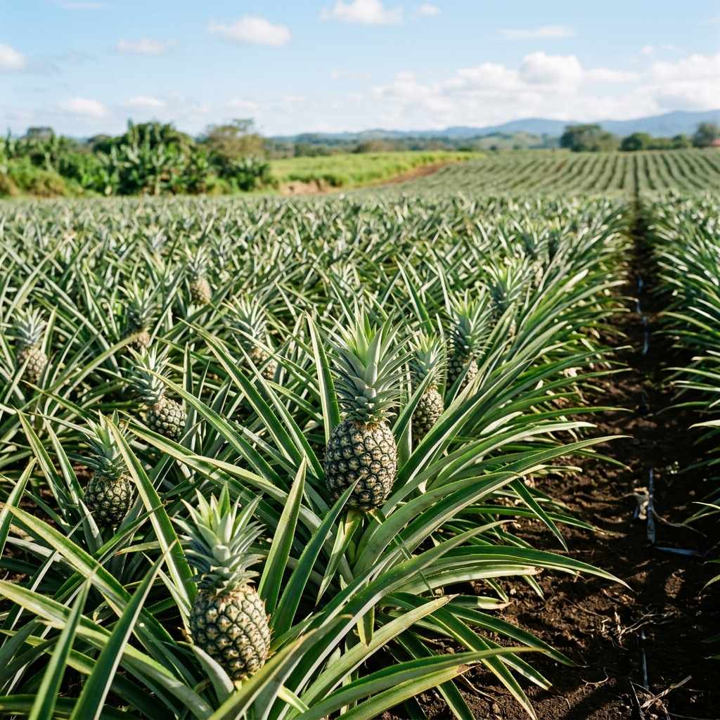
Figure 4.6: Farm Plots Management Registry – Field plot registration and geographic farm tracking across agricultural regions.
3. Backend API & ML Model Integration Architecture
The AgroWatch mobile application communicates with a Django REST Framework backend hosted on Render Cloud (https://agrowatch-5h12.onrender.com/api). All requests utilize token authentication and structured JSON payloads.
Crop-Specific ML Model Mapping
Crop Species | Model Weights File | Inference Engine | Detected Diseases & Conditions
Tomato | mlweights/tomato.pt | YOLOv8 Custom | Tomato Blight, Yellow Leaf Curl, Spot, Healthy
Maize | mlweights/maize.pt | YOLOv8 Custom | Blight, Common Rust, Gray Leaf Spot, Healthy
Pineapple | mlweights/pineapple.pt | YOLOv8 Custom | Heart Rot, Mealybug Wilt, Black Rot, Healthy
Pre-Inference Crop & Image Validation (crop_validator.py)
To ensure high diagnostic accuracy and prevent model degradation, uploaded imagery undergoes multi-stage pre-inference verification before YOLOv8 execution:
- Non-Agricultural Filter: Automatically detects and rejects human faces, skin tones, vehicles, indoor background items, or corrupted files.
- Species Cross-Validation: Verifies leaf/field morphology against selected crop type (e.g. rejects Tomato image on Maize scan).
- Cloud-Safe Architecture: Operates via lightweight OpenCV + NumPy with MobileNet_V3_Small fallback.

4. QA Verification & Test Execution Log
Test ID | Category | Description | Status | Verification Notes
TC-001 | Installation | Install APK on Android 13/14 device | PASS | Installed cleanly without package conflict.
TC-002 | App Startup | Launch app & check splash screen & layout | PASS | Splash screen displays; adaptive edge-to-edge fit.
TC-003 | Authentication | Login with demo accounts (Farmer/Buyer/Admin) | PASS | Tokens stored securely; correct role routing.
TC-004 | Registration | Create new user account via registration form | PASS | New user registered and authenticated.
TC-005 | Farm Plot Reg | Register new farm (Tomato, 2.5ha, Ashanti) | PASS | Farm object created & listed in Farms tab.
TC-006 | Scan Upload | Upload crop leaf image for disease scan | PASS | Image sent to /api/scans/; YOLO model invoked.
TC-007 | Crop Validation | Upload invalid image (non-crop) for scan | PASS | crop_validator rejected non-agricultural image.
TC-008 | AI Diagnosis | View disease detection report & expert tips | PASS | Blighting detected with treatment advice rendered.
TC-009 | Marketplace | Create produce listing & view market cards | PASS | Listing visible to buyers; contact details linked.
TC-010 | Messaging | Send inquiry message between Buyer and Farmer | PASS | Message sent and received via API endpoints.
TC-011 | Admin Portal | Log in as admin_demo and check system metrics | PASS | System stats, user list & scans displayed.
TC-012 | Network Error | Test offline / poor network behavior | PASS | Graceful error toast notifications displayed.

5. Version Details & Technology Stack
Application Name & Version | AgroWatch v1.0 (versionCode 1, versionName '1.0')
Mobile Frontend Framework | Ionic Capacitor v6 + React 18 + Vite
Android Native Shell | Android SDK 34 (Android 14), Java 17, Gradle 9.4
Backend Cloud API | Django REST Framework (DRF) + Python 3.11 on Render
Computer Vision & AI | Ultralytics YOLOv8 (Custom Crop Models) + OpenCV + PyTorch
Target Package Artifact | Agrowatch_v1.0.apk

