VR Final Major Project

DATE DUE: 2/5/25

Game Technology Project

Oluwasomisayo Euler-Ajayi

Q16049845

Contents

Table of Contents
VR Final Major Project 1
Contents 2
VR’s Background 4
Project Definition 5
Aim of the Project 5
Project Objectives 5
Stretch Goals 5
6
Project Scope 6
Feasability 7
Product Design 7
Design Documentation 7
Technical Design 7
Project Plan 7
Scope 7
Schedule 7
Risk Management 7
Tracking Methodology 8
Referencing 8

 | What am I making?  What’s my inspiration  Why am I making it?  VR’s Background  Virtual Reality (VR) is a newly developing platform for media that attempts to fully immerse the player in the subject they are exposed to. The term virtual reality was first referred to as Jaron Lanier 1987, he played a fundamental role in the evoloution of VR. VR at first was tightly linked to the military having it’s early work funded by the United States Department of Defense, Lowood (2025). | Over the course of this project, I plan to be make game using Virtual Reality, wherein the player uses martial arts like gestures to affect the landscape around them in a manner reminiscient of:  - the fantastical settings of popular media akin to Avatar: The Last Airbender (2005)  - The Dragon Prince. (2018)  Now many games that translate similar magic systems, tend to easily implement these systems through a combination of more standard analog inputs  - a combination of button presses  - inputs on a controller  Although commonly this can be quite engaging there is a fundamental disconnect between the player inputting these actions and the results created on screen.  Similarly the limit in what actions a player can make is dependant on the number of buttons they have access to. With true mastery coming with how well a player can use a controller or keyboard as opposed to physical mastery that is often sold with said power fantasy.
 | 25
 | Project Definition  Aim of the Project  With VR being constantly in and out of the eye of the public, the platform as a whole is constantly developing and with the release of Meta Quest 3s:  - VR is affordable (compared to console competitors  - Hardware is widely of an excellent standard  - Great games of a high commercial standard are being produced | Project Objectives  During the length of this project these are what I will be aiming to achieve:  Player VR Integration  - Read player controllers  - allow their hands and head to be represented in game and fully animated  Movement  - implement a means for the player to navigate the level using their controller  Gesture reading  - Recognise the poses a player may make based on their controllers  Abilities  - Implement 4 element-based abilities  - Activate them through gesture and input.  Settings & Accessibility  - Allow the player to modify and save settings  - Examples: snap turning, volume and vignettes.  Non standard UI  - Create UI that is intuitive and makes use of the advantages of VR.  - Diegetic UI such as consoles, books and terminals  Object Interaction  - Create a variety of objects that can be interacted with by the players hands  - In ways like being: picked up, thrown, punched, dropped and/or used

Stretch Goals
Should I complete every other task in time I would like to further work on the following:
- Body Representation – Give the player a model that is procedurally animated and allow them to see it when they are controlling it.
- Game Objectives – Program a system that tracks outstanding tasks and notifies the player of their status as: In Progress, Complete or Failed
- Special status effects – Create a scalable system that allows entities including the player to be effected by specific buffs or nerfs pertaining to an ability, for example: Burning, Wet or Frozen
- Implement Audio Input – Develop a subsystem that retrieves input from the players audio device and allows this to be used as input for the player. This is not speech recognition but can allow player to perform actions such as blowing out a candle.
- AI Logic – implement an AI logic algorithm that allows non player characters to perform actions, such as traversing the area, using abilities or interacting with objects
- Puzzles – Create puzzles for the player to complete using the abilities they’ve learned and the Objectives system. Some of these can act as tutorial to the player
- Entities – Program a solution to handle logic specific to entities, allowing them to be damaged, use abilities or move WC 24/3

Project Scope

For my product I plan to make a simple demo of a game where you the player:

- Can use their arms, head and a combination of buttons to activate various abilities.

- Have access to multiple abilities all at once, all the while making them intuitive and easy to use.

- Use gesture activated moves akin to martial arts; using a series of in person moves and poses in order to activate specific abilities.

The main brunt of the work will be in developing a solution that allows the player to freely make a move and have it checked against a library of possible a gestures. Ideally, by combining these recognised gestures different abilities can be activated.

The gameplay related part will be:
- the creation of the elemental abilities, with 4 in total I would like to make the system for new abilities easy to update and upgrade.

- Summon rocks, use water streams, burn with fire or blow objects around with air
I would also like to have a major focus on accessibility and immersion, with multiple settings, the ability to save them and appropriate UI throughout the game. In my opinion good UI in VR must:

- Make use of the 3d nature
- Be easy and intuitive to use. Such as simply grabbing and moving levers
- Be thematic and appropriate for the setting
I would like to avoid UI that is too traditional or flat such as in figure 01 and 02.

Lastly, I would like a simple tutorial area where that:
- The player can experiment with the gesture system and abilities in.
- Has structures for them to be able to interact with
- Has entities that can attack or move around.

The most important part of this area however will be the UI/Interactable Objects.
I would like a variety of interactable objects that allow the player to interact with the area
- Like a lever that will swap what’s on the platform in front of the player.
- A switch which activates an enemy

Feasability

In regards, to my capability in delivering on this project my main source of confidence stems from:

- My previous projects in Unity being some of my best assignments
- A variety of VR games, within a similar genre that I have played or researched (For example: Rumble, Magitech VR)

Product Design

Design Documentation

[Appendix A. Game Design Document]

Technical Design

Project Plan

Scope
[Appendix C. WBS(Development)]

Schedule

Risk Management

[Appendix E. Risk Assessment]

Tracking Methodology

[Appendix F. Tracking Methodology]

Referencing
- Lowood, Henry E. Britannica. 4 Feb 2025. <https://www.britannica.com/technology/virtual-reality>
- Avatar, [television programme], Paramount Pictures, Hollywood, CA, [2008]
- The Dragon Prince [television programme], Bardel Entertainment, United States Canada, [2018]
- Meta.com. (2024). Meta Quest 3S. [online] Available at: https://www.meta.com/gb/quest/quest-3s/. [2025]

Appendix

Appendix B. Game Design Document
I will be attempting to bind the user’s possible progression to the aforementioned chakra’s using abilities from each of the standard 7 which also links them closely to a part of the body, and an element of nature. With this as the basis for how different abilities are unlocked I would similarly like to use these for the theming of the game. Overall I plan to divide the 7 chakras into two groups. Abstract Elements and Tangible Elements. Abstract elements will be used more subtly, for the likes of UI elements and menus; Tangible Elements will be more gameplay specific

Abstract Elements
In regards, to the utilization of abstract elements, they, as mentioned, will be used a passive thematic layer for certain aspects of the game. An example of this would be utilising OM for pause menus and light; making the surroundings darken and bringing up menus in front of the player.
I would like it to be done in such a way that it doesn’t remove the player from the action, and keeping them immersed up until they decide to take off the headset.

As such my UI designs will be simple at first, but I hope to properly design them in a way that best makes use of UI’s physical advantages. For example, making sliders grabbable objects and menus physical walls.

[Insert Examples of UI Wireframes here]

Tangible Elements
The more fun of the two, Tangible elements are the abilities that player can use to interact with the world. Whether by using wind to blow a sail, fire to burn a barricade or earth to get over a wall.
In order to make use of an ability, the player will need to
- Have the element profile unlocked
- Have the ability unlocked
- Know the gesture for said ability
Once these checks are all true the player can use an ability by first selecting a stance, a set of pre-determined positions in local space that the controllers can be, then performing a gesture or combination of gestures. Each ability will have an attributed combination of gestures that will be checked against a Gesture Recogniser which will broadcast an event when a gesture is made.

When a set of gestures are performed in order, an ability corresponding to this will be activated.

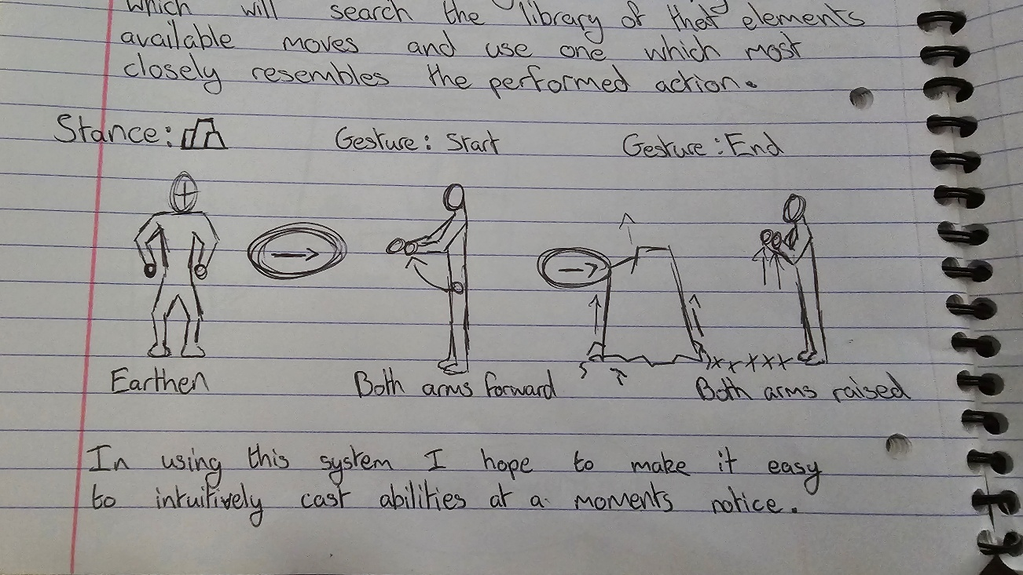

Appendix C. Work Breakdown Structure
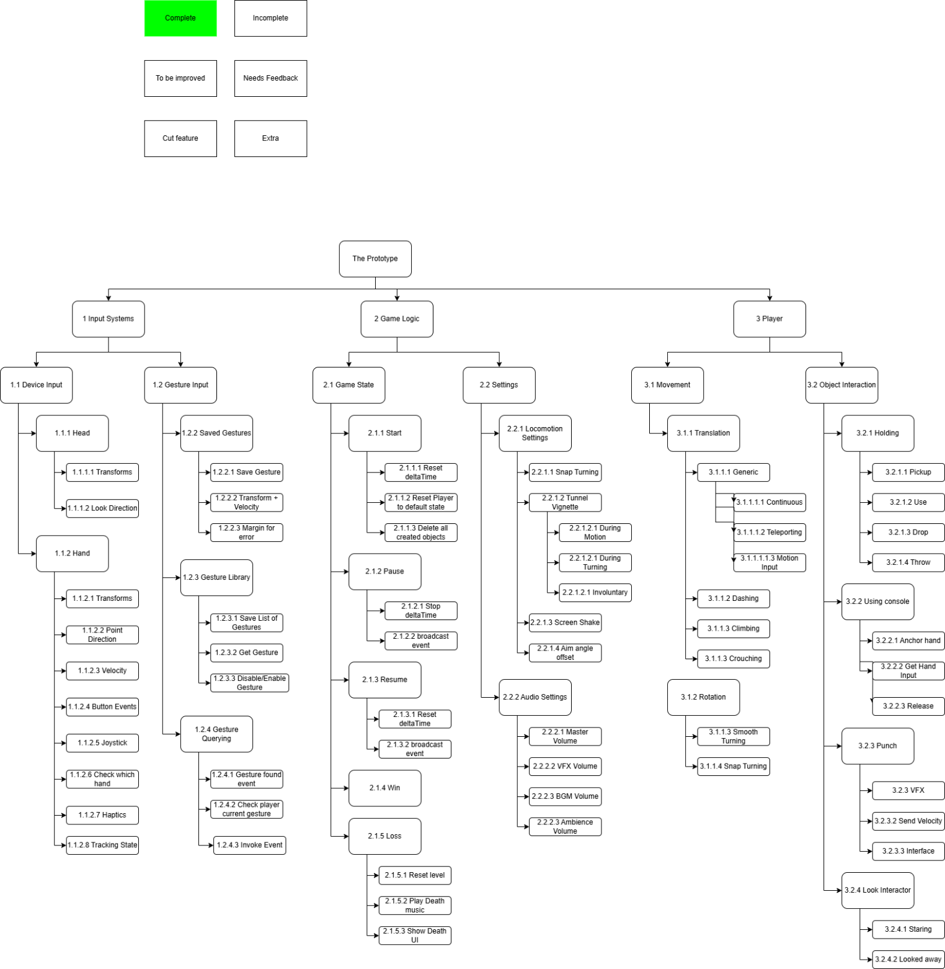

Appendix E Risk Assessment
ID | Description | Likelihood | Impact | Mitigation | Contingency
1 | Running low on project time | Low | High | Manage time effectively | Cut features and unnecessary aspects from demo
2 | Falling Ill, incapable of work | Low | High | Keep healthy and don’t expose self to possible situations where this could occur | Work on smaller tasks during this period  Discuss with university for advice
3 | Project corruption or work loss | Low | High | Actively backup project onto hardrive, PC and source control | Rollback project to older version
4 | Hardware Failure | Low | High | Maintain the device well. Keep it stored correctly and | Fix or find replacement ASAP
5 | Gesture Recognition is Inaccurate | Medium | High | Develop recognition with ample margin for error | Record gestures in reality as accurately
6 | Playing the game induces motion sickness | Medium | Medium | Implement the motion sickness options with variability. Good sound design | Increase the effectiveness of things like tunneling vignette
7 | Game does not run well on headset | High | High | Optimize game code as best as possible | Replace assets or return to blocking in order to maximize performance
8 | Using ability is not fun | Medium | Medium | Add ample game feel. VFX, SFX, screenshake and Haptics | Return to effects and get feedback on the ability and replace it if helpless
9 | Demo is unintuitive to use | Medium | High | Have good UX. Display instructions around the game when interactions are likely | Create dedicated tutorial section for the player to go through and select
10 | Not enough testers as each must have a Meta Quest | High | High | Make the game as cross platform as possible and look for testers well in advance | Dedicate testing period where I will bring in the devkit for out of house testers
11 | In-game body is disorienting | Medium | Medium | Make it so the body parts work as effectively as possible. Spend time working on procedural animation | Give the option to disable the top and bottom part of the body to the player.
12 | Hard to differentiate what is interactable | Medium | Low | Lower number of non-interactable probs in game | Default to using UI to indicate what can be interacted with

Appendix F. Tracking Methodology
Use case | Solution | Needed for | Utilisation
Project Management | Team Gantt | Viewing the progress of the entire project compared to the time started and complete | Priority tasks are selected from the ordered list and then redirected to the Weekly Task Tracker
Version Control | GIT | Managing the source code and storing backups should it anything be corrupted or unforeseen events occur | I will be using Github Desktop as the interface to be uploading individual iterations on the source control. As I complete a task, I will upload the project’s changes to Github. Not before nor after
Bug Tracking | Excel | Keeping note of outstanding programmatic issues that require attention during development | Any bugs that are found and not immediately fixed are logged in the bug tracker and reviewed at the end of the week. And will then be added to the Weekly Task Tracked
Weekly Task Tracking | Hack N Plan | Getting a view/breakdown of tasks more relevant to an individual sprint | Tasks will be set at the beginning of the week based on the Project Management view. Then as work is done through the week each task is moved to a section representing it’s state of completion

