VR Final Major Project

DATE DUE: 2/5/25

Game Technology Project

Oluwasomisayo Euler-Ajayi

Q16049845

Contents

Table of Contents
VR Final Major Project 1
Contents 2
VR’s Background 3
Project Definition 4
Aim of the Project 4
Project Objectives 4
Stretch Goals 5
5
Project Scope 5
Feasibility 6
Product Design 7
Design Documentation 7
Technical Design 7
Project Plan 8
Scope 8
Schedule 8
Risk Management 8
Tracking Methodology 8
Referencing 8
Appendix 8

 | What am I making?  What’s my inspiration  Why am I making it?  VR’s Background  Virtual Reality (VR) is a newly developing platform for media that attempts to fully immerse the player in the subject they are exposed to. The term virtual reality was first referred to as Jaron Lanier 1987, he played a fundamental role in the evoloution of VR. VR at first was tightly linked to the military having it’s early work funded by the United States Department of Defense, Lowood (2025). | Over the course of this project, I plan to be make game using Virtual Reality, wherein the player uses martial-arts like gestures to affect the landscape around them in a manner inspired by:  - Avatar: The Last Airbender (2005)  - The Dragon Prince. (2018)  - Rumble VR (2022)  Now many games that translate magic systems or combat, tend to use either:  - a combination of button presses  - inputs on a controller  - Motion Inputs of a joystick  Although each has merit, when it comes to fighting games, there is an obvious desire to break the limit on the number of potential moves a character can make based on the mentioned input schemes.  As cited by GuinnessWorldRecords (2013): “The character "King" has the most moves with 176” different possible inputs on a single controller that. King: a character from Tekken 7(2015),movelist on dashfight.com.
 | 25
 | Project Definition  Aim of the Project  I aim to:  - learn how to develop in VR  - to create a system to break past the limit of traditional game input methods  - tackle common issues found in VR that may normally turn players away  I aim to learn how to develop a game in VR that provides a unique and intuitive experience to the player  What I want Reason How  To learn to develop a game in VR It’s an interesting field still finding it’s place Learn to use the VR portions of a common game engine  Look deeply into what makes a good player experience With industry standards already in place there isn’t much novelty for basic elements like UI in VR Research methods in games to create excellent integrated UI | Project Objectives  During the length of this project these are what I will be aiming to achieve:  Player VR Integration  - Read player controllers  - allow their hands and head to be represented in game and fully animated  Movement  - implement a means for the player to navigate the level using their VR Controller  Gesture reading  - Recognise the poses a player may make based on their controllers  - Compare controller data (Velocity, position and rotation) to preset in engine data and detect when the two match closely enough  Abilities  - Implement 4 element-based abilities  - Activate them through gesture and input.  Settings & Accessibility  - Allow the player to modify and save settings  - Examples: snap turning, volume and vignettes.  Nonstandard UI  - Create UI that is intuitive and makes use of the advantages of VR.  - Diegetic UI such as consoles, books and terminals  Object Interaction  - Create a variety of objects that can be interacted with by the players hands  - Interactions like being: picked up, thrown, punched, dropped and/or used

Stretch Goals
Should I complete every other task in time I would like to further work on the following:
- Full Body Representation – Give the player a model that is procedurally animated and allow them to see it when they are controlling it.

- Game Objectives – Program a system that tracks outstanding tasks and notifies the player of their status as: In Progress, Complete or Failed

- Special status effects – Create a scalable system that allows entities including the player to be affected by specific buffs or nerfs pertaining to an ability, for example: Burning, Wet or Frozen

- Implement Audio Input – Develop a subsystem that retrieves input from the players audio device and allows this to be used as input for the player.
- This is not speech recognition but can allow player to perform actions such as blowing out a candle.
- AI Logic – implement an AI logic algorithm that allows non player characters to perform actions, such as traversing the area, using abilities or interacting with objects

- Puzzles – Create puzzles for the player to complete using the abilities they’ve learned and the Objectives system. Some of these can act as tutorial to the player

- Entities – Program a solution to handle logic specific to entities, allowing them to be damaged, use abilities or move WC 24/3

Project Scope

For my product I plan to make a simple demo of a game where you the player:

- Can use their arms, head and a combination of buttons to activate various abilities.

- Have access to multiple abilities all at once, all the while making them intuitive and easy to use.

- Use gesture activated moves akin to martial arts; using a series of in person moves and poses in order to activate specific abilities.

The main brunt of the work will be in developing a solution that allows the player to freely make a move and have it checked against a library of possible a gesture. Ideally, by combining these recognised gestures different abilities can be activated.

The gameplay related part will be:
- the creation of the elemental abilities, with 4 in total I would like to make the system for new abilities easy to update and upgrade.

- Summon rocks, use water streams, burn with fire or blow objects around with air
I would also like to have a major focus on accessibility and immersion, with multiple settings, the ability to save them and appropriate UI throughout the game. In my opinion good UI in VR must:

- Make use of the 3d nature

- Be easy and intuitive to use. Such as simply grabbing and moving levers

- Be thematic and appropriate for the setting

I would like to avoid UI that is too traditional or flat such as in the Meta Quest Home Screen [Appendix G.] and more like Rumble VR’s matchmaking screen (2021)[Appendix H]

Lastly, I would like a simple tutorial area where that:
- The player can experiment with the gesture system and abilities in.
- Has structures for them to be able to interact with
- Has entities that can attack or move around.

An important part of this area however will be the aforementioned UI/Interactable Objects.
I would like a variety of interactable objects that allow the player to interact with the area

- Like a lever that will swap what’s on the platform in front of the player.
- A switch which activates an enemy

The game I present to you is an experience that aims to capture what it feels like to truly be in control of the elements. VR holds itself back by relying on industry norms when it comes to UI, game beats and even controls. My Avatar based VR game aims to capture the real feeling of being a master of the elements. Empowering the player to truly command the world they reside in, all the while feeling completely at home. Learn the martial art and use the power of Earth, Wind, Fire and Water to break down your foes

The mission of this demo is:
- To sell the fantasy of being able to control the elements
- Give the player all the tools they need to learn potentially daunting mechanics
- Create a game that can be built upon to provide a low skill floor and high skill Ceiling

Feasibility

In regards, to my capability in delivering on this project my main source of confidence stems from:

There are many reasons why I believe I have the relevant skills for this project

The type of game I am making has many parallels to
- Fighting games that use motion inputs on a smaller scale. Games like:
Name | Relevance | What I’ve learnt
Guilty gear Strive (2021)  -Traditional fighting game | The gesturing system I am developing can be quite similar to traditional fighting games wherein the aim is to match a pattern to get a desired attack or ability.  These types of games frequently manage to make it so that even when playing different characters though the same controller it almost always feels notable different. | As a game that uses controller motion inputs in several core mechanics and in all character movesets. I would like to adopt some core philosophies in how these moves can affect the feel of a character or in my case the elements a player uses. Youtuber “GekkoSquirrel” covers this quite well in the video Motion Inputs and Character Feel (2022)
Super smash brothers ultimate (2018)  -platform fighter with countless moves and abilities | With over 74 playable characters this game has an enormous total selection of moves, but attempts to simplify | Having played over 727 games at professional events, I have been greatly exposed to the unique ways that a game with this size of a roster, can handle an absurd number of potential moves and making even the most similar feel distinct.
Rumble VR (2022)  -VR earthbending game of an adjacent genre | Quite literally the closest to my game in terms of genre. This allows players many earth-based abilities which uses a potentially similar gesturing system. | Where other sources influence the way, I think about the game design this one has greatly influenced my thoughts on the behind the scene systems.  It differs in being multiplayer focused but I hope to be able to rival their core mechanics in an impactful way

- I am an experienced Unity developer and am quick with prototyping. Having received 21/25 for my last Unity based module for an FPS Horror technical demo made in 3 weeks:

  - Has parallels in how key systems are made

  - Can be found here https://github.com/Afronomical/GSP-Tech-Demo-2-Horror/releases/tag/GSP.

- I have worked in the engine for 4 years now and am accustomed to its layout having made several games included working on 2 Studio projects for Duskforge Studios(2022) and CherryTree games

- I have a deep appreciation of the Avatar: the last Airbender franchise, and find it a point of frequent enjoyment. Being well accustomed to its magic system gives me many points of reference when translating my own similar system

Product Design

Design Documentation

[Appendix A. Game Design Document]

Technical Design
[Appendix B. Technical Design]

Project Plan

Scope
[Appendix C. WBS(Development)]

Schedule
[Appendix D. Gantt Chart]

Risk Management

[Appendix E. Risk Assessment]

Tracking Methodology

[Appendix F. Tracking Methodology]

Referencing
- Lowood, Henry E. Britannica. 4 Feb 2025. <https://www.britannica.com/technology/virtual-reality>
- Avatar, [television programme], Paramount Pictures, Hollywood, CA, [2008]
- The Dragon Prince [television program], Bardel Entertainment, United States Canada, [2018]
- Rumble VR (2022)RUMBLE on Steam. [online] Available at: https://store.steampowered.com/app/890550/RUMBLE/.
- Meta.com. (2024). Meta Quest 3S. [online] Available at: https://www.meta.com/gb/quest/quest-3s/. [2025]
- GekkoSquirrel (2021). Motion Inputs And Character Feel. [online] YouTube. Available at: https://www.youtube.com/watch?v=3h5PReoTtkg [Accessed 8th Feb. 2025].
- Masahiro Sakurai (2018)Super Smash Bros Ultimate [game, Nintendo Switch] Japan 045496422899
- Duskforge Studios (2022) DuskforgeStudio Homepage Available at: https://duskforge-studio.itch.io/
[Accessed 9th Feb 2025]

Appendix

Appendix A. Game Design Document

The team working on Avatar the last Airbender made links between said abilities and the chakras. A (believed to be) originating meditation practice. There are mentioned to be seven which I’ve listed below.
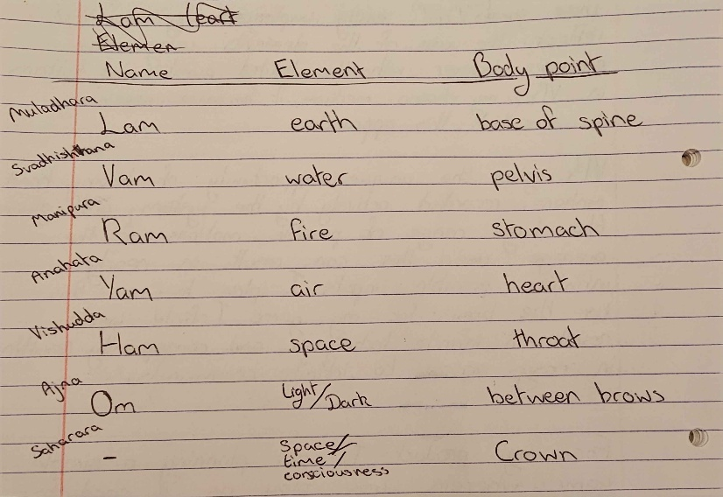
Figure 1 A table of the seven Chakras and their Chant

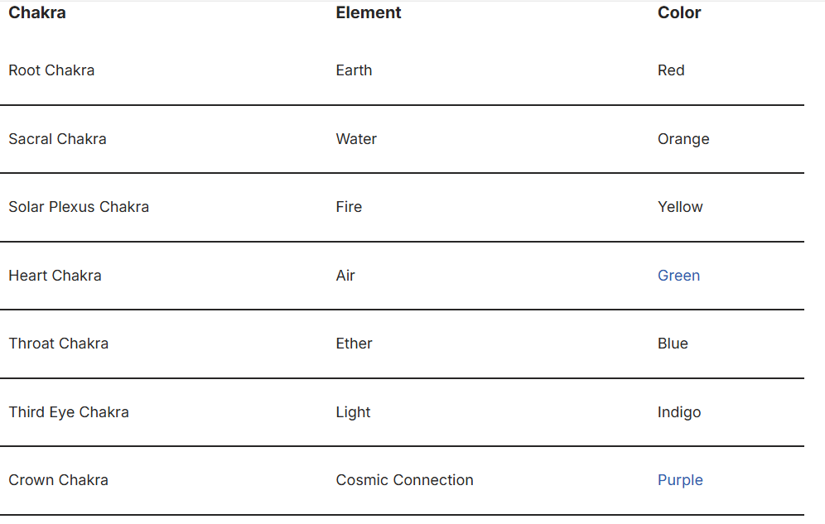
Figure 2 table from https://chakraseeker.com/what-are-the-elements-of-the-7-chakras/ on the 7 Chakras
I will be attempting to bind the user’s possible progression to the aforementioned chakra’s using abilities from each of the standard 7 which also links them closely to a part of the body, and an element of nature. With this as the basis for how different abilities are unlocked, I would similarly like to use these for the theming of the game. Overall, I plan to divide the 7 chakras into two groups. Abstract Elements and Tangible Elements. Abstract elements will be used more subtly, for the likes of UI elements and menus; Tangible Elements will be more gameplay specific.

Abstract Elements
In regards, to the utilization of abstract elements, they, as mentioned, will be used a passive thematic layer for certain aspects of the game. An example of this would be utilising OM for pause menus and light; making the surroundings darken and bringing up menus in front of the player.
I would like it to be done in such a way that it doesn’t remove the player from the action, and keeping them immersed up until they decide to take off the headset.

As such my UI designs will be simple at first, but I hope to properly design them in a way that best makes use of UI’s physical advantages. For example, making sliders grabbable objects and menus physical walls.

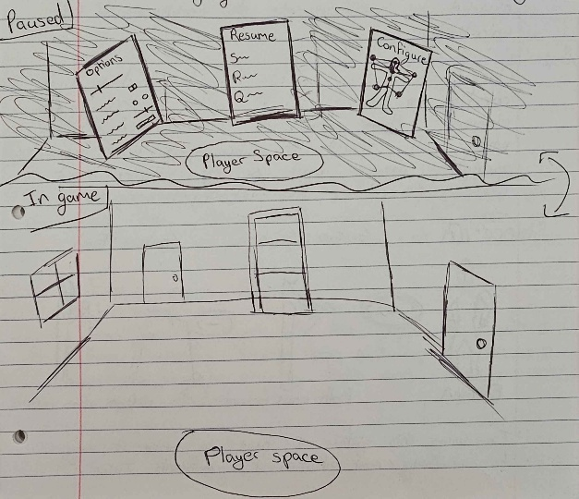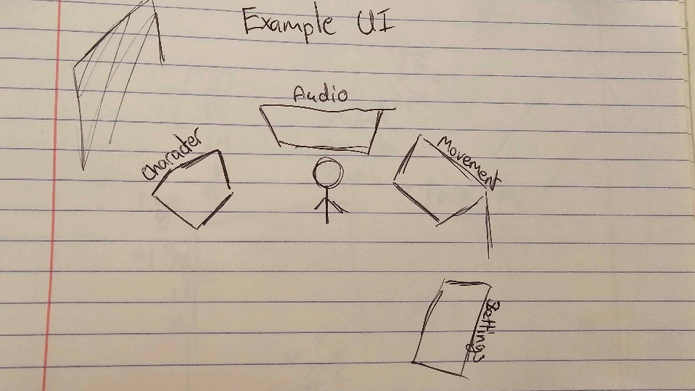
Tangible Elements
The more fun of the two, Tangible elements are the abilities that player can use to interact with the world. Whether by using wind to blow a sail, fire to burn a barricade or earth to get over a wall.
In order to make use of an ability, the player will need to
- Have the element profile unlocked
- Have the ability unlocked
- Know the gesture for said ability
Once these checks are all true the player can use an ability by first selecting a stance, a set of pre-determined positions in local space that the controllers can be, then performing a gesture or combination of gestures. Each ability will have an attributed combination of gestures that will be checked against a Gesture Recogniser which will broadcast an event when a gesture is made.

When a set of gestures are performed in order, an ability corresponding to this will be activated.

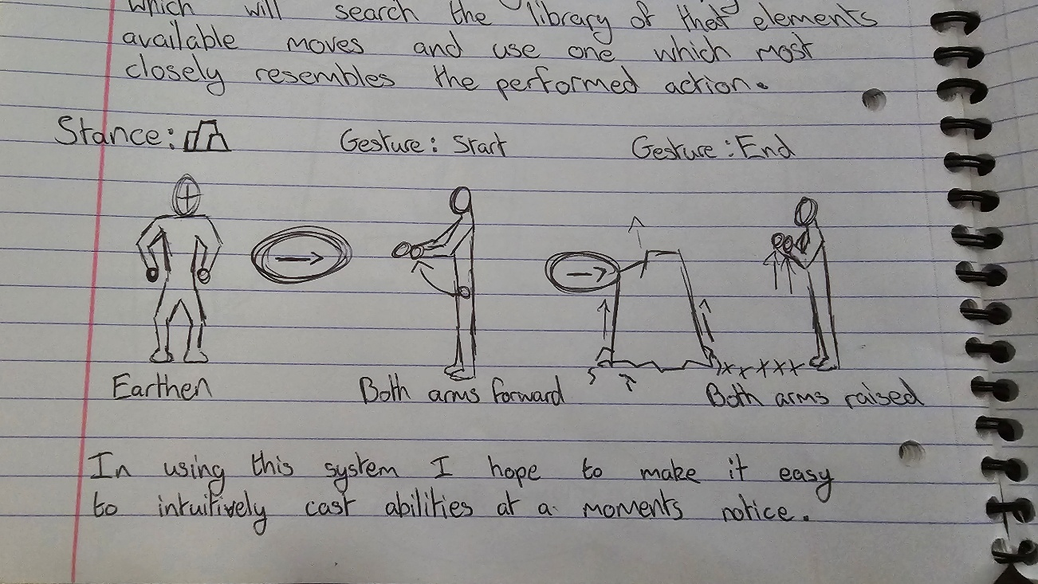
Figure 3 A diagram of the 3 steps to activating an ability
Abilities
Before Beta I would love to have 4 main abilities:

Earth – Rock Summon
As shown in the above image I would like to have a rock that rises from the ground. Can launch items that are above it or the player if they are on top when it rises.

Water – Bubble control
Using this ability drags a bubble of water from a nearby source. Can be used to carry random items or just hovered around

Fire – Heated Fist
The hands of the player will ignite and can be used set objects on fire which causes them to emit particles and melt ice.

Air – Gust
A gust of wind blows in a direction, knocking objects around in the direction the player is facing.

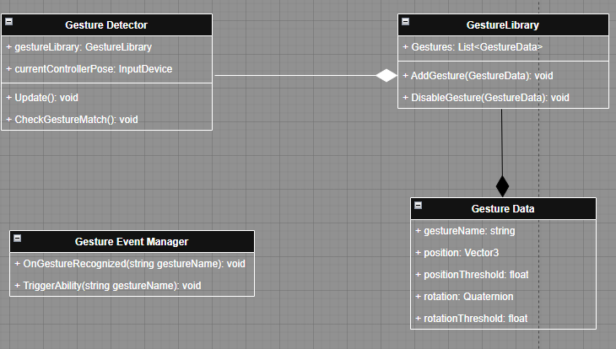
Appendix B. Technical Design
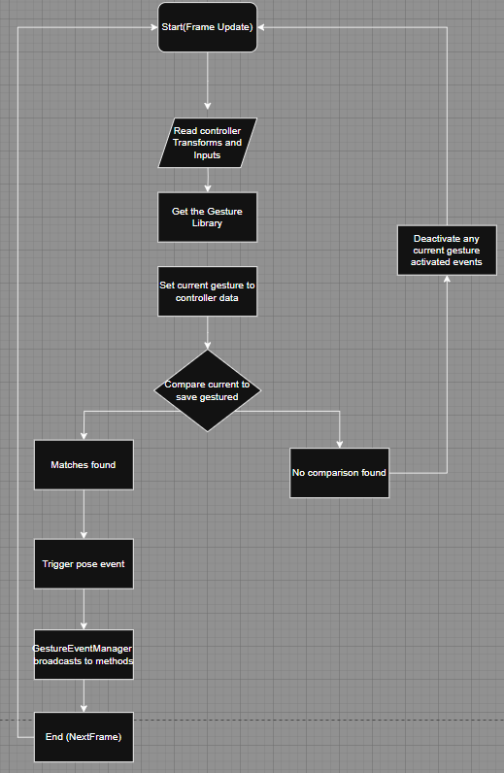

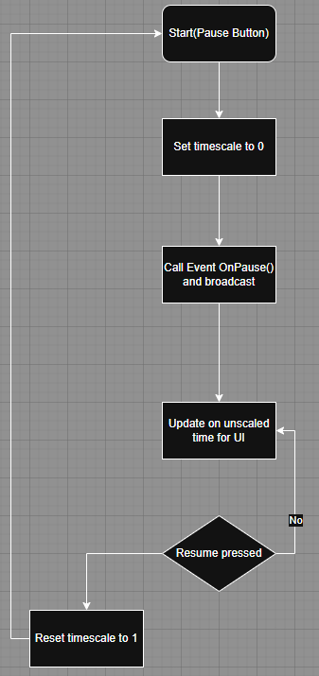

Appendix C. Work Breakdown Structure
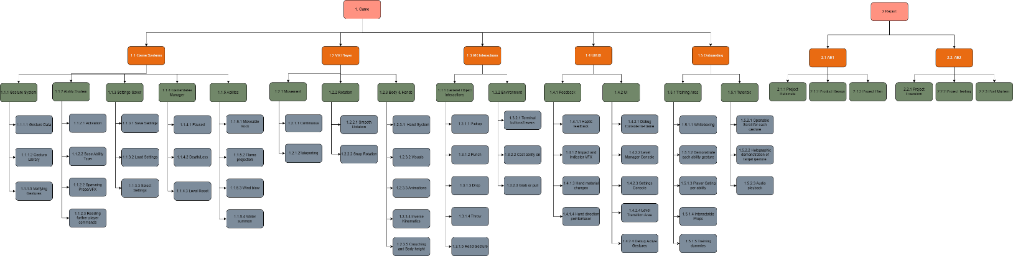

Appendix D. Gantt Chart
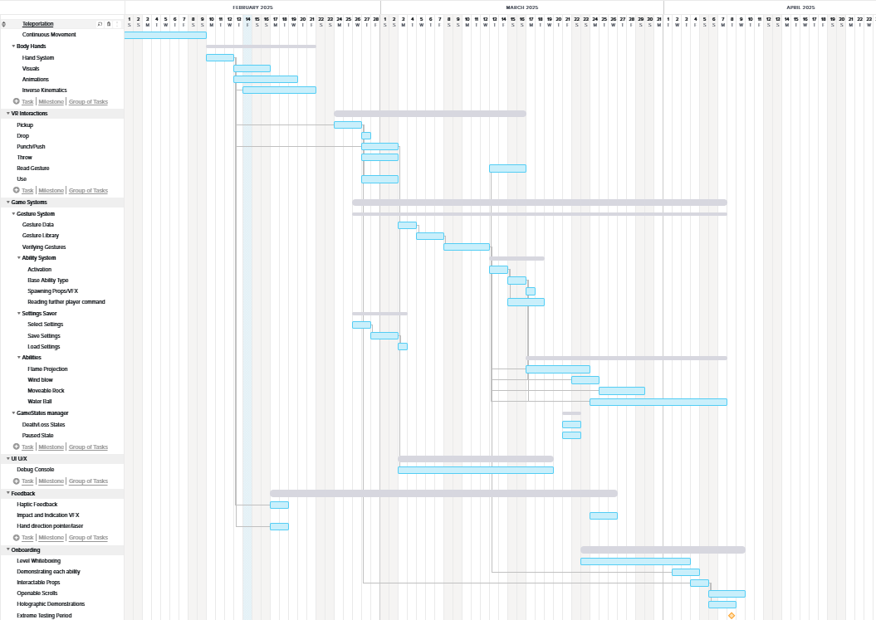
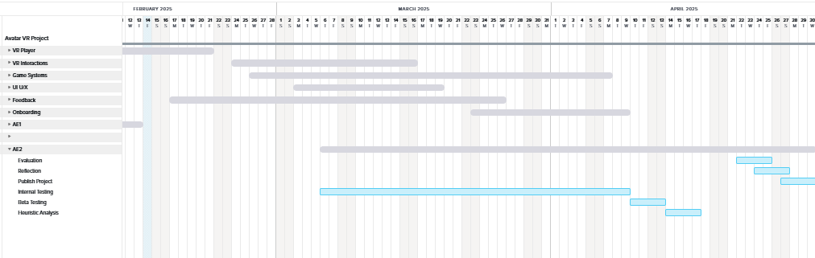

Appendix E Risk Assessment
ID | Description | Likelihood | Impact | Mitigation | Contingency
1 | Running low on project time | Low | High | Manage time effectively | Cut features and unnecessary aspects from demo
2 | Falling Ill, incapable of work | Low | High | Keep healthy and don’t expose self to possible situations where this could occur | Work on smaller tasks during this period  Discuss with university for advice
3 | Project corruption or work loss | Low | High | Actively backup project onto hardrive, PC and source control | Rollback project to older version
4 | Hardware Failure | Low | High | Maintain the device well. Keep it stored correctly and | Fix or find replacement ASAP
5 | Gesture Recognition is Inaccurate | Medium | High | Develop recognition with ample margin for error | Record gestures in reality as accurately
6 | Playing the game induces motion sickness | Medium | Medium | Implement the motion sickness options with variability. Good sound design | Increase the effectiveness of things like tunneling vignette
7 | Game does not run well on headset | High | High | Optimize game code as best as possible | Replace assets or return to blocking in order to maximize performance
8 | Using ability is not fun | Medium | Medium | Add ample game feel. VFX, SFX, screenshake and Haptics | Return to effects and get feedback on the ability and replace it if helpless
9 | Demo is unintuitive to use | Medium | High | Have good UX. Display instructions around the game when interactions are likely | Create dedicated tutorial section for the player to go through and select
10 | Not enough testers as each must have a Meta Quest | High | High | Make the game as cross platform as possible and look for testers well in advance | Dedicate testing period where I will bring in the devkit for out of house testers
11 | In-game body is disorienting | Medium | Medium | Make it so the body parts work as effectively as possible. Spend time working on procedural animation | Give the option to disable the top and bottom part of the body to the player.
12 | Hard to differentiate what is interactable | Medium | Low | Lower number of non-interactable props in game | Default to using UI to indicate what can be interacted with
13 | Hard to know when to use specific abilities | Medium | Medium | Design game to be more free form and enable player discovery | When onboarding, tutorialise the introduction of abilities so the player gets a general idea

Appendix F. Tracking Methodology
Use case | Solution | Needed for | Utilisation
Project Management | Team Gantt | Viewing the progress of the entire project compared to the time started and complete | Priority tasks are selected from the ordered list and then redirected to the Weekly Task Tracker
Version Control | GIT | Managing the source code and storing backups should it anything be corrupted or unforeseen events occur | I will be using GitHub Desktop as the interface to be uploading individual iterations on the source control. As I complete a task, I will upload the project’s changes to GitHub. Not before nor after
Bug Tracking | Excel | Keeping note of outstanding programmatic issues that require attention during development | Any bugs that are found and not immediately fixed are logged in the bug tracker and reviewed at the end of the week. And will then be added to the Weekly Task Tracked
Weekly Task Tracking | Hack N Plan | Getting a view/breakdown of tasks more relevant to an individual sprint | Tasks will be set at the beginning of the week based on the Project Management view. Then as work is done through the week each task is moved to a section representing its state of completion

Appendix G. Meta Quest Home Screen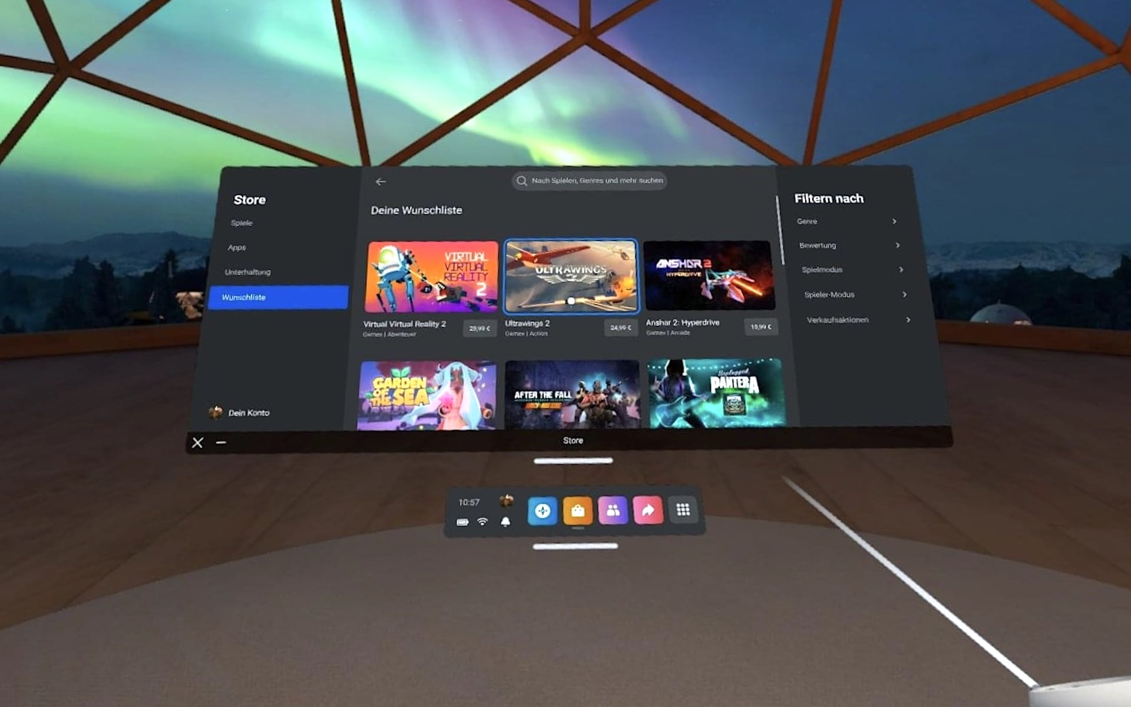

Appendix H. Rumble Matchmaking screen