Largest_number.htm
<!DOCTYPE html>
<html lang="en">
<head>
<meta charset="UTF-8">
<meta name="viewport" content="width=device-width, initial-scale=1.0">
<title>Find the Largest Element In An Array</title>
</head>
<body>
<script src="Odd_numbers.js"></script>
</body>
</html>
Largest_number.js
const array=[115,5,40,8,145,197]
let largest = array[0]
array.forEach(element => {
if(element>largest){
largest=element
}
});
console.log("Largest element:", largest);
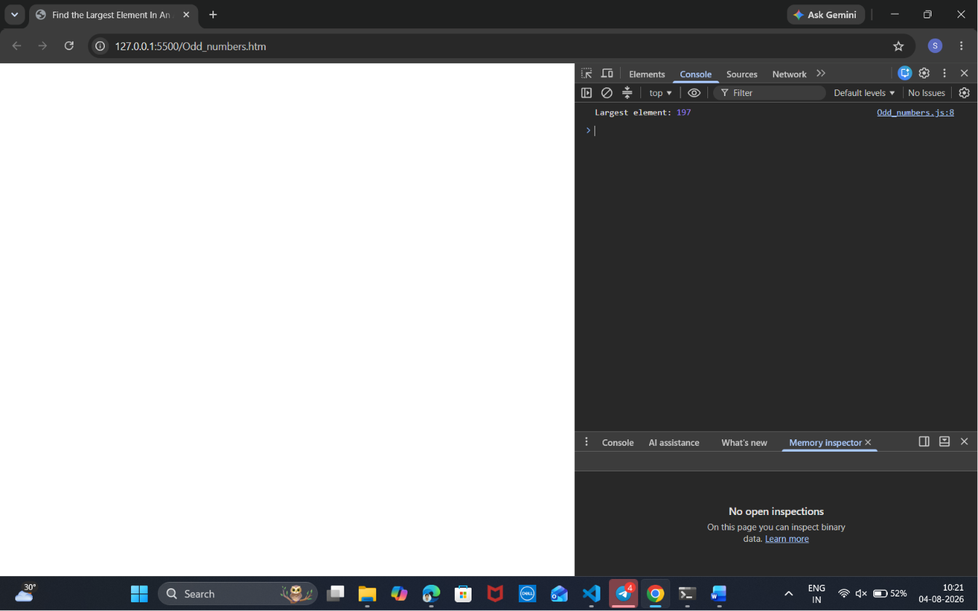
Smallest_number.htm
<!DOCTYPE html>
<html lang="en">
<head>
<meta charset="UTF-8">
<meta name="viewport" content="width=device-width, initial-scale=1.0">
<title>find the smallest number in an array</title>
</head>
<body>
<script src="Smallest_number.js"></script>
</body>
</html>

Smallest_number.js
const array = [1, 2, 3, 4, 5, 6, 7, 8, 9, 10];
let smallest = array[0];
array.forEach(element => {
if (element < smallest) {
smallest = element;
}
});
console.log("Smallest element:", smallest);
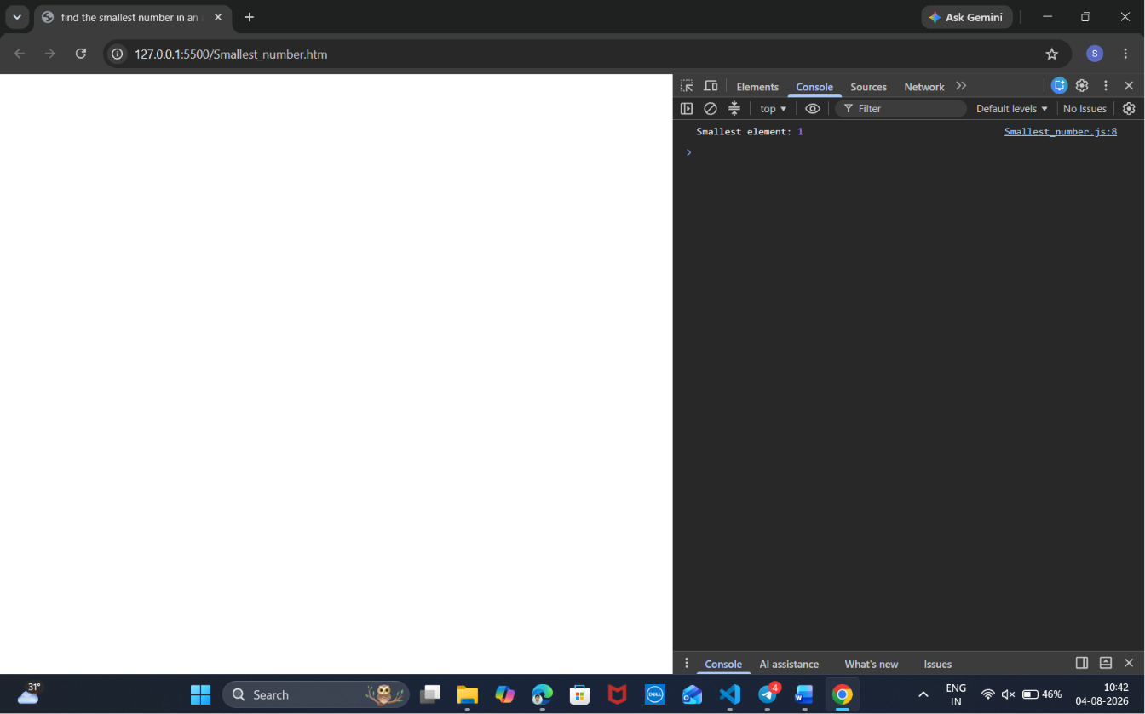
Odd_numbers.htm
<!DOCTYPE html>
<html lang="en">
<head>
<meta charset="UTF-8">
<meta name="viewport" content="width=device-width, initial-scale=1.0">
<title>Odd Numbers</title>
</head>
<body>
<script src="Odd_numbers.js"></script>
</body>
</html>

Odd_numbers.js
const array = [1, 2, 3, 4, 5, 6, 7, 8, 9, 10];
for(let i = 0; i < array.length; i++) {
if(array[i] % 2 !== 0) {
console.log(array[i]);
}
}
console.log("Odd numbers are printed successfully.");
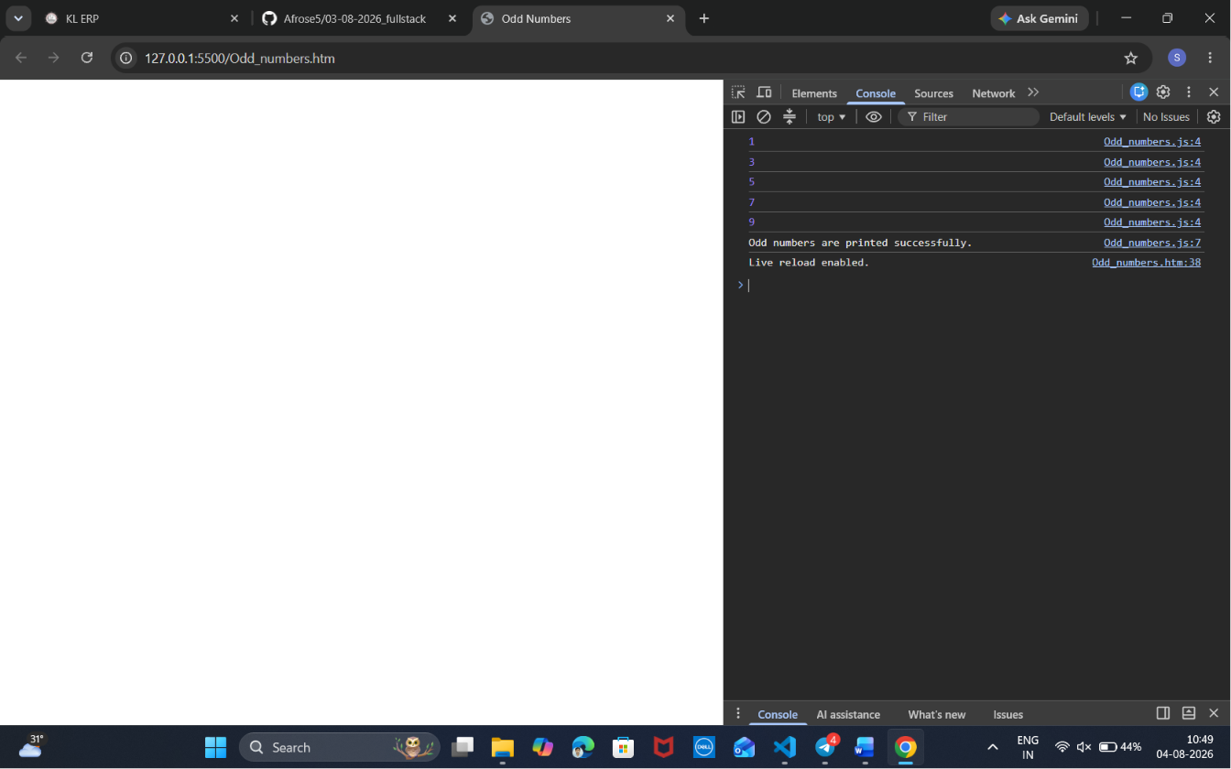
Even_numbers.htm
<!DOCTYPE html>
<html lang="en">
<head>
<meta charset="UTF-8">
<meta name="viewport" content="width=device-width, initial-scale=1.0">
<title>Even numbers</title>
</head>
<body>
<script src="Even_numbers.js"></script>
</body>
</html>

Even_numbers.js
const array = [1, 2, 3, 4, 5, 6, 7, 8, 9, 10];
for (let i = 0; i < array.length; i++) {
if (array[i] % 2 === 0) {
console.log(array[i]);
}
}
console.log("Even numbers are printed successfully.");
