Flex.htm
<body>
<div style="display:flex; justify-content:space-between;">
<div>Menu 1</div>
<div>Menu 2</div>
<div>Menu 3</div>
</div>
</body>
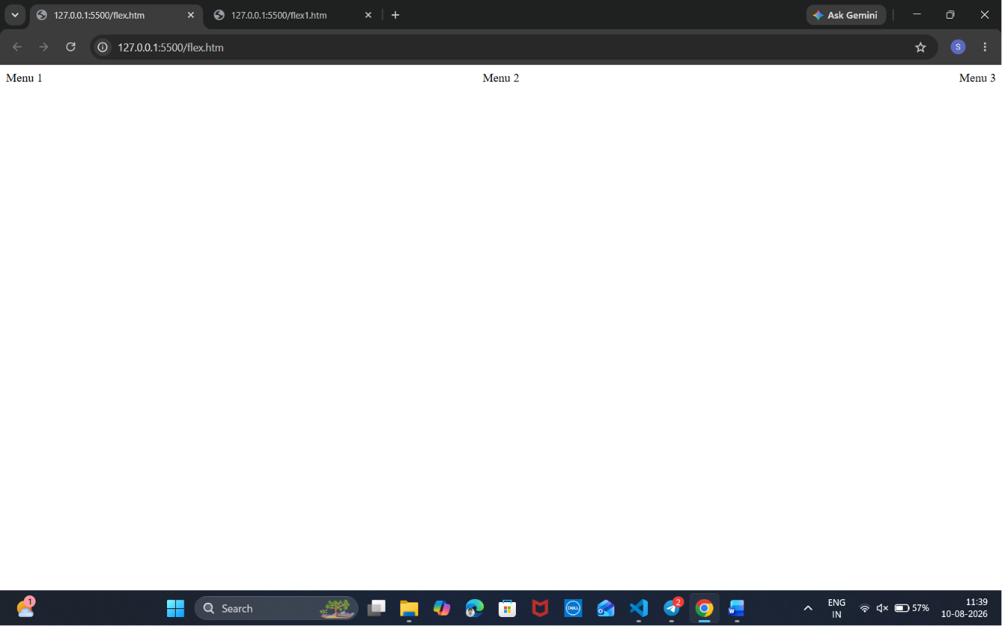
Flex1.htm
<body>
<div style="display:flex; justify-content:space-between;">
<div style="background-color:aqua;
font-family:'Courier New', Courier, monospace;
font-weight:bold;
padding:10px;">
File
</div>

<div style="background-color:bisque;
padding:10px;">
Edit
</div>

<div style="background-color:aliceblue;
padding:10px;">
Selection
</div>
</div>

</body>
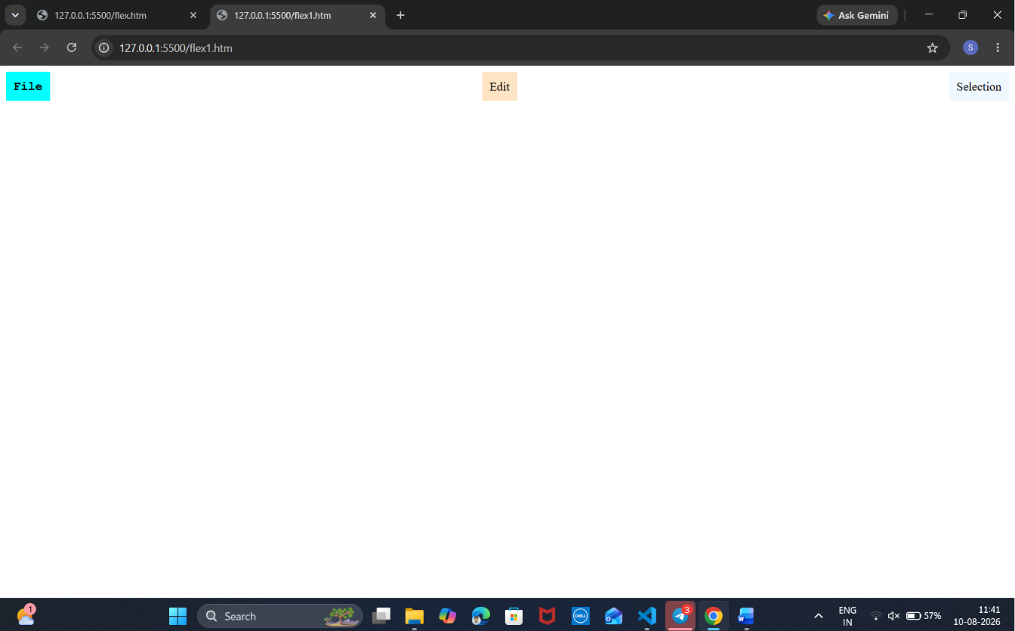
Flex2.htm
<html>
<head>
<style>
.container {
display: grid;
grid-template-columns: 2fr 1fr; /* main + sidebar */
gap: 20px;
}
.main {
display: flex;
flex-direction: column;
gap: 10px;
background: #e0f7fa;
padding: 10px;
}
.sidebar {
background: #ffe0b2;
padding: 10px;
}
.box {
background: #c5e1a5;
padding: 10px;
}
</style>
</head>
<body>
<div class="container">
<div class="main">
<div class="box">Main Content</div>
<div class="box">Article</div>
</div>
<div class="sidebar">Sidebar</div>
</div>
</body>
</html>
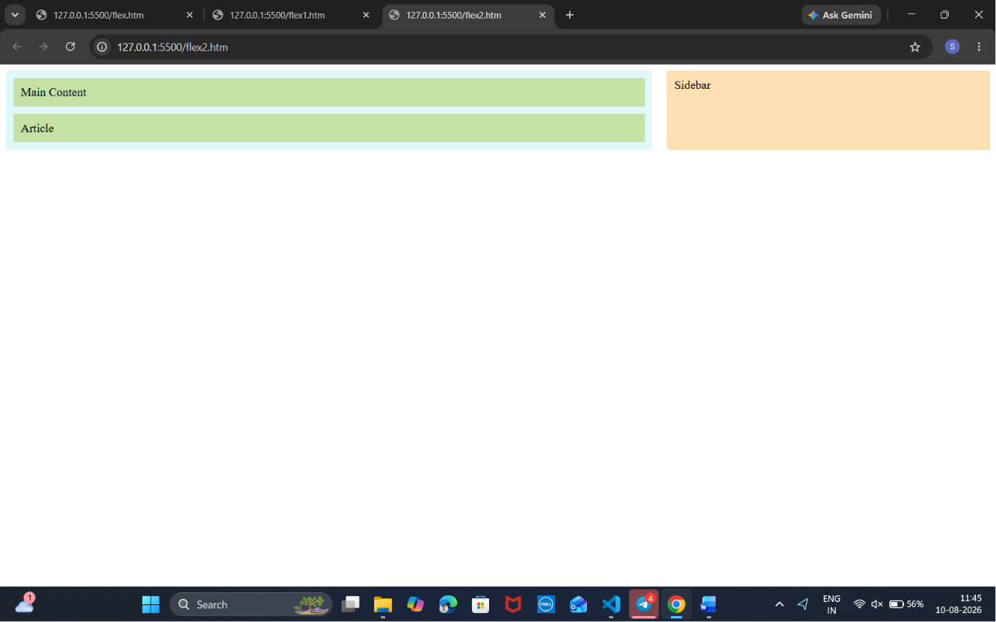
Grid.htm
!DOCTYPE html>
<html lang="en">
<head>
<meta charset="UTF-8">
<meta name="viewport" content="width=device-width, initial-scale=1.0">
<title>Grid_Display</title>
</head>
<style>
*{
padding: 5px;
margin: 2px;
}
.container{
display: grid;
height: 100vh;
grid-column: 33% 33% 34%;
grid-row: 10% 10% 80%;
}
.head{
height: 10vh;
background-color: aquamarine;
grid-column: 1/4;
grid-row: 1/2;
}
.search{
height: 10vh;
background-color: blanchedalmond;
grid-column: 1/3;
grid-row: 2/3;
}
.left{
height: 80vh;
background-color: greenyellow;
grid-column:1/2 ;
grid-row: 3/4 ;
}
.middle{
height: 80vh;
background-color: pink;
grid-column: 2/3;
grid-row:3/4 ;
}
.right{
height: 93vh;
background-color: orange;
grid-column: 3/4;
grid-row: 2/4;
}
</style>
<body>
<div class='container'>
<div class='head'> Header<h1> This part belongs to <b>HEADER SECTION</b></h1></div>
<div class='search'> Search<input textbox = ""; type= "text":value="Type to search"></textbox></><button type="submit">Search</button></div>
<div class='left'> Left <menu>
<ol start="1" type="a"><b> <u>Products </u></b>
<li> Leather Products</li>
<li> Cosmetics Products</li>
<li> Agro Products</li>
<li> Electronic Products</li>
</ol>
</menu></div>
<div class='middle'> Middle</div>
<div class='right'> Right</div>
</div>
</body>
</html>
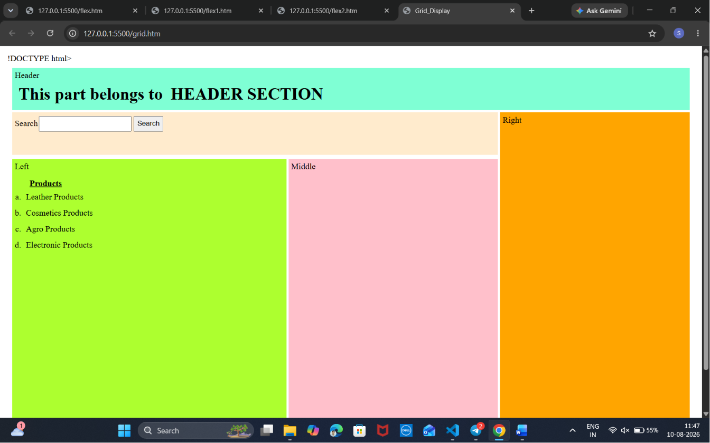
Bootstrap_example1.htm
<!DOCTYPE html>
<html lang="en">
<head>
<meta charset="UTF-8">
<meta name="viewport" content="width=device-width, initial-scale=1.0">
<title>Bootstrap Example</title>
<!-- Bootstrap CSS -->
<link href="https://cdn.jsdelivr.net/npm/bootstrap@5.3.8/dist/css/bootstrap.min.css" rel="stylesheet">
</head>
<body>
<div class="container mt-5">
<button class="btn btn-primary">Bootstrap Button</button>
</div>
<!-- Bootstrap JS -->
<script src="https://cdn.jsdelivr.net/npm/bootstrap@5.3.8/dist/js/bootstrap.bundle.min.js"></script>
</body>
</html>
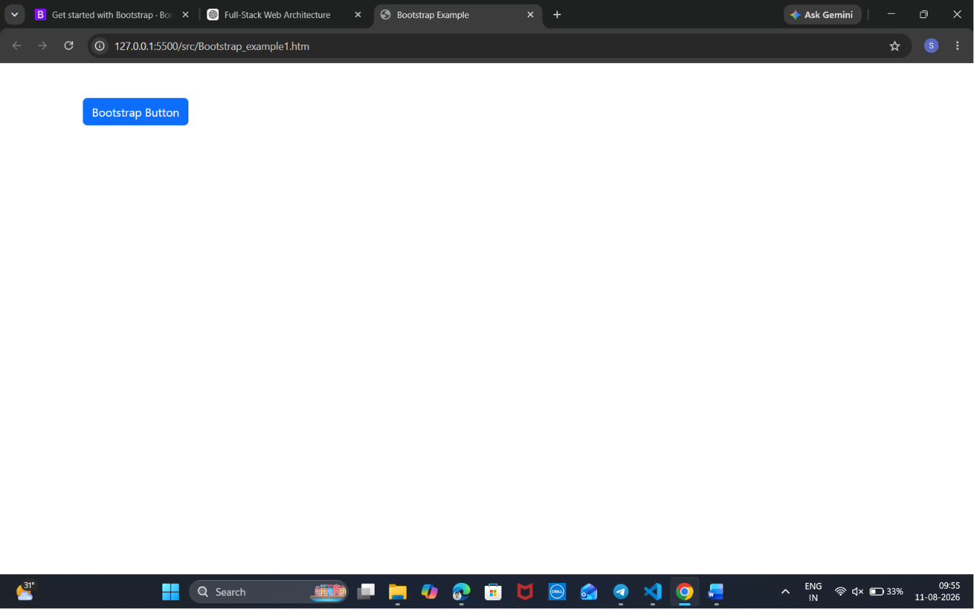
Bootstrap_example2.htm
<!DOCTYPE html>
<html lang="en">
<head>
<title>Bootstrap Example</title>
<meta charset="utf-8">
<meta name="viewport" content="width=device-width, initial-scale=1">
<link href="https://cdn.jsdelivr.net/npm/bootstrap@5.3.8/dist/css/bootstrap.min.css" rel="stylesheet">
<script src="https://cdn.jsdelivr.net/npm/bootstrap@5.3.8/dist/js/bootstrap.bundle.min.js"></script>
</head>
<body>

<div class="container-fluid mt-3">
<h1>Six equal width columns</h1>
<div class="row">
<div class="col p-3 bg-primary text-white">Col1</div>
<div class="col p-3 bg-dark text-white">col2</div>
<div class="col p-3 bg-success text-white">col3</div>
<div class="col p-3 bg-danger text-white">col4</div>
<div class="col p-3 bg-warning text-white">col5</div>
<div class="col p-3 bg-info text-white">col6</div>
</div>
</div>
</body>
</html>
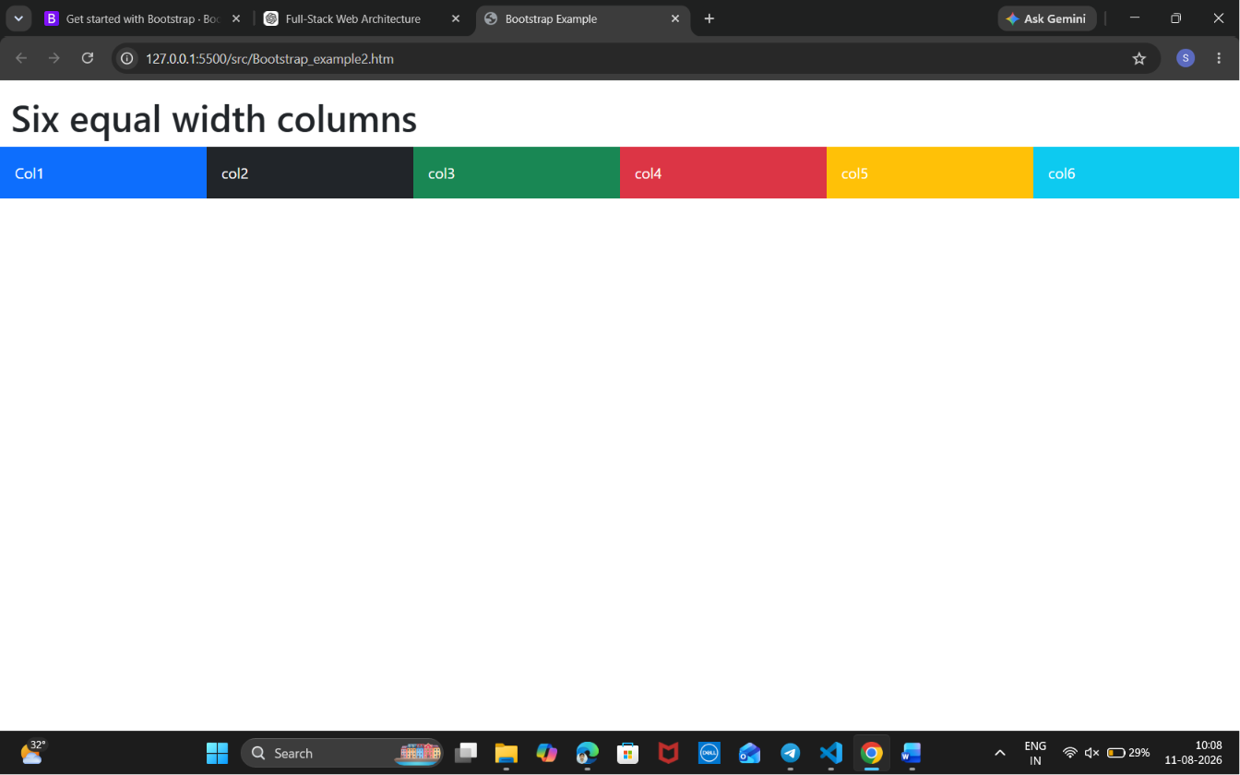
Bootstrap_example3.htm
<!DOCTYPE html>
<html lang="en">
<head>
<meta charset="UTF-8">
<meta name="viewport" content="width=device-width, initial-scale=1.0">
<title>Contextual class</title>
</head>
<body>
<table class="table">
<tr class="">
<td>John</td>
<td>Doe</td>
<td>john@example.com</td><!DOCTYPE html>
<html lang="en">
<head>
<meta charset="UTF-8">
<meta name="viewport" content="width=device-width, initial-scale=1.0">
<title>Bootstrap Contextual Classes</title>
<!-- Bootstrap CSS -->
<link href="https://cdn.jsdelivr.net/npm/bootstrap@5.3.8/dist/css/bootstrap.min.css" rel="stylesheet">
</head>
<body>
<div class="container mt-5">
<h2 class="text-center mb-4">Bootstrap Contextual Table</h2>
<table class="table table-bordered table-hover">
<thead class="table-dark">
<tr>
<th>First Name</th>
<th>Last Name</th>
<th>Email</th>
</tr>
</thead>
<tbody>
<tr class="table-primary">
<td>John</td>
<td>Doe</td>
<td>john@example.com</td>
</tr>
<tr class="table-success">
<td>Mary</td>
<td>Moe</td>
<td>mary@example.com</td>
</tr>
<tr class="table-warning">
<td>July</td>
<td>Dooley</td>
<td>july@example.com</td>
</tr>
<tr class="table-danger">
<td>Peter</td>
<td>Parker</td>
<td>peter@example.com</td>
</tr>
<tr class="table-info">
<td>David</td>
<td>Smith</td>
<td>david@example.com</td>
</tr>
<tr class="table-secondary">
<td>Emma</td>
<td>Watson</td>
<td>emma@example.com</td>
</tr>
</tbody>
</table>
</div>
</body>
</html>
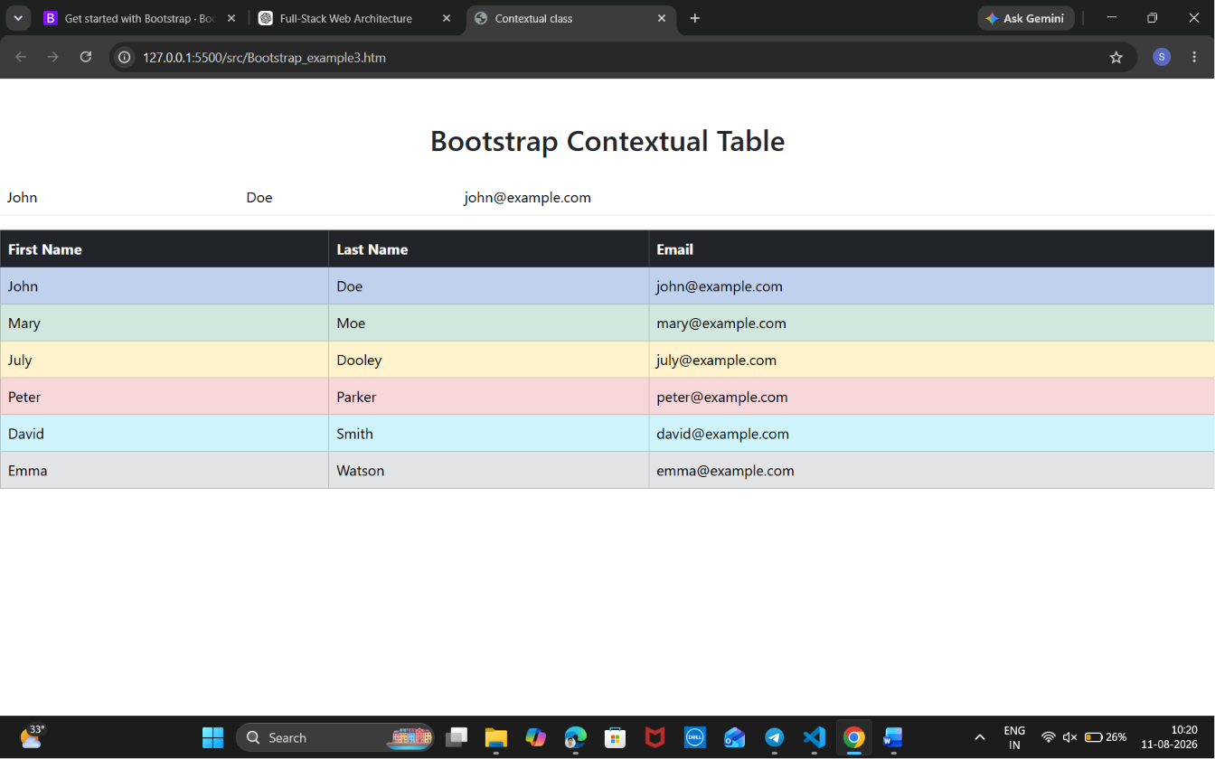
LoginForm.htm
<!DOCTYPE html>
<html lang="en">
<head>
<meta charset="UTF-8">
<meta name="viewport" content="width=device-width, initial-scale=1.0">
<title>Bootstrap Login Form</title>

<link href="https://cdn.jsdelivr.net/npm/bootstrap@5.3.8/dist/css/bootstrap.min.css" rel="stylesheet">

<style>
body{
background: linear-gradient(135deg,#4facfe,#00f2fe);
height:100vh;
display:flex;
justify-content:center;
align-items:center;
}

.login-box{
width:380px;
background:#fff;
padding:35px;
border-radius:15px;
box-shadow:0 10px 25px rgba(0,0,0,0.3);
}

.logo{
font-size:60px;
text-align:center;
color:#0d6efd;
}

.btn-login{
width:100%;
}

.password-box{
position:relative;
}

#togglePassword{
position:absolute;
right:15px;
top:50%;
transform:translateY(-50%);
cursor:pointer;
font-size:20px;
}
</style>
</head>
<body>

<div class="login-box">

<div class="logo">👤</div>
<h2 class="text-center mb-4">Login</h2>

<form id="loginForm">

<div class="mb-3">
<label class="form-label">Username</label>
<input
type="text"
id="username"
class="form-control"
placeholder="Enter Username"
required>
</div>

<div class="mb-3">
<label class="form-label">Password</label>

<div class="password-box">
<input
type="password"
id="password"
class="form-control"
placeholder="Enter Password"
required>

<span id="togglePassword">👁</span>
</div>
</div>

<div class="mb-3 form-check">
<input type="checkbox" class="form-check-input" id="remember">
<label class="form-check-label" for="remember">
Remember Me
</label>
</div>

<button class="btn btn-primary btn-login">
Login
</button>

<div class="text-center mt-3">
<a href="#">Forgot Password?</a>
</div>

<div class="text-center mt-2">
Don't have an account?
<a href="#">Register</a>
</div>

</form>

</div>

<script src="script.js"></script>

</body>
</html>
Script.js
const password = document.getElementById("password");
const toggle = document.getElementById("togglePassword");

// Show/Hide Password
toggle.addEventListener("click", function () {

if (password.type === "password") {
password.type = "text";
toggle.textContent = "🙈";
} else {
password.type = "password";
toggle.textContent = "👁";
}

});

// Login Validation
document.getElementById("loginForm").addEventListener("submit", function(e){

e.preventDefault();

let username = document.getElementById("username").value;
let pass = password.value;

if(username === "Afrose" && pass === "Afrose@123"){
alert("✅ Login Successful");
}
else{
alert("❌ Invalid Username or Password");
}

});
