***Symphony Limited Institute Portal***

Project Report

**Submitted By:**

**Afroz Khan**

**MUHAMMAD FAISAL**

**MUQEEM AHSAN**

**Sumair**

**Roll Numbers:**

Student1509019

Student1490545

Student1529730

Student1529472

**Semester:**

3rd Semester

**Submitted To:**

Sir Ahsan Raza

**Date of Submission:**

22/07/2025

**1. Introduction**

**1.1 Brief Overview of the System**

The Symphony Limited Institute Portal is a web-based application designed to streamline institute management by providing an efficient platform for administrators and students. The system facilitates tasks such as student registration, course management, attendance tracking, and performance monitoring, ensuring a seamless digital experience for all users.

**1.2 Purpose of the Project**

The primary goal of this project is to:

1. Automate manual processes (e.g., student records, attendance, and course management).
2. Enhance communication between administrators and students.
3. Provide a user-friendly interface for managing academic activities.
4. Ensure data security and accuracy through a robust database system.

**1.3 Technologies Used**

The project is developed using the following technologies:

1. Backend: ASP.NET Core MVC (Model-View-Controller)
2. Database: Microsoft SQL Server
3. Frontend: HTML5, CSS3, Bootstrap (for responsive design)
4. Version Control: Git & GitHub

**1.4 Target Users**

The system caters to two main user roles:

**Admin**

1. Manages student records, courses, and faculty details.
2. Generates reports (attendance, grades, etc.).
3. Controls user access and permissions.

**Students**

1. View course details and schedules.
2. Check attendance and academic progress.

**2. Objective**

**2.1 Problem Statement**

The current manual or outdated systems used by educational institutes face several challenges, including:

1. Time-consuming processes (student registration, attendance, record-keeping).
2. Prone to errors due to paper-based or unorganized digital records.
3. Lack of real-time access for students and administrators.
4. Inefficient communication between faculty and students.
5. No centralized platform for managing courses, exams, and results.

**The Symphony Limited Institute Portal aims to solve these issues by providing a fully automated, secure, and user-friendly web-based solution.**

**2.2 Goals of the System**

The primary objectives of this project are:

**✅ Develop a Modern & Dynamic Website**

* A responsive, interactive frontend for students and faculty.
* Easy navigation and accessibility on all devices (desktop, tablet, mobile).

**✅ Admin Panel for Efficient Management**

* Secure login with role-based access (Admin, Faculty, Students).
* Dashboard for managing students, courses, attendance, and exams.
* Automated report generation (attendance, grades, performance analytics).

**✅ Enhance Student Experience**

* Self-service portal for viewing courses, schedules, and results.
* Real-time notifications (new announcements, exam updates).
* Secure profile management.

**✅ Scalable & Secure Architecture**

* Built with ASP.NET Core MVC for high performance.
* SQL Server for reliable and structured data storage.
* Secure authentication using ASP.NET Core Identity.

**Key Improvements Over Existing Systems**

✔ Faster Processing – Reduces manual paperwork and delays.

✔ Error Reduction – Minimizes human errors in record-keeping.

✔ 24/7 Accessibility – Available anytime, anywhere with internet access.

✔ Cost-Effective – Reduces the need for physical storage and resources.

**3. ScreenShots of Website**

**1. Home Page**

**Welcome Section**

Symphony Institute

"Empowering future through quality education & professional training"

**Call-to-Action Buttons**

Explore Courses

Apply Now

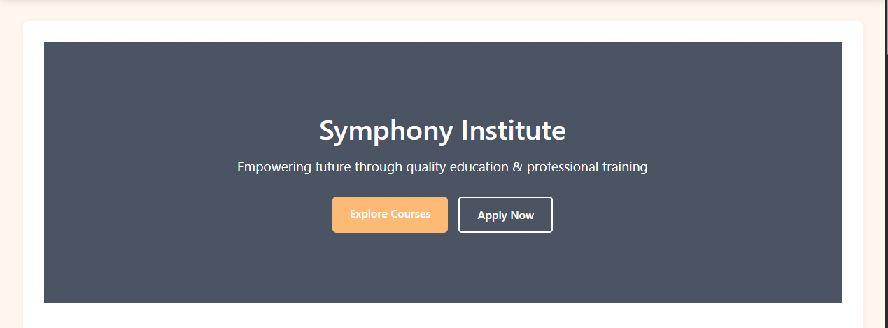

**2. About Our Institute**

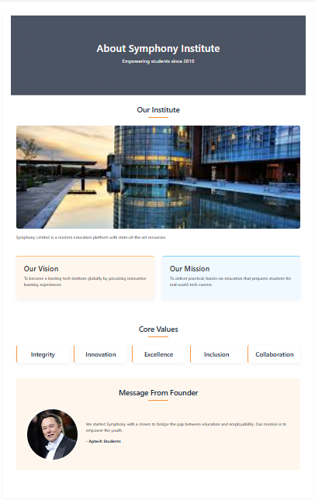

**Description**

Symphony Limited is a modern education platform with state-of-the-art resources.

**Key Highlights**

1. Qualified Faculty
2. 100% Placement Assistance
3. Flexible Learning Modes
4. Scholarship Programs

**3. Courses Offered**

|  |  |  |
| --- | --- | --- |
| Course | Description | Duration |
| Artificial Intelligence | Learn AI concepts and algorithms. | 3 Months |
| Machine Learning | Hands-on ML with real-world datasets. | 3 Months |
| Data Science | Data analysis, visualization, and ML. | 4 Months |
| Ethical Hacking | Learn to ethically test and secure systems. | 2 Months |
| DevOps | CI/CD, Docker, Jenkins, cloud infrastructure. | 3 Months |

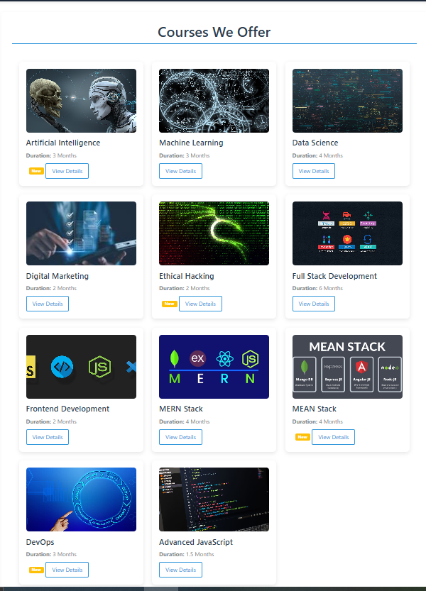

**4. Why Choose Us?**

* Qualified Faculty
* Placement Assistance
* Flexible Learning
* Scholarship Programs

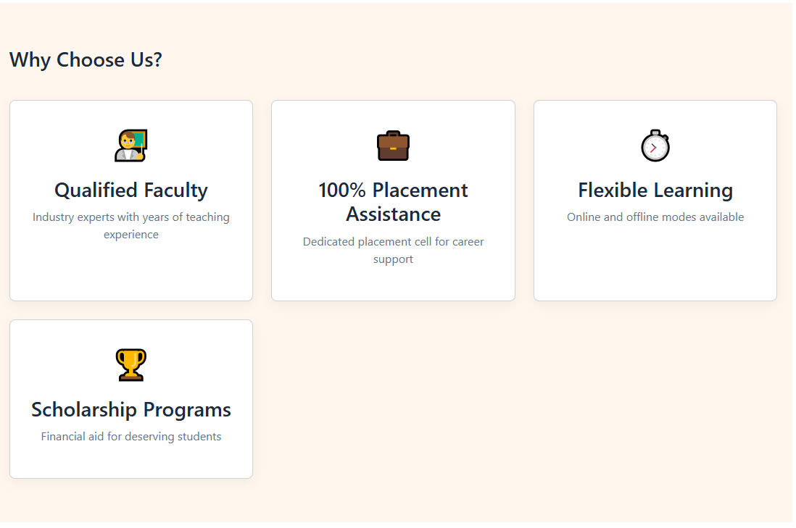

**5. Student Testimonials**

Ayesha (Computer Science)

"The faculty helped me secure a job at a top IT company."

Rehman (Web Developer)

"Exceptional guidance and practical training."

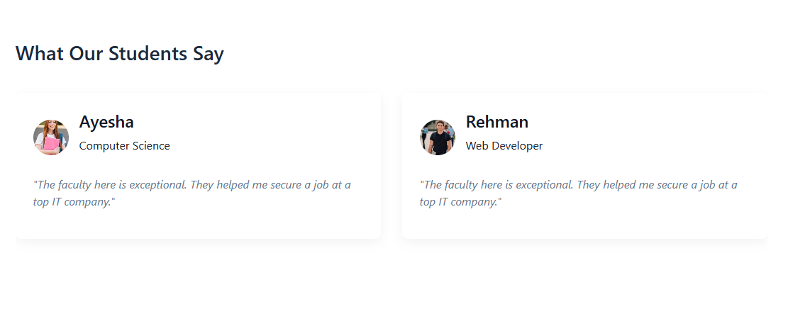

**Stats**

* 5000+ Students Trained
* 30+ Courses
* 98% Exam Success Rate
* 10+ years in Experience

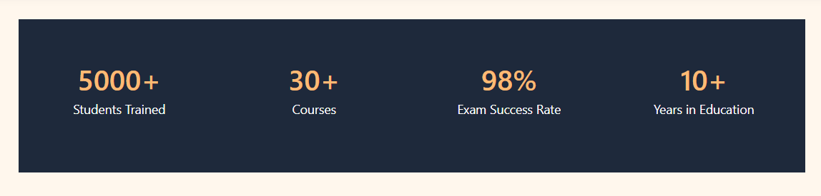

**6. Upcoming Events**

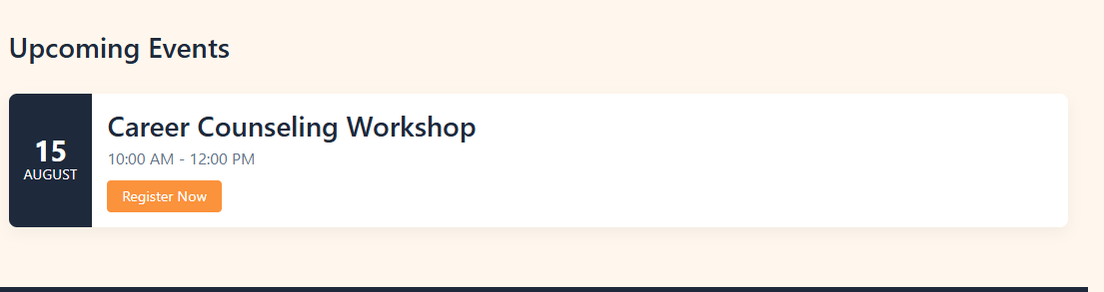

Career Counseling Workshop

📅 15 August | 🕙 10:00 AM - 12:00 PM

📍 Register Now

**7. Footer & Contact**

**Quick Links**

* Course Catalog
* Admission Process
* FAQs

**Contact Info**

* 📌 123 Education St, Kansoft
* 📞 +92 311 1234567
* ✉️ [info@symphony.edu](mailto:info@symphony.edu)

***© 2025 Symphony Institute***



**8. Entrance Examination Module**

**8.1 Exam Details Page**

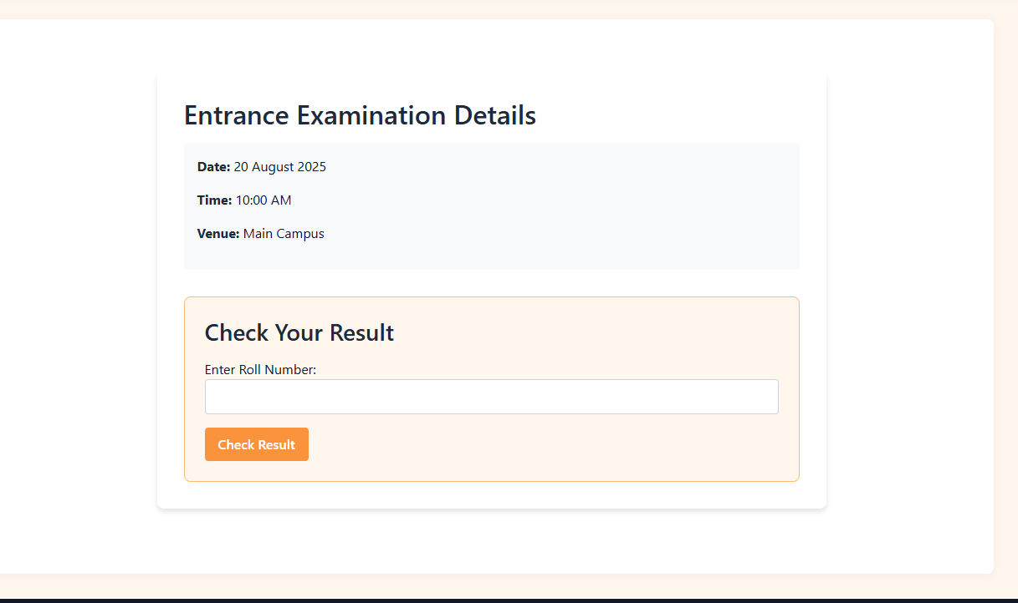

**Entrance Examination Details**

* **Date:** 20 August 2025
* **Time:** 10:00 AM
* **Venue:** Main Campus

**Check Your Result**

Enter Roll Number:

[Input Field]

[Check Result Button]

**Functionality:**

Validates roll number against SQL Server database.

* If valid → Redirects to Result Page.
* If invalid → Shows error: "Invalid Roll Number. Try Again!"

**8.2 Result Page (Success Case)**

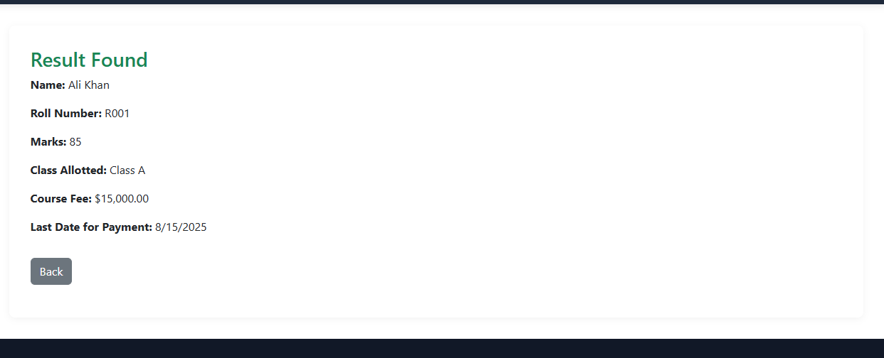

**Result Found**

* Name: Ali Khan
* Roll Number: R001
* Marks:85/100
* Class Allotted: Class A
* Course Fee:$15,000.00
* Last Date for Payment:15 August 2025

[Back Button]

[Back Button]

**Features:**

* Fetches data dynamically using ASP.NET Core MVC + Entity Framework.
* Displays payment deadline (auto-calculated 5 days post-result).

**8.3 Error Page (Invalid Roll Number)**

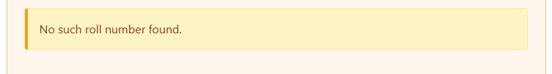

**Error**

* ❌ Invalid Roll Number.
* Please check and try again.

[Back to Exam Page]

**Flow Diagram**

1. Student enters roll number → submits.
2. System checks SQL Database:
   * + - No Match? → Show error.
       - Match? → Show result.

**9. Contact Us Module**

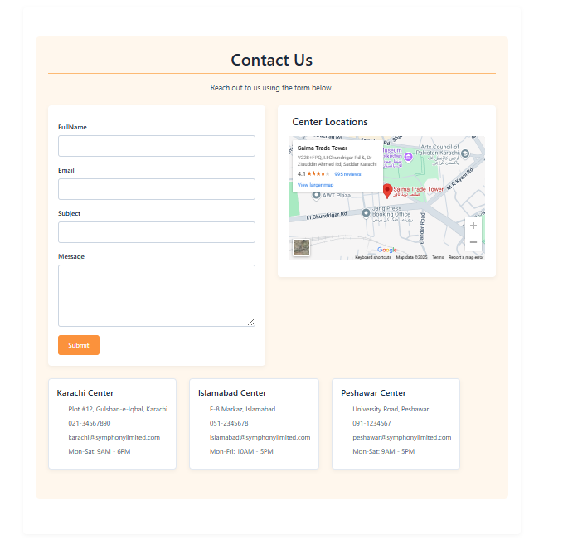

**9.1 Contact Form**

**Contact Us**

Reach out to us using the form below.

* [Name Input Field]
* [Email Input Field]
* [Message Text Area]
* [Submit Button]

**9.2 Center Locations**

|  |  |  |  |  |
| --- | --- | --- | --- | --- |
| **Center** | **Address** | **Contact** | **Hours** | **Email** |
| Karachi | Pier #12, Gulshan-e-Hadeed | 📞 021-24567880 | Mon-Sat: 9AM-5PM | ✉️ karachi@symphonylimited.com |
| Islamabad | F-8 Markaz, Islamabad | 📞 051-2345678 | Mon-Fri: 10AM-5PM | ✉️islamabad@symphonylimited.com |
| Peshawar | University Road, Peshawar | 📞 091-1234567 | Mon-Sat: 9AM-5PM | ✉️peshawar@symphonylimited.com |

**10. Frequently Asked Questions (FAQ)**

**10.1 General Questions**

Q1. How do I join a course?

➡️ Register online via the Admissions Portal or visit any campus.

Q2. Why should I join Symphony Institute?

➡️ We offer:

* Industry-expert faculty
* 100% placement support
* Flexible learning modes (online/offline)

**10.2 Entrance Exams**

Q3. When are entrance exams conducted?

➡️ Exams are held monthly. Check Exam Schedule for dates.

Q4. How do I apply for the entrance exam?

➡️ Fill the Online Application Form (No fees for applications).

Q5. Are there hidden charges for lab facilities?

➡️ No! Lab access is free for enrolled students during operational hours.

**10.3 Payments**

Q6. How can I pay course fees?

➡️ Options:

* Online (Credit/Debit, JazzCash, EasyPaisa)
* Bank Transfer
* On-campus payment counter

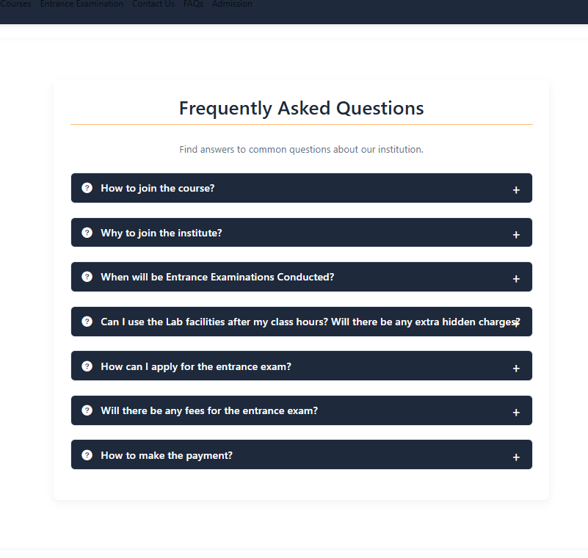

**11. Admission Module**

**11.1 Online Admission Form**

**Admission Form**

**\*\*Personal Details\*\***

* [Student Name] * (Required)
* [Email] * (Validation: example@domain.com)
* [Phone Number] * (Format: +92-XXX-XXXXXXX)

**\*\*Course Information\*\***

* [Course Dropdown] * (Options: AI, ML, Data Science, etc.)
* [Admission Date Picker] * (mm/dd/yyyy)

*[Message Text Area] (Optional)*

*[Submit Button]*

**Features:**

1. Field Validation (ASP.NET Core Data Annotations)
2. Dynamic Course List (Fetched from SQL Database)
3. Mobile-Friendly (Bootstrap 5 Responsive Layout)

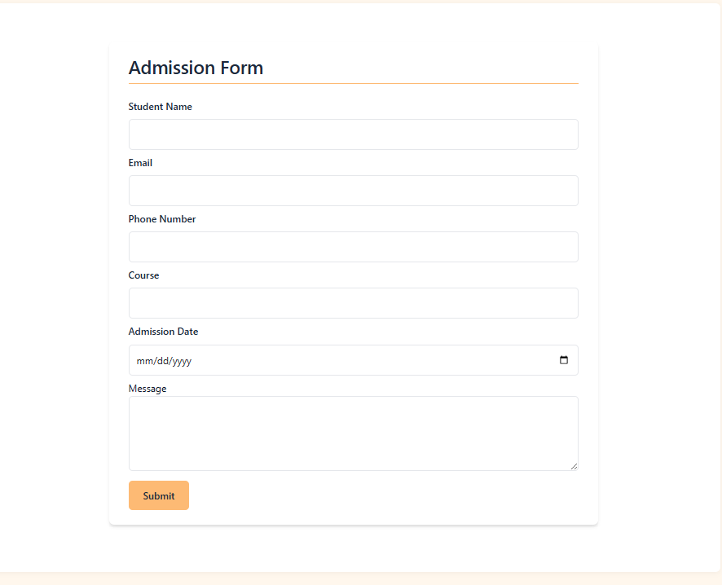

**12. Admin Panel**

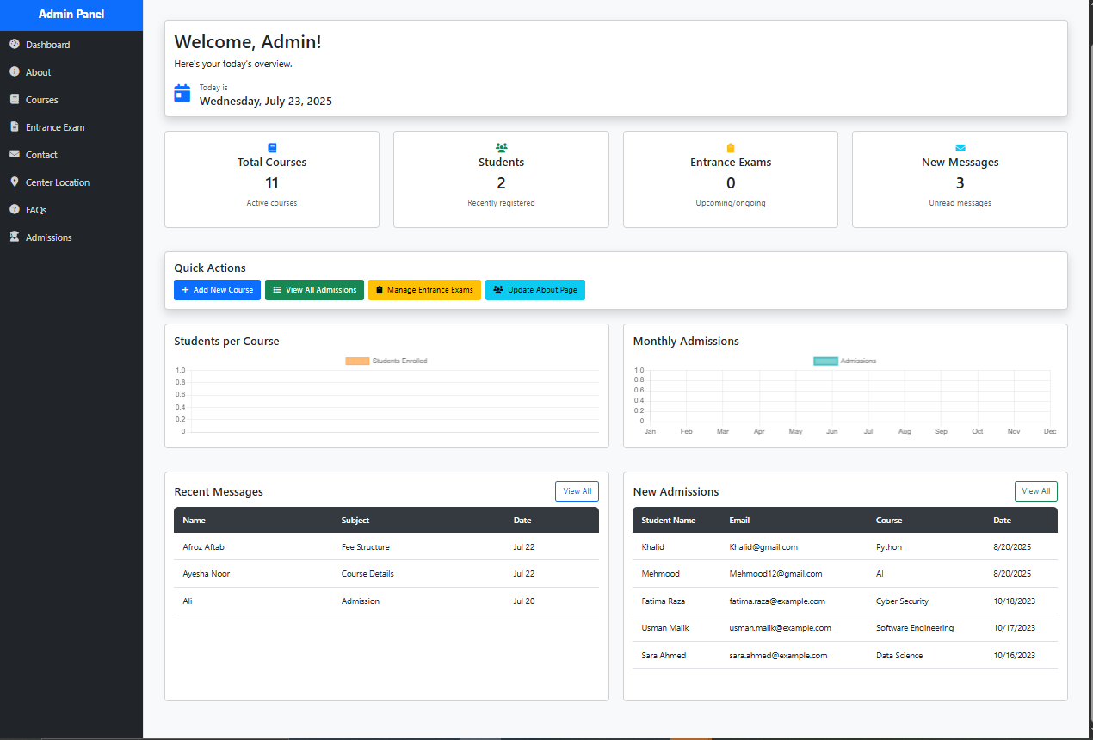

**12.1 Dashboard Overview**

Navigation Menu (Checkbox-Enabled Modules):

✅ About

✅ Center Location

✅ Courses

✅ Entrance Exam

✅ FAQ

✅ Admissions

**Today's Date: Wednesday, July 23, 2025**

**Key Metrics:**

* Total Courses: 11
* New Students: 2
* Upcoming Exams: 0
* Unread Messages: 3

**Quick Actions:**

* Add Course
* Manage Exams
* Update About Page

**12.2 Other Admin Pages**

Courses Management

* Add/Edit/Delete Courses
* Set Durations & Fees

Entrance Exam Control

* Schedule Exams
* Publish Results

Admissions Hub

* View/Filter Applications
* Export Data (Excel/PDF)

Content Management

* Edit FAQs, About Us, Contact Info

Messages Inbox

* Reply to Student Queries

**Admin Panel Overview**

The admin panel is a fully responsive control center that allows authorized personnel to manage all aspects of the institute portal seamlessly across devices (desktop, tablet, mobile).

**Core Operations**

**CRUD Functionality:**

* Create: Add new courses, exam schedules, FAQs, and center locations.
* Read: View student admissions, messages, and analytics.
* Update: Modify course details, edit website content (About Us/Contact), and reschedule exams.
* Delete: Remove outdated courses or inactive student records.

**Key Features**

* Real-Time Dashboard: Displays live metrics (new admissions, unread messages, upcoming exams).
* Role-Based Access: Ensures only admins can modify critical data.
* Cross-Device Compatibility: Built with Bootstrap 5 for optimal viewing on all screens.

**Modules**

* Courses Management: Edit durations, fees, and descriptions.
* Admissions Hub: Process applications and generate enrollment reports.
* Exam Control: Schedule tests and publish results.
* Content Editor: Update FAQs, institute policies, and contact info.

***Each Page is Mobile Friendly***

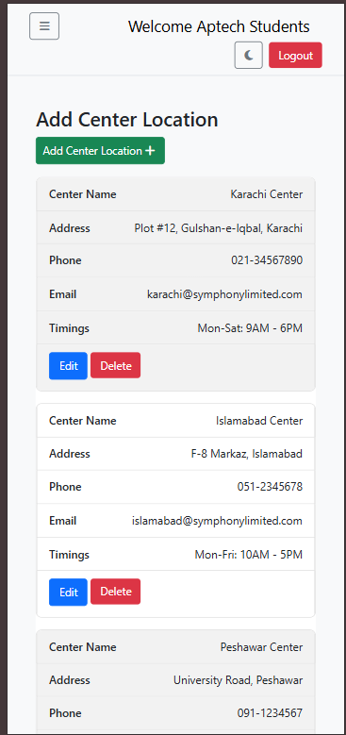

***Dark and Light Theme combination is used in Dashboard***

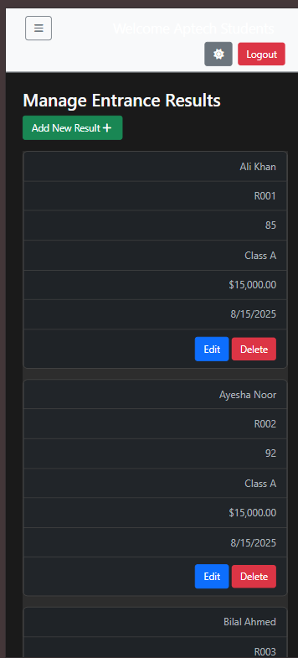

**Summary**

*The Symphony Limited Institute Portal is a comprehensive, responsive web application designed to streamline institute management. It features:*

1. **Student Portal: Course registration, exam results, and FAQs.**
2. **Admin Panel: Full CRUD operations (Create, Read, Update, Delete) for courses, admissions, exams, and content.**
3. **Responsive Design: Works seamlessly on all devices (desktop, tablet, mobile).**
4. **Modern Tech Stack: Built with ASP.NET Core MVC, SQL Server, and Bootstrap 5.**