**Bangabandhu Sheikh Mujibur Rahman Agricultural University**

**EDGE_Batch-06**

**Project Report Marks: 25**

**Name: Afruja Sharmin Joty**

**Reg. No: 2019-05-4966 ; Institute of Biotechnology and Genetic Engineering (IBGE)**

**Note: Submit the completed file as *pdf* to** [**nazmol.stat.bioin@bsmrau.edu.bd**](mailto:nazmol.stat.bioin@bsmrau.edu.bd) **with subject *EDGE_06_Project_Your registration number_ Department by 26th of December, 2024.***

**Problem# 1:**

A split-plot design was conducted considering tree blocks, three levels/treatments of variety in the main plot, and five levels/treatments of nitrogen in the split-plot. Afterward, the yield of certain plant characteristics was observed. The data regarding this experiment were given in the file “Split_Plot_Design”. Answer the following question using this data.

1. Construct an ANOVA table using the mentioned dataset based on R programming.
2. Write down the null hypothesis of all possible effects and interpret the results based on the ANOVA table.
3. Perform a post-hoc test for the interaction effect (variety × nitrogen) and draw a bar diagram with lettering.

**Problem# 2:**

1. What is principal component analysis?
2. What are the main purposes of principle component analysis in your study area?
3. Compute the eigenvalue and eigenvector using the iris data based on R programming.
4. Construct a scree plot and interpret how many principal components should be retained to interpret the iris dataset.
5. Construct a bi-plot for the iris data based on R programming and interpret the results.

**ANSWER:**

**Solution 01:**

1. **Construction of an ANOVA table using the mentioned dataset based on R programming is given below:**

**# Code**

data<-read.csv("Split_Plot_Design.csv")

attach(data)

dim(data)

blk<-c("Block1","Block2","Block3")

variety<-c("variety1","variety2","variety3")

nitrogen<-c("Nitrogen1","Nitrogen2","Nitrogen3","Nitrogen4","Nitrogen5")

b<-length(blk)

v<-length(variety)

n<-length(nitrogen)

block<-gl(b,v*n,b*v*n,factor(blk))

vari.fact<-gl(v,n,b*v*n,factor(variety))

nitro.fact<-gl(n,1,b*v*n,factor(nitrogen))

library(agricolae)

ANOVA.Fact<-aov(YIELD~vari.fact+nitro.fact+block+vari.fact*nitro.fact,data = data)

summary(ANOVA.Fact)

**Result:**

Df Sum Sq Mean Sq F value Pr(>F)

vari.fact 2 1.93 0.963 22.09 1.75e-06 ***

nitro.fact 4 66.03 16.507 378.73 < 2e-16 ***

block 2 1.25 0.627 14.39 5.02e-05 ***

vari.fact:nitro.fact 8 6.10 0.763 17.50 5.23e-09 ***

Residuals 28 1.22 0.044

---

Signif. codes: 0 ‘***’ 0.001 ‘**’ 0.01 ‘*’ 0.05 ‘.’ 0.1 ‘ ’ 1

1. **The null hypothesis of all possible effects and interpretion of the results based on the ANOVA table is given below:**

**Variety (vari.fact):**

* **Null Hypothesis (H0​):** The mean yield does not differ among varieties.
* **Result:** With p=1.75×10−6 we reject H0​. Variety significantly affects yield.

**Nitrogen (nitro.fact):**

* **Null Hypothesis (H0​):** The mean yield does not differ among nitrogen levels.
* **Result:** With p<2×10−16, we reject H0​. Nitrogen levels have a highly significant impact on yield.

**Block:**

* **Null Hypothesis (H0​):** Yield does not vary due to tree blocks.
* **Result:** With p=5.02×10−5 we reject H0​. Tree blocks significantly affect yield.

**Interaction (vari.fact:nitro.fact):**

* **Null Hypothesis (H0​):** There is no interaction effect between variety and nitrogen on yield.
* **Result:** With p=5.23×10−9 we reject H0​. A significant interaction exists, meaning the effect of nitrogen on yield depends on the variety.

The analysis shows that variety, nitrogen levels, and their interaction significantly influence yield, with additional variation attributed to tree blocks.

1. **Perform a post-hoc test for the interaction effect (variety × nitrogen) and draw a bar diagram with lettering.**

**# Code**

Post.Hoc.Test<-with(data,HSD.test(YIELD,vari.fact:nitro.fact,DFerror = 28,MSerror = 0.044))

Mean.matrix<-Post.Hoc.Test$means

Mean.matrix<-Mean.matrix[order(Mean.matrix$YIELD,decreasing = TRUE),]

Mu_Tret<-Mean.matrix$YIELD

SE_Treat<-Mean.matrix$std/sqrt(Mean.matrix$YIELD)

Bar.Plot <- barplot2(Mu_Tret, names.arg = rownames(Mean.matrix),

xlab = "Treatment Combinations",

ylab = "Mean Yield", plot.ci = TRUE,

ci.l = Mu_Tret - SE_Treat, ci.u = Mu_Tret + SE_Treat,

col = "green", las = 2)

letters <- c("a", "ab", "ab", "bc", "bc", "bc", "c", "cd", "de",

"e", "e", "e", "f", "f", "f")

text(x = Bar.Plot, y = Mu_Tret + SE_Treat + 0.1, labels = letters, cex = 0.8)

**#RESULT:**

$statistics

MSerror Df Mean CV MSD

0.044 28 5.094 4.11782 0.6348227

$groups

YIELD groups

variety2:Nitrogen3 6.806667 a

variety2:Nitrogen4 6.490000 ab

variety3:Nitrogen4 6.346667 ab

variety1:Nitrogen4 6.070000 bc

variety3:Nitrogen5 6.056667 bc

variety1:Nitrogen5 5.923333 bc

variety2:Nitrogen5 5.596667 c

variety3:Nitrogen3 5.443333 cd

variety3:Nitrogen2 4.910000 de

variety1:Nitrogen2 4.760000 e

variety2:Nitrogen2 4.743333 e

variety1:Nitrogen3 4.636667 e

variety3:Nitrogen1 2.993333 f

variety2:Nitrogen1 2.936667 f

variety1:Nitrogen1 2.696667 f

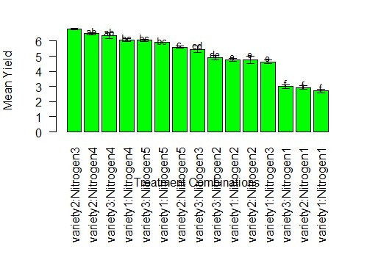

**Solution 02:**

**a). Principal Component Analysis (PCA)**

Principal Component Analysis (PCA) is a statistical technique used to simplify complex datasets by reducing their dimensions while retaining most of the original information. It transforms correlated variables into a smaller number of uncorrelated variables called principal components, which capture the maximum variance in the data.

**Key Points:**

1. **Dimensionality Reduction**: Makes large datasets easier to analyze and visualize.
2. **Variance Focus**: The first few components capture the most important patterns in the data.
3. **Applications**: Used for pattern recognition, data visualization, feature selection, and noise reduction.

**b). The main purposes of Principal Component Analysis (PCA) in Biotechnology and Genetic Engineering (my study area) are:**

1. **Dimensionality Reduction**:
   * In genomics and proteomics, datasets often involve thousands of genes, proteins, or metabolites. PCA reduces the dimensionality of these datasets, making them easier to visualize and analyze without losing significant information.
2. **Data Visualization**:
   * PCA projects high-dimensional data into 2D or 3D space, allowing for easier visualization of patterns, clusters, and relationships between samples, such as gene expression profiles or genetic variation.
3. **Feature Selection**:
   * PCA identifies the most influential variables (principal components) in a dataset, helping researchers focus on the key factors driving variability, such as genes linked to a specific phenotype or disease.
4. **Noise Reduction**:
   * By filtering out minor components associated with noise, PCA improves the quality of data, especially in high-throughput experiments like RNA sequencing or microarrays.
5. **Pattern Recognition and Classification**:
   * PCA helps uncover hidden patterns in genetic and biochemical data, enabling classification of samples (e.g., diseased vs. healthy tissue) based on molecular profiles.
6. **Correlation Analysis**:
   * PCA identifies correlated variables, such as genes or proteins that behave similarly across different conditions, aiding in pathway and network analysis.
7. **Variant Analysis**:
   * In population genetics, PCA is used to analyze genetic variation, study population structure, and identify evolutionary relationships among species or individuals.
8. **Bioprocess Optimization**:
   * PCA helps in analyzing complex datasets from bioprocessing (e.g., fermentation or bioreactor data) to optimize conditions for yield and productivity.

PCA helps Biotechnologist and Genetic Engineers to interpret complex data effectively and draw meaningful conclusions.

**c). Computation of the the eigenvalue and eigenvector using the iris data based on R programming is given below-**

**## Code**

# Load the data

iris_data <- read.csv("iris_Data.csv")

# Extract numerical columns (exclude the species column)

numeric_data <- iris_data[, 1:4]

# Compute the covariance matrix

cov_matrix <- cov(numeric_data)

# Compute eigenvalues and eigenvectors

eigen_results <- eigen(cov_matrix)

# Display the eigenvalues

cat("Eigenvalues:\n")

print(eigen_results$values)

# Display the eigenvectors

cat("\nEigenvectors:\n")

print(eigen_results$vectors)

**Result:**

**Eigenvalues:**

[1] 4.22824171 0.24267075 0.07820950 0.02383509

**Eigenvectors:**

[,1] [,2] [,3] [,4]

[1,] 0.36138659 -0.65658877 0.58202985 0.3154872

[2,] -0.08452251 -0.73016143 -0.59791083 -0.3197231

[3,] 0.85667061 0.17337266 -0.07623608 -0.4798390

[4,] 0.35828920 0.07548102 -0.54583143 0.7536574

**d). Construction of a scree plot and interpretation of how many principle components should be retained to interpret the iris dataset is given below:**

**## Code**

# Load the data

iris_data <- read.csv("iris_Data.csv")

# Extract numerical columns (exclude the species column)

numeric_data <- iris_data[, 1:4]

# Perform PCA

pca_result <- prcomp(numeric_data, scale. = TRUE) # Scale the data for standardization

# Compute the proportion of variance explained

explained_variance <- (pca_result$sdev^2) / sum(pca_result$sdev^2) * 100

# Cumulative variance explained

cumulative_variance <- cumsum(explained_variance)

# Create a scree plot

plot(

explained_variance,

type = "b",

xlab = "Principal Components",

ylab = "Percentage of Variance Explained",

main = "Scree Plot",

pch = 19,

col = "blue"

)

abline(h = 10, col = "red", lty = 2) # Optional: threshold for significance

# Add cumulative variance interpretation (optional)

cat("Explained Variance by Principal Components:\n")

print(explained_variance)

cat("\nCumulative Variance:\n")

print(cumulative_variance)

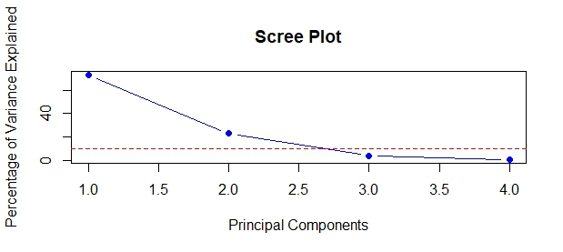

pca_result

Standard deviations (1, .., p=4):

[1] 1.7083611 0.9560494 0.3830886 0.1439265

Rotation (n x k) = (4 x 4):

PC1 PC2 PC3 PC4

Sepal.Length 0.5210659 -0.37741762 0.7195664 0.2612863

Sepal.Width -0.2693474 -0.92329566 -0.2443818 -0.1235096

Petal.Length 0.5804131 -0.02449161 -0.1421264 -0.8014492

Petal.Width 0.5648565 -0.06694199 -0.6342727 0.5235971

Explained Variance by Principal Components:

[1] 72.9624454 22.8507618 3.6689219 0.5178709

Cumulative Variance:

[1] 72.96245 95.81321 99.48213 100.00000

**Interpretation:**

**Scree Plot Insight:**

In the scree plot, observed a sharp drop in variance explained from PC1 to PC2, and then the curve flattens after PC2. This suggests that **two principal components** would be adequate to interpret the dataset.

It can be choosen to retain **two components** for dimensionality reduction, as this will capture most of the variance without losing much information.

# The scree plot shows the **percentage of variance explained** by each principal component (PC):

1. **PC1** (first component):
   * Explains the largest variance (around 72.96% as per your data).
   * Represents the most significant pattern in the dataset.
2. **PC2** (second component):
   * Adds a significant amount of variance (around 22.85%, bringing the cumulative variance to 95.81%).
   * Together, PC1 and PC2 capture the majority of the information (approximately 96%).
3. **PC3 and PC4**:
   * Contribute very little additional variance (3.67% and 0.52%, respectively).
   * These components are not significant for explaining the variability in the data.

**## Retain PC1 and PC2**: These two components explain around **96% of the total variance**, which is sufficient to summarize the dataset effectively.

**Discard PC3 and PC4**: These components add minimal new information and can be ignored in most analyses.

**e). Construction a bi-plot for the iris data based on R programming and interpretion of the the results is given below:**

# Load the iris dataset

data(iris)

# Perform PCA on the numerical columns of the iris dataset (excluding the Species column)

pca_result <- prcomp(iris[, 1:4], center = TRUE, scale. = TRUE)

# Plot the bi-plot

biplot(pca_result, main = "Bi-plot of Iris Data")

# Optionally, you can customize the plot with different colors for each species

library(ggplot2)

pca_data <- data.frame(pca_result$x, Species = iris$Species)

# Plot with ggplot2 for better customization

ggplot(pca_data, aes(PC1, PC2, color = Species)) +

geom_point(size = 3) +

labs(title = "PCA Bi-plot of Iris Data", x = "Principal Component 1", y = "Principal Component 2") +

theme_minimal()

Ans:

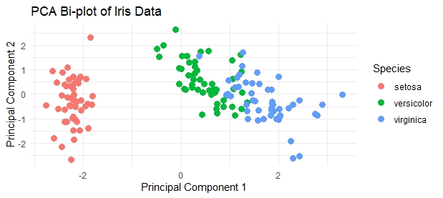

**Interpretion:**

* **Species Labels**: Each point is labeled with its species (setosa, versicolor, or virginica), making it easy to see how the species are distributed along the principal components.
* **Cluster Separation**: To observe clear separation of points between species (e.g., setosa may cluster in one part of the plot while versicolor and virginica cluster in other parts), this suggests that the principal components (PC1 and PC2) capture the variation that distinguishes these species.
* **Principal Components**: The arrows in the bi-plot represent the loadings of the original variables (sepal length, sepal width, petal length, and petal width) on the principal components.