**VISVESVARAYA TECHNOLOGICAL UNIVERSITY**

BELAGAVI, KARNATAKA-590014



**Industry Internship Report**

on

**“STUDENT GRADE BOOK SYSTEM”**

Submitted by

**Ms Afsa Banu**

**4DM21CS005**

**UNDER THE GUIDANCE OF**

**Dr Abdul Majid**

Professor

Department of Computer Science & Engineering

In partial fulfillment for the award of the degree of

**BACHELOR OF ENGINEERING**

In

**COMPUTER SCIENCE AND ENGINEERING**



**YENEPOYA INSTITUTE OF TECHNOLOGY**

**N.H.13, THODAR, MOODBIDRI-574225, MANGALORE, D.K.**

**2023-24**

**YENEPOYA INSTITUTE OF TECHNOLOGY**

**THODAR, MIJAR POST, MOODBIDRI**-**574225**

**(Affiliated to Visvesvaraya Technological University, Belagavi)**

**DEPARTMENT OF COMPUTER SCIENCE AND ENGINEERING**





**CERTIFICATE**

This is to certify that the Industry Internship report entitled **“STUDENT GRADE BOOK SYSTEM”** is an authentic record of the work carried out by **Ms Afsa Banu,** USN: 4DM21CS005, students of 5th semester in partial fulfillment of requirements for the award of Bachelor’s Degree in **Computer Science & Engineering** prescribed by Visvesvaraya Technological University during the year **2023-24**

_________________________ _______________________

Signature of the Guide       Signature of the HOD

**(Dr Abdul Majid) (Dr Manjunath Kamath)**

External Viva

**Name of the examiner**

**Signature with Date**

1**.**________________ 1. ________________

2. ________________ 2.________________

**DECLARATION**

This is to certify that I have followed the guidelines provided by the University & Institute in preparing this Internship report. I, solemnly declare that the React Js Internship report submitted herewith is an honest and comprehensive account of my work and experiences, and I have adhered to ethical and professional standards throughout its preparation.

Signature of student

Name : **AFSA BANU**

USN : **4DM21CS005**

**ACKNOWLEDGEMENT**

The successful completion of any work would be incomplete without a mention of the people who made it possible, whose constant guidance and encouragement served as a beacon light and crowned our efforts with success. We owe our gratitude to many people who helped and supported us during our Project “**Student Grade Book System”**.

Our deepest thanks to our guide **Dr Abdul Majid** Professor, Dept. of CSE, Yenepoya Institute of Technology for his/her constant support, encouragement and providing us with the necessary advices and help. We are highly indebted to him/her for taking keen interest in our work, monitoring and providing guidance throughout the completion of our work.

We also thank **Dr Athokpam Bikramjit Singh.,** Professor and Industry Internship Coordinator, Department of Computer Science & Engineering for his constant encouragement and support extended throughout.

We express our sincere gratitude to **Dr Manjunath Kamath,** Professor & Head of the Department of Computer Science & Engineering for his invaluable support and guidance.

We sincerely thank **Dr R G. D’Souza**, Principal, Yenepoya Institute of Technology support and providing us with all the facilities that were required for his constant

Finally, yet importantly, we express our heartfelt thanks to our family & friends for their wishes, encouragement and providing me moral strength for the successful seminar presentation.

**AFSA BANU (4DM21CS005)**

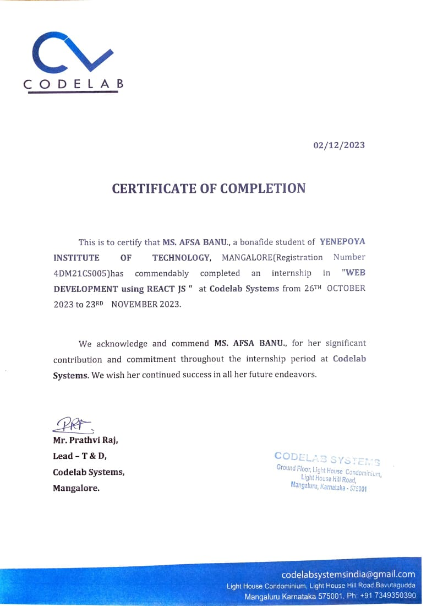

**ABSTRACT**

In today’s world the management system is very important and essential for every system. This management system is an application-based system, having applications developed for students to manage their mark details. Every organisation whether government or private uses an information system to store data of their students. However, in India it is found that many small scale industries or colleges use pen and paper to keep a record. However, there are many advanced technology systems available that can do this work but they all are costly for these low level industries.

This project is useful for easy user interface. The system uses the powerful database management system, data retrieval and data manipulation. This project provides more ease for managing the data than manually maintaining the data. Hence it saves the lot of time of ours also. So we can say that the project is useful for saving valuable time and reducing huge paper work.

**Contents**

1. Introduction1

2. Literature Survey2

**3. Problem Statement and Solution Specification3-4**

3.1 Problem Identification3

* 1. Solution Strategy3-4

4. Proposed System5

**5. System Requirements Analysis and Specification6**

* 1. Hardware requirements 6

5.2 Software requirements 6

**6. System Design7-8**

6.1 Student Grade Book System Architecture types7

6.2 Component Design 8

**7. Implementation9-11**

**8. Snapshots12-14**

8.1 Home Page12

8.2 Register and Login Page12

8.3 Admin Page13

8.4 Add Student Page13

8.5 Student List Page 14

8.6 Trash Page14

**9. Reflection15-16**

9.1 Technical Learnings15

9.2 Project Management Skills15

9.3 Personal Growth16

**10. Conclusion17**

**BIBLIOGRAPHY**

References18

**CHAPTER 1**

**INTRODUCTION**

The student grade book system is an environment where all the process of the student in the institution is managed. It is done through the automated computerized method. Conventionally this system is done using papers, files and binders. This system saves the time of the student and of the administrator. It includes process like registration of student details like usn, name, marks etc. This system reduces the cost and workforce required for this job. As the system is online the information is globally present to everyone.

This makes the system easy to handle and feasible for finding the omission with updating at the same time. As for the existing system, they use to maintain their record manually which makes it vulnerable to security. If filed a query to search or update in a manual system, it will take a lot of time to process the query and make a report which is a tedious job.

As the number of student increases in the institute manually managing the strength becomes a hectic job for the administrator. This computerized system stores all the data in the database which makes it easy to fetch and update whenever needed.

With the development of technology, the rise of digitization and the rise of sort social networks, the sharing of information online kind of basically has generally literally become very pretty quiet in a fairly major way in a sort of big way. As a result, the definitely really entire online system really kind of has mostly definitely become very popular over the basically for all intents and purposes past years in a sort of generally big way, which literally is fairly significant.

It is a web-based system where students can find their results or details by entering their usn or department. In this system we have put the login and registration functionality. Without login user can’t access the system. Also, Admin has given the functionality of CRUD operation. CRUD stands for Create, Read, Update and Delete. Admin can perform CRUD operation on any student. Hence this system is to provide an alternate and convenient way for any school or college to maintain the required data for students through an autonomous software application approach.

**CHAPTER 2**

**LITERATURE SURVEY**

The research was carried out at Mbarara Army Senior Secondary School, Mbarara district- Uganda. The study was

mainly carried out in the department of academics. The academic department uses a manual filing system for the

storage of students’ results. The design of this study consisted of six respondents who were selected at random at

Mbarara Army Senior Secondary School, which gave the researcher relevant information about the system at the

school. Various methods of research finding methods were used to collect the data from the field questionnaire,

interview and observation. Both secondary and primary data were collected using the methods identified above. The

researcher faced problems like the delay of the respondents to return questionnaires in time because of the failure of

the respondents about the new system and some respondents hid vital information because of the fear of losing their

job. Problems faced by the current system in recording students’ results; students’ results can be lost at any time.

The students’ results management system will help MASSS to capture, process, store and disseminate students’

results easily. SGMS was designed in Microsoft visual basic (6.0) and its related technologies of the database as the

designing tools. It makes it easy to access information as faster as possible and this involves real-time reports. It

also shows how the whole system can be made secure to avoid authorized access to its various resources. Role

authentication is put into use so as to accomplish the goal of the whole project which is to provide students results

management system that facilitates an effective, user-friendly and efficient students result management system

(SRMS) at Mbarara Army Senior Secondary School.

The research was carried out at Mbarara Army Senior Secondary School, Mbarara district- Uganda. The study was mainly carried out in the department of academics. The academic department uses a manual filing system for the storage of students’ results. The design of this study consisted of six respondents who were selected at random at Mbarara Army Senior Secondary School, which gave the researcher relevant information about the system at the school. Various methods of research finding methods were used to collect the data from the field questionnaire, interview and observation. Both secondary and primary data were collected using the methods identified above. The researcher faced problems like the delay of the respondents to return questionnaires in time because of the failure of the respondents about the new system and some respondents hid vital information because of the fear of losing their job. Problems faced by the current system in recording students’ results; students’ results can be lost at any time. The students’ results management system will help MASSS to capture, process, store and disseminate students’ results easily. SGMS was designed in Microsoft visual basic (6.0) and its related technologies of the database as the designing tools. It makes it easy to access information as faster as possible and this involves real-time reports. It also shows how the whole system can be made secure to avoid authorized access to its various resources. Role authentication is put into use so as to accomplish the goal of the whole project which is to provide students results management system that facilitates an effective, user-friendly and efficient students result management system (SRMS) at Mbarara Army Senior Secondary School.

The research was carried out at Mbarara Army Senior Secondary School, Mbarara district- Uganda. The study was

mainly carried out in the department of academics. The academic department uses a manual filing system for the

storage of students’ results. The design of this study consisted of six respondents who were selected at random at

Mbarara Army Senior Secondary School, which gave the researcher relevant information about the system at the

school. Various methods of research finding methods were used to collect the data from the field questionnaire,

interview and observation. Both secondary and primary data were collected using the methods identified above. The

researcher faced problems like the delay of the respondents to return questionnaires in time because of the failure of

the respondents about the new system and some respondents hid vital information because of the fear of losing their

job. Problems faced by the current system in recording students’ results; students’ results can be lost at any time.

The students’ results management system will help MASSS to capture, process, store and disseminate students’

results easily. SGMS was designed in Microsoft visual basic (6.0) and its related technologies of the database as the

designing tools. It makes it easy to access information as faster as possible and this involves real-time reports. It

also shows how the whole system can be made secure to avoid authorized access to its various resources. Role

authentication is put into use so as to accomplish the goal of the whole project which is to provide students results

management system that facilitates an effective, user-friendly and efficient students result management system

(SRMS) at Mbarara Army Senior Secondary School.

**CHAPTER 3**

**PROBLEM STATEMENT AND SOLUTION STRATEGY**

**3.1 Problem Statement:**

The current manual grading processes lead to inefficiencies, delayed result dissemination, and potential errors. Moreover, the lack of real-time updates hampers the overall academic management. The study identified issues such as data inconsistency, limited accessibility, and resistance to change among educators. To address these challenges, the implementation of a Student Grade Book System using React.js is proposed. This solution aims to enhance efficiency, accuracy, and accessibility, providing a modern and user-friendly platform for managing student grades.

**3.2 Solution Strategy:**

To tackle the challenges outlined in the problem statement, a React.js-based front-end solution can be implemented. Here's a strategy to guide the development of the Student grade Book System Project.

**3.2.1 User-Friendly Interface:**

***Problem:*** Users need an intuitive and responsive interface to access and manage student data.

***Solution:*** Utilize React.js to create a dynamic and user-friendly interface. Leverage React components to modularize the UI, making it easy to navigate and interact with the system.

**3.2.2 Data Organization and Management:**

***Problem:*** Efficiently organize and manage student information and grade details.

***Solution:*** Implement state management in React to handle dynamic data. Utilize context API or global state management tools like Redux to maintain a centralized data store for student and grade information.

**3.2.3 Real-time Updates:**

***Problem:*** Ensure real-time updates for changes in student records or grade details.

***Solution:*** Utilize React's virtual DOM to efficiently update the UI in response to changes in the underlying data. Consider integrating WebSocket or other real-time communication technologies to provide instant updates.

**3.2.4 Responsive Design:**

***Problem:*** Ensure the system is accessible and functional across various computers and screen sizes.

***Solution:*** Leverage React's responsive design capabilities to create a layout that adapts to different screen sizes.

**3.2.5 Search and Filter Functionality:**

***Problem:*** Enable users to efficiently search and filter through student records.

***Solution:*** Implement search and filter functionalities using React components. Utilize libraries like React-Query for efficient data fetching and caching to enhance performance.

**CHAPTER 4**

**PROPOSED SYSTEM**

Student Grade Book System is essential. Gather the student information such as name, usn, attendance, department and marks. Utilize this collected information of the students to form a record

Firstly, built a home page where you can find an Admin and Student page, you need to sign up and login to get into the Admin page.

**Admin Page:** In this service, the admin will be able to add, modify and delete the student record Admin will also be able to add, update and delete the subjects of the particular student

First Admin need to enter the student details like name, usn, marks, attendance and department in Add Student Page and the record of the entered student details will be displayed in the Student list page, the deleted student record will be saved in Trash page where you can delete it permanently and can also restore it back to the Student list Page. Admin can find the details of a particular student by entering the student department or usn.

**Student Page:** In this service student can view the Student list page which consist of Student details, but there is no Authority to Student to edit or delete the entered details

**CHAPTER 5**

**SYSTEM REQUIREMENTS ANALYSIS AND SPECIFICATION**

**5.1 Hardware Requirements**

**Processor:** Intel Core i5 or above.

**Hard Disk/SSD:** 512 GB or more for storage.

**RAM:** 8.00 gigabytes or above.

**5.2 Software Requirements**

**5.2.1 Development Stack**

**Language:** JavaScript (React.js for frontend).

**Operating System:** Windows 7 or above.

**5.2.2 Frontend**

React.js for building the user interface.

**Styling:** CSS or CSS-in-JS solutions like Styled Components.

**Package Manager:** npm (Node Package Manager)

**5.2.3 Build Tools**

Webpack or Create React App for bundling and building the project.

**5.2.4 Development Environment**

**Code Editor:** Visual Studio Code or any preferred code editor.

**CHAPTER 6**

**SYSTEM DESIGN**

**6.1 Student Grade Book System Architecture types**

* Client-Server Architecture
* Two-Tier Architecture
* Three-Tier Architecture

Student Grade Book System follows Client-Server Architecture.

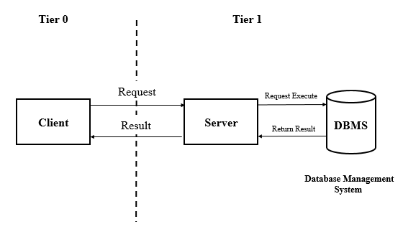

6.1.2 Client-Server Architecture

**6.1.2 Client-Server Architecture**

In this architecture, the client(browser) sends the requests to the server, and the server processes the request if a request is valid then it responds with the requested data to the client. The client hosts the user interface(UI) while the server hosts the business logic and database.

**6.1.3 Advantages**

* This architecture has a clean separation of concerns between the client and server.
* The server becomes overloaded with many client requests.
* It is easy to manage, and the data can be easily delivered to the client.

**6.1.4 Disadvantages**

* Clients systems can get a virus or any malicious scripts if any are running on the server.
* Extra security must be added so that the data does not get spoofed in between the transmission.
* The main problem can be server down. When the server is down, the client loses its connection and will not access the data.

**6.2 Component Design**

The Student Grade Book design includes a Home page that allows Admin and Students to access the System.

**Admin-:** Consist of Add Student Page where student details can be stored, Student List Page which contains the list of the student details entered in Add Student Page and a Trash Page which consist of deleted contents from Student List Page. Overall Admin can make changes in Any of the Pages

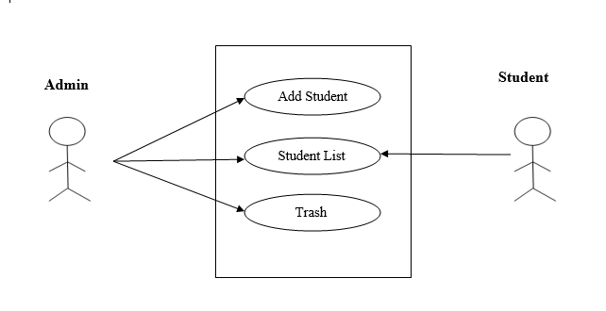Student-: Because every college student plays such an essential role, the student is the  
center of attention. student can view the update on his grade sheet like marks, subject, attendance etc in Student List Page but cannot make any changes to it.

6.2.1 User Case Diagram

**CHAPTER 7**

**IMPLEMENTATION**

**Weekly report:**

**1st Week:**

|  |  |  |
| --- | --- | --- |
| **DATE** | **DAY** | **NAME OF THE TOPIC/MODULE COMPLETED** |
| 25/10/23 | Wednesday | Introduction of html & html tags |
| 26/10/23 | Thursday | Cheak box & Radio & Select course |
| 27/10/23 | Friday | Introduction of CSS |
| 28/10/23 | Saturday | Background image & functions of CSS |

On the first week of my React JS internship I learnt about basic of HTML, Tags, Checkboxes, radios, and selectors. CSS styles make pages look good, and background images add flair. CSS functions control layout and design. In the internship, I learned how to structure content, make interactive elements, and style pages for a great user experience. In the first week of my internship, I have done task like registration form, time table.

**2nd week:**

|  |  |  |
| --- | --- | --- |
| **DATE** | **DAY** | **NAME OF THE TOPIC/MODULE COMPLETED** |
| 30/10/23 | Monday | Introduction to Java Script |
| 31/10/23 | Tuesday | Types of Variables, |
| 1/11/23 | Wednesday | Arrays |
| 2/11/23 | Thursday | Object |
| 3/11/23 | Friday | Document Object Model |
| 4/11/23 | Saturday | Input Fields and Alert |

In my React JS internship, I explored JavaScript essentials like variable types, arrays, and objects, laying the foundation for dynamic data handling. Understanding the Document Object Model (DOM) empowered us to manipulate web content effectively. Learning input fields facilitated user data capture, while alert notifications enhanced user interactions. These key topics formed the basis for React development, enabling us to build responsive and interactive web applications, making our internship a comprehensive exploration of fundamental JavaScript concepts essential for proficient React development. In the second week of my internship, I have done task like calculator, changing the background colors using functions, e-commerce website.

**3rd week:**

|  |  |  |
| --- | --- | --- |
| **DATE** | **DAY** | **NAME OF THE TOPIC/MODULE COMPLETED** |
| 6/11/23 | Monday | Types Of Loops |
| 7/11/23 | Tuesday | Operators |
| 8/11/23 | Wednesday | Conditional Statements |
| 9/11/23 | Thursday | Introduction To React JS |
| 10/11/23 | Friday | MERN STACK |
| 11/11/23 | Saturday | Inline, Internal & External React |

On the 3rd week, I explored essential programming concepts like loops, operators, and conditional statements. React, a JavaScript library, enables efficient UI development. The MERN stack, incorporating MongoDB, Express, React, and Node.js, facilitates full-stack web development. We delved into React's versatility with inline, internal, and external styling. Understanding loops and operators aids dynamic content, while conditional statements enhance decision-making. Overall, the internship covered React's core concepts and application within the MERN stack, emphasizing styling approaches for effective and responsive user interfaces. In the third week of my internship, I have done task like checking odd or even number, report card, multiplication table.

**4th week:**

|  |  |  |
| --- | --- | --- |
| **DATE** | **DAY** | **NAME OF THE TOPIC/MODULE COMPLETED** |
| 14/11/23 | Tuesday | Arrow Functions |
| 15/11/23 | Wednesday | Array Methods |
| 16/11/23 | Thursday | Destructuring |
| 17/11/23 | Friday | Spread Operators |
| 18/11/23 | Saturday | Ternary Operators |

On 4th week, I focused on advanced JavaScript concepts. Arrow functions streamline syntax for concise code. Array methods enhance data manipulation efficiency. Destructuring simplifies object or array extraction. Spread operators facilitate seamless data spreading. Ternary operators offer concise conditional expressions. These concepts empower React developers with cleaner and more expressive code, improving overall development efficiency and code readability within the React framework. The internship emphasized leveraging these techniques for effective and streamlined React application development. In the fourth week of my internship, I have done task like creating student table using array method, time checker using arrow function, changing the dark mode to light mode.

Top of Form

**5th week:**

|  |  |  |
| --- | --- | --- |
| **DATE** | **DAY** | **NAME OF THE TOPIC/MODULE COMPLETED** |
| 20/11/23 | Monday | React Props |
| 21/11/23 | Tuesday | Router |
| 22/11/23 | Wednesday | Local Storage & MUI |
| 23/11/23 | Thursday | Project Distribution |

In my React JS internship, I delved into React Props, facilitating data flow between components for dynamic rendering. Router implementation enabled multi-page navigation within a single-page application. Local Storage and MUI (Material-UI) enhanced state management and UI design, respectively. Project distribution involved deploying applications for public access. Overall, the internship emphasized mastering these concepts to create modular, navigable, visually appealing React applications, enhancing our ability to develop efficient and user-friendly web projects in the third week of my internship I have done task like creating table, updating deleting data on the tab.

**CHAPTER 8**

**SNAPSHOTS**

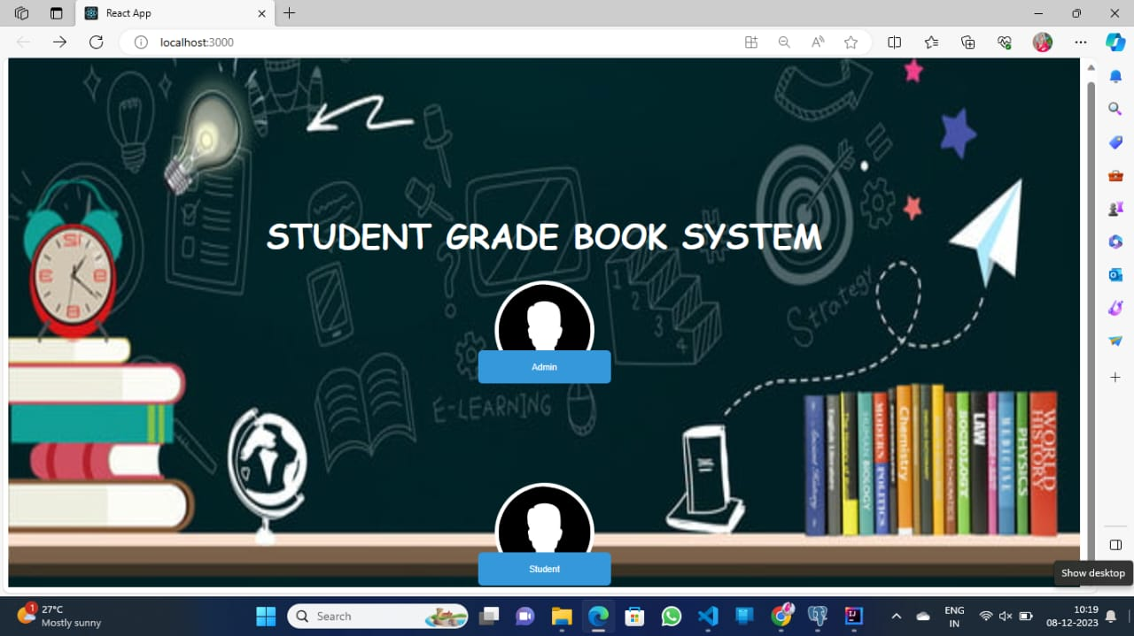**8.1 Home Page**

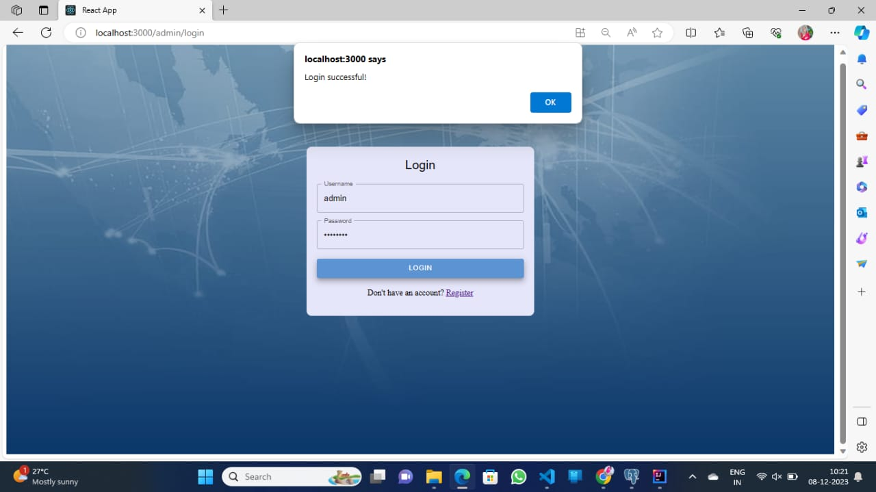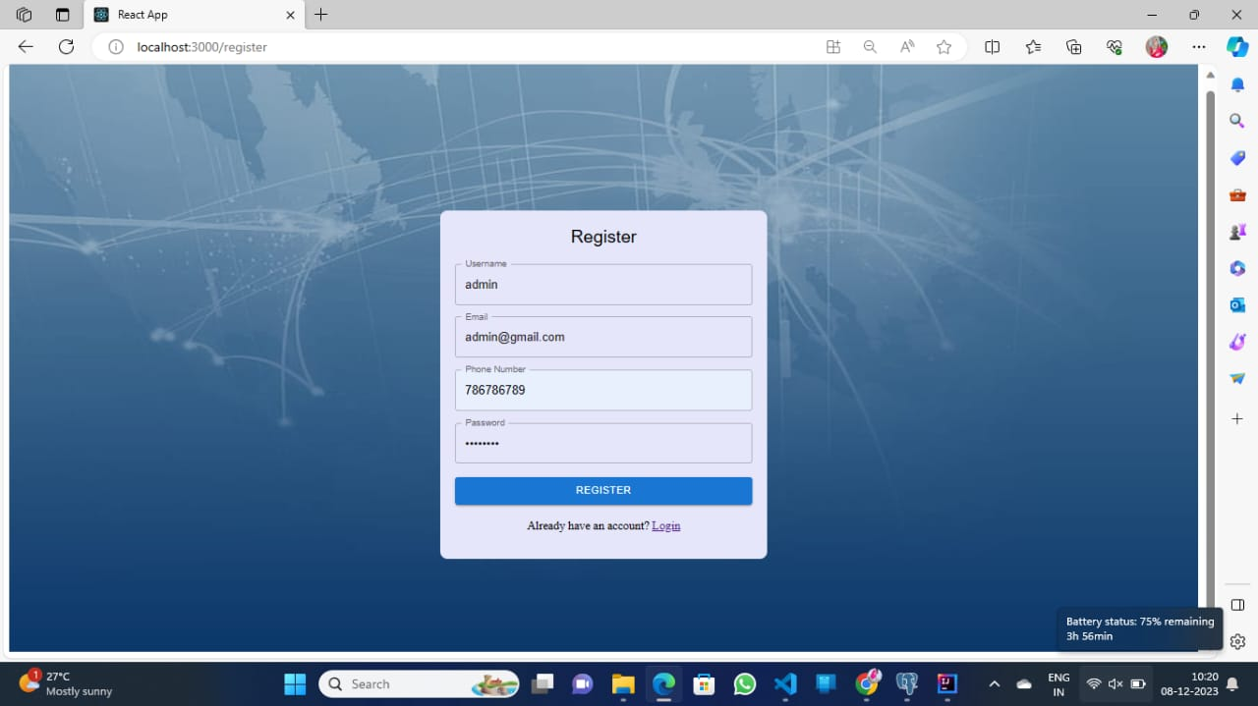**8.2 Register and Login Page**

**8.3 Admin Page**

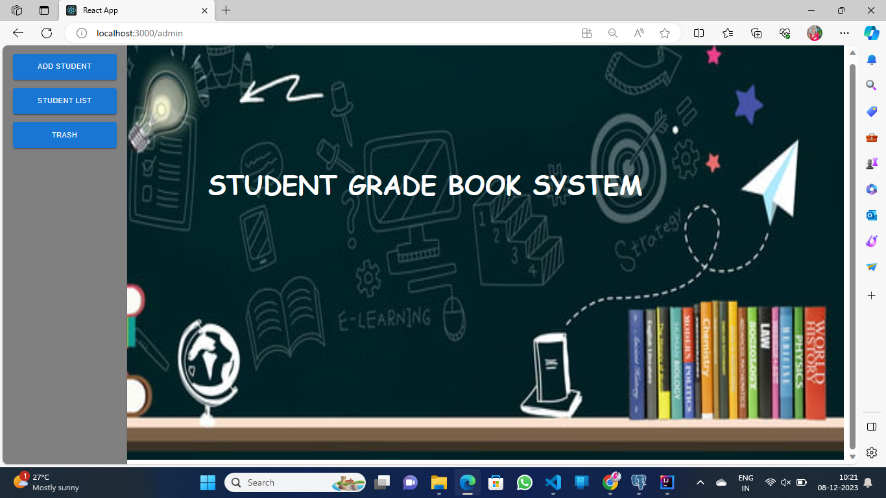

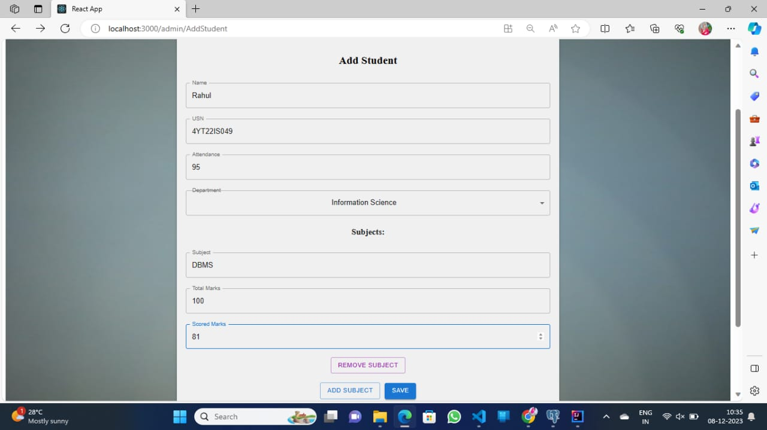**8.4 Add Student Page**

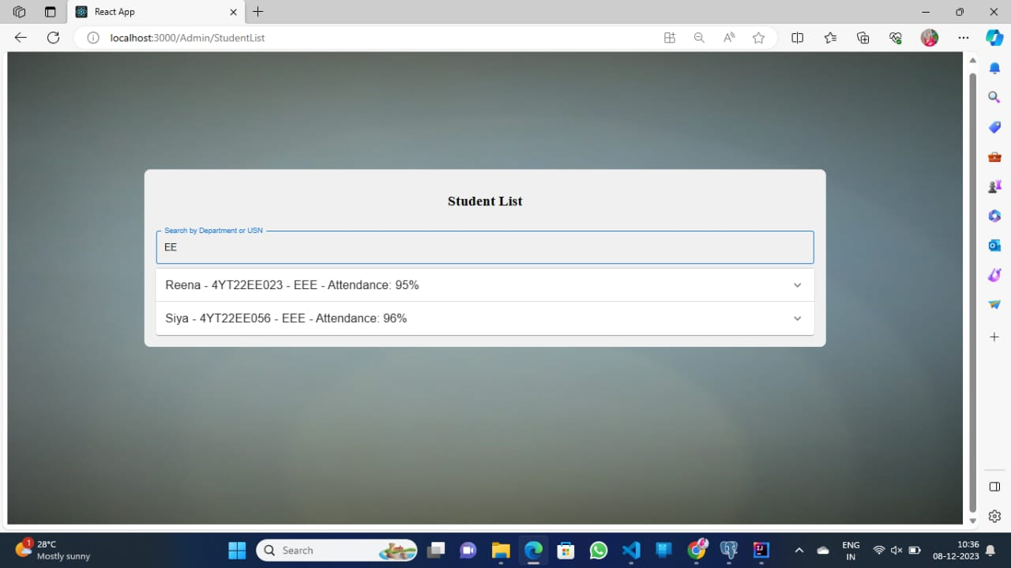**8.5 Student List Page**

**8.6 Trash Page**

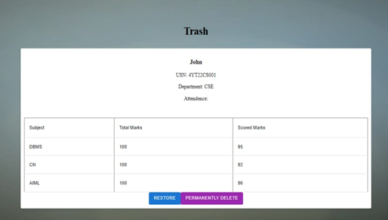

**CHAPTER 9**

**REFLECTION**

**9.1 Technical Learnings**

**9.1.1 React.js Proficiency**

* Initial Experience: Starting with limited knowledge, the internship provided an opportunity to dive into React.js deeply.
* Skill Development: Gained proficiency in creating efficient and reusable components, understanding state management, and utilizing React hooks effectively.
* Impact: Improved ability to build dynamic user interfaces and contribute to the development of a feature-rich e-commerce website.

**9.1.2 Component-Based Architecture**

* Understanding: Grasped the principles of component-based architecture and its advantages in terms of code organization and reusability.
* Application: Applied the knowledge to design and develop modular components for both admin and user interfaces.
* Outcome: Enhanced code maintainability and flexibility in accommodating future feature expansions.

**9.2 Project Management Skills**

**9.2.1 Collaborative Coding**

* Collaboration Approach: Embraced collaborative coding practices, leveraging tools like Visual Studio Code Live Share.
* Impact: Facilitated real-time collaboration among team members, leading to faster issue resolution and improved code quality.
* Lesson Learned: Recognized the importance of teamwork in achieving project goals.

**9.3 Personal Growth**

**9.3.1 Adaptability**

* Adaptation to New Technologies: Successfully adapted to the React.js library and other technologies used in the project.
* Lesson Learned: Developed the ability to quickly learn and apply new technologies, showcasing adaptability in a dynamic work environment.

**9.3.2 Resilience in Problem-Solving**

* Challenges Faced: Encountered technical challenges, especially during the integration phase.
* Response: Demonstrated resilience by seeking assistance, researching solutions, and persistently working towards problem resolution.
* Lesson Learned: Cultivated resilience and problem-solving skills in the face of complex technical issues.

**9.3.3 Growth Mindset**

* Mindset Shift: Transitioned from a fixed mindset to a growth mindset throughout the internship.
* Mindset Characteristics: Embraced challenges as opportunities for learning, viewing failures as stepping stones to success, and maintaining a positive attitude towards continuous improvement.
* Lesson Learned: Understood the transformative power of a growth mindset in personal and professional development.

**9.3.4 Future Development Goals**

* Continuous Learning: Recognized the need for continuous learning in the rapidly evolving field of web development.
* Goals: Setting goals for ongoing improvement in React.js proficiency, exploring additional frontend frameworks, and deepening understanding of backend technologies.

**CHAPTER 10**

**CONCLUSION**

In conclusion, the internship experience involved the development of a Student Grade Book System utilizing React.js. This project not only provided a hands-on opportunity to enhance my programming skills but also deepened my understanding of web development and user interface design. The implementation of React.js allowed for the creation of a dynamic and responsive user interface, significantly improving the overall user experience.

Throughout the internship, I faced and overcame various challenges, gaining valuable problem-solving and debugging skills. Collaborating with the development team exposed me to industry best practices and fostered a sense of teamwork and effective communication. The feedback received from mentors and end-users played a crucial role in refining the system, emphasizing the importance of user feedback in software development.

Furthermore, the project underscored the significance of adopting modern technologies like React.js to build scalable and maintainable applications. The versatility of React.js in handling complex user interfaces and managing state efficiently became evident as the project progressed.

**BIBLIOGRAPHY**

**REFERENCES**

**Journals:**

[1]<https://www.researchgate.net/publication/371858033_A_Student_Grading_Management_System_a_Case_Study_of_Mbarara_Army_Senior_Secondary_School>

[2]<https://www.researchgate.net/publication/359120519_STUDENT_INFORMATION_MANAGEMENT_SYSTEM>

**Text Books:**

[1] Robin Wieruch, “[The Road to Learn React: Your Journey to Master Plain Yet Pragmatic React.Js](https://www.google.com/search?sca_esv=586895506&cs=0&sxsrf=AM9HkKnTyQN_3M4OPd4ofQg_4Oo1fbhgdQ:1701420662433&q=The+Road+to+Learn+React:+Your+Journey+to+Master+Plain+Yet+Pragmatic+React.+Js&stick=H4sIAAAAAAAAAG2RP4jTUBzHk-CF3OsdNimKxuVZQUoH0yS20QOtWG85rnjEIt6ipMlLm5qXV1-eMckkgvvh4ObiooM4i4MUNx0cBF0E8Q8ILjrqaMPRHAe-4cHn976f9378nrRUX9VGmq7Hpjn0zk4t4xhFPqIochEcEnIT-oRCihyXwUn8lt8fXrDf0uk4THHJed7yh5G74HGL-aaPzyzYbesxi3JzL5_dmVqTkic4nk5yMy3zeorx2E3K-3TcbhvW3vs6zaxOcuMb_0KoVH_-_VxTnwsPnr35yD8RQHWTkBiFmY1ChyFvQJTDQFyPWMAyZUUFQNKw1vI6I6rc50HlCmID0ide4GdKorD_2EdL-6C6CiqFrRuhnqSJsr7f7yinwXIf4SGi8WVfOQFAj4QhcllAIuWQWgOy5pYFrZh2vCY0-Pot4_rL9w_fiddkbr5-2PYFtdGUgXiJYCeI5Ksns4tf-e_dZg1IAyclEcGZ3PvU-zLzf3frx5cL6ZH1q1vYd4Pz52ZHeHigwelF_c8Ha9bkdgT-3qunr0VJ4qucIUhczq08XuoPxgjaxPEgI3ATOTSCdvHxa3Cb3KZwY75FKCsO-07MEIVb4bwduI0Y3KLOCDsscHeNU3Aj3hH5f9awr3ddAgAA&sa=X&ved=2ahUKEwju-8jx7e2CAxWG-jgGHQmCAFQQ7fAIegQIABAO)”.

[2] Ludovico Fischer, “React for Real: Front-End Code, Untangled”