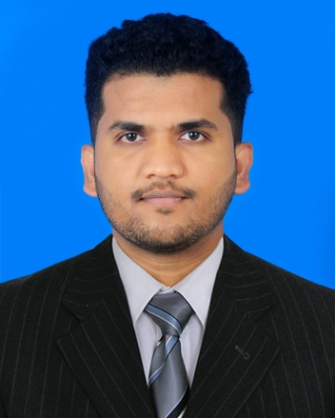

**AFSAL MADATHINGAL**

**OBJECTIVE**

Highly skilled and experienced data entry professional with a proven track record of accuracy and efficiency in managing data entry tasks. Seeking a challenging position in a dynamic organization where my expertise can be utilized to contribute to the company's success.

**CONTACTS**

**WORK EXPERIENCE**



* **DATA ENTRY CLERK (SAP , MYCOM)**

**SAUDIA GROUP OF COMPANIES**

DOHA, QATAR

**3 YEAR**

* Entered and updated invoices and other relevant data into the company's database.
* Assisted in preparing reports and presentations by collecting and organizing data.
* Maintained proper filing and organization of physical and electronic documents.
* **CYBER CAFE ADMINISTRATOR**

**PINNACLE INTERNET CAFE**

KERALA INDIA

**3 YEARS**

* Monitor and maintain the availability and functionality of computer systems, peripherals, and network infrastructure in the cyber cafe.
* Install, update, and configure software applications, antivirus programs, and operating systems on computers.
* Maintain knowledge of the latest technology trends and security measures to ensure a secure and up-to-date cyber cafe environment.

Doha . Qatar

+974 74457582

Afsalshaofficial@outlook.com





**EDUCATION**

* **+2 (HIGHER SECONDARY)**

KERALA ,INDIA

* **SSLC ( HIGH SCHOOL)**

KERALA, INDIA

**PASSPORT DETAILS**

* NO : N3032624
* VALIDITY : 15/10/2025

**COMPUTER SKILL**

* **SAP Business one**
* **Basic Coding (c)**
* **Typing (40 WPM)**
* **Photoshop**

**PERSONAL DETAILS**

**LANGUAGES KNOWN**

* Date of birth : 09/07/1997
* Gender : Male
* Nationality : Indian
* Marital status : Single
* English
* Hindi
* Tamil
* Malayalam

**SKILLS**

* Good communication skill
* Energetic, Dynamic and result oriented nature
* Honestly and hardworking
* Obedience to superiors

**DECLARATION**

I hereby declare that the information provided in this CV is true and accurate to the best of my knowledge. I understand that any false statement may lead to disqualification from further consideration for the job.