**Topics: Descriptive Statistics and Probability**

1. Look at the data given below. Plot the data, find the outliers and find out $μ, σ, σ^{2}$

|  |  |
| --- | --- |
| **Name of company** | **Measure X** |
| Allied Signal | 24.23% |
| Bankers Trust | 25.53% |
| General Mills | 25.41% |
| ITT Industries | 24.14% |
| J.P.Morgan & Co. | 29.62% |
| Lehman Brothers | 28.25% |
| Marriott | 25.81% |
| MCI | 24.39% |
| Merrill Lynch | 40.26% |
| Microsoft | 32.95% |
| Morgan Stanley | 91.36% |
| Sun Microsystems | 25.99% |
| Travelers | 39.42% |
| US Airways | 26.71% |
| Warner-Lambert | 35.00% |

Ans:

Mean: 0.333

Variance: 0.029

Standard Deviation: 0.169

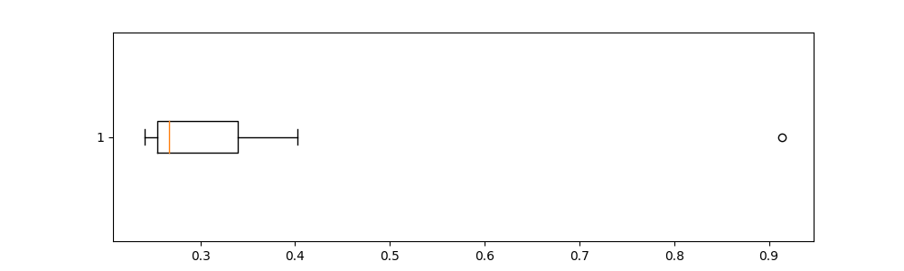

The following is the outlier in the boxplot: Morgan Stanley 91.36%



Answer the following three questions based on the box-plot above.

1. What is inter-quartile range of this dataset? (please approximate the numbers) In one line, explain what this value implies.

Ans: Approximately

(First Quantile Range) Q1 = 5

(Third Quantile Range) Q3 = 12,

Median (Second Quartile Range) = 7

(Inter-Quartile Range) IQR = Q3 – Q1 = 12 – 5 = 7

1. What can we say about the skewness of this dataset?

Ans: Right-Skewed median is towards the left side it is not normal distribution

1. If it was found that the data point with the value 25 is actually 2.5, how would the new box-plot be affected?

Ans: In that case there would be no Outliers on the given dataset because of the outlier the data had positive skewness it will reduce and there will be a chance to be the data normal distributed.



Answer the following three questions based on the histogram above.

1. Where would the mode of this dataset lie?

Ans:

The mode of this data set lies in between 4.5 to 10.

1. Comment on the skewness of the dataset.

Ans:

There is a one outlier in right. It is Right-Skewed. Mean>Median.

1. Suppose that the above histogram and the box-plot in question 2 are plotted for the same dataset. Explain how these graphs complement each other in providing information about any dataset.

Ans:

They both are right-skewed and both have outliers the median can be easily visualized in box plot where as in histogram mode is more visible.

1. AT&T was running commercials in 1990 aimed at luring back customers who had switched to one of the other long-distance phone service providers. One such commercial shows a businessman trying to reach Phoenix and mistakenly getting Fiji, where a half-naked native on a beach responds incomprehensibly in Polynesian. When asked about this advertisement, AT&T admitted that the portrayed incident did not actually take place but added that this was an enactment of something that “could happen.” Suppose that one in 200 long-distance telephone calls is misdirected. What is the probability that at least one in five attempted telephone calls reaches the wrong number? (Assume independence of attempts.)

Ans:

the probability of a call being directed correctly (*p*)= 199/200=0.995

the probability of at least one misdirected call in five attempts= 1-*p*5 =1-0.9955 = 0.0248

or

the probability of a call being misdirected (*p*)= 1-*p* = 1/200= 0.005

the probability of a call being directed correctly (*q*) = 1-*p* = 0.995

the probability of at least one misdirected call in five attempts= ⁿCₓ *p*x *q*n-x P(x)

= (5C1) (0.0051) (0.9954) = 0.0248

1. Returns on a certain business venture, to the nearest $1,000, are known to follow the following probability distribution

|  |  |
| --- | --- |
| x | P(x) |
| -2,000 | 0.1 |
| -1,000 | 0.1 |
| 0 | 0.2 |
| 1000 | 0.2 |
| 2000 | 0.3 |
| 3000 | 0.1 |

1. What is the most likely monetary outcome of the business venture?

Ans:

The most likely monetary outcome of the business venture is 2000$ As for 2000$ the probability is 0.3 which is maximum as compared to others

1. Is the venture likely to be successful? Explain

Ans:

* Expected Value (Mean):

The expected value 

= -2000 x 0.1 -1000 x 0.1+0 x 0.2+ 1000 x 0.2+ 2000 x 0.3 + 3000x 0.1

= 800

expected value is positive, it suggests that, on average, the venture is profitable.

* Cumulative Probability:

the probability that the venture will make a profit or more than zero

P(X>0) = p(x>0) + p(x>1000) + p(x>2000) + p(x=3000)

= 0.2+0.2+0.3+0.1 = 0.8

this states that there are a good 80% chances for this venture to be making a profit

1. What is the long-term average earning of business ventures of this kind? Explain

Ans:

The long-term average is Expected value = 800 which means on an average the returns will be + 800$

1. What is the good measure of the risk involved in a venture of this kind? Compute this measure

Ans:

The standard deviation / variance gives an indication of how spread out the possible outcomes are from the expected value. A higher standard deviation / variance implies greater variability or risk.

= 800

= 2800000

 = 2160000

standard deviation=1469.7