Software Development
Specification
For
Campus Management System
(CMS)

Prepared By
Afsana Rahman (1430458042)
Fozle Rabbi(1610737042)
Sumaia Rahman(1430058042)

North South University, Dhaka
Software Engineering (SE)
22 July 2019

Table of Contents

1. Diagrams
1.1 E-R Diagram
1.2 Database Schema
1.3 UML Diagrams
1.3.1 Use Case Diagram
1.3.2 Class Diagram
1.3.3 Sequence Diagram

  - E-R Diagram
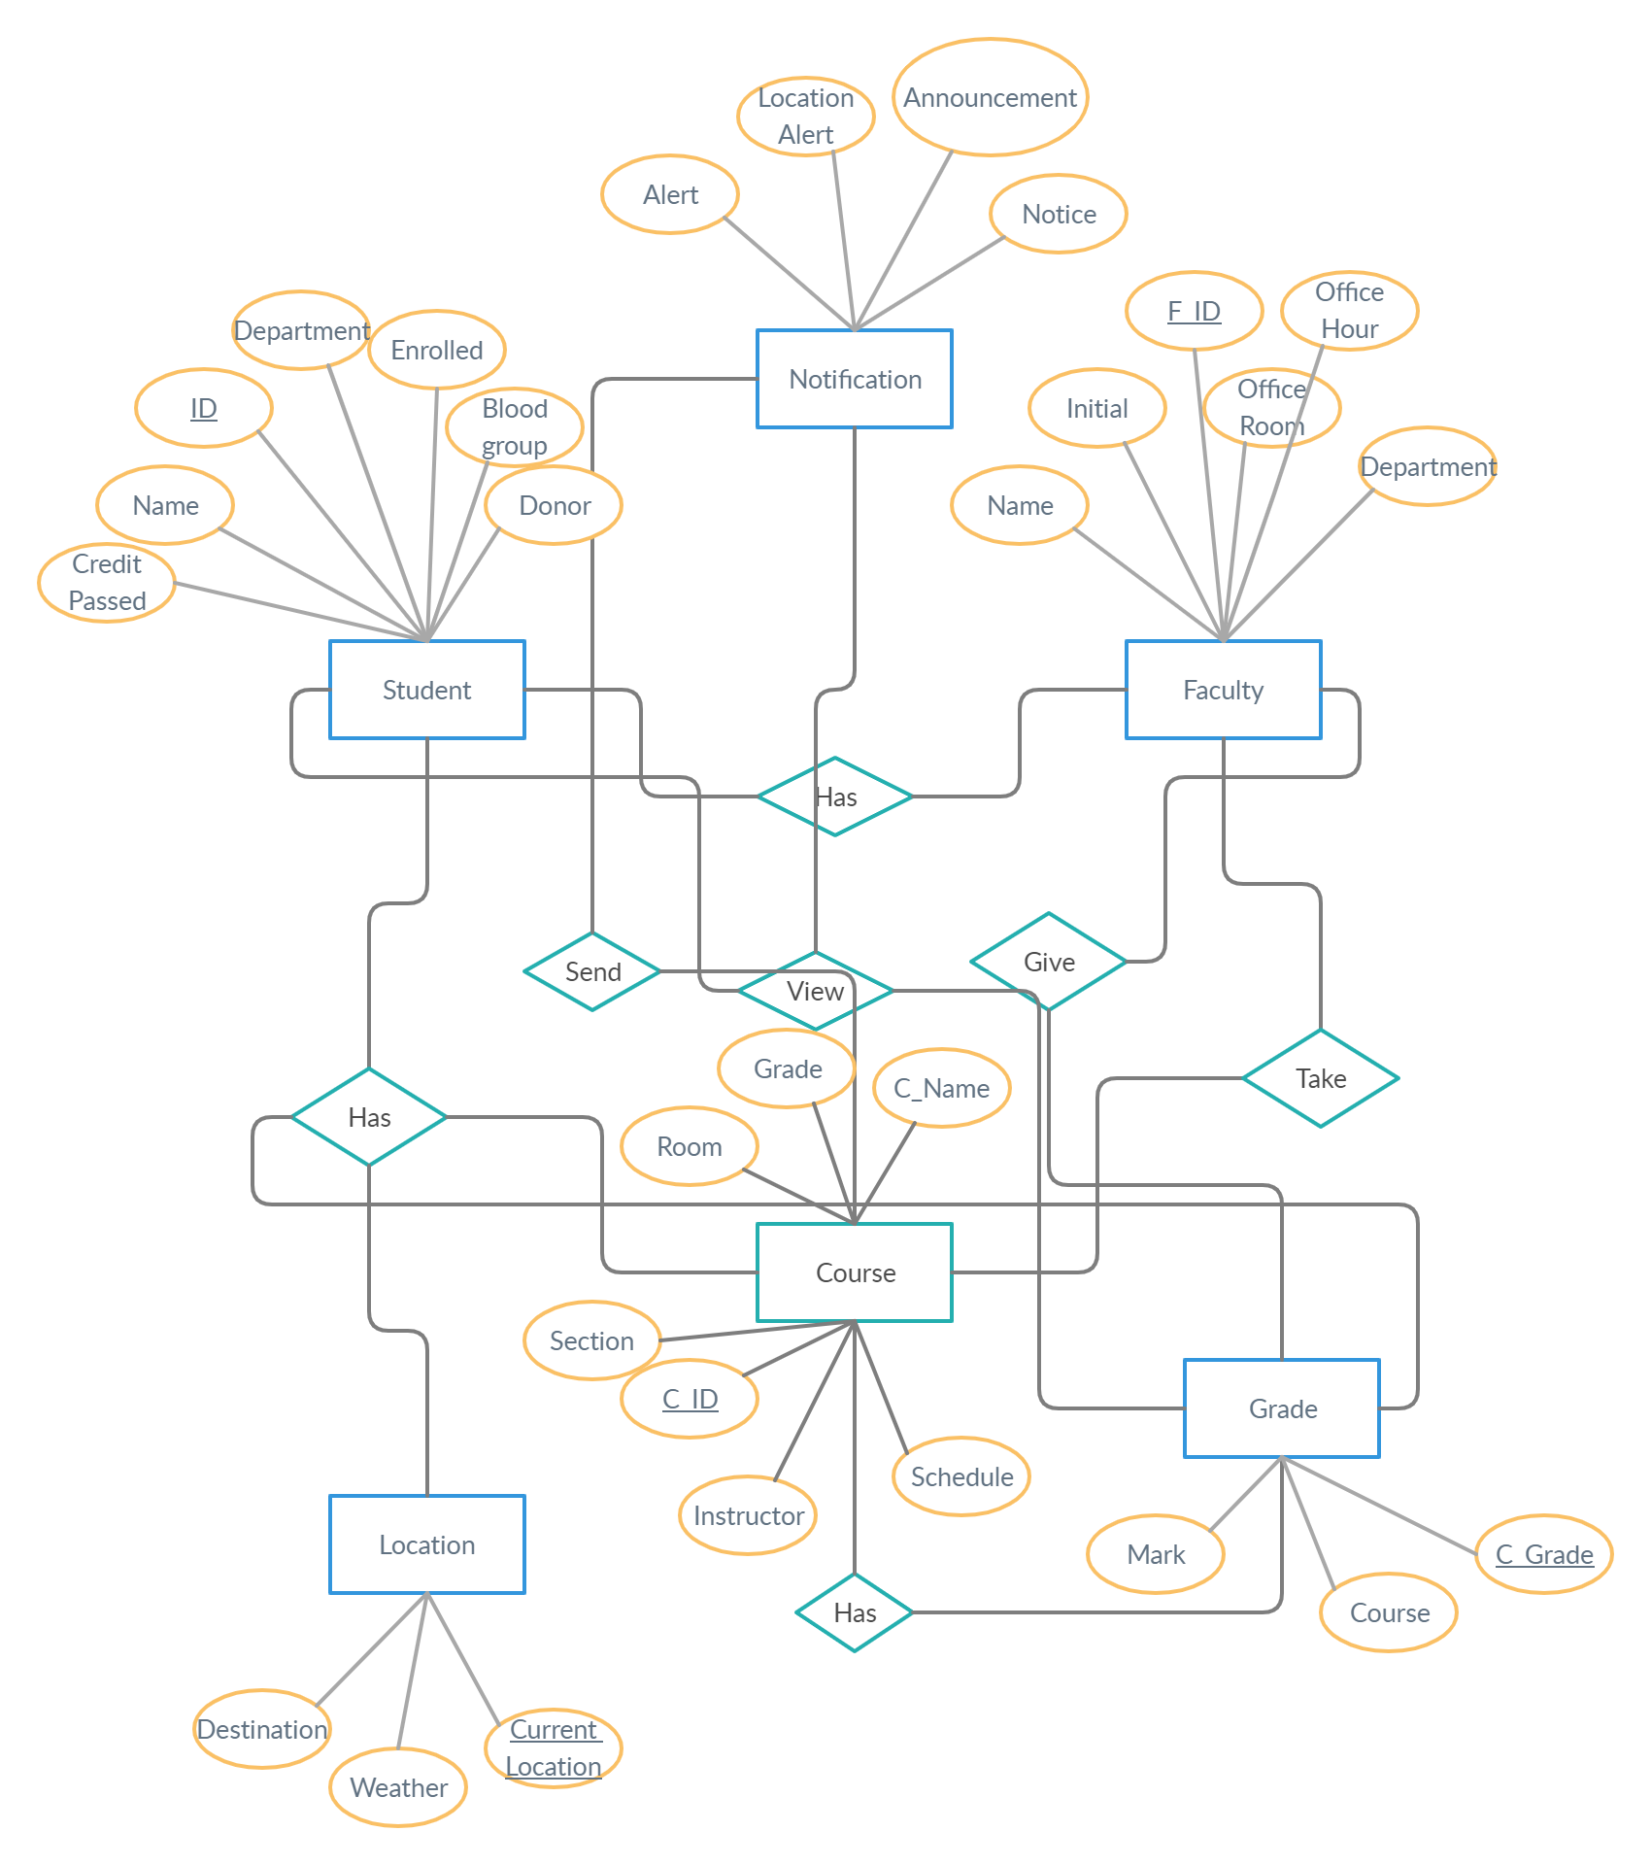
Campus Management System

  - Database Schema
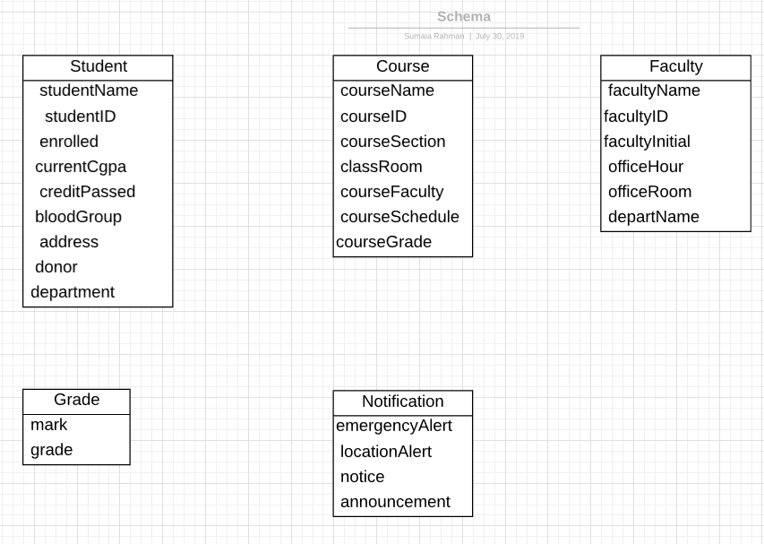

  - UML Diagram
1.3.1 Use Case Diagram
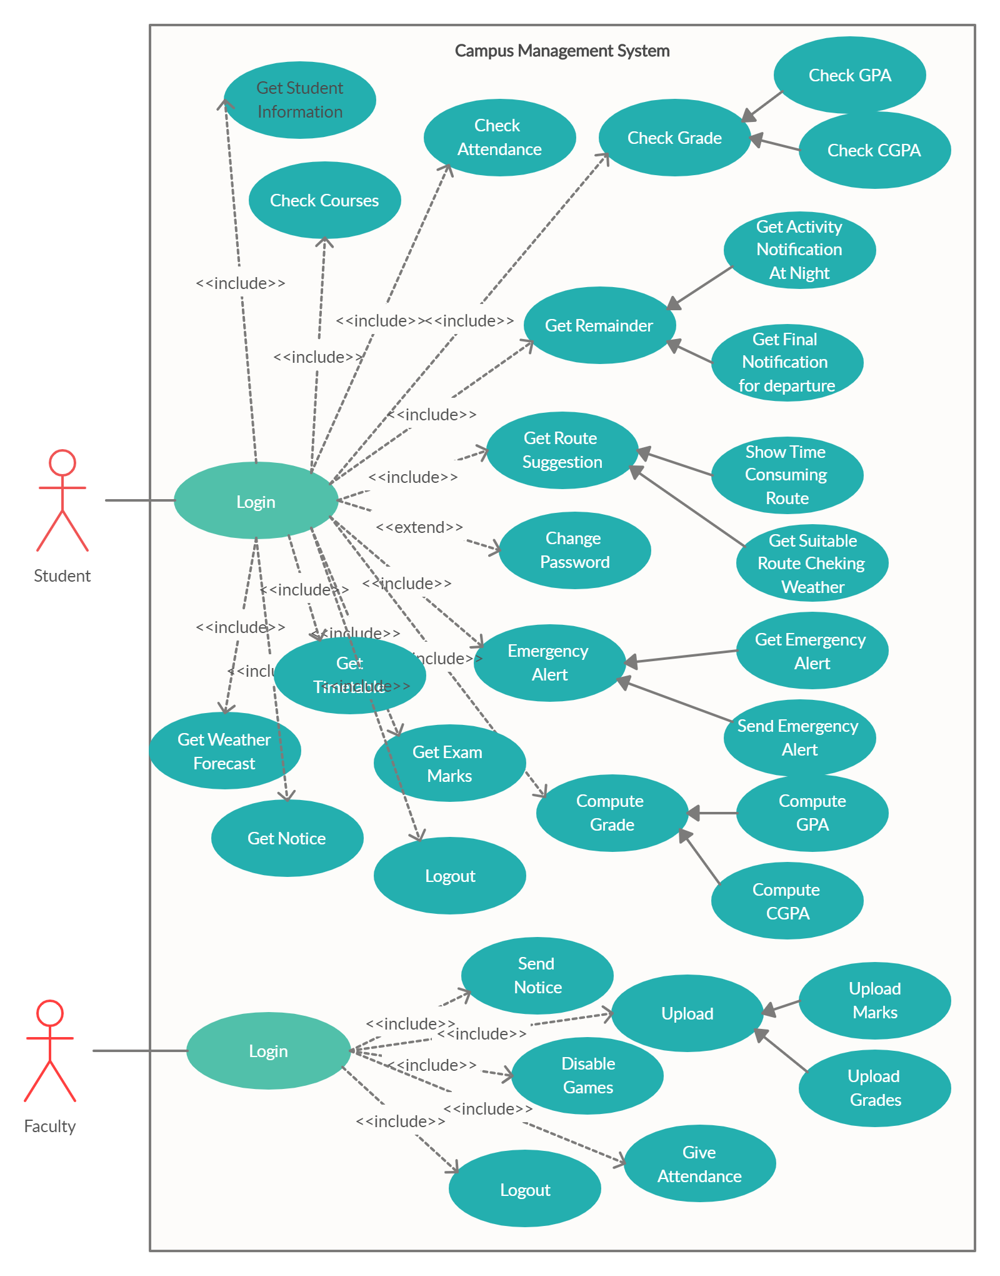
Use Case Scenario:

Use Case Name: Get Student Information

Actors: Students

Precondition: Students must login to the system

Scenario:
1. Students login to the system by using their ID and password.
2. Student selects the profile.
3. Student selects the student information.

Exception:
The student puts wrong username or password.

Post condition:
The student can view their information.

Use Case Scenario:

Use Case Name: Check or compute grades.

Actors: Students

Precondition: Students must login to the system

Scenario:
1. Students login to the system by using their ID and password.
2. Student selects the grades.
3. Student selects the grade history to see their grades or student selects the compute grades to calculate their grades.

Exception:
The student puts wrong username or password.

Post condition:
The student can view their grades and student can compute their grades.

Use Case Scenario:

Use Case Name: Check courses

Actors: Students

Precondition: Students must login to the system

Scenario:
1. Students login to the system by using their ID and password.
2. Students go to the menu.
3. Student selects the course status.

Exception:
The student puts wrong username or password.

Post condition:
The student can view their previous courses, sections, faculty initials, schedule, room number and grades.

Use Case Scenario:

Use Case Name: Get Time table

Actors: Students

Precondition: Students must login to the system

Scenario:
1. Students login to the system by using their ID and password.
2. Students can view their timetable at the homepage.

Exception:
The student puts wrong username or password.

Post condition:
The student can view their current semester’s courses, schedule, faculty initials, section number, and room number in the home page.

Use Case Scenario:

Use Case Name: Send Notice

Actors: Faculty

Precondition: Faculty must login to the system.

Scenario:
1. Faculties login to the system by using their initials and password.
2. Faculty selects the menu.
3. Faculty selects the send notification for sending notice.
4. Faculty sends notice.

Exception:
The Faculty puts wrong username or password.

Post condition:
The faculty can send a notice to every students of a particular section.

1.3.2 Class Diagram

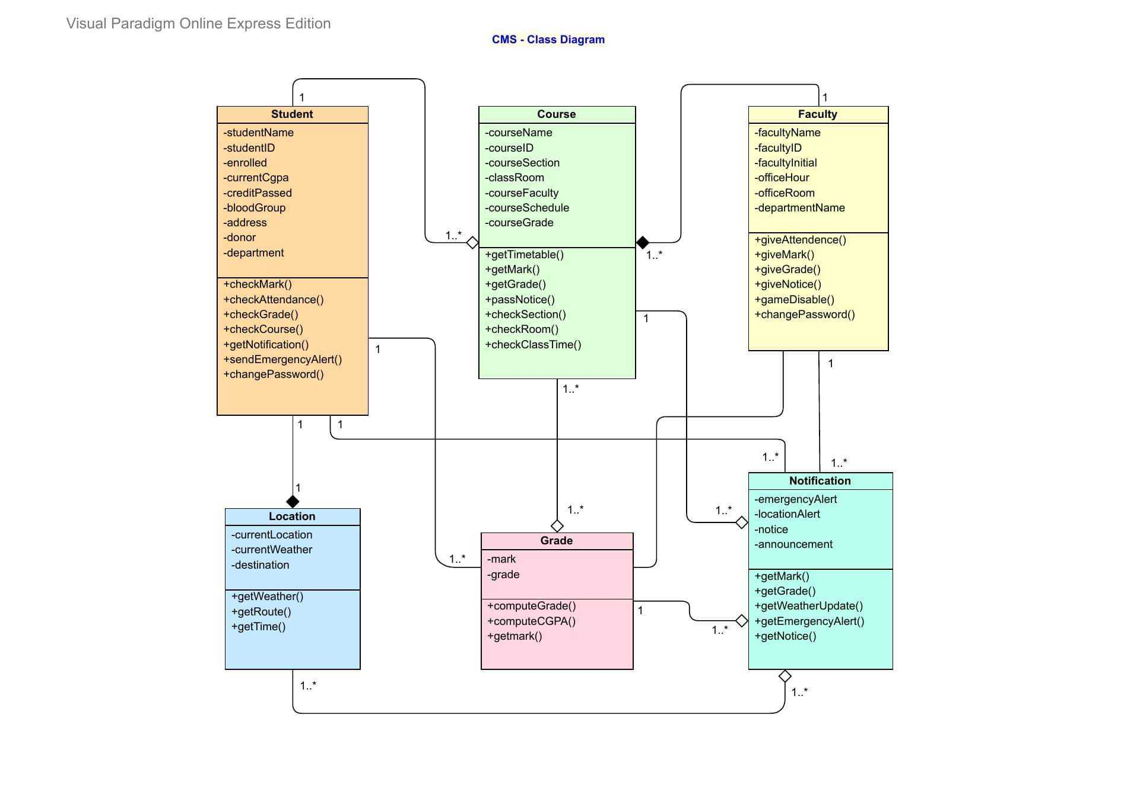

1.3.3 Sequence Diagram

Sequence diagram for login

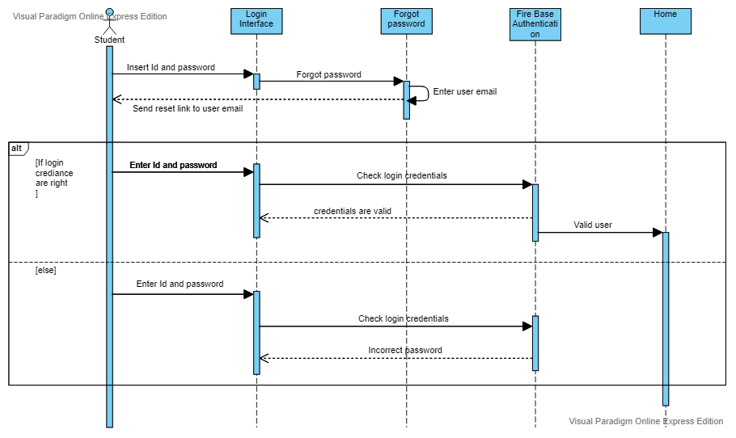

Sequence Diagram for checking grades
