**Title: Pattern-based digital lock system**

**Primary Part**

**Input:** The users will be provided with a keypad for giving input to the system.

**Output:**There will be two types of displays.

Display 1: Any input given by the users through keypad will be displayed here. at a time 4 values must be displayed. If more values are provided by the user always the oldest value must be removed to accommodate the latest value. It is mandatory to use 7 segments for this purpose

Display 2: If the pattern is correct the result will be displayed in this display. The result can be just a letter printed on the 7 segments (O/N).

**Modes:** There will be two modes to operate the lock. In mode 1 the user can store a specific pattern. In mode 2, the user can input a pattern that will be matched with the stored pattern.

**Sample pattern:** The pattern will consist of the 4 digits.

[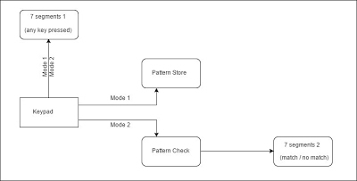](https://sites.google.com/site/neuro11school/cse-231/cse231-project-spring/project.jpg?attredirects=0)

Block Diagram of the System

**Secondary Part**

Users will be able to store 3 Patterns. Patterns can be of any length. (max 5)

While checking an input pattern all stored Patterns must be checked.

There will be a button for Admin mode. Admin will be able to check the Patterns one after another

Admin will be able to edit the Passwords.

Admin will be able to delete the Patterns sequentially or selectively.

The displays will automatically be off if no input is received for n second