**Configure and Verify Layer 2 Protocols:**

CDP and LLDP, serve the same purpose, identify neighbour devices, LLDP is an industry standard

and CDP is Cisco proprietary. CDP is used for many purposes in our current network like device

identification and carrying vlan information for cisco devices. The voice vlan in Cisco switches

carried by CDP packets to ip phone, if you have other vender such as Avaya phone, you can use

LLDP to send the voice vlan information LLDP packets just like CDP.

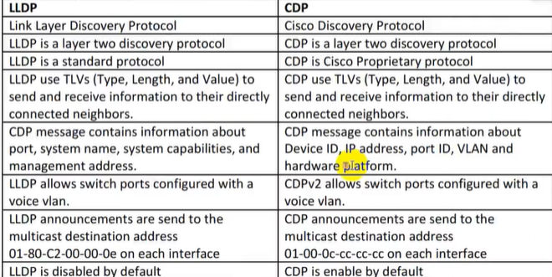

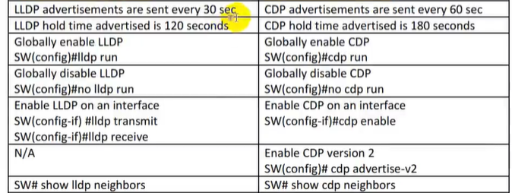

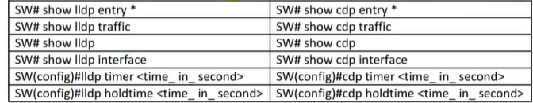

# 



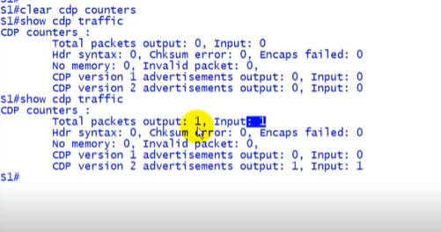

* Here we stopped getting neighbour info from some interface.
* It will helpful in attacking

**OverAll Command For CDP :**

* **S1# Cdp run**
* **S1# no cdp run**
* **S1(config)# cdp enable**
* **S1(config)# no cdp enable**

**S1(config)#interface g0/0**

**S1(config-if)# no cdp enable**

