**Redundancy:**

* Redundancy, Failover, High Availability, Clustering, RAID and Fault-tolerance.
* A good network design provides the redundancy in devices and network links.
* Redundancy is basically extra hardware or software that can be used as backup.
* If the main hardware or software fails or link fail or unavailable in case of emergency.
* It is method for ensuring network availability in case of network device or path failure.
* It is method for ensuring network availability in case of network device unavailability.
* Network redundancy i* process through which additional or alternate instances of network
* devices, equipment & communication mediums are installed within network infrastructure.
* Redundancy can be achieved via failover, load balancing & high availability in automatically.
* High availability is a feature which provides redundancy and fault tolerance automatically.
* High Availability is a number of connected devices processing and providing a services.
* The goal is to ensure this service is always available even in the event of a failure or down.
* Clustering is similar to redundant servers & provides fault tolerance in case of emergency.

**First-Hop Redundancy Protocols:**

* FHRP is a term which is stands for First Hop Redundancy Protocol.
* FHRP provide redundancy & load balancing of default gateway (First Hop).
* FHRP connecting multiple physical router & treat as one or more logical router.
* FHRP connecting multiple physical switch, which work as gateway for LAN devices.
* FHRP allow for transparent fail-over at the first-hop Cisco IP Router or Cisco Switch.
* FHRP protocols protect against a single point of failure for the default gateway.
* FHRP provide load balancing if multiple uplinks are available at first-hop routers.
* FHRP two or more routers sharing a single MAC and IP (Internet Protocol) address.
* There are three types of FHRP protocol which are Cisco HSRP, VRRP and Cisco GLBP.

**FHRP Working:**

* Creating group of Physical gateway using Layer 3 device Router or Switches.
* Agree to assign one virtual IP address, which same to all first hop devices.
* Virtual IP (Internet Protocol) going to use as gateway address to all LAN device.
* The FHRP creating one or more Virtual MAC (Media Access Control) address.
* One first hop is respond Address Resolution Protocol request (Active/AVG/Master).
* It is using the keepalives messages in order to get Virtual gateway status.
* LAN devices use Virtual IP & MAC (Media Access Control) address as default gateway.

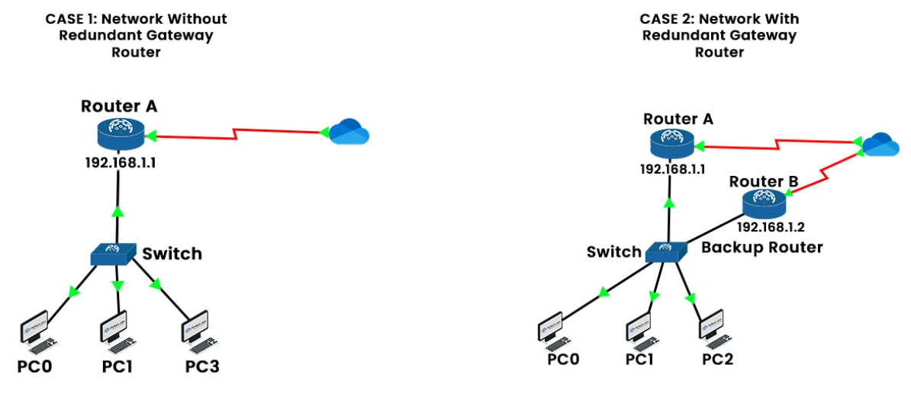

**HSRP (Hot Standby Router Protocol):**

* HSRP stands for Hot Standby Router Protocol & Cisco proprietary protocol.
* There are two versions of Hot Standby Router Protocol (HSRPv1 & HSRPv2).
* Two or more Cisco Routers or Switches on LAN segment form an HSRP group.
* In HSRP, one Cisco Router or Switch assumes the function of "Active" Device.
* In HSRP, other Routers or Switches is known as "Standby/' Router or Switch.
* In HSRP, the highest priority gateway is elected as active gateway of group.
* In HSRP the active gateway is the owner of Virtual MAC & Virtual IP address.
* In HSRP, the default priority is set to 100 but it can be easily modified (0-255).
* Highest interface IP as the tiebreaker and preempt option is disabled by default.
* HSRP Version 1 uses Multicast Address 224.0.0.2 for sending the Hello traffic.
* HSRP Version 2 uses Multicast Address 224.0.0.102 for sending the Hello traffic.
* In HSRP, the messages can be authenticated using the clear text or the MD5.
* HSRP Version 1 allows for group numbers ranging from O — 255 not more then.
* HSRP Version 2 allows for group numbers ranging from O — 4095 which is more.
* HSRP Version 1 virtual MAC 0000. Oc07.acxx. (XX is group no. {0-255}).
* HSRP version 2 virtual MAC 0000. Oc9f.fXXX. (XXX is group no. {0-4095}).
* HSRP Version 2 support IPv6 address but HSRP version 1 doesn't support IPV6.
* HSRP Version I and HSRP Version 2 are not compatible with each other.
* Load sharing using multiple groups and virtual IP with priority modification.
* In HSRP Version I & 2 Default Hello time is 3 seconds, Hold time is IO seconds.
* On Cisco Router or Switches By default, version I is enable until version 2 enabled.
* By default, in all Cisco Routers or Cisco Switches have priority 10011

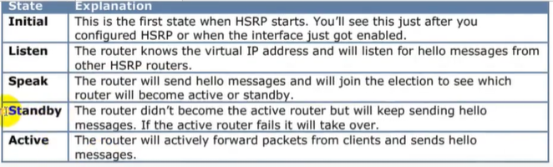

 On both routers internal interfaces acquire this ip by this method.

