**NAT on Cisco Router:**

* NAT is a cisco term which is stand for Network Address Translation.
* NAT is a process that involves translating Private IP into Public IP addresses.
* The process of translating one IP address to another is known as a NAT,
* Router and Firewall is a device, which is used for network Address Translation.
* There are many forms and kinds of Network Address Translation (NAT).
* Network Address Translation used to reduce requirement of the Public IP address.
* Network Address Translation increase security of Internal Computer Networks.
* NAT Translate Private IP into Public IP address & Public IP into Private IP address.
* NAT used to connect a device with Private IP address to the Internet or WAN.
* Network Address Translation hide an organization internal network from external.
* Network Address Translation (NAT) modifies only the Layer 3 header of IP address.
* PAT, translation of an IP address and Port to another IP address and Port number.
* Port Address Translation (PAT) modifies both the Layer 3 and Layer 4 header of IP.

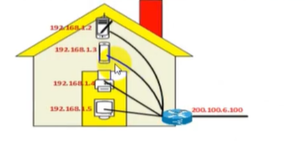

**NAT:**

Network Address Translation, or NAT, implies a translation of an IP address to another IP

address. Network Address Translation (NAT) modifies only the Layer 3 header of IP.

**PAT:**

Port Address Translation, or PAT, implies a translation of an IP address and Port to another IP

address and Port. PAT modifies both Layer 3 and Layer 4 header. PAT as a subset of NAT.

Static vs Dynamic:

Both a NAT and a PAT can exist in two forms: Static NAT or Dynamic NAT.

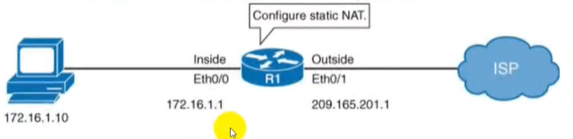

**Static NAT:**

A Static mapping is sometimes referred to as a One-to-One translation. Static NAT translation is

bidirectional. Whether the internal host or the external host sent the first packet, it would

"pass through" the Static NAT. Static NAT is used to do a one-to-one mapping between an

inside address and an outside address. Static NAT also allows connections from an outside host

to an inside host.

**Dynamic NAT:**

A Dynamic mapping is sometimes referred to as a One-to-Many— implying that in a Dynamic

translation, many addresses can appear as one. Dynamic NAT is used when you have a "pool"

of public IP addresses that you want to assign to your internal hosts dynamically.

**Static NAT:**

Static NAT implies a translation of single IP address to another single IP address. Static NAT

modifies only the L3 header. Static NAT is useful when a network device inside a private

network needs to be accessible from internet.

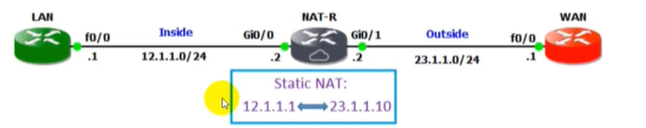

**Dynamic NAT:**

Translation of just the IP address, where the device determines the new IP address after

translation. Dynamic NAT can be defined as mapping of a private IP address to a public IP

address from a group of public IP addresses called as NAT Pool.

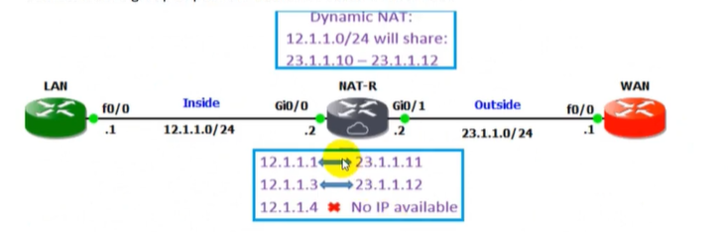

**PAT (Port Address Translation):**

PAT is another type of dynamic NAT, which can map multiple private IP addresses to a single

public IP address by using a technology known as Port Address Translation. When a client from

inside network communicate to a host in the internet, the router changes the source port

number with another port number. These port mappings are kept in a table. When the router

receives data packet from internet, it will refer the table, which keep the port mappings and

forward the data packet to the original

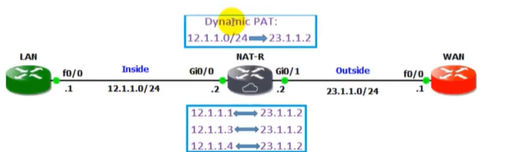

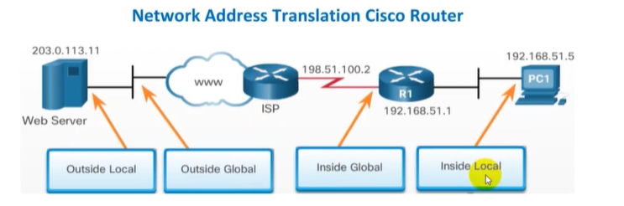

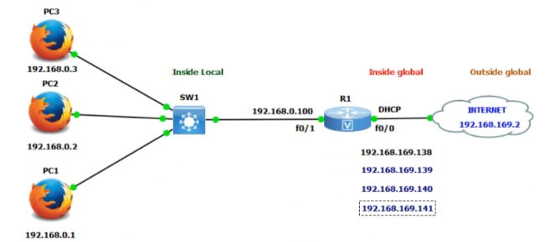

**Static NAT Configuration:**

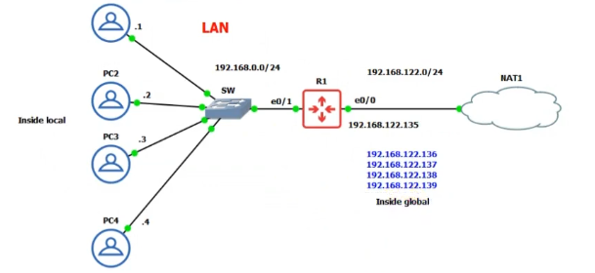

R1(config-if)#ip address dhcp [interface e0/0]

R1(config-if)#ip address 192.168.0.100 [interface e0/1]

R1(config)#ip name-server 8.8.8.8

R1(config)#ip domain-lookup

This uses google search engine for ip to name and name to ip.

R1(config)#ip nat inside source static 192.168.0.1 192.168.122.136

.

.

.

R1(config-if)#ip nat outside [interface e0/0]

R1(config-if)#ip nat inside[interface e0/1]

Configure this for every inside local private ip . now every private ip has seprate public ip.

R1(config)#show ip nat translation

To see the traffic carrier.

**Dynamic NAT:**

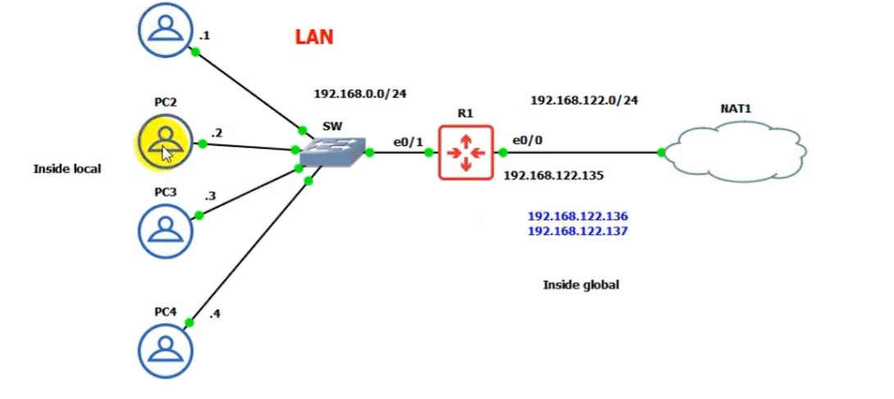

R1(config-if)#ip address dhcp [interface e0/0]

R1(config-if)#ip address 192.168.0.100 [interface e0/1]

R1(config)#ip name-server 8.8.8.8

R1(config)#ip domain-lookup

This uses google search engine for ip to name and name to ip.

R1(config)#access-list 1 permit 192.168.0.0 0.0.0.255

R1(config)#ip nat pool test 192.168.122.136 192.168.122.137 netmask 255.255.255.0

R1(config)#ip nat inside source list **1** pool **test**

R1(config-if)#ip nat inside [interface e0/1]

R1(config)#ip nat outside [interface e0/0]

**PAT:**

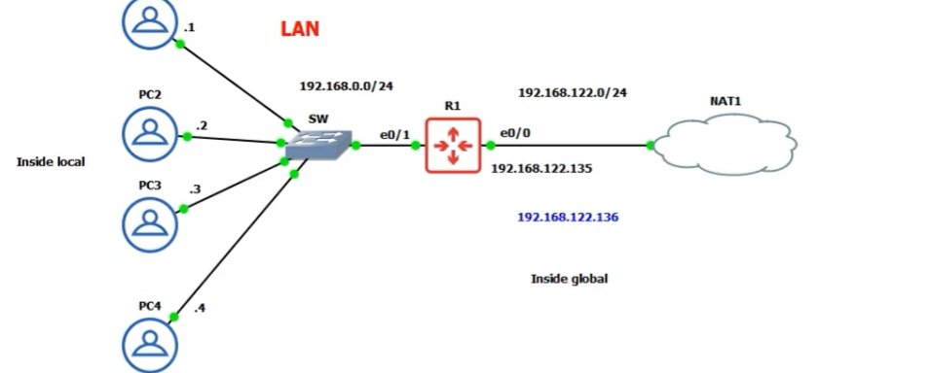

R1(config-if)#ip address dhcp [interface e0/0]

R1(config-if)#ip address 192.168.0.100 [interface e0/1]

R1(config)#ip name-server 8.8.8.8

R1(config)#ip domain-lookup

This uses google search engine for ip to name and name to ip.

R1(config)#access-list 1 permit 192.168.0.0 0.0.0.255

R1(config)#ip nat pool test 192.168.122.136 192.168.122.136 netmask 255.255.255.0

R1(config)#ip nat inside source list **1** pool **test** overload

R1(config-if)#ip nat inside [interface e0/1]

R1(config)#ip nat outside [interface e0/0]

