**DNS Server:**

* DNS Stands for Domain Name System or Domain Name Server.
* DNS is a large database, which resides on various computers in world.
* DNS contains names & IP addresses of hosts on Internet & various domains.
* DNS servers match domain names to their associated IP addresses.
* The Domain Name Systems (DNS) is the phonebook of the Internet.
* DNS convert IP Address to domain name & domain name into IP address.
* DNS names are assigned through the Internet Registries by the

IANA (Internet Assigned Numbers Authority).

* There are 13 root name servers from a.root-server.net to m.root-server.net.
* 13 DNS root name servers can be check on this link http://www.root-servers.org.
* DNS primarily uses User Datagram Protocol on port number 53 to serve requests.
* Domain name system of the Internet works in an inverted tree structure.
* The TLD is the letters immediately following the final dot in an Internet address.
* In Internet address, http://mail.google.com, com is the top-level domain (TLD) name.
* Google is the second-level domain name and mail is a subdomain name.
* Altogether, http://mail.google.com is fully qualified domain name (FQDN).
* Addition of HTTP:// makes a fully qualified domain name FQDN complete URL.

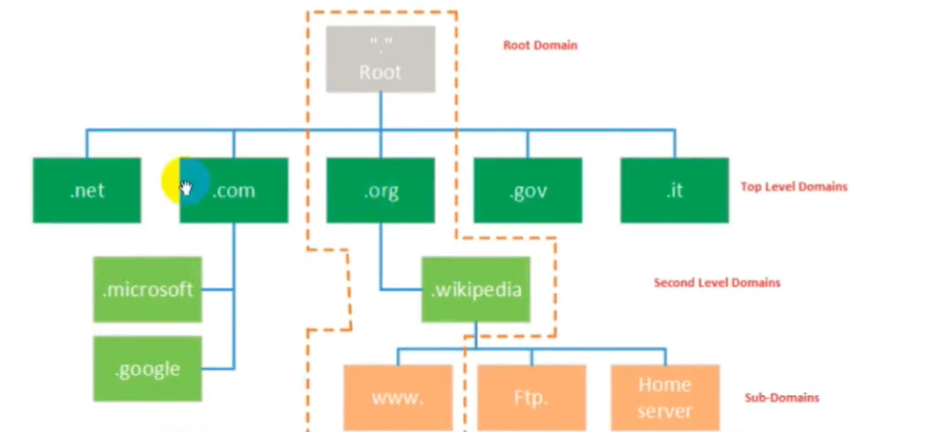

**DNS Record:**

* There are several different types of resource records used by DNS.
* The A record specifies IP address Internet Protocol (IPv4) for given host.
* A, records are used for conversion of domain names to correspond IP addresses.
* The AAAA record specifies Internet Protocol (IPv6) address for given host name.
* Domain name system also allows us to name single device but give it multiple names.
* Give it nickname or secondary name it has called Canonical Name record, or CNAME.
* CNAME records in the DNS Server are used for creating aliases of domain names.
* CNAME records are truly useful when want to alias domain to an extemal domain.
* The MX (Mail Exchanger) resource record specifies a Mail Exchange server for a DNS domain name.
* SMTP (Simple Mail Transfer Protocol) use MX resource record to route emails to proper hosts uses the information.
* PTR stand for Pointer Record, this is opposite of an address record (A or AAAA).
* An address record took a name and provided you with an IP address IPV4 or IPV6.
* A Pointer record in DNS Server took IP address and come up with a name.
* Name Server (NS) The NS record specifies who the DNS servers are for the zone.
* Start of Authority (SOA) The SOA record stores the settings for the DNS zone.

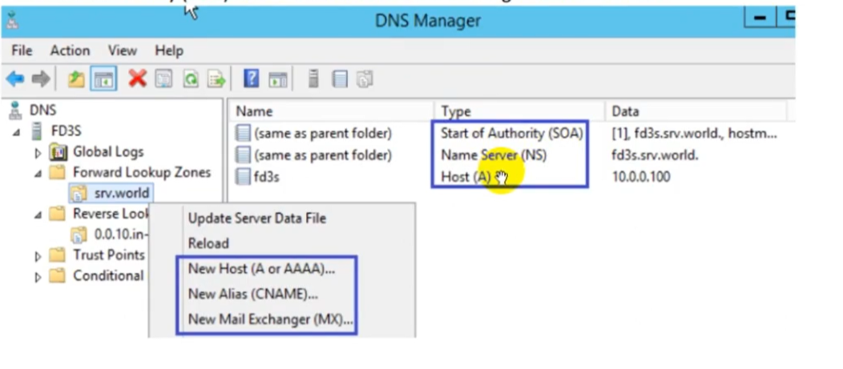

**Configure DNS Locally:**

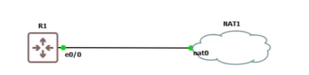

R1(config)# inter e0/0

R1(config-if)# ip address dhcp

R1(config)#ip name-server 8.8.8.8

R1(config)#ip lookup

R1(config)#exit

Now ping google.com will be working

**Create DNS Locally:**

R1(config)# ip host test 192.168.1.135 [if someone ping test it will use ip address 192…]

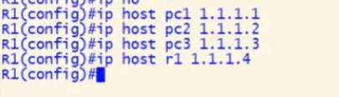

If someone ping pc1 it will utilize 1.1.1.1 ip address. And if someone ping 1.1.1.1 it will use this as destination.

**Namecheap: (domain name registrar)**

