**Syslog:**

* Syslog stands for System Logging, standard protocol used to send system log.
* Cisco network devices Routers and Switches use Syslog to send system messages.
* Cisco network devices use debug output to a local logging process inside the device.
* Syslog is used on a variety of devices to give system information to the system admin.
* Most Cisco devices use the syslog protocol to manage system logs and system alerts.
* Logging can be used for fault notification, network forensics, and security auditing.
* Syslog messages can be output to the console, local buffer or a remote syslog serve.
* Logs can include content flow, configuration changes and new software installs etc.
* Logging helps to detect unusual network traffic, network device failures, issue etc.
* The standard port for syslog is UDP port 514. However, TCP port 6514 is also used, especially when TLS encryption is enabled for security

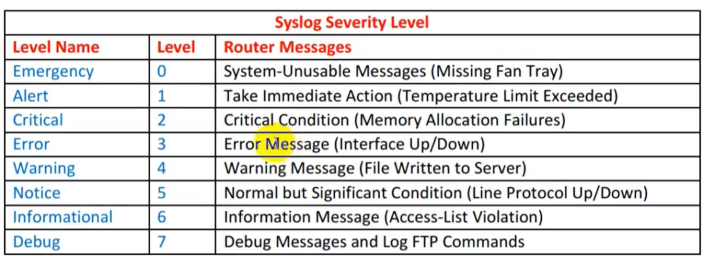

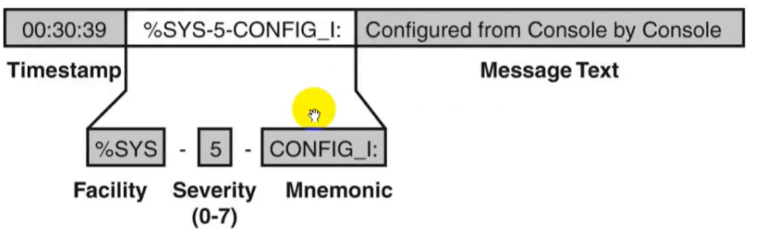

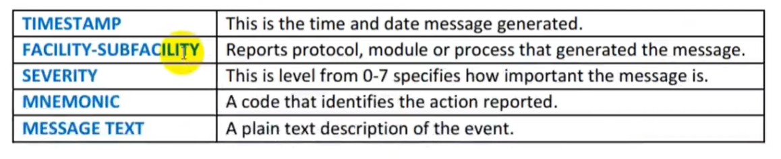

**EXAMPLE:**

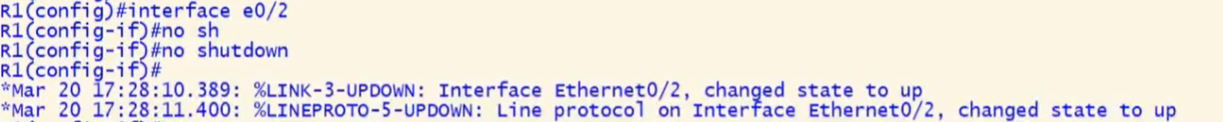

|  |  |
| --- | --- |
| **TIMESTAMP** | Mar 20 17:28:10.389: Time stamp |
| **FACILITY** | %LINK |
| **SEVERITY** | 3 |
| **MNEMONIC** | UPDOWN |
| **MESSAGE TEXT** | Interface e0/2, changed state to up |

**Commands:**

**Show logging [it will show all the logs issued by device but limited 4096 bytes buffer]**

**R1#logging on-success log**

**R1#logging on-failure log**

**Local Logging:**

* Everything happens on router or switch can be logged.
* By default, syslog messages are only displayed to the console.
* Because the logging console command is enabled by default.
* By default, the router sends all log messages to its console port.
* Only users physically connected to the router console port can view messages.
* This can be turned off with the **no logging** command.
* For local logging, Cisco IOS can save syslog messages to the internal buffer.
* Syslog messages can be output to the console or a remote syslog server.
* The logging is basically the process that generated the syslog message.

**Terminal Logging**

* It is like console logging, but it displays log messages to the router's VTY lines instead.
* This is not enabled by default. To enable it to use this command: **R1# terminal monitor**

**Buffered Logging:**

* This type of logging uses Cisco Router's & Switches RAM for storing log messages.
* Buffer has fixed size to ensure that the log will not deplete valuable system memory.
* Router accomplishes this by deleting old messages as new messages are added.
* To enable it use configuration mode command: **R1 (config)# logging buffered**

**Syslog Server Logging:**

* Router can use syslog to forward log messages to external syslog servers for storage.
* Syslog Server Logging method of type of logging is not enabled by default in devices.
* **R1 (config)# logging #serverIP**

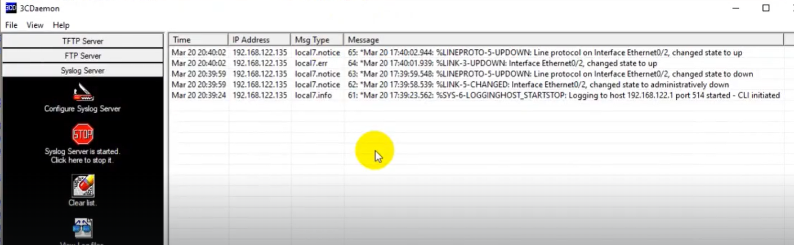

**3CDaemon** is application used as a admin for monitoring purpose. Multiple routers syslog messages can be shown into one place like admin can view what and where changes are being configured.