**SNMP (Simple Network Management Protocol)**

# **SNMP (Simple Network Management Protocol)**

* SNMP is term which is stands for Simple Network Management Protocol.
* SNMP is used to monitor and manage devices on your whole networks.
* It has several uses, from monitoring & generating alerts to device configuration.
* Simple Network Management Protocol (SNMP) is the application layer protocol.
* SNMP is the key protocol used to retrieve information from the network devices.
* SNMP is used to retrieve information from routers, switch & network servers etc.
* SNMP can be configured as Read-Only mode to retrieve only information from devices.
* SNMP Read-Write mode can be used to retrieve or configure the network devices.
* All SNMP messages are transported via User Datagram Protocol (UDP).
* SNMP agent receives requests on User Datagram Protocol (UDP) port 161.
* SNMP Traps, information to the manager over Port User Datagram Protocol UDP 162.

## **SNMP Manager:**

* A software that runs on the device of the Network Administrator System.
* A Computer to monitor network, also called Network Management System.

## **SNMP Agent:**

* A software runs on network devices that we want to monitor router, firewall, etc.

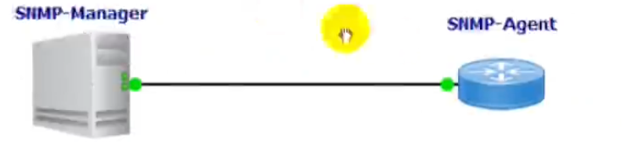

## **Management Information Base (MIB):**

* Management Information Base (MIB) is the collection of managed objects.
* MIB contains a set of questions that the SNMP Manager can ask the Agent.
* MIB contains a set of questions that the Agent can understand them.
* MIB is commonly shared between the Agent and the SNMP Manager.

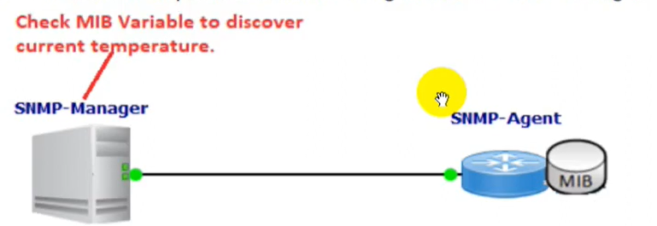

## **SNMP Messages:**

* SNMP Messages are used to communicate between the SNMP Manager and Agents.
* SNMPv1 supports five basic SNMP messages Get, Get-Next, Get-Response, Set & Trap.
* SNMPv2c, two new messages were added Inform and Getbulk.
* GET Messages are sent by the SNMP Manager to retrieve info from SNMP Agents.
* SET Messages are used by the SNMP Manager to assign the value to SNMP Agents.
* GET-NEXT retrieves value of the next object in the MIB.
* GET-RESPONSE Message is used by SNMP Agents to reply to GET & GET-NEXT messages.
* TRAP Messages are initiated from the SNMP Agents to inform the SNMP Manager on event.
* Inform Message, SNMP Manager acknowledge that the message has been received.
* Getbulk operation efficiently retrieve large blocks of data, such as multiple rows in a table.

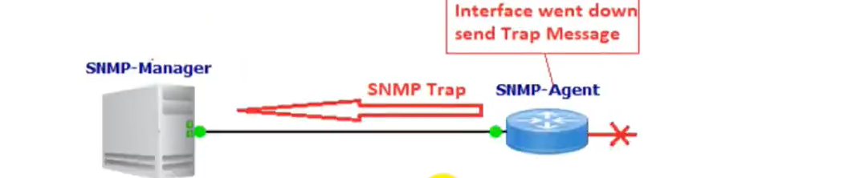

**SNMPv1:**

* SNMP version 1 security is based on community strings.
* An SNMP community string can be considered as password.

**SNMPv2c:**

* SNMPv2c is an update SNMPv2 and SNMPv2c.
* SNMPv2c uses the community-based security model of SNMPv1.
* SNMPv2c "c" in SNMPv2c stands for "community".
* SMMPv2c sends the community strings in clear text.

**SNMPv3:**

* SNMPv3 is the most secure version among other SNMP versions.
* SNMPv3 provides secure access to devices using authentication & encryption.
* Authentication security feature makes sure that the message is from a valid source.
* Integrity security feature makes sure that the message has not been tampered.
* Encryption security feature provides confidentiality by encrypting the contents.
* SNMPv3 will never send the user password in the clear text.
* SNMPv3 uses the SHAI or MD5 hash-based authentication.
* SNMPv3 encryption is done using the AES, 3DES and DES.
* SNMP offers three security levels: noAuthNoPriv, AuthNoPriv and AuthPriv.
* Auth stands for Authentication and Priv for Privacy.
* NoAuthNoPriv = no authentication and no encryption.
* AuthNoPriv = authentication but no Gcryption.
* AuthPriv = authentication AND encryption.

# **Commands:**

Snmp-server community test[password] rw[permission]

Snmp-server host 192.168.122.1 version 2c test

Snmp-server enable traps[logs]

Host 192.168.122.1 is the server where logs will be shown.