Describe the capabilities and function of TFTP/FTP in the network

**Trivial File Transfer Protocol:**

* TFTP Stand for Trivial File Transfer Protocol.
* TFTP is used to save and restore a router or switch configuration.
* TFTP is used to backup, restore and upgrade IOS image.
* TFTP uses UDP (User Datagram Protocol).
* TFTP uses a well-known UDP port 69.
* TFTP requires very small amount of memory.
* TFTP uses the connection-less UDP for communication.
* Trivial File Transfer Protocol (TFTP) is a simple file transfer protocol.
* TFTP uses the connection-less UDP for communication.
* TFTP does not support user authentication & all data is sent in clear text.
* TFTP uses less resource as compare to FTP.
* TFTP doesn't provide user authentication.

**FTP (File Transfer Protocol):**

* FTP stands for File Transfer Protocol.
* FTP is used to send & receive file from the remote device.
* FTP is a complete, session-oriented file transfer protocol.
* FTP depends on TCP, is connection oriented, and provides reliable control.
* FTP provides user authentication.
* FTP uses usernames and passwords for setup.
* Devices are required to have a username and password setup for FTP.
* FTP is faster when compared to TFTP.
* FTP uses two TCP ports 20 for sending data & 21 for sending control commands.

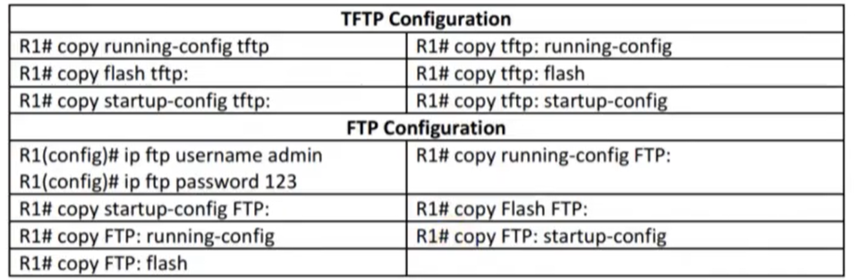

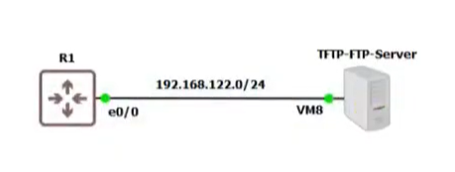

R1(config)#ip address dhcp

**Backup Restore: TFTP**

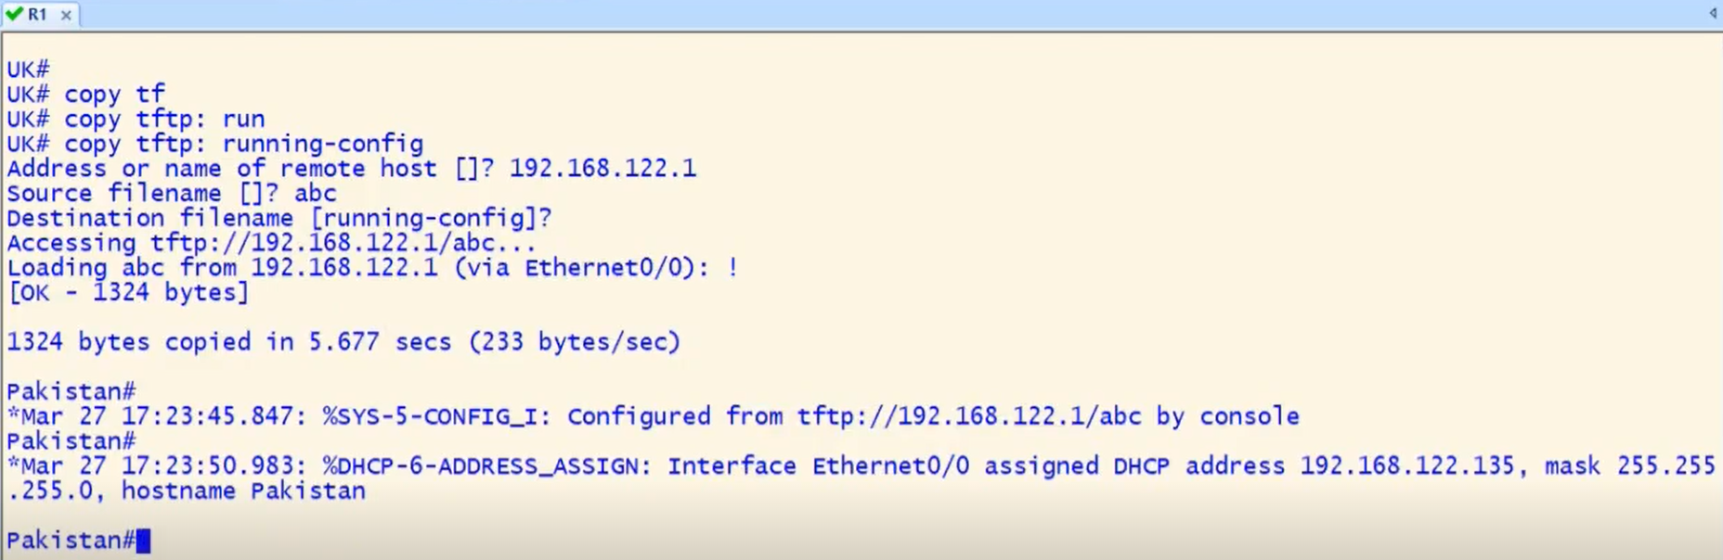

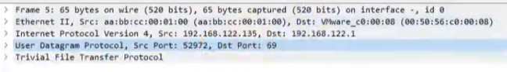

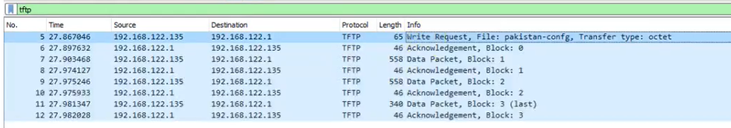

FTP :

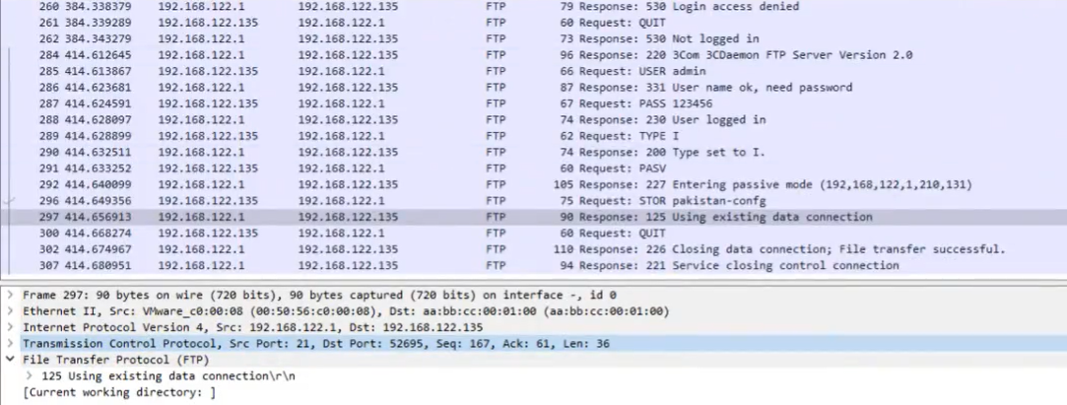

**3Caemon:**

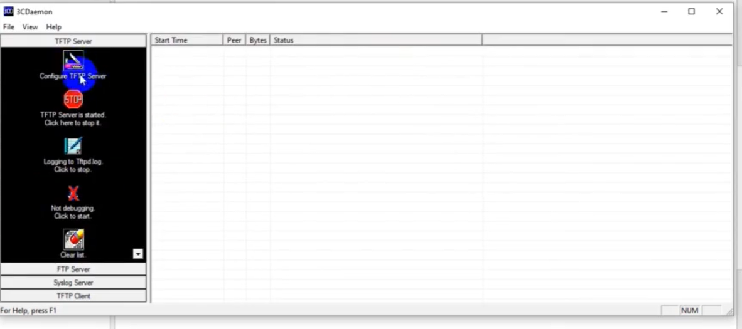

This is application used by server to store backup and upload or download the files .

**Assessment:**

