Virtualization Fundamental

**Physical Server:**

* The physical server vs virtual server comparison should start with the definition.
* Physical server, also known as a 'bare-metal server,' is ingle-tenant computer server.
* Meaning that a specific physical server is designated to use & utilize a single user.
* Resources & components of physical server are not shared between multiple users.
* Each physical server includes memory, processor, network connection, hard drive.
* Each Physical server includes operating system for running programs & applications.
* Bare-metal server is large in size due to powerful processing components that contains.

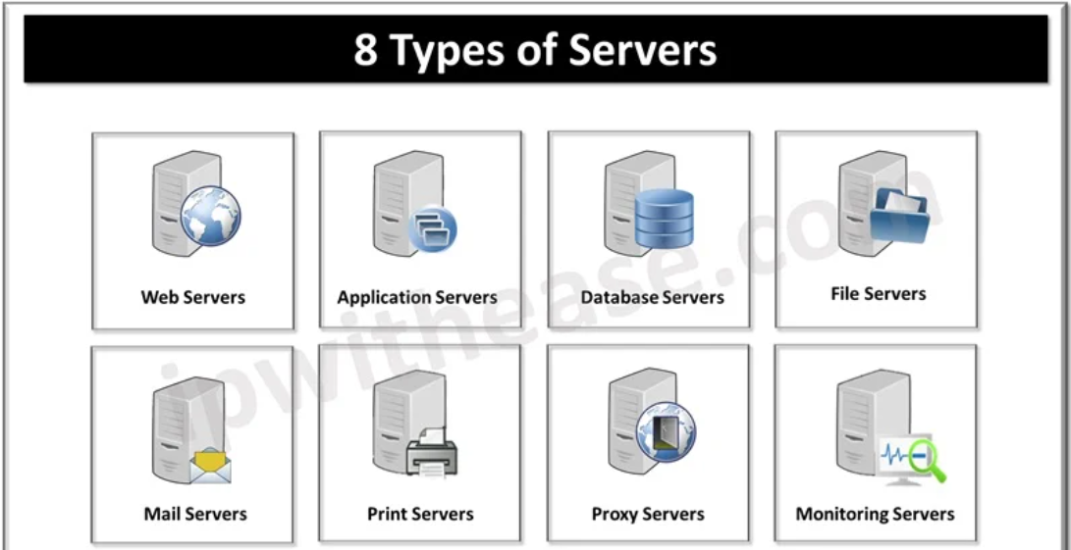

**VM (Virtual Machine):**

* VM is a virtualization term, which is stands for Virtual Machine.
* A virtual machine is pretty identical to a physical server except it's virtual.
* VM is special piece of software which emulates operation of physical machine.
* Virtual hardware (CPUs, memory, storage, etc.) which runs on a hypervisor.
* VM is a software emulation of a physical server with an operating system.
* Virtual machine is a file often called hypervisor that acts as physical computer.
* Server virtualization takes the advantage of idle resources and consolidates.
* The operating system the virtual machine is installed on is called the host OS.
* the operating system of the virtual machine itself is referred to as the guest OS.

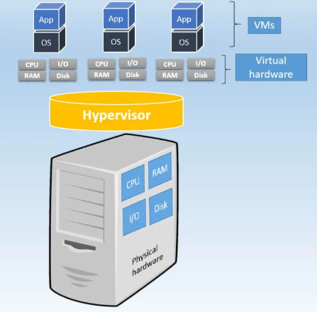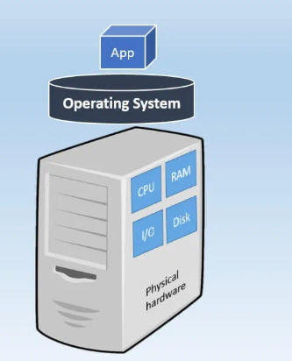

**Hypervisor:**

* The hypervisor is the server virtualization software that runs on the physical server.
* All virtual hardware which powers guest OS is handled by engine called hypervisor.
* In the world of Virtualization, the hypervisor is known as virtual machine manager.
* Allocates physical resources to each of systems & ensures do not interrupt each other.
* Where create virtual machines & configure how much CPU cores, memory, storage, etc.
* The Virtualization software that creates VMS and performs the hardware abstraction.
* Virtualization software to allow multiple VMS to run concurrently is known as hypervisor.

**Type 1 Hypervisor:**

* Type one (l) Hypervisor is type of hypervisor runs directly on the system hardware.
* Type one (1) Hypervisor is commonly referred to as "bare metal" or "native" as well.
* Examples are VMware vSphere, Microsoft Hyper-V, Citrix XenServer, & Red Hat (KVM).

**Type 2 Hypervisor:**

* This hypervisor runs on top of an operating system like MS Windows, MacOS, or Linux.
* Type two 2 Hypervisor is the type of hypervisor that is typically used by client devices.
* This type of hypervisor for example, VMware Fusion, VMware requires a host OS to run.
* We usually use a type two (2) hypervisor on desktops or the laptops system to run VMs.
* Two popular hypervisors are Qracle VM VirtualBox and VMWare Workstation in windows.

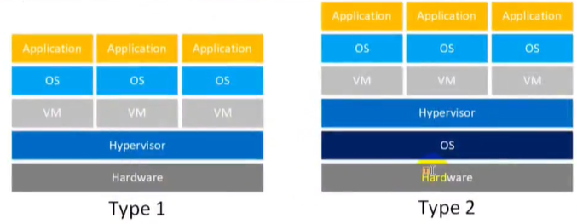

**Advantages of VM:**

* If physical server needs memory upgrade, VMS migrated to other with no downtime.
* VM is that we are familiar physical servers, easy to understand, it's server, but virtual.
* Use all management & security tools we know to manage our physical or virtual servers.
* Multiple OS environments exist simultaneously on same machine, isolated from each other.
* VM is easy maintenance, application provisioning, availability and convenient recovery.
* Another advantage of Virtualization technology is that it provides high availability.
* For example, if a server fails, the VMS can be spun up on other servers in the network.
* Biggest point for VM, is that, it is offer the greatest amount of deployment flexibility.
* Use of virtualization normally includes redundancy to protect from single point of failure.
* Services running on are virtual and dynamically installed or uninstalled, as needed.
* Advantage of virtualization is Less equipment; less energy and Less space is required.