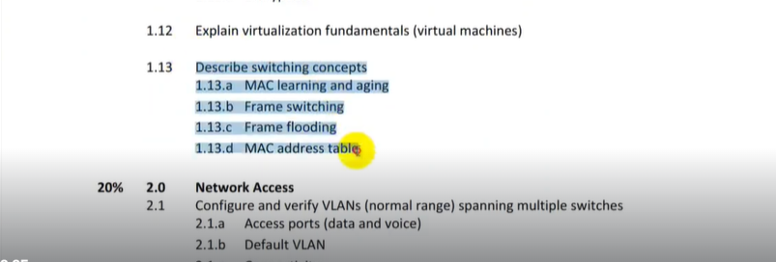Switch

**Cisco Switch:**

* Switch is a device, which is used to connect multiple computers inside LAN.
* Switches are used to connect multiple devices on the same network.
* Switches which operate at Data Link Layer of OSI model called Layer 2 Switches.
* Switches which operate at Network Layer 3 called Layer 3 or multilayer switches.
* Basic Function of a Cisco Network Switch is to forward Layer 2 packets.
* Switch forward Ethernet Frames from source device to destination device.
* Switches are a key component of many business networks now a day.
* Switches connect multiple PCs, laptops, Printers, APS, Phones, Servers etc.
* Switches allow to send and receive information in the Computer Network.
* Switches access-shared resources in a smooth, efficient, highly secure manner.
* Cisco Layer 2 or Layer 3 switches can be managed both locally and remotely.
* 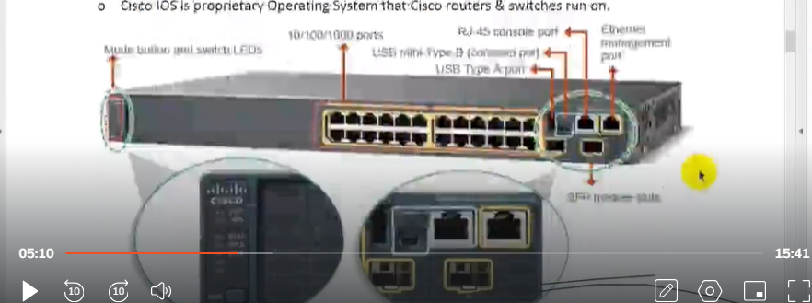Cisco IOS (internetwork operating system) is proprietary Operating System that Cisco routers **& switches run on.**

**Cisco Operating System:**

* Cisco IOS (Originally Internetwork Operating System) is a family of software.
* IOS is an Operating System used on Cisco devices, such as routers and switches.
* Multitasking OS that implements and controls logic and functions of a Cisco device.
* Cisco IOS runs as a single image and all processes share the same memory space.
* To configure a Cisco device running IOS, the Command-Line Interface (CLI) is used.
* CLI comes with predefined number of commands to configure routing & switching.
* The CLI is usually accessed from local or remote Computer running Telnet or SSH.
* The IOS is usually stored as a system image within a router or switch flash memory.
* 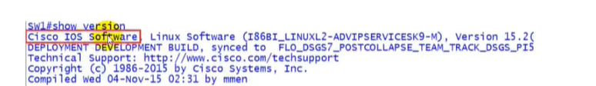Not all Cisco products routers or switches run IOS (Internetwork Operating System).

**NX-OS(Nexus Operating System)**

* The Cisco NX-OS Software is a Data Center-Class OS (Operating System).
* NX-OS is a network operating system for the Nexus-series Ethernet switches.
* NX-OS is for Fabric Channel storage area network switches made by Cisco Systems.
* Originally named SAN-OS where the SAN acronym stood for Storage Area Network.
* NX-OS doesn't share a single memory space and it support symmetric multiprocessing.
* The Command-Line Interface of Nexus Operating System is similar to that of Cisco IOS.
* Nexus feature offers capability to partition Nexus switch into multiple logical switches.

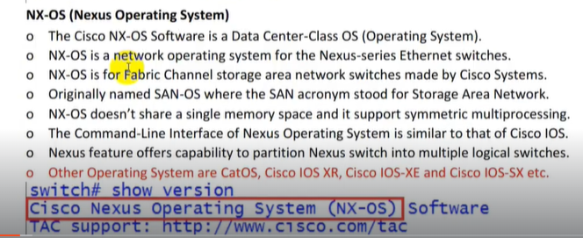

**Catalyst Switch:**

* Catalyst was a company which produced switches & which was bought by Cisco.
* Cisco sold that series of switches by company named catalyst as catalyst switches.
* Catalyst switches are switches belonging to that old series of Cisco switches.
* for example, Catalyst 2960 series, Catalyst 4500 series, Catalyst 6500 series etc.
* For Catalyst switches, CatOS (Catalyst Operating System) and IOS are available.
* Catalyst switches are mainly designed for distribution & core layers in the network.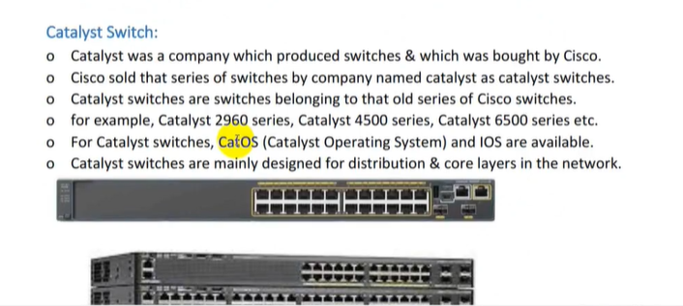
* Catalyst switches are those networking devices that use catalyst operating system (CatOS).

**Nexus Switch:**

* Nexus switches have a different architecture different then Catalyst Switches.
* The Operating System of Nexus Switches is not IOS anymore, it is NX-OS.
* All switches in Nexus range run the modular NX-OS firmware & operating system.
* Cisco Nexus switches are mainly used for DC (Data Centers) in many organizations.
* 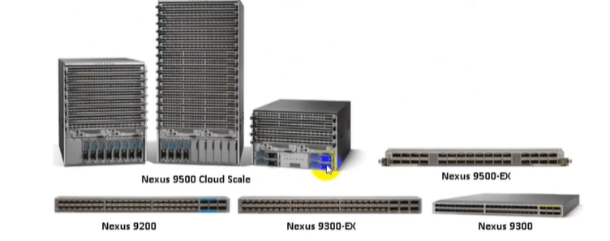Catalyst Switches uses IOS Operating System where Nexus Switches use NX-OS.

**Modular Switch:**

* These switches let you add expansion modules into the switches as needed.
* Modular Switches giving you the flexibility if your network needs change.
* These types of switches offer more flexibility in their configuration.
* Such as expansion modules for additional interfaces, power supplies, or cooling fans.
* 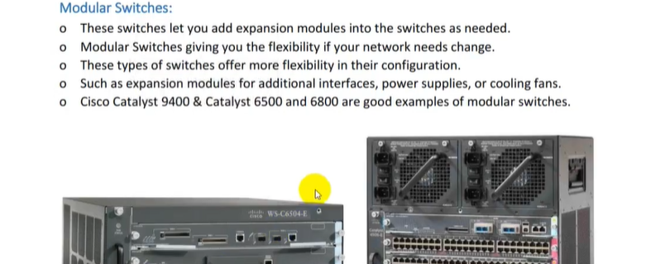Cisco Catalyst 9400 & Catalyst 6500 and 6800 are good examples of modular switches.

**Fixed Switch:**

* These switches are switches with fixed number of ports & are typically not expandable.
* Fixed Configuration Switches are types of switches are fixed in their configuration.
* Cannot add features or options to switch beyond those that originally came with switch.
* The particular model you purchase determines the features and options available.
* Cisco Catalyst 2000, 9300, 9500 and the Cisco 110-550X series are good examples.

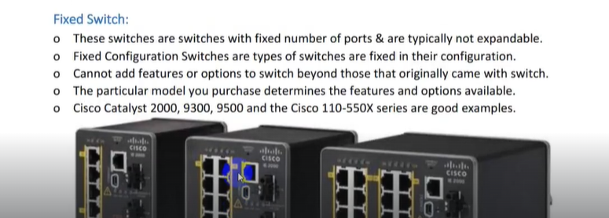

**Standalone Switch:**

* Standalone switches need to be configured and managed individually.
* Standalone switches troubleshooting needs to be handled on individual basis.

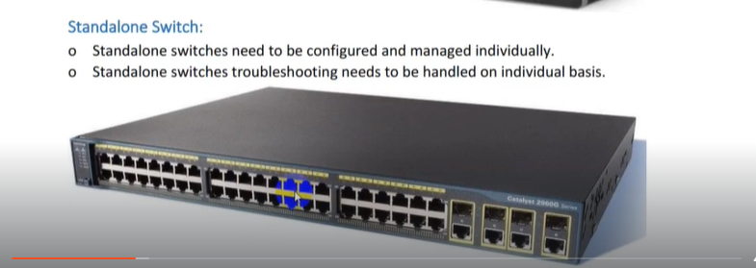

**Stackable Switch:**

* Switch stacking technology make stack of physical switches act like one switch.
* The stacking cables together make a ring between the switches.
* The switches connect in series, with the last switch connecting again to the first.
* Switch stacking, STP, CDP & VTP run on one switch, not multiple switches.
* Switch Stacking is one logical switch the port density is increase very much.
* Switch stacking is a feature of certain Cisco access layer switches.
* Stackable switches logically become one switch.
* The stacked switches effectively operate as a single larger switch.
* STP (spanning tree protocol): prevents looping in network.
* CDP (Cisco Discovery Protocol): share info between connected devices
* VTP(VLAN Trunking Protocol): manages vlans across network.

**Layer 2 Switch:**

* Terms Layers 2 & 3 are adopted from the Open System Interconnect (OSI) model.
* he Layer 2 provides direct data transfer between two devices within a LAN.
* Layer 2 switch functions by keeping a table of media access control (MAC) addresses.
* witching operates at the Layer 2 of the OSI Reference Model.
* Uses MAC addresses to facilitate communication within devices from same network.
* Layer 2 Network devices can only communicate within the same network.
* end packet to destination on the basis of MAC address, work with MAC address only.
* witching at Layer 2 is quite fast as they do not look at the Layer 3 portion.
* 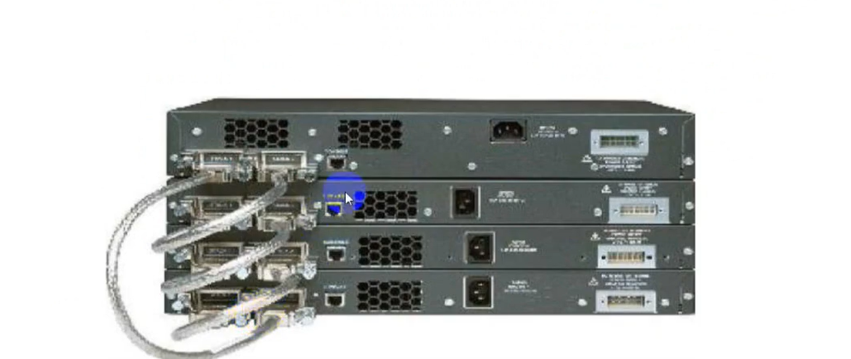Devices in the same layer 2 segment do not need routing to reach local peers.

**Layer 3 or Multilayer Switch:**

* Operate on Layer 3 (Network Layer) of OSI model.
* Layer 3 switch also called Multilayer Switch as well.
* Can perform functioning of both 2 Layer and 3-Layer switch.
* Perform the routing of data packets using IP addresses.
* Layer 3 switches are the fast routers for Layer 3 forwarding in hardware.
* Layer 3 handles packet routing by logical addressing and subnet control.
* Layer 3 checks the source and destination IP addresses of every packet.
* Functions of Layer 3 switch combine some of a Layer 2 switch and some of a router.
* The main difference between Layer 2 and Layer 3 is the routing function.
* 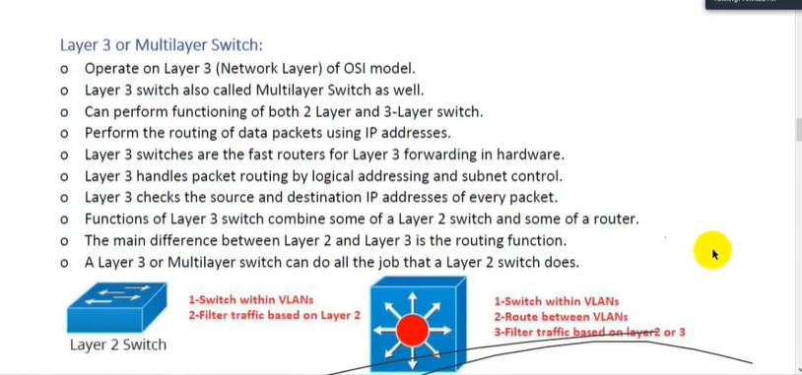A Layer 3 or Multilayer switch can do all the job that a Layer 2 switch does.

**Unmanaged Switch**

* Unmanaged network switch is designed simply plug them in and they work.
* Unmanaged Switch allows Ethernet devices to communicate with one another.
* They are shipped with fixed configuration & do not allow changes to configuration.
* Unmanaged Network switch require no configuration and management.
* Unmanaged network switches are typically for basic connectivity.
* Often used in home networks, desk, in a lab, or in a conference room etc.
* Key difference between Managed & Unmanaged Switches is the ability to configure.

**Managed Switch**

* Manage Network switches give greater security and more features.
* Managed Switches provide all the features of an Unmanaged Switch.
* Managed Switches provide the ability to configure, manage & monitor LAN.
* Provide more control over LAN traffic & offers advanced features to control traffic.
* Provide flexibility because you can configure them to custom-fit your network.
* 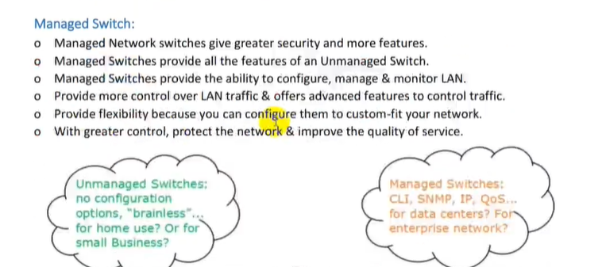With greater control, protect the network & improve the quality of service.

**How Switch Work**

* Each network card has a unique identifier called Media Access Control address.
* This address is used in LANs for communication between devices on same network.
* Devices that want to communicate need to know each other MAC address.
* Use process called ARP to find out the MAC address of another device in LAN.
* When the hardware address (MAC Address) of the destination host is known.
* Sending host has all the required information to communicate with the remote host.

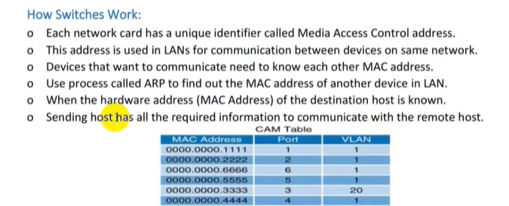

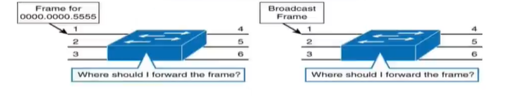

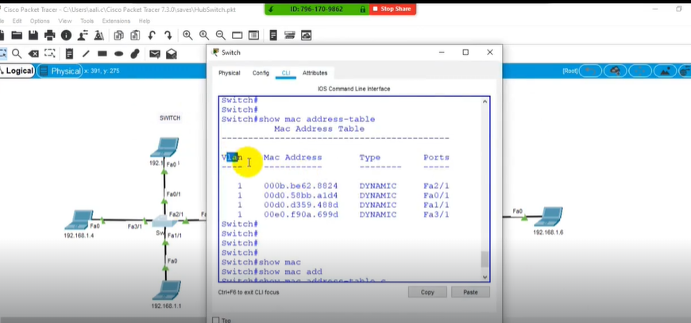

**ROM (Read-Only Memory):**

* ROM stand for Read Only Memory also called Permanent Memory.
* ROM used to store Bootstrap Programs, Mini IOS & Diagnostic Applications.
* Bootstrap program is loaded when the device first powers on.
* it is used to find IOS image & manage the process of loading the IOS into RAM.

**RAM (Random Access Memory):**

* RAM stand for Random Access Memory also called Volatile Memory.
* Routing table, ARP Cache, Running Configuration File & IOS loaded in RAM.
* This type of memory loses its content when the device loses power.

**NVRAM (Nonvolatile RAM):**

* NVRAM stand for Non Volatile Random Access Memory.
* NVRAM is Permanent Memory used to store startup configuration file.
* This type of memory retains its content even after the device loses power.

**Flash Memory**

* Flash Memory is also Permanent Memory like NVRAM.
* Flash Memory stored Cisco Operating System IOS in compress format.
* Flash Memory also store IOS software images and other files.
* This type of memory retains its content even after the device loses power.
* Flash Memory normal size are 32MB, 64MB, 128 MB, 256 MB & 512 MB.
* Flash Memory can be upgraded as per environment requirements.

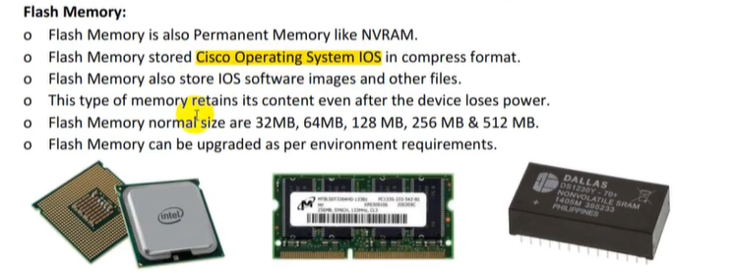

* **show version is the command to figure out the Ram, Rom and operating system.**
* **Show mac address-table : to see the mac address of connected devices**
* **Ios(Internetwork operating system) operating system of Cisco devices use CLI to configure the devices.**