Three schema architecture & data independence:

Three schema architecture
There are three levels that needs to be defined. Here three schema architecture comes in action.
Internal Schema: defines the physical storage of data.
Conceptual Schema: defines the overall structure of database.
External Schema: defines the user interaction rules.

Mapping:
Request specified on external schema Transformed into conceptual schema Request transformed into Internal schema processing
This is called mapping.

Data Independence:
It is the property of database that require not any modifications in changes occurring on one schema. Data independence can be seen as Logical data independence and physical data independence.

Logical data independence:
If some changes occur on conceptual level then internal level and external should not be changed. Only conceptual level is changed accordingly. Changes includes updating, modification, inserting etc.

Physical data Impendence:
In dbms files are changed then only this level should be modified accordingly. The remaining levels should remain intact.

Super Key:
Super key is a combination of all possible attributes which can uniquely identify two tuples in a table.
Super Key = {RollNumber, CNIC, Account Number, names, age etc}.
S1 = {RollNumber, Name}
S2 = {RollNumber, Age}
{Age, Name} (not a super key)

Candidate Key:
The set of all possible attributes that can individually identify the tuples uniquely.
Candidate key = {RollNumber, CNIC, Account Number etc}.

Primary Key:
One attribute from a candidate set is call primary key other are known as alternative keys.
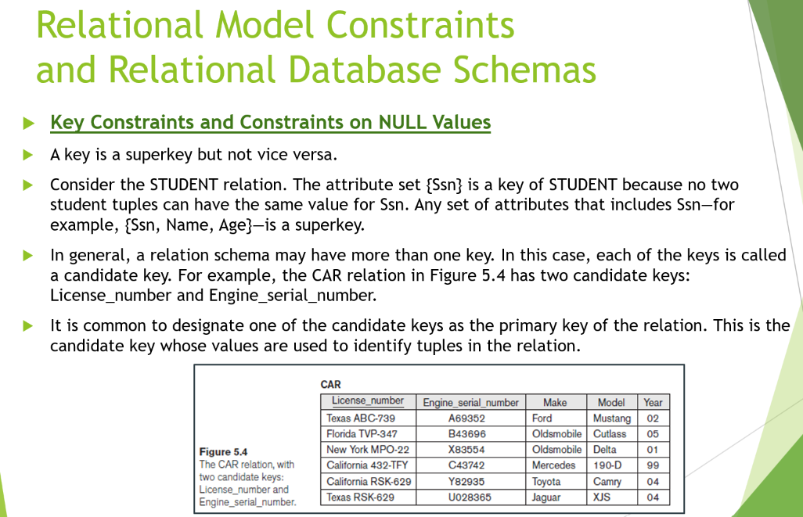

Constraints in Database:

Implicit Constraints:
These are built in relation constraints like a relation is a set of tuples but a set can not have duplicate values.
StudentID | Name
101 | Ali
101 | Ali
- Invalid

Explicit Constraints or schema-based constraints:
These are defined while defining the schema of a relation. These are specified in DDL (create, insert etc)

Semantic Constraints or application-based constraints:
These constraints cannot be easily implemented. These arise from real-world policies like bank rule employee salary raise cannot be more than previous year.
Constraint Type | Who Defines It? | Example
Inherent Model-Based (Implicit) | Relational model itself | No duplicate tuples, atomic values
Schema-Based (Explicit) | Database designer in DDL | Primary Key, Foreign Key, CHECK
Application-Based / Semantic | Business rules/application | Salary increase rule, maximum credit hours

Constraints
│
├── Inherent (Implicit) Constraints
│
├── Schema-Based (Explicit) Constraints
│ ├── Domain Constraint
│ ├── Key Constraint
│ ├── Entity Integrity Constraint
│ └── Referential Integrity Constraint
│
└── Application-Based (Semantic) Constraints

Relational Model Constraints:
What is relational database?
It is the set of relational schemas. Employee is one relation schema from relational schemas.
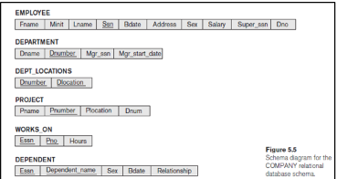

Constraints:

Entity Integrity Constraint:
No primary key can have NULL value.

Referential Integrity Constraint:
A foreign key value must already exist in the table being referenced; otherwise, the record cannot be inserted.

SQL Commands:

Create Domain:
CREATE DOMAIN AgeType AS INT
CHECK (VALUE >= 0 AND VALUE <= 120);
CREATE TABLE Employee (
EmpID INT PRIMARY KEY,
Age AgeType
);
CREATE TABLE Student (
StudentID INT PRIMARY KEY,
Age AgeType
);

