Infosys Springboard Virtual Internship 6.0 Completion Report

Team Details
Batch Number - 1
Start date:
Names:
Internship Duration: 8 Weeks

1. Project Title
Smart Urban Mobility and Traffic Intelligence Dashboard

2. Project Objective
The objective of Urban Pulse is to develop a smart city mobility intelligence platform that integrates transportation, weather, demographic, and geospatial data into a unified analytics environment. The project aims to analyze transportation demand, transit performance, mobility accessibility, and infrastructure gaps, enabling city planners and transport authorities to make informed and data-driven decisions.

3. Project description in detail
Urban Pulse – Smart Urban Mobility and Traffic Intelligence Dashboard is a data-driven platform designed to provide comprehensive insights into urban mobility patterns. It integrates data from public transit, ride-hailing, bike-share systems, weather sources, demographic datasets, and geospatial information using data integration and ETL processes.
The platform provides interactive dashboards for analyzing transit reliability, mobility demand, geospatial patterns, ride-hailing and cycling activity, and mobility equity. It also includes features such as demand heatmaps, accessibility analysis, the Mobility Access Index (MAI), forecasting, anomaly detection, and the City Mobility Health Score. These insights help stakeholders understand mobility challenges and support better transportation planning and decision-making.

4. Timeline Overview
Week | Activities Planned | Activities Completed
Week 1 | Understand project requirements, define scope and KPIs, identify mobility data sources, and plan the overall system. | Reviewed project requirements, finalized the project scope and identified relevant mobility, transit, weather, and demographic datasets.
Week 2 | Design the data architecture, star schema, and ETL workflow. Prepare dashboard and analytics requirements. | Designed the data model and architecture, defined fact and dimension tables, and planned ETL workflows and dashboard components.
Week 3 | Develop ETL pipelines for transit, ride-hailing, bike-share, weather, and demographic data. Clean and standardize datasets | Implemented data ingestion and transformation workflows, performed data cleaning and schema standardization, and prepared data for analytics.
Week 4 | Develop geospatial and transit analytics, including demand heatmaps, flow analysis, accessibility, and transit reliability. | Developed geospatial visualizations, demand heatmaps, accessibility analysis, and transit performance and reliability metrics.
Week 5 | Develop ride-hailing and micromobility analytics, including demand, utilization, and service patterns. | Implemented ride-hailing demand analysis and developed cycling/bike-share and micromobility analytics.
Week 6 | Analyze modal substitution, weather sensitivity, demand patterns, and develop forecasting and trend analysis. | Developed modal substitution analysis, weather-related mobility insights, demand analysis, and forecasting components.
Week 7 | Develop mobility equity analysis, Mobility Access Index (MAI), demographic comparisons, and City Mobility Health Score. | Implemented accessibility and equity analysis, MAI indicators, demographic comparisons, and executive-level mobility performance metrics.
Week 8 | Integrate all modules, perform testing and validation, finalize dashboards, documentation, presentation, and project handover. | Integrated the analytics modules and dashboards, performed validation and testing, prepared documentation and finalized the project deliverables.

5a. Key Milestones
Milestone | Description | Date Achieved
Project Kickoff | Finalized project requirements, objectives, KPIs, data sources, and overall project scope.
Prototype/First Draft | Completed the initial data model, ETL workflow, and early analytics/dashboard components.
Mid-Term Review | Completed major geospatial, transit, demand, and mobility analytics components and reviewed project progress.
Final Submission | Integrated all analytics modules, completed testing and validation, and finalized dashboards and documentation.
Presentation | Prepared the final project presentation and demonstrated the completed Urban Pulse platform and key insights.

5b. Project execution details
- Requirement Analysis: Analyzed project requirements and identified relevant mobility, transit, weather, demographic, and geospatial datasets.
- Data Integration & ETL: Developed workflows to ingest, clean, standardize, and organize the collected datasets.
- Data Modeling: Structured the processed data using a suitable data model for analytics and reporting.
- Mobility Analytics: Developed geospatial, transit, ride-hailing, and micromobility analytics to understand urban mobility patterns.
- Demand & Accessibility Analysis: Analyzed mobility demand, accessibility, and related transportation patterns.
- Dashboard Development: Created interactive dashboards to present mobility trends, performance metrics, heatmaps, and key indicators such as the Mobility Access Index (MAI).
- Testing & Validation: Tested and validated the integrated solution and refined the dashboards and analytical outputs.
- Finalization: Completed project documentation and prepared the final project deliverables.

6. Snapshots / Screenshots
Include relevant visuals such as screenshots of work done, dashboards, code snippets, or designs.
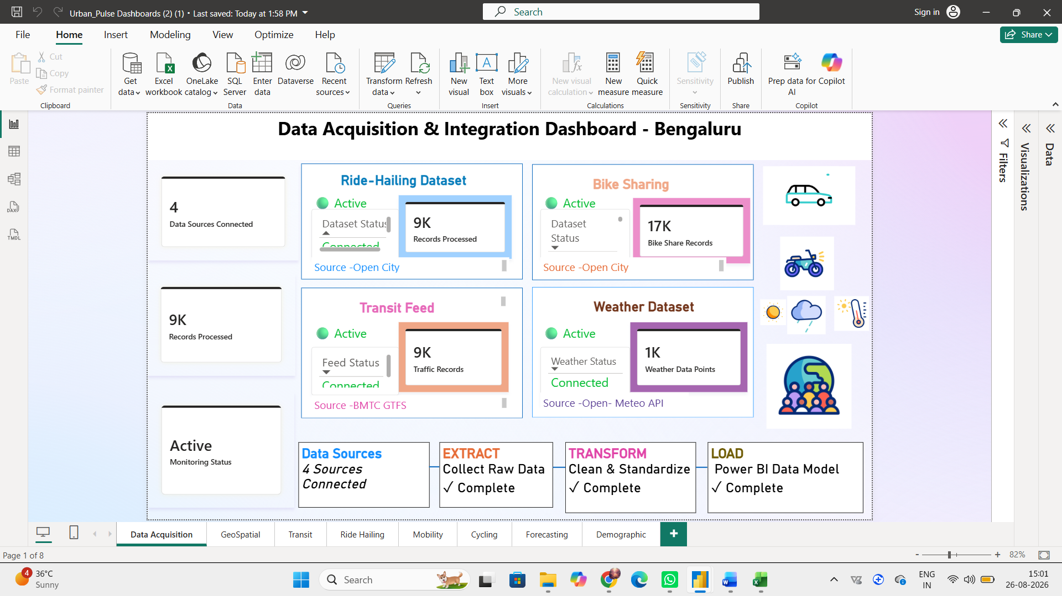
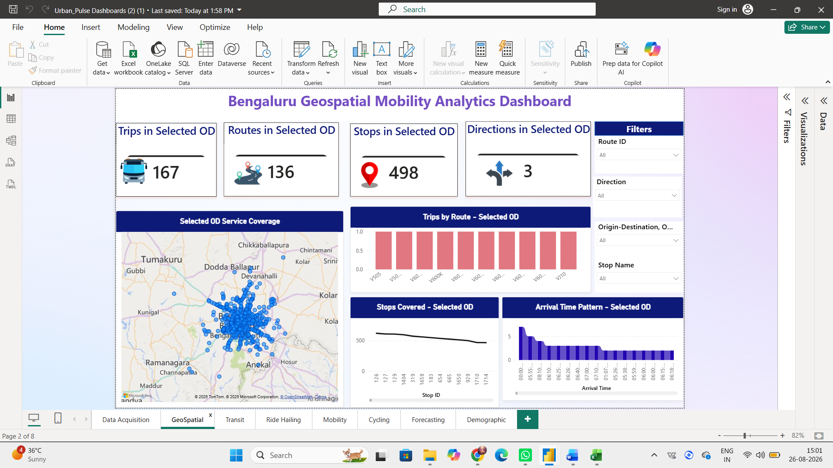
````
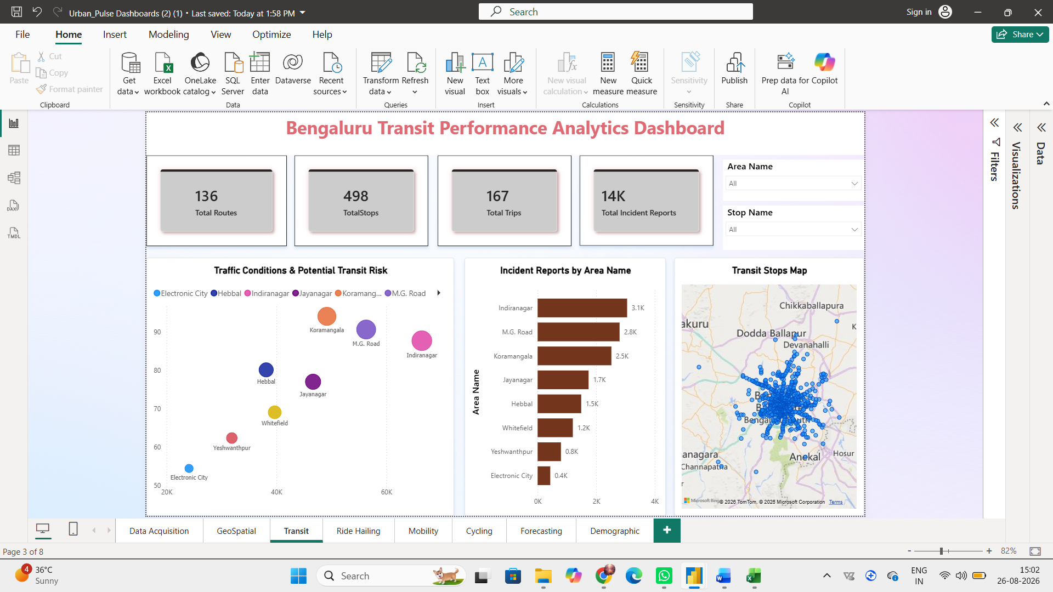
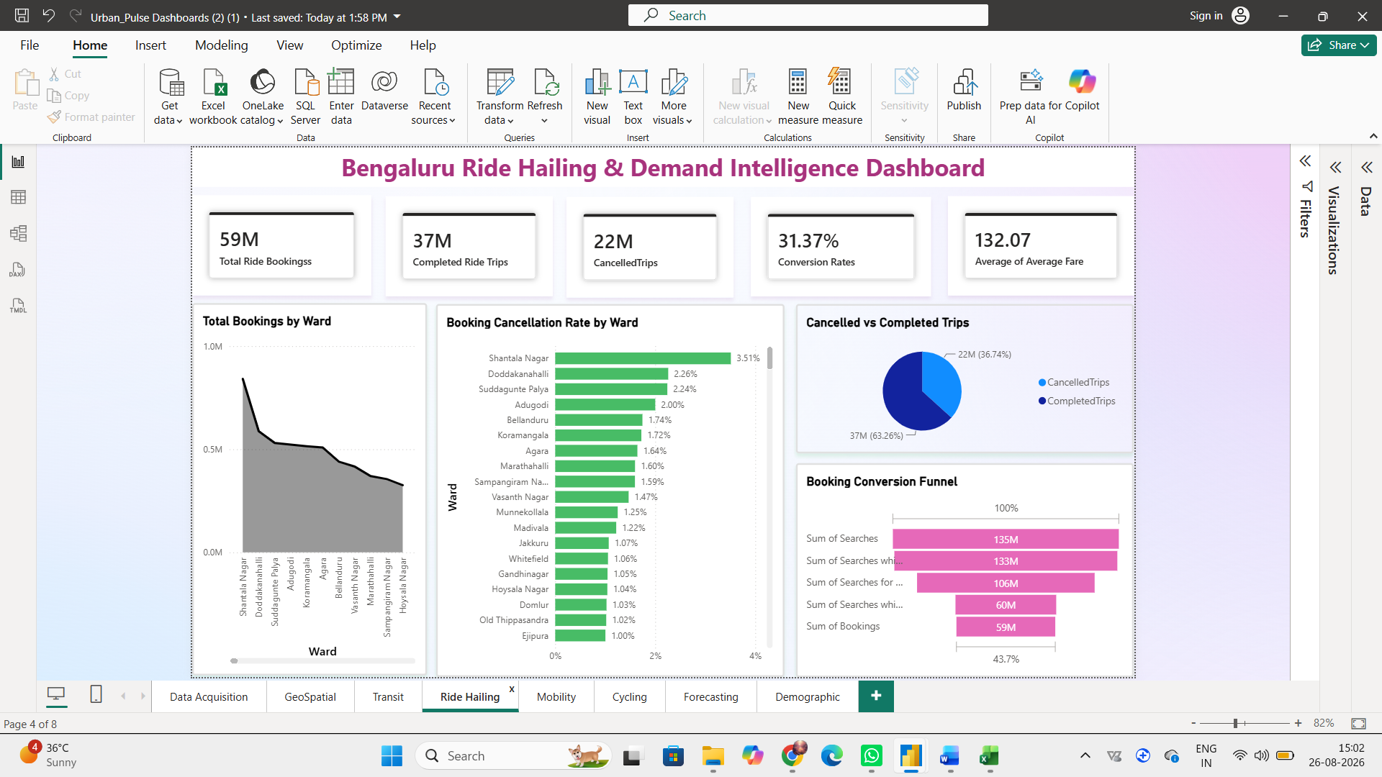

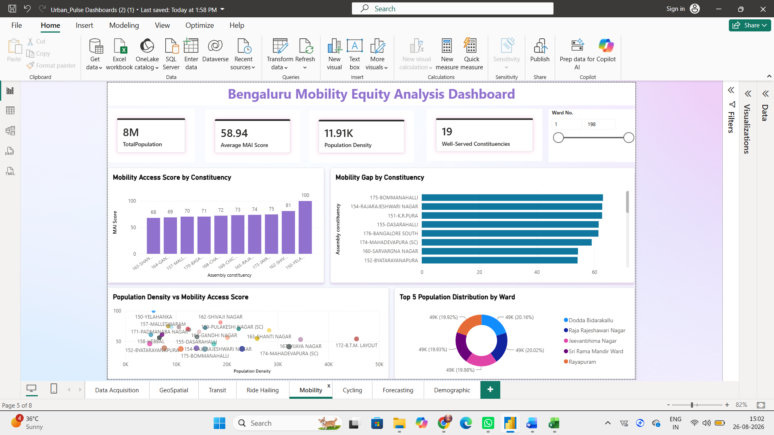
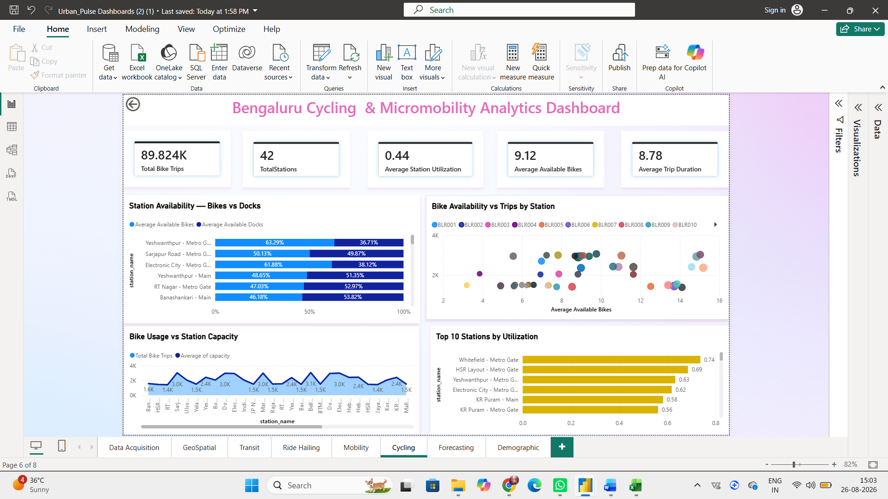

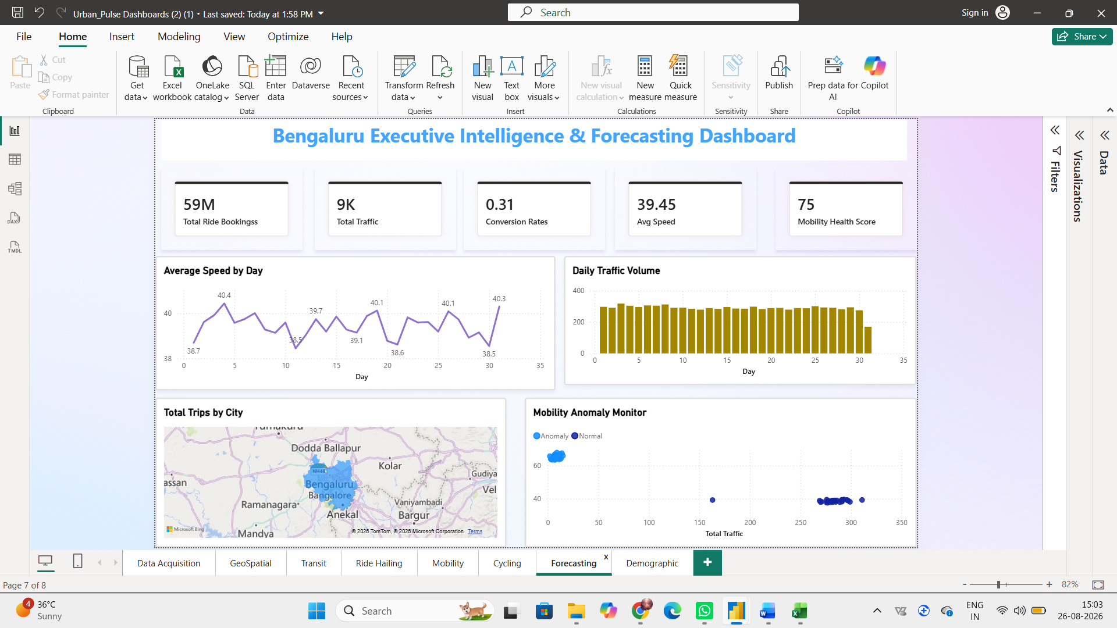

7. Challenges Faced
- Faced difficulties in connecting and integrating multiple datasets from different sources.
- Encountered challenges in designing the star schema and creating proper relationships between fact and dimension tables.
- Data cleaning and standardization were required due to inconsistent data formats and structures.
- Ensuring accurate data connections and outputs in the dashboards required multiple rounds of testing and validation.

8. Learnings & Skills Acquired
- Gained practical experience in data integration, ETL, and data cleaning.
- Learned to design star-schema data models and establish relationships between datasets.
- Improved skills in data analysis, geospatial analytics, and dashboard development.
- Gained understanding of mobility analytics, accessibility analysis, and data-driven decision-making.
- Improved teamwork, problem-solving, communication, and project management skills.

9. Testimonials from team
The project provided a valuable hands-on learning experience in data analytics and smart mobility. Working as a team helped us improve our technical skills, problem-solving abilities, collaboration, and understanding of real-world data-driven solutions.

10. Conclusion
The Urban Pulse project provided practical experience in data integration, ETL, data modeling, analytics, and dashboard development. It helped us understand how different mobility datasets can be connected and transformed into meaningful insights for urban transportation planning. The project also improved our technical, problem-solving, and teamwork skills, supporting our academic and career goals in data analytics.

11. Acknowledgements
We sincerely thank Infosys Springboard for providing us with this valuable internship opportunity and a platform to gain practical experience through a real-world project.
We are especially grateful to our mentor for their continuous guidance, encouragement, and valuable feedback throughout the internship. Their patience in explaining concepts, helping us overcome challenges, and motivating us whenever we faced difficulties played an important role in our learning and project development.
We would also like to thank our project coordinators and team members for their constant support, cooperation, and teamwork. This experience has been truly valuable and memorable, and we are grateful to everyone who contributed to making our internship journey successful.

