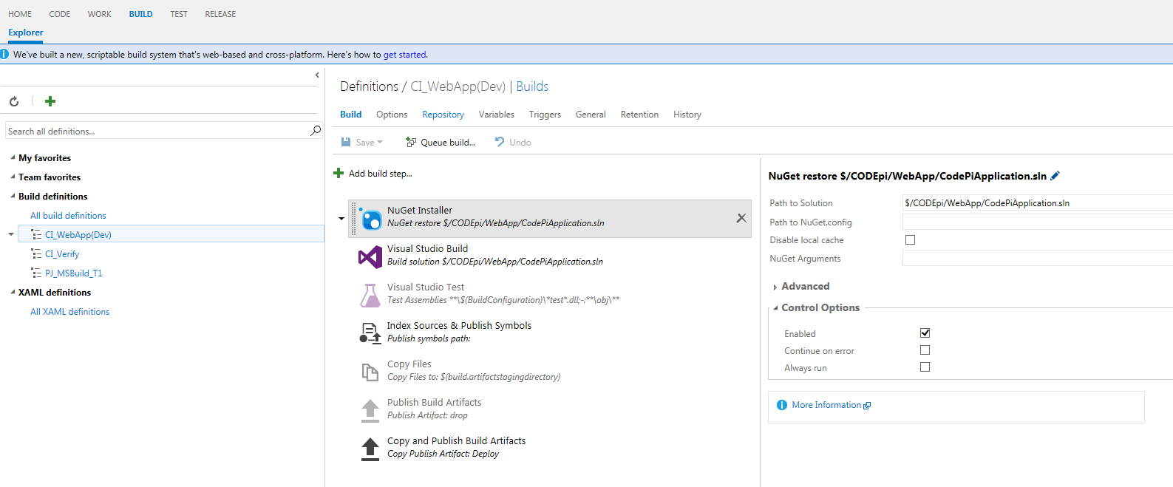

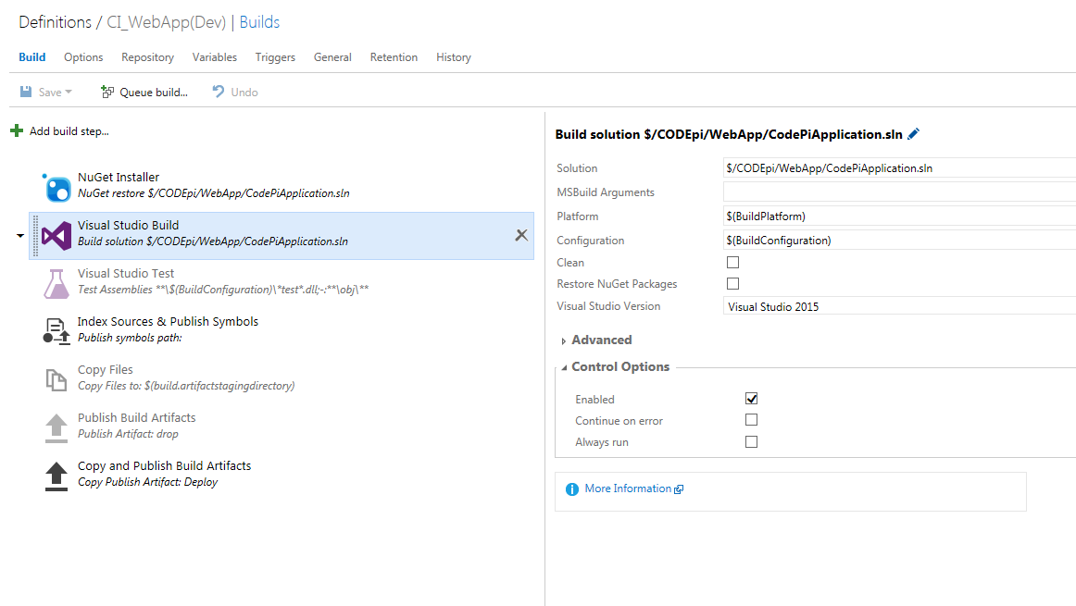

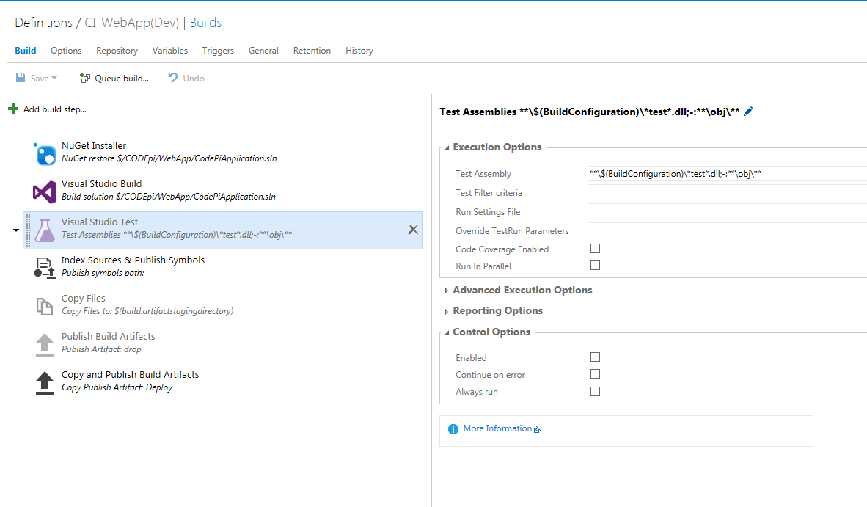

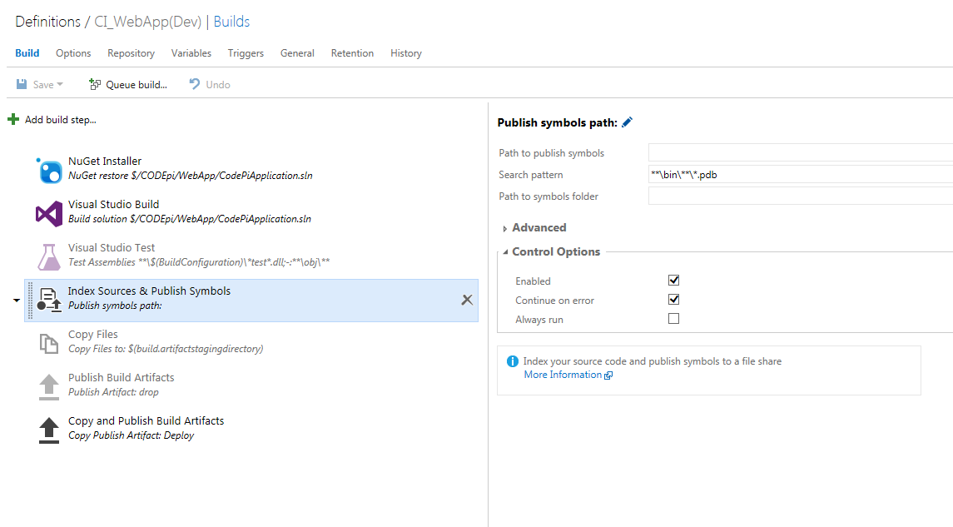

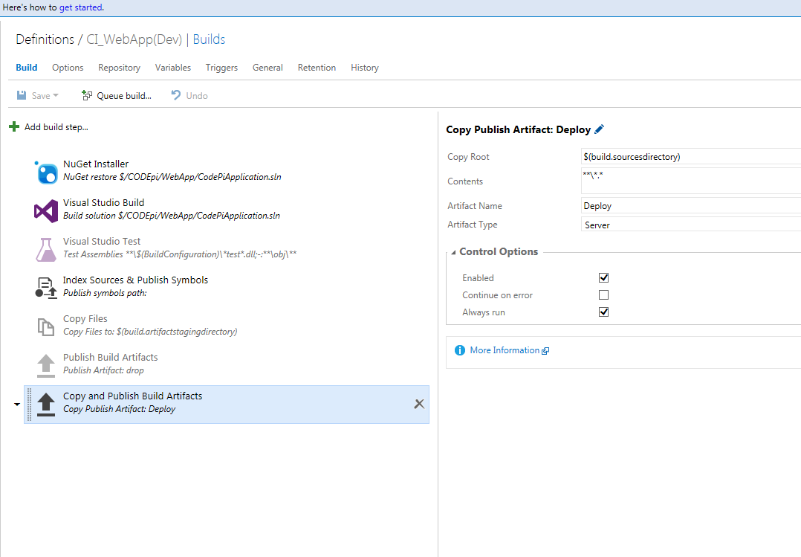

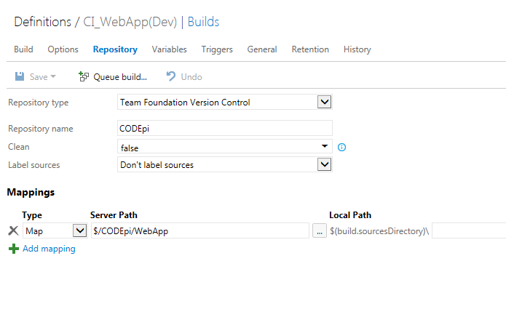

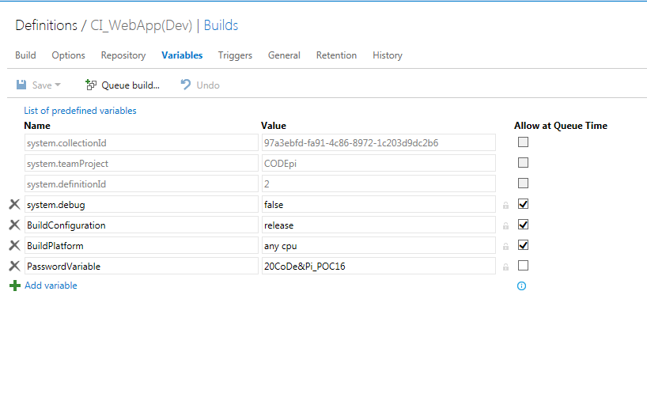

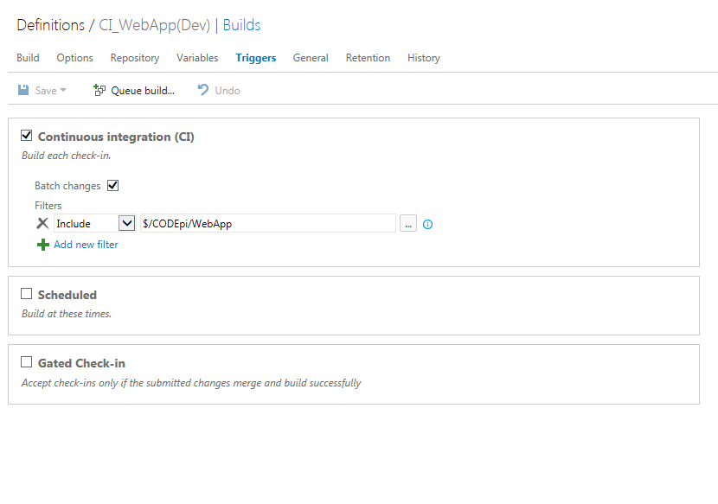

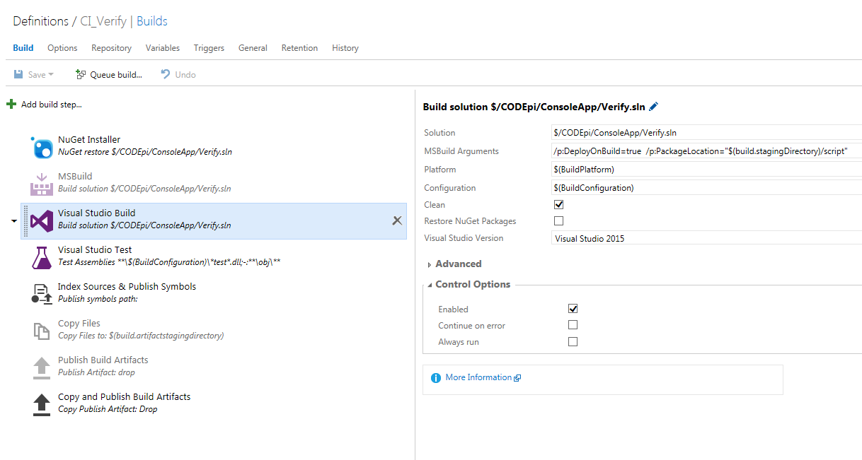

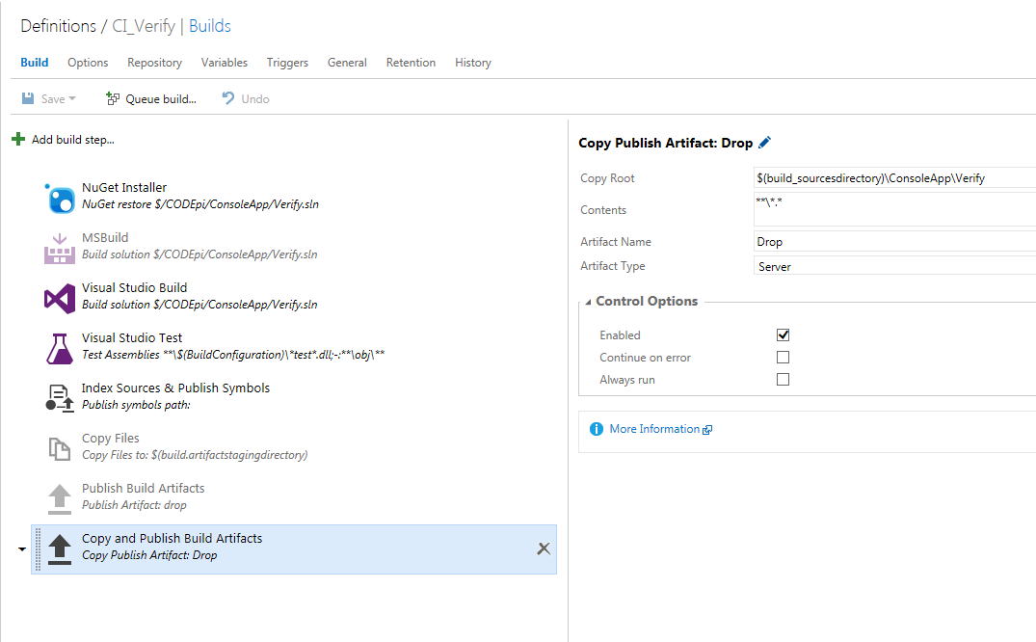

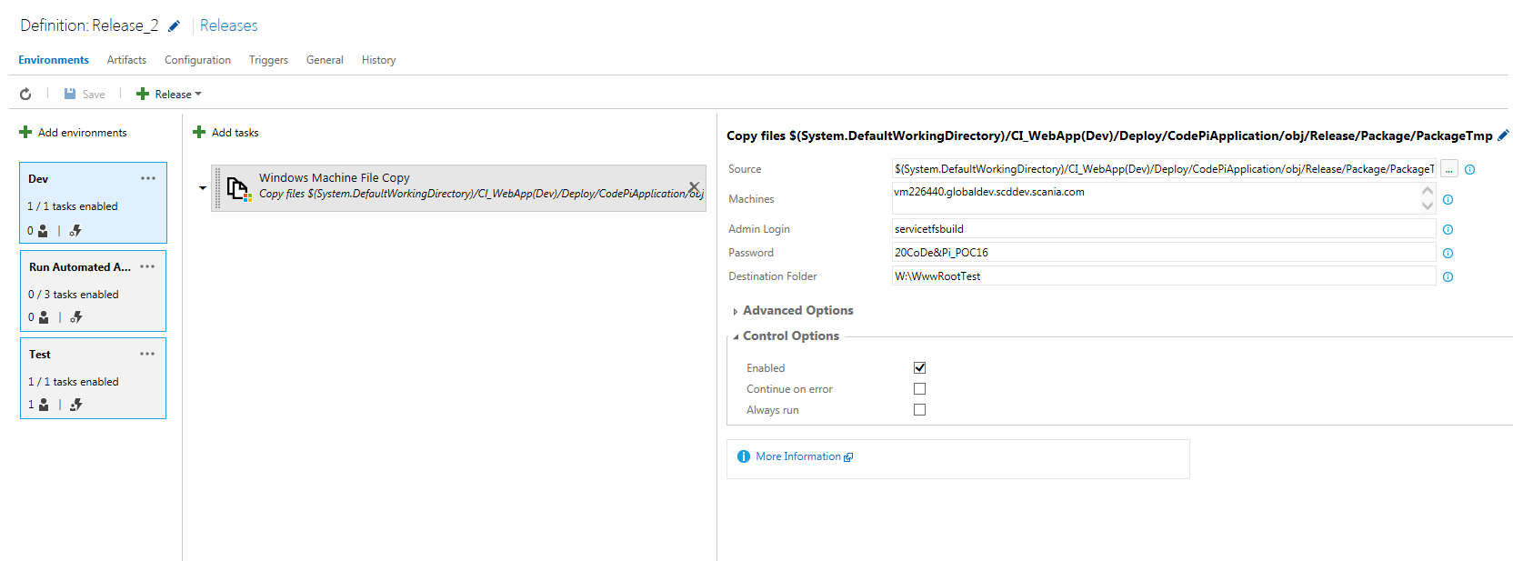

$(System.DefaultWorkingDirectory)/CI_WebApp(Dev)/Deploy/CodePiApplication/obj/Release/Package/PackageTmp

vm226440.globaldev.scddev.scania.com

servicetfsbuild

20CoDe&Pi_POC16

W:\WwwRootTest

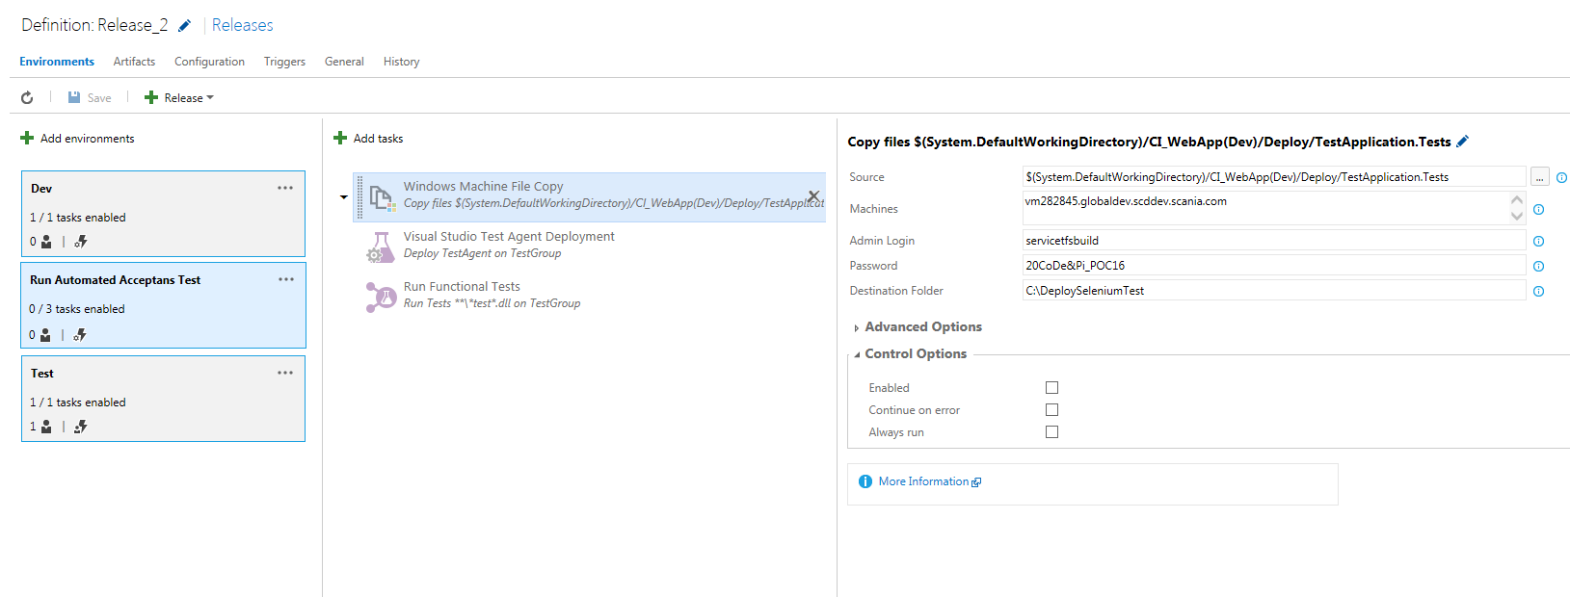

$(System.DefaultWorkingDirectory)/CI_WebApp(Dev)/Deploy/TestApplication.Tests

vm282845.globaldev.scddev.scania.com

servicetfsbuild

20CoDe&Pi_POC16

C:\DeploySeleniumTest

