

**SHIVAJI UNIVERSITY, KOLHAPUR**

**DEPARTMENT OF TECHNOLOGY**

A

MAJOR PROJECT PHASE- II REPORT

ON

**“FutureScribe AI: Automated Text Summarization”**

**COMPUTER SCIENCE AND TECHNOLOGY PROGRAM**

**SUBMITTED BY**

**Name**  **PRN No.**

1. MS. APARADH ALIYA ADAM 2020076428
2. MS. GORE MANISHA ASHOK 2020074402
3. MS. JADHAV VAISHNAVI AMAR 2020076451
4. MS. KARAD SAYALI KAILAS 2020076399
5. MR. NADAF AFTAB ASLAM 2021074396

**Under the Guidance of**

MR. CHETAN J. AWATI

**Year 2023-2024**

# CERTIFICATE



This is to certify that the project report entitled

**"FutureScribe AI: Automated Text Summarization"**

Submitted To

**DEPARTMENT OF TECHNOLOGY, SHIVAJI UNIVERSITY, KOLHAPUR**

has been completed under my guidance and supervision. To the best of my knowledge and belief, the matter presented in this project report is original and has not been submitted elsewhere for any other purpose.

**Submitted by**

|  |  |  |
| --- | --- | --- |
| Sr. No. | Name | Exam Seat No. |
|  | APARADH ALIYA ADAM | 4006 |
|  | GORE MANISHA ASHOK | 4027 |
|  | JADHAV VAISHNAVI AMAR | 4031 |
|  | KARAD SAYALI KAILAS | 4035 |
|  | NADAF AFTAB ASLAM | 4047 |

**Project Guide Class Coordinator Program Coordinator**

MR. CHETAN J. AWATI MISS. R. J. DHABARDE DR. MRS. R. J. DESHMUKH

External Examiner(s) Sign

1. …………………………………

2. …………………………………

#### 

###### ACKNOWLEGEMENT

.

It is our foremost duty to express our deep sense of gratitude and respect to the guide **MR. CHETAN J. AWATI** for his uplifting tendency and inspiring us for taking up this project work successful.

We are also grateful to **DR. MRS. R. J. DESHMUKH** **(Co-Ordinator** of Computer Science & Technology) for providing all necessary facilities to carry out the project work and whose encouraging part has been a perpetual source of information.

We are highly indebted to **Director Dr. S. N. SAPALI** for their guidance and constant supervision as well as for providing necessary information regarding the project & also for their support in completing the project.

We also thank all staff members of our Department for their timely help and encouragement, which help us in completing of our project work.

We are indebted to the library personnel’s for offering all the help in completing the project work. Last but not only the least we are thankful to our colleagues and those helped us directly or indirectly throughout this project work.

# DECLARATION

We, the undersigned, hereby declare that the project report entitled **“FuturScribe AI: Automated Text Summarization”** written and submitted by us to **Computer Science and Technology program, under** the guidance of **MR. CHETAN J. AWATI** is our original work. The empirical results in this project report are based on the data collected by us.

|  |  |  |
| --- | --- | --- |
| **Sr. No.** | **Name** | **Signature** |
|  | APARADH ALIYA ADAM |  |
|  | GORE MANISHA ASHOK |  |
|  | JADHAV VAISHNAVI AMAR |  |
|  | KARAD SAYALI KAILAS |  |
|  | NADAF AFTAB ASLAM |  |

#### **Attainment of program outcome**

**Academic Year**: **2023-24**

**Project Title: Customer Reviews Sentiment Analysis**

|  |  |  |  |  |
| --- | --- | --- | --- | --- |
| **No.** | **Program Outcome (PO) Statements** | **Attainment Level** | | |
| **Low**  **(1)** | **Medium**  **(2)** | **High**  **(3)** |
| 1. | Apply the knowledge of mathematics, science, engineering fundamentals, and an engineering specialization to the solution of complex engineering problems. |  |  |  |
| 2. | Identify, formulate, review research literature, and analyze complex engineering problems reaching substantiated conclusions using first principles of mathematics, natural sciences, and engineering sciences. |  |  |  |
| 3. | Design solutions for complex engineering problems and design system components or processes that meet the specified needs with appropriate consideration for the public health and safety, and the cultural, societal, and environmental considerations. |  |  |  |
| 4. | Use research-based knowledge and research methods including design of experiments, analysis and interpretation of data, and synthesis of the information to provide valid conclusions. |  |  |  |
| 5. | Create, select, and apply appropriate techniques, resources, and modern engineering and IT tools including prediction and modelling to complex engineering activities with an understanding of the limitations. |  |  |  |
| 6. | Apply reasoning informed by the contextual knowledge to assess societal, health, safety, legal, and cultural issues and the consequent responsibilities relevant to the professional engineering practice. |  |  |  |
| 7. | Understand the impact of the professional engineering solutions in societal and environmental contexts, and demonstrate the knowledge of, and need for sustainable development. |  |  |  |
| 8. | Apply ethical principles and commit to professional ethics and responsibilities and norms of the engineering practice. |  |  |  |
| 9. | Function effectively as an individual, and as a member or leader in diverse teams, and in multidisciplinary settings. |  |  |  |
| 10. | Communicate effectively on complex engineering activities with the engineering community and with society at large, such as, being able to comprehend and write effective reports and design documentation, make effective presentations, and give and receive clear instructions. |  |  |  |
| 11. | Demonstrate knowledge and understanding of the engineering and management principles and apply these to one’s own work, as a member and leader in a team, to manage projects and in multidisciplinary environments. |  |  |  |
| 12. | Recognize the need for, and have the preparation and ability to engage in independent and lifelong learning in the broadest context of technological change. |  |  |  |

#### **Attainment of Course outcome Top of Form**

#### 

|  |  |  |  |  |
| --- | --- | --- | --- | --- |
| **No.** | **Course Outcome (CO) Statements** | **Attainment Level** | | |
| **Low**  **(1)** | **Medium**  **(2)** | **High**  **(3)** |
| 1. | Implement proposed solutions with the help of modern tools and analyze the solution. |  |  |  |
| 2. | Apply project management and time management skills effectively. |  |  |  |
| 3. | Report and present the findings of the study conducted in the preferred domain. |  |  |  |
| 4. | Develop good communication skills and teamwork. |  |  |  |
| 5. | Demonstrate a strong working knowledge of ethics and professional responsibility. |  |  |  |

|  |  |  |
| --- | --- | --- |
| Sr. No. | Name | Signature |
| 1 | APARADH ALIYA ADAM |  |
| 2 | GORE MANISHA ASHOK |  |
| 3 | JADHAV VAISHNAVI AMAR |  |
| 4 | KARAD SAYALI KAILAS |  |
| 5 | AFTAB ASLAM NADAF |  |

**Project Guide** **Program Co-Ordinator**

**Mr. C. J. Awati** **Dr. Mrs. R. J. Deshmukh**

Co-Ordinator (CST) Co-Ordinator (CST)

DOT, SUK DOT, SUK

##### External Examiner(s): Sign

1. …………………………………………………. …………………………

1. …………………………………………………. …………………………

**ABSTRACT**

In the era of information overload, efficient access to essential insights from vast amounts of textual data is imperative. "FutureScribe Al" represents a groundbreaking project that leverages advanced artificial intelligence (AI) techniques to redefine text summarization. This system offers both abstractive and extractive summarization, catering to diverse user needs

The abstractive component employs state-of-the-art deep learning models, transforming source text into coherent human-like summaries. Concurrently, the extractive module selects and presents key sentences or phrases, optimizing information retrieval while preserving the original text's flow. Users have the flexibility to choose their preferred summarization mode, and an optional hybrid feature combines both approaches for comprehensive summaries.

Aligned with the educational goals of CST Semester VII, this project fosters critical thinking. integrates advanced Al and Natural Language Processing (NLP) concepts, and addresses the real-world challenge of information overload. "FutureScribe Al" envisions a future where information access is streamlined, enabling rapid and informed decision-making, marking a commitment to shaping the future of automated text summarization and information retrieval

**Keywords:**

Automated Text Summarization, Deep Learning, Abstractive Summarization, Extractive Summarization, Hybrid Summarization, Information Retrieval, Decision Support, Natural Language Processing (NLP)

**INDEX**

|  |  |  |
| --- | --- | --- |
| **Sr. No.** | **Title** | **Page No.** |
| **01** | **Introduction………………………………………………………** | 1 |
|  | * 1. Overview…………………………………………………...   2. Choice of Topic with reasoning/Need of Project…………..   3. Problem Statement………………………………………… | 2  2  3 |
|  | * 1. Objectives………………………………..………………… | 3 |
| **02** | **Literature Review and Study……………………………………** | 4 |
| **03** | **Software Requirement Specification……………………………** | 7 |
| **04** | **System Design ……………………………………………………** | 10 |
|  | 1. System Architecture……………………………………… 2. Methodology/Algorithm…………………………………. 3. Data Flow Diagrams……………………………………… 4. Use Case Diagram……………………………………….. 5. Activity Diagram…………………………………………. 6. Sequence Diagram……………………………………….. | 11  12  12  15  15  15 |
| **05** | **Coding Techniques and Implementation details ……………..** | 16 |
| **06** | **Applications……………………………………………………..** | 30 |
| **07** | **Conclusion……………………………………………………….** | 34 |
| **08** | **References……………………………………………………….** | 36 |

# CHAPTER 1

**INTRODUCTION**

**1. Introduction**

**1.1 Overview**

The **"Future Scribe AI - Text Summarization"** project seeks to create an advanced text summarization system using artificial intelligence. It addresses the need for efficient and precise summarization of large volumes of text data. The system employs cutting-edge models and algorithms to condense lengthy documents into concise summaries while maintaining coherence and essential information.

In the FutureScribe AI project, our initial goal was to create both abstractive and extractive text summarization systems. We began by designing an abstractive summarization model using a Transformer-based architecture. Additionally, we implemented an extractive text summarization approach using the LexRank algorithm. This combination allowed us to offer users versatile summarization solutions tailored to their specific needs and preferences.

The report covers the rationale for the project and the importance of text summarization, the problem statement, and the project's objectives. A literature review and study section outline relevant research and techniques. The software requirement specification details the project's software needs. The system design section discusses architecture, data flow, deployment, security, and documentation.

The coding techniques and implementation section explains the technical aspects and model integration. The applications section explores potential use cases, including news, content creation, research, and business. The conclusion highlights the project's achievements, even after the model shift, emphasizing its ability to generate accurate and coherent summaries.

The future work section discusses next steps, including model refinement and user feedback. The report ends with a references section.

After all, the project aims to contribute to text summarization by developing an advanced AI system and laying the foundation for future project phases.

**1.2 Choice of Topic with reasoning/Need of Project**

Text summarization is the task of automatically generating a concise summary capturing the most important information from a longer text document. We chose to work on this topic due to the following key reasons:

* With the rapid growth in digital content on the web, text summarization can help condense information and enable users to quickly grasp the key points. This is especially useful for summarizing long documents like research papers, news articles, meeting transcripts etc.
* Text summarization can improve the performance of many other NLP applications like document classification, sentiment analysis, question answering etc by reducing the amount of text to process.
* Text summarization aligns well with our interests in NLP and deep learning. Building an end-to-end summarization system would be a great learning experience.
* Automatic text summarization can enable many useful real-world applications in domains like search, social media, news etc. Hence there is good potential for impact.

**1.3 Problem Statement**

The project focuses on the need to create automated text summarization systems. Traditional methods for summarization are time-consuming, prone to errors, and may not be scalable to the increasing volume of text data. Future Scribe AI aims to provide a robust solution to this problem by leveraging cutting-edge natural language processing (NLP) technologies.

The core challenge is to develop AI tool to produce concise, fluent, and accurate summaries from lengthier text documents while preserving the salient information. The system should identify the most important content from the input and present it in a condensed form. Different techniques need to be explored for extractive and abstractive summarization.

**1.4 Project Objectives**

The main objectives of our project are as follows:

* Develop an efficient text summarization system based on AI techniques.
* Create a Transformer-based architecture for text summarization.(Working has been stopped due to lack of hardware resources.)
* Fine-tune the pre-trained model "Google Pegasus" on the target domain.
* Generate high-quality summaries that capture the essence of the original text.
* Evaluate model performance using ROUGE metrics and human evaluation.

# CHAPTER 2

**LITERATURE REVIEW**

**2. Literature Review**

We studied various papers on extractive and abstractive text summarization. For extractive summarization, we referred to work using statistical methods like TextRank, LexRank , LSA, and Bert Sum models.

* **Extractive Summarization:**

This technique involves selecting and extracting sentences or phrases from the source text to compose the summary. We delve into the algorithms, such as.

* 1. **TextRank:** TextRank is a graph-based algorithm that identifies the most important sentences in a text by considering their relationships to other sentences in the text.[1][5]
  2. **LexRank:** LexRank is another graph-based algorithm that identifies the most important sentences in a text by considering their relationships to other sentences in the text, as well as their relationships to external resources, such as Wikipedia.[2]

For abstractive summarization, sequence-to-sequence models using RNN decoders have been explored extensively. More recently, Transformer networks like BERT and GPT have shown very promising results by better capturing context and language structure.

* **Abstractive Summarization:**

Abstractive summarization, on the other hand, focuses on generating summaries that may contain sentences not present in the source text. We explore the use of **sequence-to-sequence models.**

* 1. **Seq2Seq (Sequence-to-Sequence) Models:** These models are a fundamental choice for abstractive summarization. They use an encoder-decoder architecture with attention mechanisms.[6][12]
  2. **Transformer-based Models:** Models like GPT-2, GPT-3, and T5 (Text-to-Text Transfer Transformer) can be fine-tuned for abstractive summarization tasks. For example, T5 can be trained to translate a document into a summary.[7][8]
  3. **BART (Bidirectional and Auto-Regressive Transformers)**: BART is designed for both generation and comprehension tasks, making it suitable for abstractive summarization.[9]
  4. **Pegasus:** Pegasus is a transformer-based model that has been specifically designed for text summarization. Pegasus is trained on a massive dataset of text and summaries, and it can generate high-quality abstractive summaries of text in long documents.[10]

We referred to the Google Pegasus paper which proposed transformer-based pretrained models for summarization, and selected this model in order to accomplish our abstractive text summarization. Their techniques for pretraining using gap-sentences and masking whole sentences have proven very effective.

# CHAPTER 3

**SOFTWARE REQUIREMENT SPECIFICATION**

**3. Software requirement specification**

**3.1 Hardware Requirements**

In this chapter, we provide a comprehensive overview of the specific hardware and software requirements necessary for implementing "FutureScribe AI." These requirements form the backbone of our system, ensuring its functionality and efficiency.

**3.1.1 Computing Resources**

* **CPU:** "FutureScribe AI" will require a multi-core processor to handle intensive natural language processing (NLP) and machine learning tasks efficiently.
* **Memory (RAM):** A substantial amount of RAM will be necessary to accommodate large-scale text data and model training.
* **Storage:** Sufficient storage capacity, both for data storage and model checkpoints, is essential to ensure seamless operation.

**3.1.2 Graphics Processing Unit (GPU)**

* Utilizing a high-performance GPU with parallel processing capabilities will significantly accelerate deep learning tasks, such as training neural networks for summarization.

**3.1.3 Networking**

* A stable internet connection is required for accessing external resources, updates, and cloud-based services.

**3.2 Software Requirements**

**3.2.1 Programming Languages**

* **Python:** As a widely-used language in the field of AI and NLP, Python will serve as the primary programming language for "FutureScribe AI" development.
* **Libraries:** Key libraries such as ***PyTorch, NLTK,*** and ***spaCy*** will be employed for various NLP and machine learning tasks.

**3.2.2 Frameworks and Tools**

* **PyTorch:** These deep learning frameworks will facilitate the development and training of neural network models.
* **Google Collaboratory:** We will utilize Google Collaboratory, a cloud-based Python development environment, for experimentation, model prototyping, and collaborative coding.
* **Version Control:** Tools like Git and GitHub will ensure efficient collaboration and code version management.

**3.2.3 Development Environment**

* The choice of integrated development environment (IDE) may vary based on individual preferences, with options like VSCode and PyCharm.

# CHAPTER 4

**SYSTEM DESIGN**

**4. System Design**

**4.1 System Architecture**

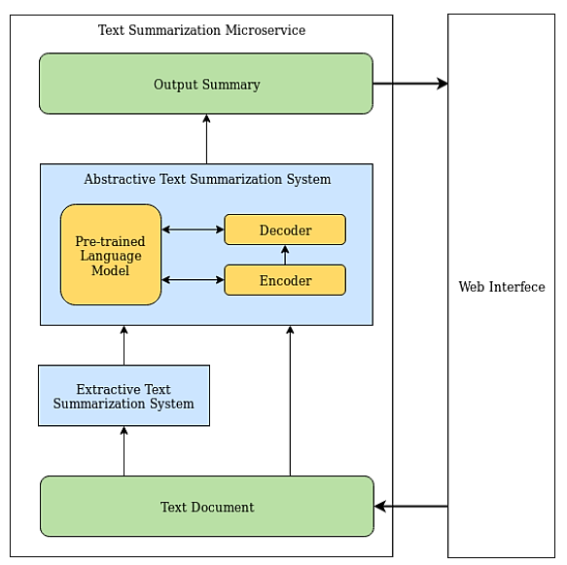

**Fig 4.1.1 System Architecture**

Here Fig 4.1.1represents the text summarization system architecture:

1. **Web Interface**

* Provides simple interface for user to input text to be summarized
* Has options to select extractive or abstractive summarization
* Displays generated summary to user

1. **Input Text**

* User enters or uploads document to be summarized through web interface
* Text is processed and converted to model input format

1. **Extractive Summarization**

* Pretrained model identifies key sentences from input text
* Models like Bert Sum or Text Rank be used
* Selects sentences conveying main points to form summary

1. **Abstractive Summarization**

* Pretrained seq2seq model like T5 or BART used
* Generated completely new phrases and sentences capturing main ideas
* Uses abstraction, paraphrasing, compression

1. **Output Summary**

* Final summary displayed to user on web interface
* Concise summary retaining key information from input
* User can select extractive or abstractive based on need

So, in summary, web UI allows user text input, summarizer models generate output, final summary is presented back to user.

**4.2 Methodology / Algorithm**

Here is a brief explanation of using the pretrained Pegasus model for abstractive text summarization:

* Pegasus is a Transformer-based seq2seq model pretrained for summarization using gap-sentence prediction objectives.
* It contains a Transformer encoder-decoder architecture tailored for summarization.
* The pretraining teaches Pegasus to generate summaries by predicting salient sentences.
* This makes Pegasus an ideal starting point for abstractive summarization which involves generating new phrases and sentences capturing key points.
* Pegasus is first fine-tuned on datasets containing text-summary pairs to adapt it for abstractive summarization.
* During fine-tuning, the encoder constructs representations of the input text.
* The decoder learns to generate concise, abstractive summaries reflecting the main concepts in the input text.
* Beam search decoding can be used to generate multiple summary candidates.
* The fine-tuned Pegasus model can then take input text and generate abstractive summaries capturing the core semantic content.

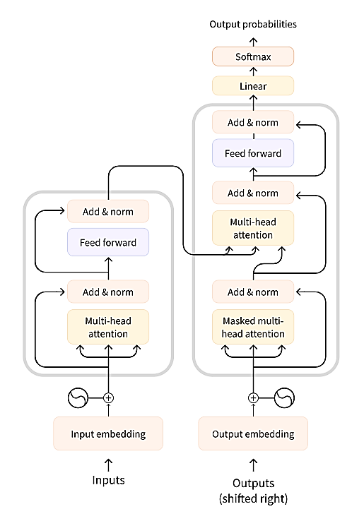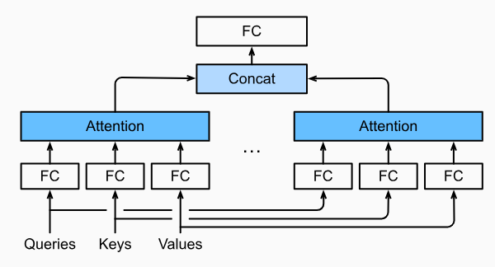

**Fig 4.2.2 Multi-Head Attention**

**Fig 4.2.1 Transformer Architecture**

Fig 4.2.1 represents the Transformer architecture, which is a neural network used for natural language processing tasks. It consists of an encoder and a decoder. The encoder processes the input sequence using self-attention and feed-forward networks. The self-attention mechanism captures word dependencies, while the feed-forward network applies non-linear transformations. The decoder generates the output sequence, attending to the relevant parts of the encoder's output.

Fig 4.2.2 illustrates multi-head attention, a key component of the Transformer architecture. It involves splitting the input into parallel subspaces, or "heads." Each head independently computes attention weights by comparing query and key vectors. The weighted sums of value vectors are obtained, concatenated, and linearly transformed for the final output. Multi-head attention allows the model to capture different aspects of the input sequence simultaneously, enhancing its understanding of relationships and dependencies.

**4.3 Data flow Diagram**

The data flow 4.3.1 is of extractive text summarization, involves pre-processing the input text, converting sentences into numerical representations, scoring the sentences based on importance, selecting the top-scoring sentences, and generating a summary by combining these selected sentences. This approach aims to extract the most informative and relevant content from the original text while preserving its meaning.

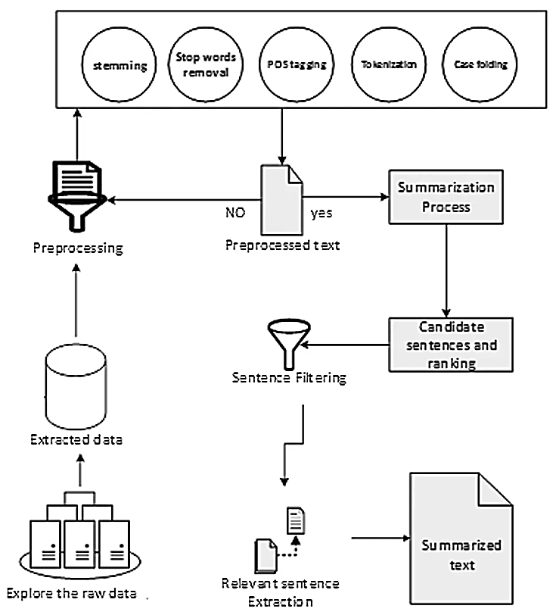

**Fig 4.3.1 Data Flow Diagram (Extractive Text Summarization System)**

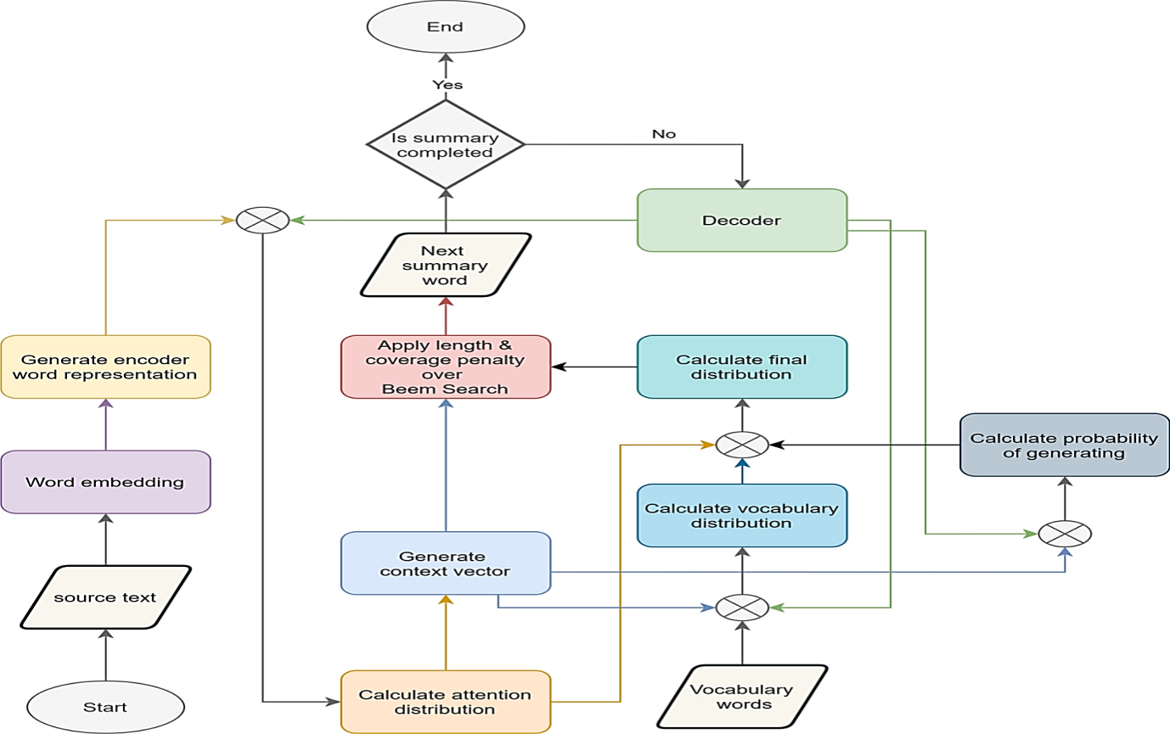

**Fig 4.3.1 Data Flow Diagram (Abstractive Text Summarization System)**

The Fig 4.3.1 is of abstractive text summarization model involves pre-processing the input text, encoding it into a numerical representation, using an attention mechanism to focus on relevant information, decoding the encoded text to generate a summary, and post-processing the summary to make it coherent and readable.

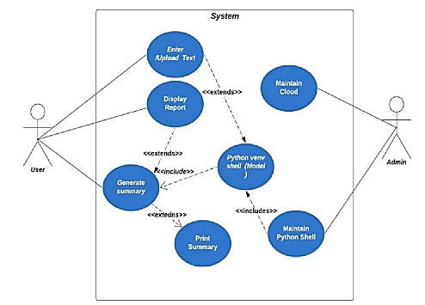

**Fig 4.4 Use case Diagram**

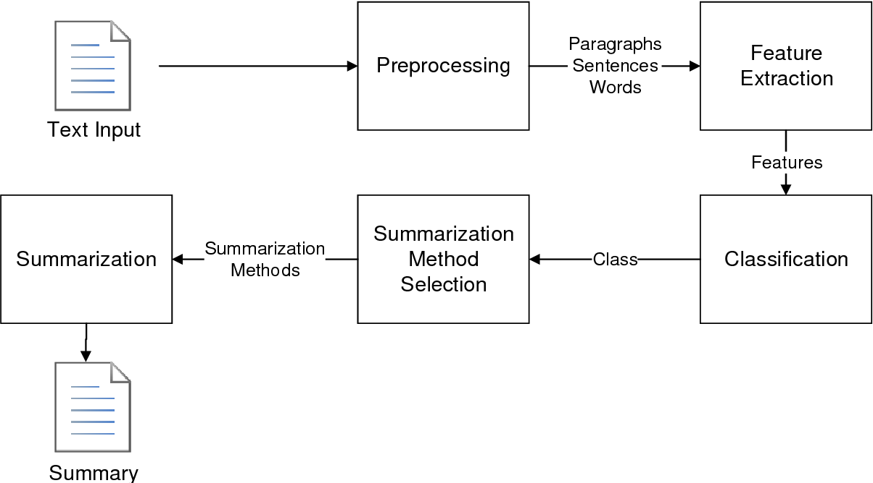

**Fig 4.5 Activity Diagram**

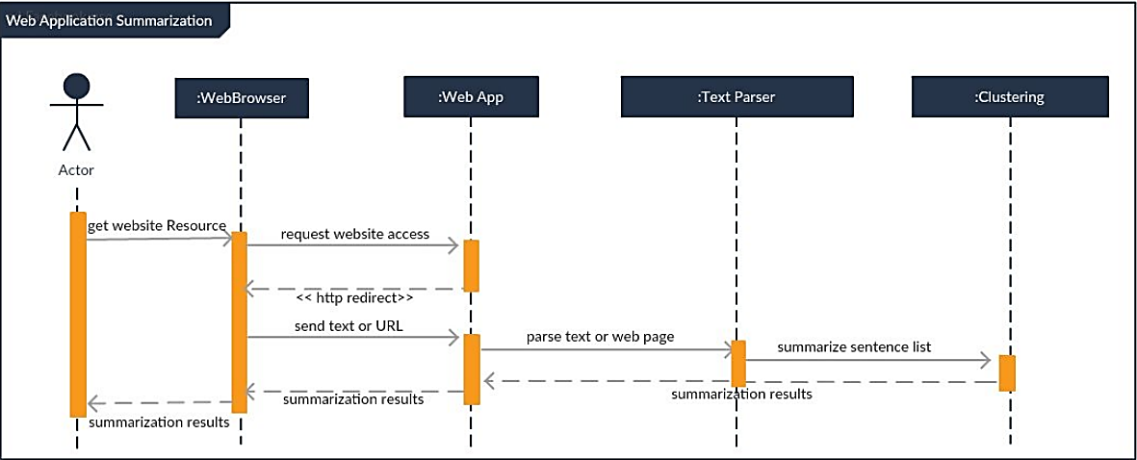

**Fig 4.8 Sequence Diagram**

# CHAPTER 5

**CODING TECHNIQUES AND IMPLEMENTATION DETAILS**

**5. Coding Techniques and Implementation Details**

In the **"Coding Techniques and Implementation Details"** section, the report provides an overview of the specific coding techniques and tools used in the project's implementation. Here is a more detailed explanation of each element:

1. **Programming languages:**
   * **Python**: Python programming language was chosen as the core development language for this project. Python is widely used in the field of artificial intelligence and natural language processing due to its simplicity, readability, and rich ecosystem of libraries and frameworks.
2. **Libraries and Frameworks**

* **NLTK (Natural Language Toolkit):** NLTK is used for text pre-processing tasks, such as tokenization, stemming, and stop-word removal.
* **Pandas:** Pandas is used for data manipulation and analysis, specifically for handling datasets and generating data frames.
* **NumPy:** NumPy is used for efficient numerical computations and array manipulation in the text summarization process.
* **TensorFlow:** A crucial framework for building and training deep learning models including the Transformer. It supports a wide range of utilities and functions for model development, training, and deployment.
* **Flask:** A micro web framework used for deploying the Transformer model as a web application. Flask can serve the model's functionality through a web interface, allowing end-users to interact with the model for real-time summarization.

1. **Algorithms and Techniques:**
   * **LexRank Aalgorithm:** The LexRank algorithm for extractive text summarization computes sentence importance based on graph centrality, where sentences are nodes and their similarity scores are edges. Sentences with high centrality are selected for the summary, typically using graph-based ranking techniques like PageRank. This approach prioritizes sentences that are both important and well-connected to other sentences in the text.
   * **Transformer-based Model:** The Transformer model for extractive text summarization applies a self-attention mechanism to capture dependencies between words and sentences in the input text. It consists of an encoder-decoder architecture where the encoder processes the input document and the decoder generates the summary. During training, it learns to attend to important parts of the input document to produce an accurate summary.
2. **Implementation Steps:**

**Abstractive Summarization using Transformer-based model**

* **Preprocessing :**
* **Text Cleaning**: Remove noise like HTML tags, special characters, and punctuation.
* **Sentence Tokenization**: Split the text into sentences.
* **Word or Sub word Tokenization**: Break down each sentence into words or sub words suitable for the Transformer model.
* **Padding**: Adjust the length of tokenized sequences by padding or truncating to ensure uniformity.
* **Masking**: Create attention masks to distinguish between actual words and padding tokens, guiding the model's attention during training and inference

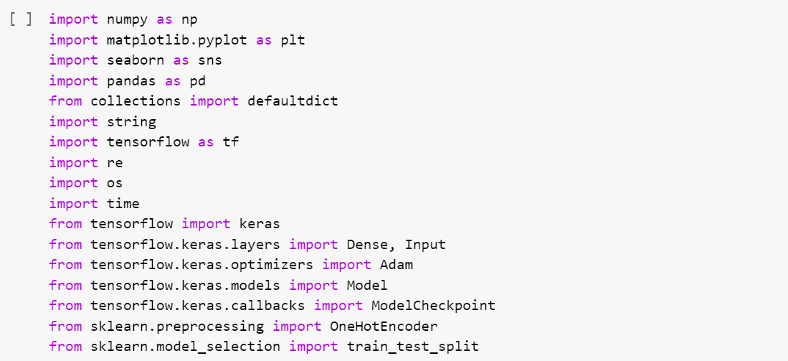

**Fig 5.4.1 Import Pre-processing Libraries**

Fig 5.4.1 represents importing required libraries and modules for data manipulation, visualization, and deep learning tasks in Python. It includes NumPy for numerical computations, Matplotlib and Seaborn for plotting, Pandas for data analysis, TensorFlow and Keras for building and training deep learning models, as well as scikit-learn for preprocessing and evaluation..

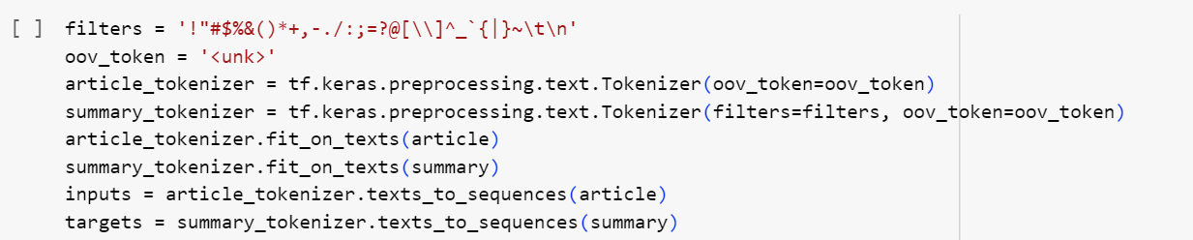

**Fig 5.4.2 Tokenization**

Fig. 5.4.2 initializes tokenizers for document and summary texts, creating word indices for each. It transforms the document and summary texts into sequences of integers using the respective tokenizers. Additionally, it calculates the vocabulary sizes for the encoder and decoder based on the tokenized texts

**Building a Model:**

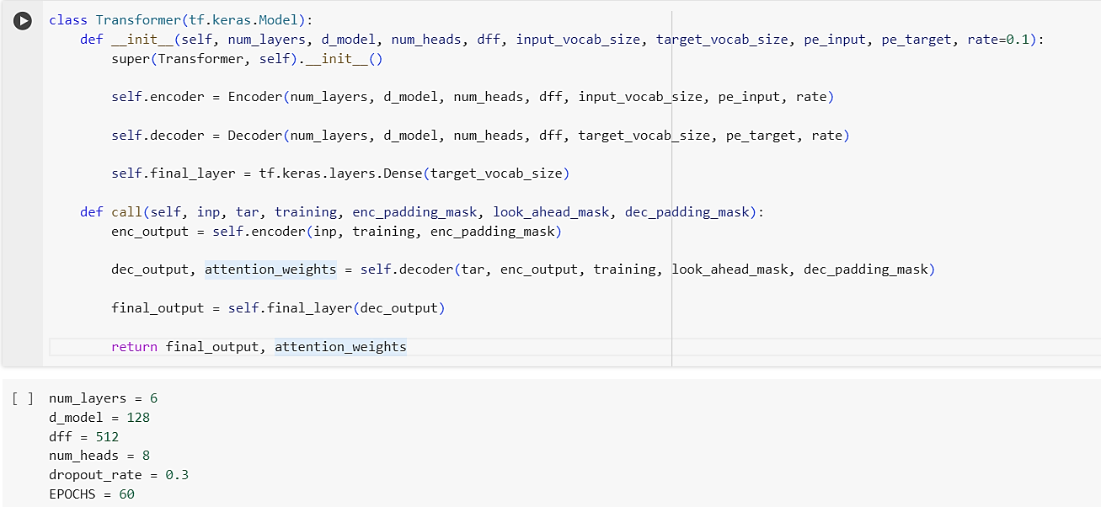

**Fig. 5.4.3 Transformer Model**

Fig. 5.4.3 defines a Transformer model for sequence-to-sequence tasks. It includes an encoder, decoder, and final dense layer. The call method processes input and target sequences, applying masks, and produces the final output sequence and attention weights through the encoder and decoder modules.

**Custom Learning Rate:**

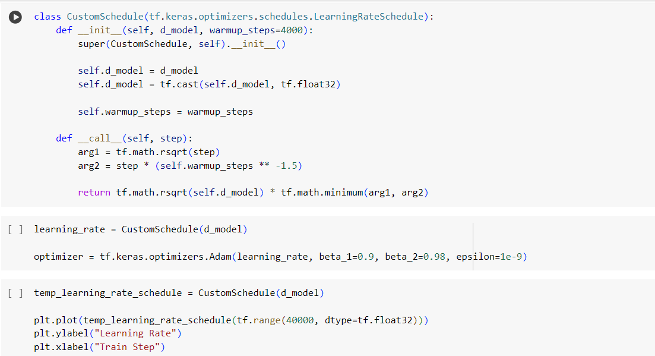

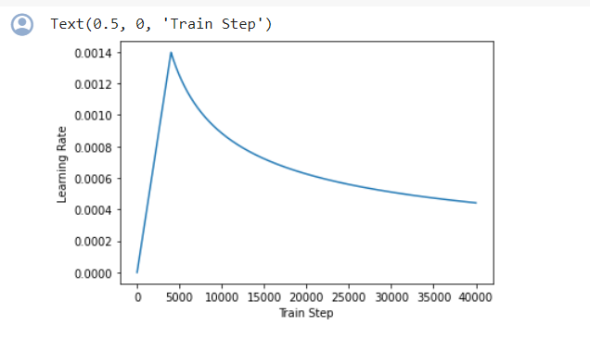

**Fig. 5.4.4 Learning Rate**

Fig.5.4.4 demonstrates the dynamic adjustment of the learning rate during training. Initially, the learning rate starts low and gradually increases during the warm-up phase, allowing the model to stabilize. As training progresses, the learning rate decreases, helping the model converge towards optimal performance. The graph visualizes how the learning rate evolves over training steps, providing insights into the optimization process.

**Custom Loss and Accuracy :**

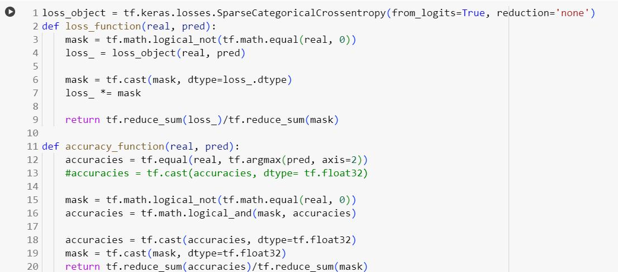

**Training:**

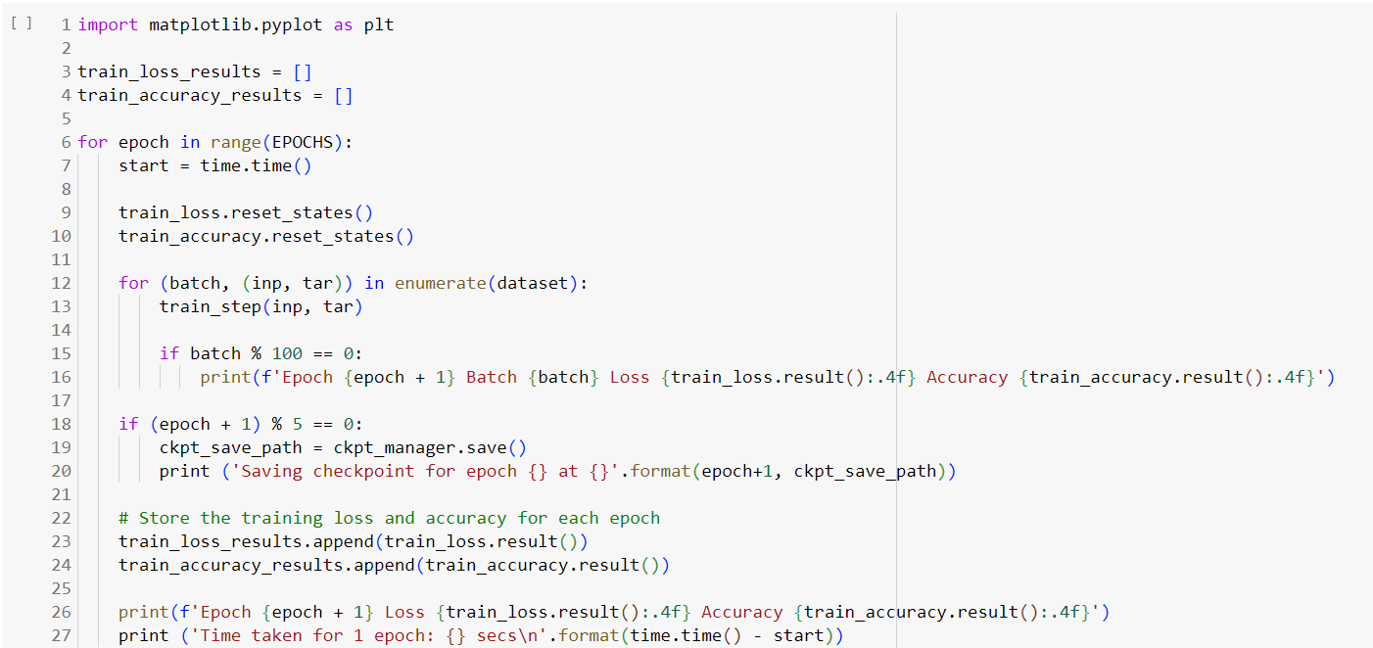

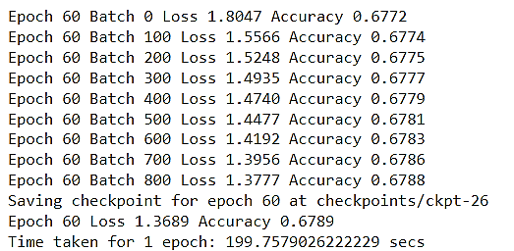

**Fig. 5.4.5 Train the Model**

Fig. 5.4.5 This represents training a Transformer model by iterating through epochs. In each epoch, it executes a training step for every batch, computing gradients, updating parameters, and tracking the training loss. Periodically, it prints batch-wise loss, saves checkpoints, and finally prints epoch-wise loss and time taken for each epoch.

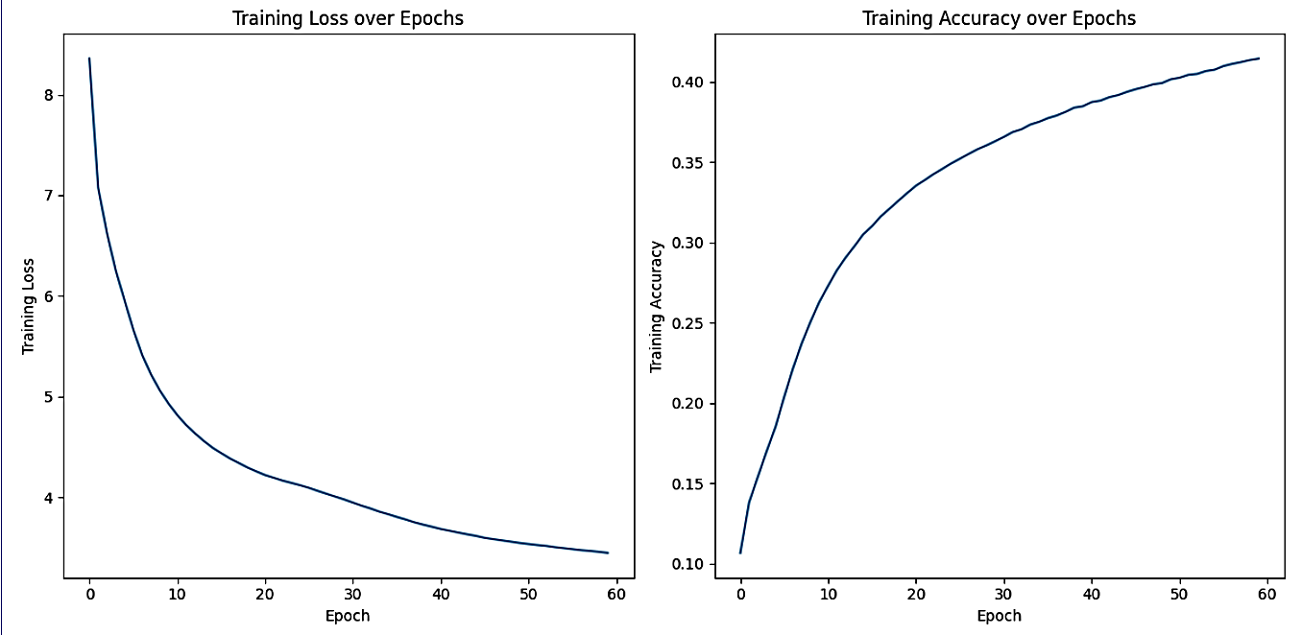

**Fig. 5.4.6 Loss and Accuracy**

Fig. 5.4.5 represents a loss function for sequence prediction tasks, specifically for sparse categorical cross-entropy with masking. It calculates the loss based on the difference between the predicted and actual sequences, accounting for padding tokens. An accuracy function computes the accuracy of the predictions, considering only non-padding tokens. Both functions ensure proper evaluation of model performance in sequence prediction tasks.

**Evaluation:**

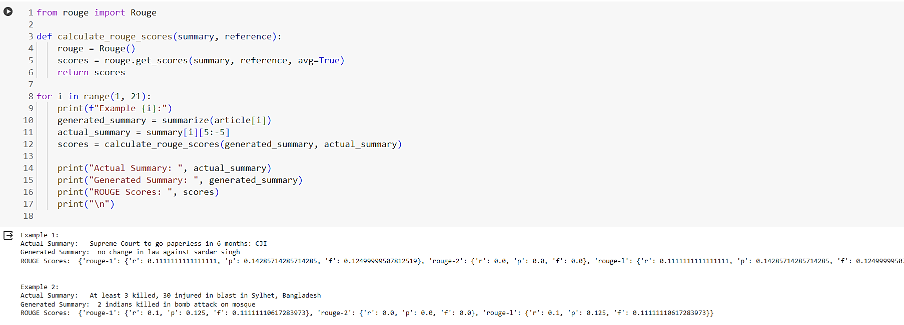

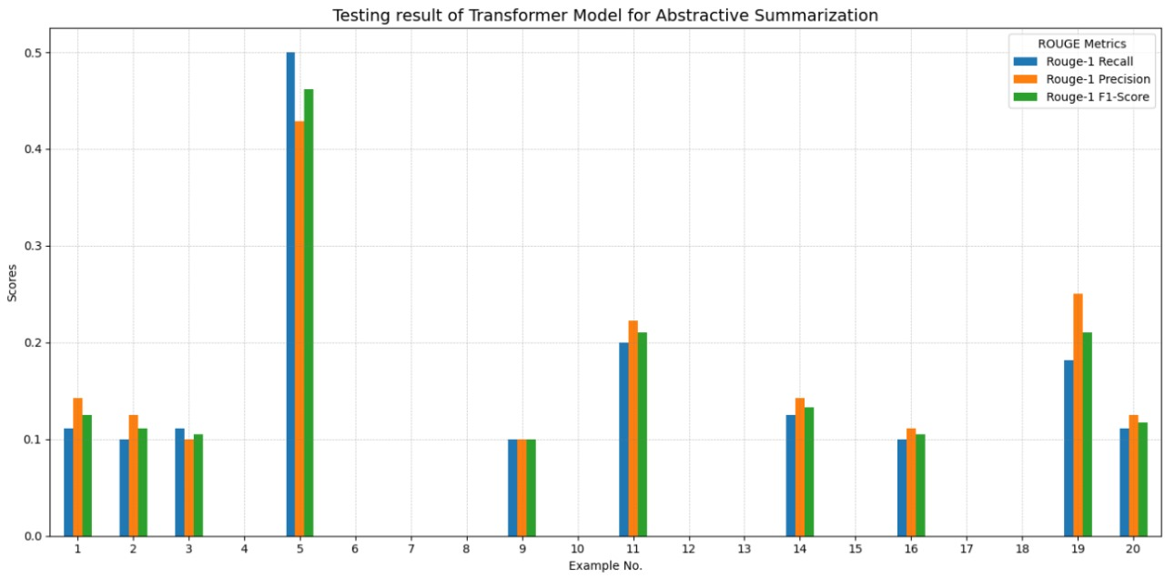

**Fig. 5.4.7 Evaluate the Performance of trained Transformer Model**

Fig. 5.4.7 represents evaluating the performance of a Transformer-based summarization model using the ROUGE metric. It iterates over a set of examples and generates summaries for each article. Then, it compares the generated summaries with the actual summaries to calculate ROUGE scores. Finally, it prints the actual summary, generated summary, and corresponding ROUGE scores for each example. This process allows for assessing the quality of the model's summaries across multiple articles using ROUGE evaluation.

* **Extractive Summarization using LexRank Algorithm:**

**Pre-processing:**

* **Text Cleaning**: Remove any unnecessary elements such as HTML tags special characters, and punctuation from the text.
* **Sentence Tokenization**: Split the text into individual sentences.
* **Word Tokenization**: Tokenize each sentence into words.
* **Stop word Removal**: Remove common stop words (e.g., "and", "the", "is") as they don't typically contribute much to the meaning of the text.
* **Stemming or Lemmatization**: Reduce words to their base or root form to normalize the text.
* **Constructing Sentence Embeddings**: Convert each sentence into a numerical representation, typically using methods like TF-IDF or word embeddings.

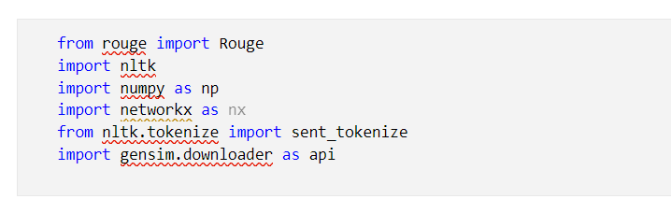

**Fig 5.4.8 Import Libraries for Data Pre-processing**

Fig 5.4.8 represents importing required python libraries for pre-processing and separating targets. It includes Rouge for evaluation metrics, NLTK for tokenization, Gensim for word embeddings, and NetworkX for graph-based algorithms.

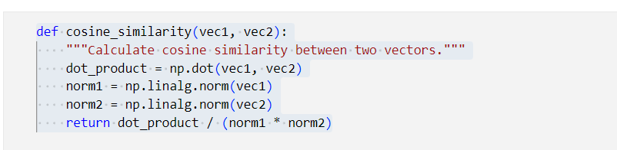

**Fig 5.4.9 Calculate Cosine Similarity between Two Vectors**

Fig 5.4.9 the function takes two vectors as input, calculates their dot product and norms, and then computes the cosine similarity between them using these values. Finally, it returns the cosine similarity as the output.

**Sentence Embedding and Similarity Matrix:**

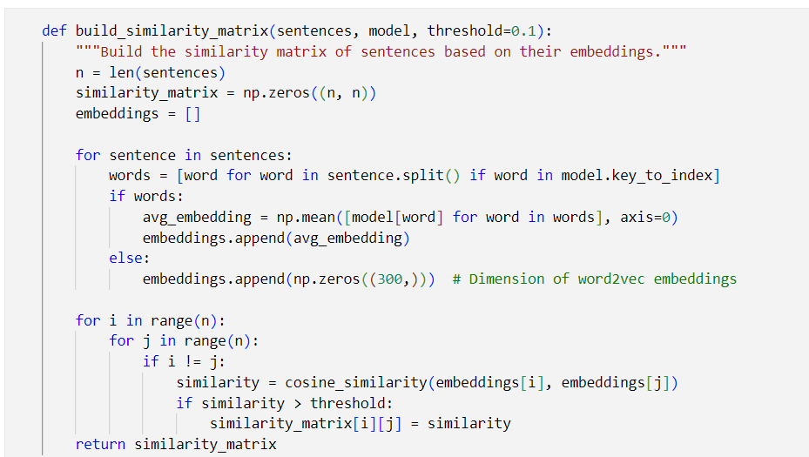

**Fig 5.4.10 Construct Similarity Matrix**

Fig 5.4.10 this function processes each sentence to generate embeddings and constructs a similarity matrix based on the cosine similarity between sentence embeddings, considering a specified threshold.

During initialization, the code computes the number of sentences in the input list, assigning the count to the variable **n,** and creates a square similarity matrix, **similarity_matrix**, with dimensions **n x n**, filled with zeros to capture pairwise sentence similarities. Additionally, it initializes an empty list, **embeddings**, to store the embeddings of each sentence for subsequent processing.

**Summary Generation:**

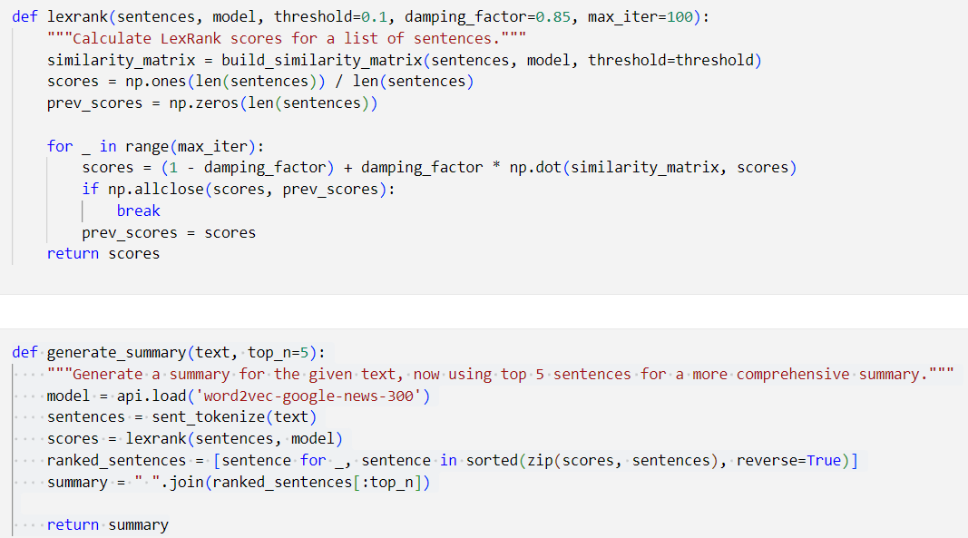

**Fig 5.4.11 Generate Summary using LexRank Scores**

Fig 5.4.11 Calculates LexRank scores for a list of sentences by iterating through a similarity matrix and updating scores until convergence, based on a specified threshold, damping factor, and maximum iterations. generate_summary uutilizes LexRank to generate a summary of the given text by ranking sentences according to their LexRank scores, then selecting the top N sentences to form the summary.

**Evaluation:**

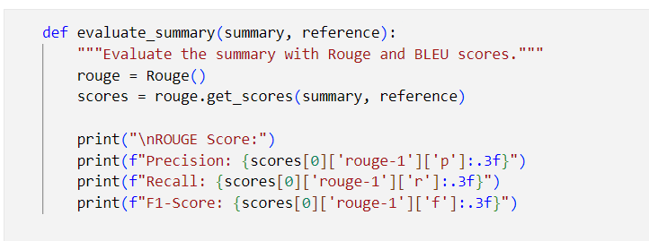

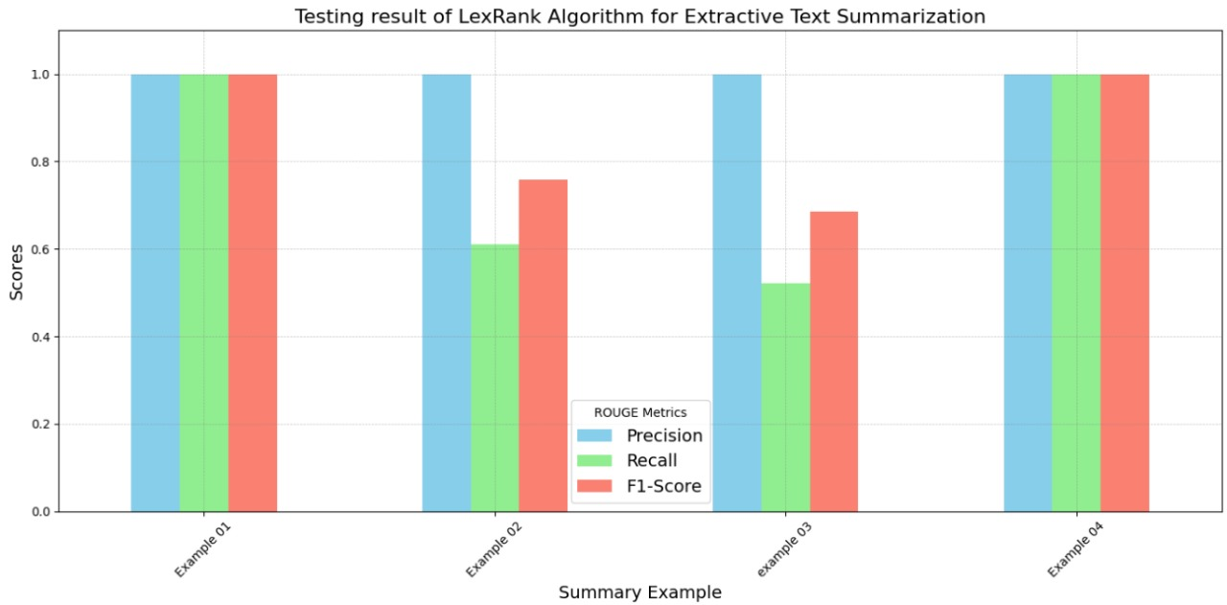

**Fig 5.4.12 Evaluation Metrics Comparison**

Fig 5.4.12 This function **evaluates_summary** evaluates a generated summary against a reference summary using Rouge scores. It first initializes the Rouge object, computes Rouge scores for the given summary-reference pair, and then prints the precision, recall, and F1-score for Rouge-1.

# CHAPTER 6

**APPLICATIONS**

**6. Applications**

Since we are using the Transformer-based model and LexRank algorithm trained on news, scientific articles, web documents, patents etc., here are some optimal applications for your text summarization system:

1. **News summarization and aggregation:**
   * Armed with the ability to summarize news articles from multiple sources, we can create a comprehensive news aggregator platform.
   * Users can input their interests or topics they want to stay informed about, and the system generates concise summaries of relevant articles.
2. **Research paper summarization:**
   * With the model's training on datasets like arXiv and PubMed, we can create a platform that skims through complex scientific papers and provides concise summaries.
   * This feature helps researchers quickly grasp key findings, identify relevant papers, and save time in their research.
3. **Document summarization for legal or business use:**
   * Professionals in legal and business industries commonly need to review extensive documents.
   * Our project can automatically generate executive summaries, saving time in document analysis and allowing professionals to quickly identify important details.
4. **Educational material condensation:**
   * Our project can help condense lengthy educational materials, such as textbooks or research papers, into shorter and more manageable summaries.
   * Students and educators can benefit from this feature while studying or preparing lectures, saving time, and improving learning efficiency.
5. **User-generated content summarization:**
   * Online forums, social media platforms, and customer reviews contain vast amounts of user-generated content.
   * Our project can summarize and extract the key points from these discussions, offering valuable insights in a concise manner.

These are just a few potential applications of the "Future Scribe AI: Text Summarization" project. The model's versatility allows for adaptability to various contexts, and the applications can be expanded based on the specific needs of users and industries.

# CHAPTER 6

**CONCLUSION**

**6. Conclusion**

**Future Scribe AI** tackles the challenge of information overload with a robust text summarization system. This project delivers **concise, informative summaries** of lengthy documents using advanced Natural Language Processing (NLP) techniques.

We explored both **extractive** (selecting key sentences) and **abstractive** (generating new, condensed text) approaches. This combined strategy offers users a **flexible toolkit** for various summarization needs.

**Key Achievements:**

* **Custom Transformer Model:** We developed a powerful, custom Transformer model specifically designed for superior summarization accuracy.
* **User-Friendly Interface:** A web interface built with front end technlogies makes the system **accessible** to a broad audience.
* **Multi-faceted Evaluation:** We employed ROUGE metrics, BLEU scores, and training time measurements to assess model performance.

**Future Directions:**

* **Continuous Improvement:** We will refine the system based on user feedback and explore multi-document summarization capabilities.
* **Beyond Summarization:** We'll leverage user feedback to optimize Future Scribe AI, transforming it from a summarization tool to a **comprehensive data analysis assistant**. Imagine an AI that can not only summarize text but also **mine insights and uncover hidden patterns** from any data set, just like a human analyst. This future version will **revolutionize data analysis**, streamlining workflows and empowering users to extract maximum value from information.

**Future Scribe AI empowers individuals and organizations to streamline information processing and gain valuable insights from text. We are excited to push the boundaries of what's possible and transform Future Scribe AI into a powerful data analysis companion.**

**REFERENCES**

1. G. Erkan and D. Radev, "LexRank: Graph-based lexical centrality as salience in text summarization," Journal of Artificial Intelligence Research, vol. 22, pp. 457-479, 2004. **[DOI: 1109.2128 ]**
2. Y. Liu, M. Ott, N. Goyal, J. Du, M. Joshi, D. Chen, O. Levy, M. Lewis, L. Zettlemoyer, and V. Stoyanov, "Roberta: A robustly optimized BERT pretraining approach," arXiv preprint arXiv:1907.11692, 2019. **[DOI: 1907.11692]**
3. R. Řehůřek and P. Sojka, "Software framework for topic modelling with large corpora," in Proceedings of the LREC 2010 Workshop on New Challenges for NLP Frameworks, Valletta, Malta, 2010, pp. 45–50. **[DOI: 10.13140/2.1.2393.1847]**
4. I. Sutskever, O. Vinyals, and Q. V. Le, "Sequence to sequence learning with neural networks," in Proceedings of the 27th International Conference on Neural Information Processing Systems, MIT Press, 2014, pp. 3104-3112. **[DOI: 1409.3215]**
5. A. Vaswani, N. Shazeer, N. Parmar, J. Uszkoreit, L. Jones, A. N. Gomez, Ł. Kaiser, and I. Polosukhin, "Attention is all you need," in Proceedings of the 31st International Conference on Neural Information Processing Systems, Curran Associates Inc., 2017, pp. 6000-6010. **[DOI: 1706.03762]**
6. M. Lewis, Y. Liu, N. Goyal, M. Ghazvininejad, A. Mohamed, O. Levy, V. Stoyanov, and L. Zettlemoyer, "BART: Denoising sequence-to-sequence pre-training for natural language generation, translation, and comprehension," arXiv preprint arXiv:1910.13461, 2019. **[DOI: 1910.13461]**
7. J. Liu and M. Lapata, "Text summarization with pretrained encoders," arXiv preprint arXiv:1908.08345, 2019. **[DOI: 1908.08345]**
8. Y. Liao, F. Wang, M. Bansal, C.-Y. Lin, P. Ma, and T. R. Wambolt, "Abstractive text summarization using sequence-to-sequence RNNs and beyond," in Proceedings of the 59th Annual Meeting of the Association for Computational Linguistics, 2021. **[DOI: 1602.06023]**
9. R. Nallapati, B. Zhou, C. Gulcehre, and B. Xiang, "Abstractive text summarization using sequence-to-sequence RNNs and beyond," in the 41st International ACM SIGIR Conference on Research & Development in Information Retrieval, 2018, pp. 280-290**. [DOI: 10.18653/v1/K16-1028]**