**EXAM MANAGEMENT SYSTEM**



**Developed By:**

**Y. Venu Sai (122cs0021)**

**Shaik Aftab (122cs0029)**

**Ravi Vasanth Kumar (122cs0018)**

**R Praharsh Sam (122cs0007)**

**Abstract:**

The Exam Management System (ExamFlow) is a comprehensive web-based application designed to simplify and automate the process of creating, organizing, and distributing exam timetables for educational institutions. By leveraging modern web technologies, ExamFlow offers a user-friendly interface that allows administrators to efficiently manage exam schedules, generate PDF timetables, and send notifications to students and faculty members.

The system is built to address common challenges faced by educational institutions, such as scheduling conflicts, last-minute changes, and efficient communication of exam details. With its intuitive design and automated processes, ExamFlow enhances the accuracy, accessibility, and efficiency of exam management.

This document provides a comprehensive overview of the project, covering its architecture, implementation, and key functionalities to give a clear understanding of how the system works and the benefits it offers to users.

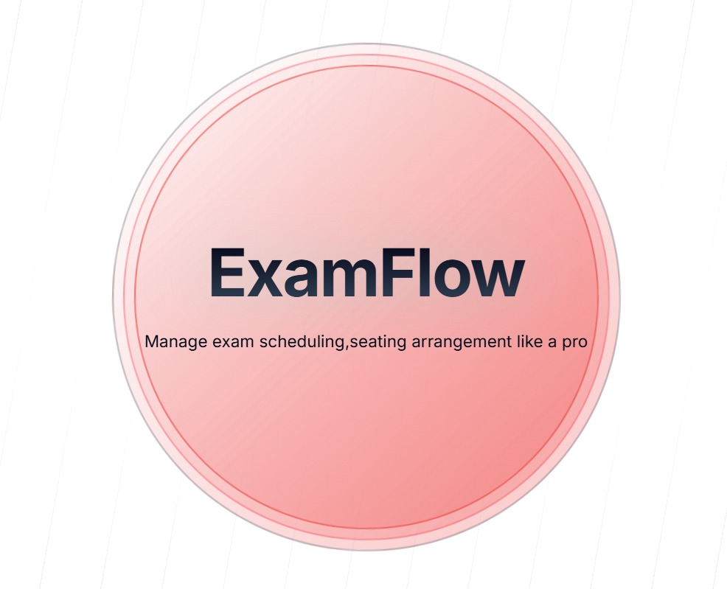

**1. Introduction**

**1.1 Overview**

Exam scheduling is a critical task for educational institutions, requiring careful organization to ensure smooth operations. Traditional methods often involve manual processes, which are time-consuming and prone to errors. The Exam Management System addresses these challenges by automating the creation and distribution of exam timetables.

**1.2 Objectives**

The primary objectives of this project are:

* Automate exam scheduling and seating arrangements.
* Provide a user-friendly dashboard for administrators.
* Generate timetables in PDF format.
* Enable notification systems for students and faculty.
* Offer an interactive calendar view for exams.
* Ensure scalability and adaptability for different educational institutions.

**2. System Workflow**

**2.1 User Login**

* Users access the system through a login portal.
* Authentication ensures only authorized users can modify schedules.

**2.2 Dashboard**

* The main dashboard contains two components:
  1. **Timetable Management**
  2. **Seating Arrangement**

**2.3 Timetable Management**

* Users can create a new timetable by entering:
  + Year (1st - 4th)
  + Branch (e.g., CSE, ME)
  + Exam Start and End Dates
* The system generates a timetable and offers options to:
  + Download PDF
  + Notify Students
  + Delete Timetable

**2.3.1 Edit Timetable**

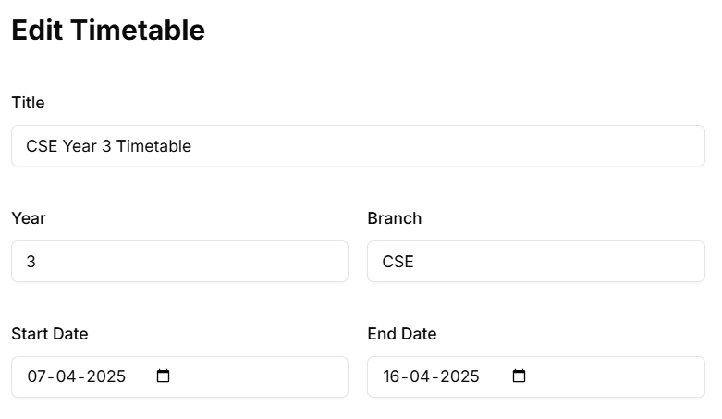

**2.3.2 Exam Schedule**

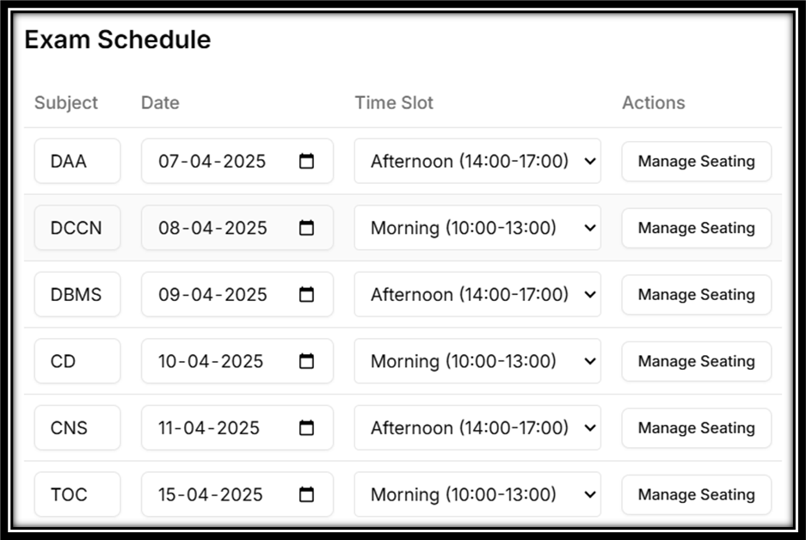

**2.3.3 Exam Calendar View**

* Displays scheduled exams in a calendar format.
* Allows users to view exam dates and time slots.

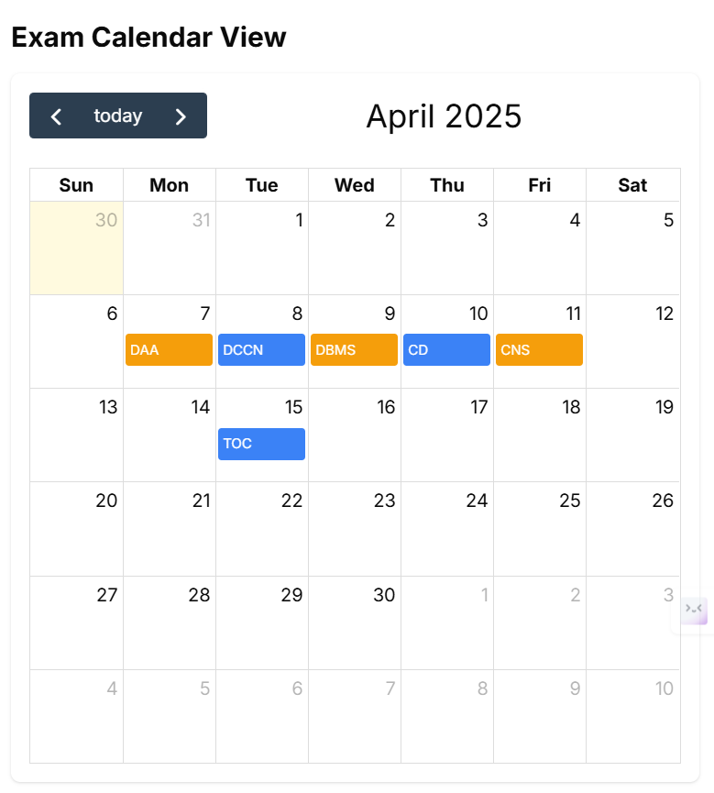

**2.4 Seating Arrangement**

* Users select classrooms based on available seating capacity.
* Students are assigned seats dynamically.
* Seating arrangement includes:
  + Student Name
  + Roll Number
  + Seat Number
  + Classroom Allocation

**3. System Architecture**

**3.1 Technologies Used**

* **Frontend**: React.js, TypeScript
* **Backend**: Prisma, server actions
* **PDF Generation**: React render
* **Email Notifications**: Resend

**3.2 Flowchart of Process**

**User Workflow**

1. **User Logs In** → Access Dashboard
2. **Create Timetable** → Input Details → Generate Timetable
3. **Edit/Delete** → Save Timetables
4. **Download PDF** → Notify Students
5. **Generate Seating Arrangement** → Assign Seats → Confirm Layout
6. **View Exam Calendar** → Monitor Exam Dates

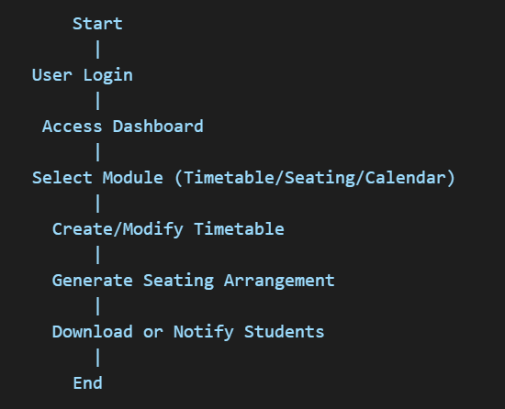

**4. Implementation Details**

**4.1 Generating Time Table**

This work presents a backend API implementation that leverages contemporary technologies for dynamic exam timetable generation and retrieval. Our approach integrates rigorous input validation using a schema-driven library to ensure data integrity before fetching subject data from a relational database. A specialized module calculates excluded dates, particularly weekends, to enforce temporal constraints within the exam schedule. By interfacing with a state-of-the-art AI model, the system generates a JSON-formatted timetable that adheres to strict constraints, including designated time slots and mandatory spacing between exams. The resulting schedule undergoes further validation and is stored persistently, ensuring both immediate and future accessibility through a dedicated retrieval endpoint. Robust error handling is employed throughout to maintain system stability and provide clear feedback in the event of failures.

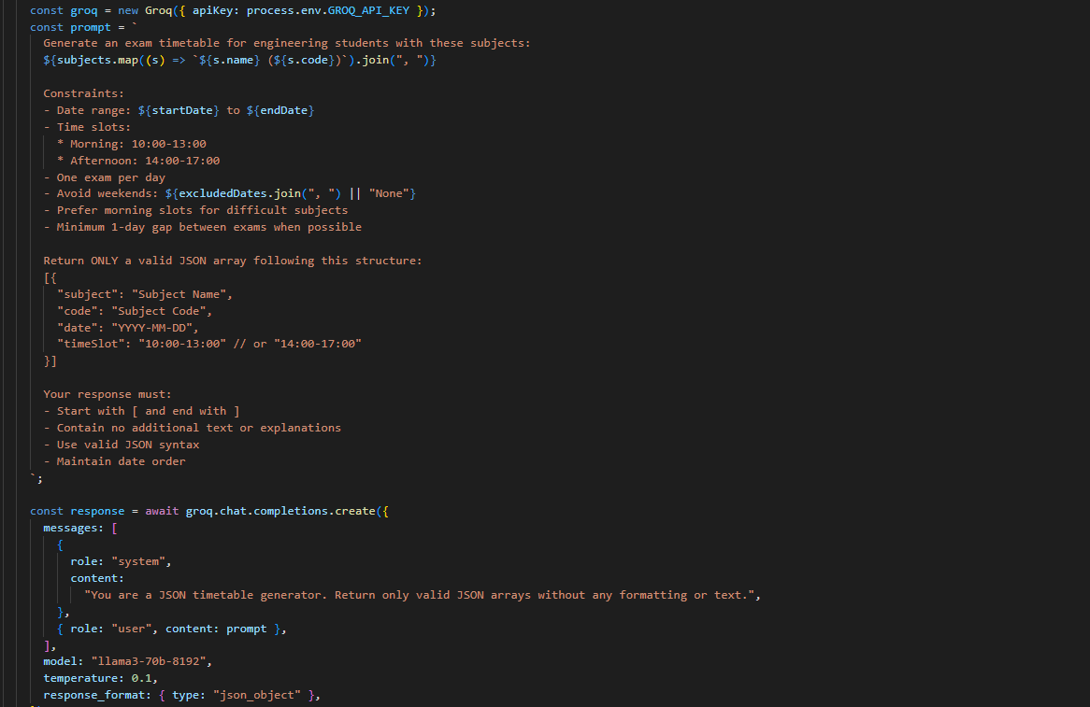

*4.1 Code snippet for Time table generation.*

**4.2 CRUD Operations on Time Tables**

Implementation provides a set of API endpoints to manage exam timetables, enabling retrieval, modification, and deletion operations. The GET endpoint fetches a specific timetable from the database, including associated exam entries, ensuring data consistency and completeness. The PATCH endpoint facilitates updates by validating incoming request data, executing a transactional update that first removes existing exam and seating arrangement records before inserting new exam entries. This transactional approach ensures atomicity and prevents partial updates. Additionally, date fields are formatted into ISO strings for seamless frontend integration. The DELETE endpoint performs a cascading deletion process, sequentially removing related seating arrangements, exam entries, and finally, the timetable itself. Throughout the implementation, robust error handling mechanisms are employed to safeguard data integrity and provide informative responses in the event of failures. This modular and scalable design ensures efficient timetable management within academic institutions.

**4.3 Seating Arrangement Generation**

API-driven solution for automated seating arrangement generation and management within academic examination settings. The implementation integrates robust input validation through schema definitions, secure user authentication, and transactional database operations to ensure data consistency and reliability. The core functionality is encapsulated in three endpoints—POST, GET, and DELETE—which together facilitate the generation, retrieval, and removal of seating assignments for a given exam.

The POST endpoint is the centrepiece of the solution. It begins by validating the incoming request, ensuring that a non-empty array of valid classroom identifiers is provided. The system then retrieves the authenticated user's database record and verifies the existence of the specified exam. Subsequently, it gathers relevant classroom and student data, checking that the collective seating capacity of the chosen classrooms meets the exam's demand. A fallback seating assignment strategy is initially employed to assign students to available seats in a prioritized order. The endpoint further enhances this basic assignment by invoking an AI model via an external service, which is tasked with generating an optimized seating arrangement based on explicit rules and constraints. Final assignments are rigorously validated against available student and seat identifiers before being persisted to the database.

The GET endpoint offers a straightforward mechanism for retrieving existing seating arrangements, enriching the response with associated student and classroom details. Meanwhile, the DELETE endpoint enables the complete removal of seating assignments for an exam, ensuring a clean slate for subsequent operations. Throughout, the system is fortified with comprehensive error handling, ensuring robust responses and clear diagnostics in the event of operational failures.

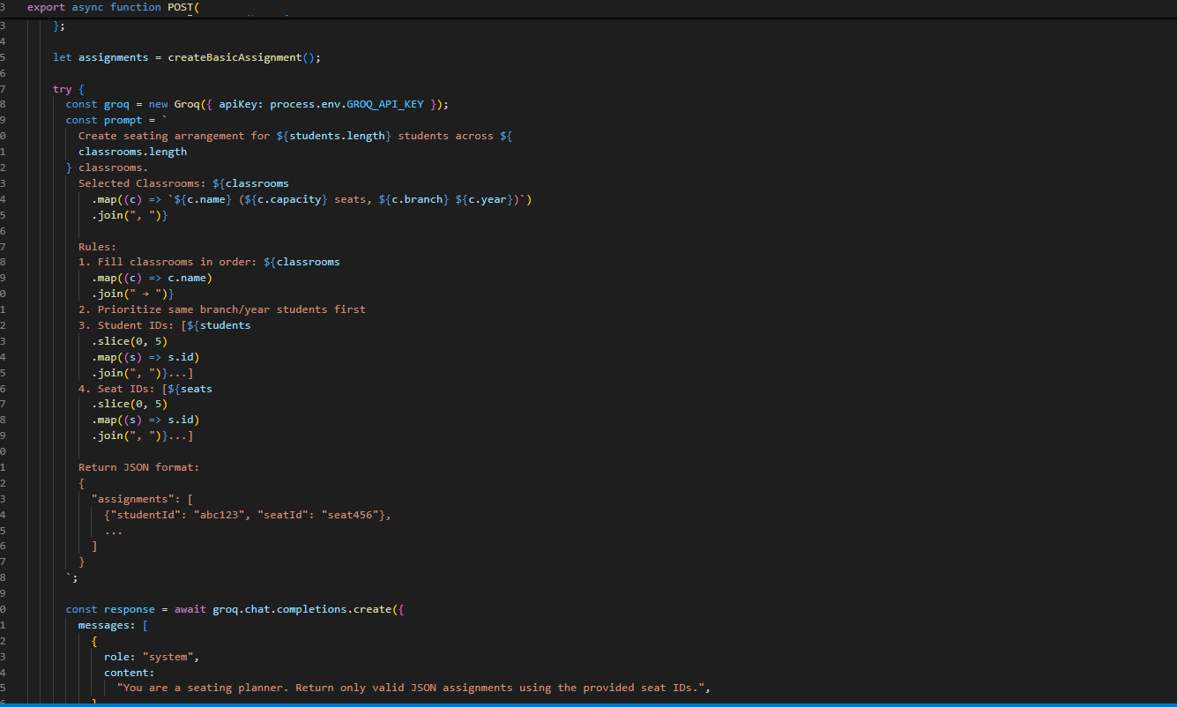

*4.3 Seat generation*

**4.4 Email Notifications**

The system retrieves a specific exam timetable from the database based on a provided identifier, ensuring that the relevant exam details are included in the query. Utilizing an external email service API, the solution iterates over a set of predefined sample email addresses to simulate student notifications. For each recipient, a personalized email is composed by integrating a React-based email template, which dynamically formats the exam schedule data into a student-friendly view. Comprehensive error handling is incorporated at both the database retrieval and email sending stages, ensuring that any failures are logged and reported appropriately. This design not only demonstrates the practical integration of modern email services but also serves as a prototype for scalable exam notification systems in academic environments.

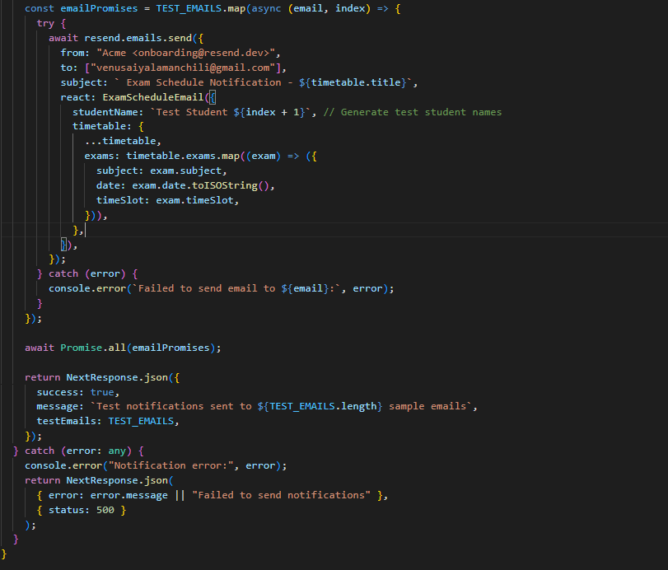

*4.4 Code Snippet Email Notification*

**4.5 Seating CRUD Operations**

Client-side component embodies a sophisticated seating arrangement interface within an exam management system, designed using modern React paradigms. Leveraging state hooks and asynchronous data fetching with Axios, the component dynamically retrieves seating arrangements and available classrooms from designated API endpoints, thereby ensuring real-time synchronization of data.

The component's architecture emphasizes user interactivity and modularity. It presents a clear and responsive UI that allows users to select one or more classrooms, triggering the generation of seating assignments via a dedicated API call. The system incorporates fallback mechanisms and error notifications through the toast messaging library, enhancing user feedback during operations such as seating generation and seat assignment modifications.

The component also integrates a modal dialog for editing seat assignments, which is activated via a dropdown menu. This modal facilitates in-context editing of seating details, thereby streamlining the update process. Furthermore, the design ensures that operations such as generation, deletion, and updating of seating arrangements are executed efficiently, with robust error handling and state management to maintain application stability and responsiveness.

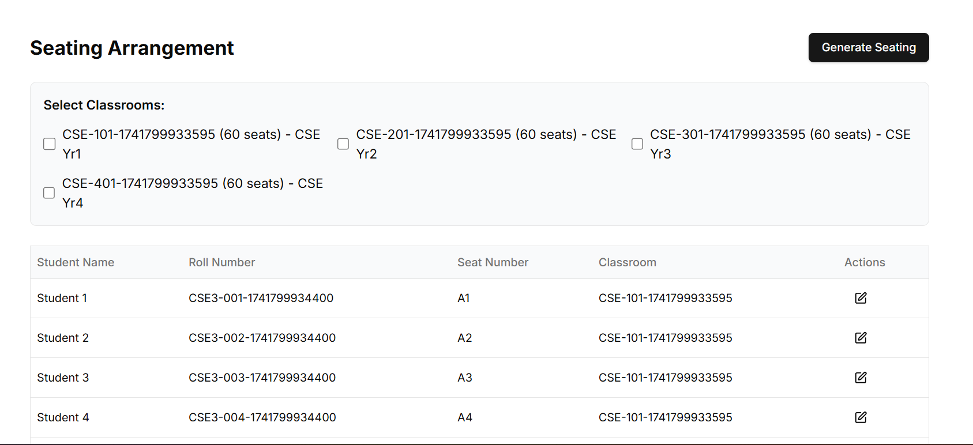

*4.5 UI Seating CRUD Operations*

**5. Features and Functionalities**

**5.1 Dashboard Features**

* Intuitive UI for navigation.
* Summary of scheduled exams and seating.

**5.2 Timetable Management**

* Auto-generation of schedules.
* Edit and delete functionalities.
* PDF export.

**5.3 Seating Arrangement**

* Dynamic seat allocation.
* Classroom selection.
* Seat assignment by roll number.

**5.4 Notifications**

* Email alerts for students and faculty.
* Downloadable PDF schedules.

**6. Results and Discussion**

The Exam Management System robustly automates the creation and distribution of exam timetables, significantly reducing manual effort and enhancing overall accuracy. By leveraging cutting-edge web technologies and AI-driven scheduling algorithms, the system generates timetables that adhere to institutional policies and real-time constraints, ensuring optimal allocation of resources and time slots. This automation minimizes human error, streamlines administrative workflows, and enables staff to focus on more strategic educational initiatives.

Furthermore, the system’s modular architecture—built on scalable microservices and well-defined API endpoints—facilitates seamless integration with existing academic databases and user management systems. This design not only ensures a smooth, intuitive user experience but also allows for rapid customization and expansion as institutional needs evolve. With robust error handling and real-time data validation, the platform delivers consistent performance even under high-volume exam scheduling scenarios, thereby maintaining operational resilience and efficiency.

1. **Project Links**

* GitHub Repo: [Click here](https://github.com/Aftab3008/exam-management)
* Live Website: [Click here](https://exam-management-three.vercel.app/)