**Lab 4: Playing around with Pointers**

1. **Identify and explain which of the following expressions are valid and which**

**are not valid as shown with an arrow. 5 pts**

char c; char *ptr;

int f;

ptr = &c; ← **Valid**

ptr = &f; ← **Invalid**

ptr = &’#’; ← **Invalid**

ptr = &500; ← **Invalid**

ptr = &(f+3); ← **Invalid**

1. **What will be the size of the following pointers? What are their scalar**

**values? Explain with screen shots. 4 pts**

int * p; **size 8, scalar 4**

double *q; **size 8, scalar 8**

char* r; **size 8, scalar 1**

float* s; **size 8, scalar 4**

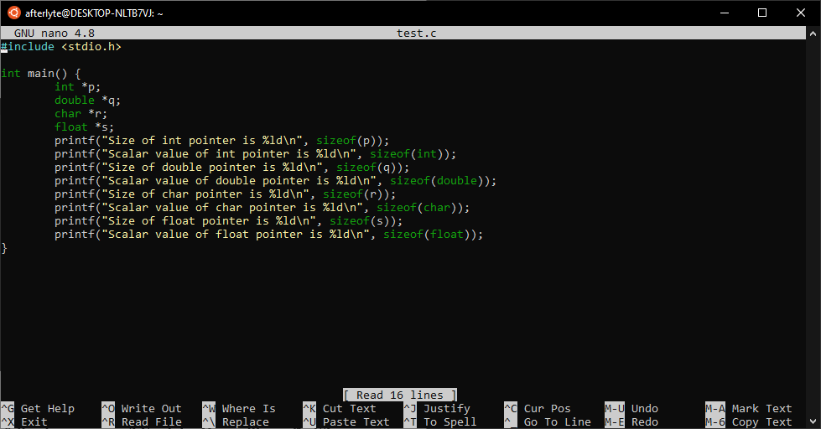

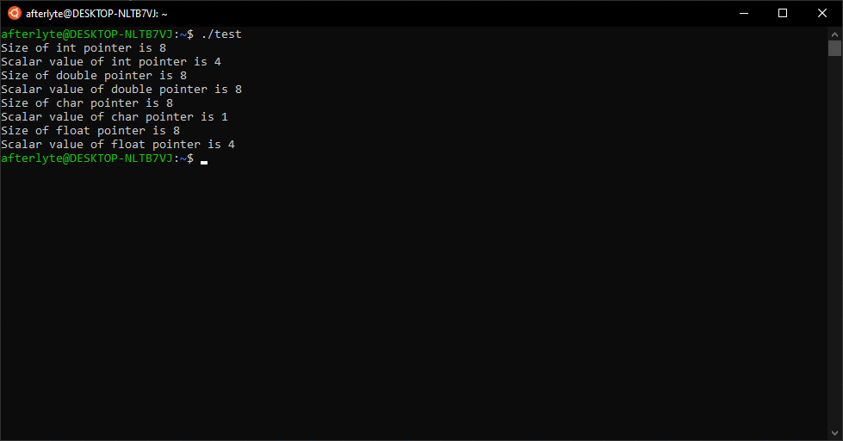

1. **What is wrong with the following program? Explain. How will you fix it?**

**1 pt**

#include <stdio.h>

int main(){

int i;

int *ptr = &i;

scanf("%d", &ptr);

printf("The value of i is: %d\n", *ptr);

return 0;

}

**In the Scanf function, the input integer is trying to be fed into the address of ptr, rather than the pointer itself, which is the correct solution. To fix it, change “&ptr” to “ptr”**

1. **Take a look at the code snippet below. What will be the final values of ‘c’, ‘a’, and ‘*p’.**

int c, a = 10; **4 pts**

int *p = &a;

c = *p; **c = 10**

*p = *p * *p;

(*p)++;

c = *&a; **c = 101**

1. **Consider the following piece of code. What will be printed by *ptr and ptr after the lines shown with an arrow? Explain with screenshots.**

int a[4] = { 8, 3, 5, 6}; **4 pts**

int *ptr = a; ← **8, -460966192 (memory location)**

ptr ++; ← **3, -460966188 (memory location)**

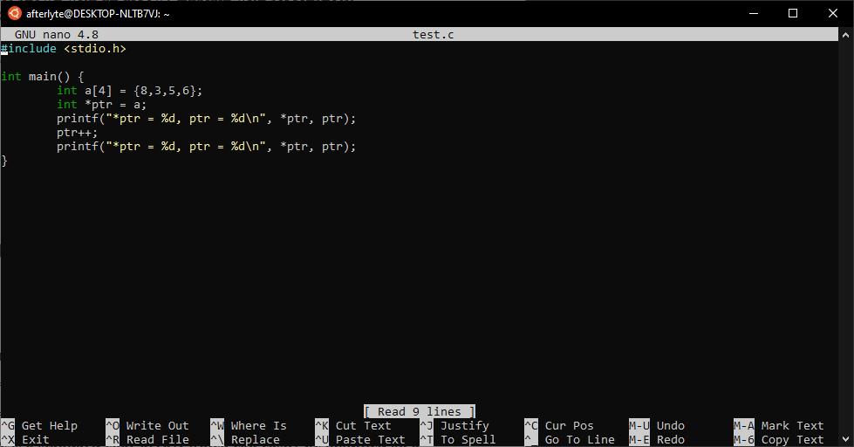

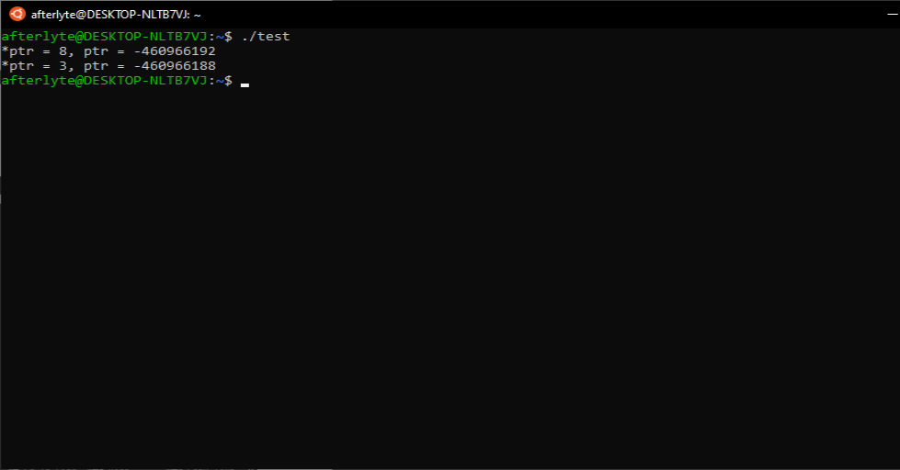

1. **What are the differences between the following two declarations? 2 pts** char array[] = “Hello World”;

char *array = “Hello World”;

**The first one is a standard char array, which can easily be modified on a character by character basis. The second one creates a constant char array pointer, which cannot be modified. Also, the size of the first one is the size of the array, and the size of the second one is the size of a pointer, 8 bytes**

**Submission:**

A pdf file containing answers to the questions and output capture wherever necessary.

Name your file with your last name first letter of your first name Lab4.pdf (ex: yasminsLab4.pdf).

**Submission deadline is: 11:59 pm, Thursday, October 29. No late submission will be considered.**