# Section 1

1. Terms
   1. Relation – A two-dimensional table of related data
      1. Example: the EMP and DEPT tables
   2. Attribute – A category of data in a relation
      1. Example: EMPNO in the EMP table
   3. Domain – The set of allowed values for an attribute
      1. Example: Hiredate in EMP being all real dates written in the date format
   4. Tuple – an entry (row) in a relation
      1. Example: Employee with EMPNO 7369 in EMP table with specified information
   5. Degree – The number of attributes in a relation
      1. Example: DEPT has a degree of 3
   6. Cardinality – the number of tuples in a relation
      1. Example: DEPT has a cardinality of 4
2. Terms
   1. Candidate Key – A super key of which there is no proper subset of attributes that is also a super key
      1. Example: DEPT has a candidate key of DEPTNO
   2. Primary Key – The candidate key chosen to be the main identifier for tuples in a relation
      1. Example: EMP would likely have a primary key of EMPNO, as it is likely made to be unique
   3. Foreign Key – Attributes in one schema that correspond to the primary key in another schema
      1. Example: DEPTNO shows up in both EMP and DEPT and correspond to each other’s values

# Section 2

create database ddlExercise

create table CATEGORY (CatCode varchar(2), CatDesc varchar(10))

create table EMPLOYEES (Emp_num int(5), Lastname varchar(18), Firstname varchar(18), Job_class varchar(4))

alter table EMPLOYEES add EmpDate date, add EndDate date

alter table EMPLOYEES modify Job_class varchar(2)

alter table EMPLOYEES drop EndDate

rename table EMPLOYEES to JL_EMPS

# Section 3

create database employeeDB

create table EMP (EMPNO int(4), ENAME varchar(18), JOB varchar(16), MGR int(4), HIREDATE date, SAL int, COMM int, DEPTNO int(2), primary key (EMPNO))

create table DEPT(DEPTNO int(2), DNAME varchar(18), LOC varchar(12), primary key(DEPTNO))

insert into EMP (empno, ename, job, mgr, hiredate, sal, deptno) values

(7369, "SMITH", "CLERK", 7902, '1980-12-17', 800, 20),

(7566, "JONES", "MANAGER", 7839, '1981-04-02', 2975, 20),

(7698, "BLAKE", "MANAGER", 7839, '1981-05-01', 2850, 30),

(7782, "CLARK", "MANAGER", 7839, '1981-06-09', 2450, 10),

(7788, "SCOTT", "ANALYST", 7566, '1982-12-09', 3000, 20),

(7876, "ADAMS", "CLERK", 7788, '1983-01-12', 1100, 20),

(7900, "JAMES", "CLERK", 7698, '1981-12-03', 950, 30),

(7902, "FORD", "ANALYST", 7566, '1981-12-03', 3000, 20),

(7934, "MILLER", "CLERK", 7782, '1982-01-23', 1300, 10);

insert into EMP values

( 7499, 'ALLEN', 'SALESMAN', 7698, '1981-02-20', 1600, 300, 30 ),

( 7521, 'WARD', 'SALESMAN', 7698, '1981-02-22', 1250, 500, 30 ),

( 7654, 'MARTIN', 'SALESMAN', 7698, '1981-09-28', 1250, 1400, 30 ),

( 7844, 'TURNER', 'SALESMAN', 7698, '1981-09-08', 1500, 0, 30 );

insert into EMP (empno, ename, job, hiredate, sal, deptno) values

( 7839, 'KING', 'PRESIDENT', '1981-11-17', 5000, 10 );

insert into DEPT values

( 10, 'ACCOUNTING', 'NEW YORK' ),

( 20, 'RESEARCH', 'DALLAS' ),

( 30, 'SALES', 'CHICAGO' ),

( 40, 'OPERATIONS', 'BOSTON' );

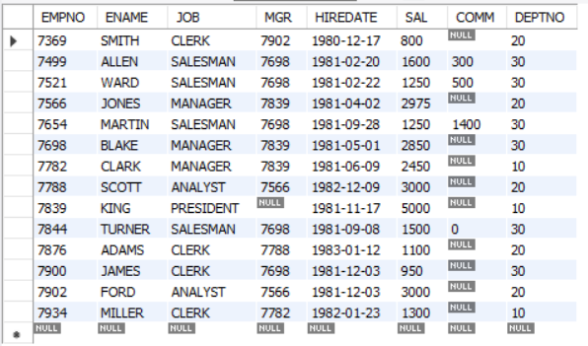

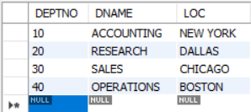

# Section 4

