# Lab 2 Submission

Ian Kaiserman

1. The Basic HTTP GET/response interaction questions
   1. Is your browser running HTTP version 1.0 or 1.1? What version of HTTP is the server
   2. running?
      1. Browser is running version 1.1. Server is running version 1.1
   3. What languages (if any) does your browser indicate that it can accept to the server?
      1. English (en-US)
   4. What is the IP address of your computer? Of the gaia.cs.umass.edu server?
      1. Computer: 10.56.1.100. Server: 128.119.245.12
   5. What is the status code returned from the server to your browser?
      1. Status code 200 OK
   6. When was the HTML file that you are retrieving last modified at the server?
      1. 23 Jan, 2021
   7. How many bytes of content are being returned to your browser?
      1. 128
   8. By inspecting the raw data in the packet content window, do you see any headers within the data that are not displayed in the packet-listing window? If so, name one.
      1. The packet listing window doesn’t show a lot of more technical information like the server, the content length, etc.
2. The HTTP CONDITIONAL GET/response interaction
   1. Inspect the contents of the first HTTP GET request from your browser to the server. Do you see an “IF-MODIFIED-SINCE” line in the HTTP GET?
      1. No
   2. Inspect the contents of the server response. Did the server explicitly return the contents of the file? How can you tell?
      1. Yes. There is a line-by-line HTML header and content length that shows the contents of the received HTML file.
   3. Now inspect the contents of the second HTTP GET request from your browser to the server. Do you see an “IF-MODIFIED-SINCE:” line in the HTTP GET? If so, what information follows the “IF-MODIFIED-SINCE:” header?
      1. Yes. Following the header is a date and time and is presumably very close to when the packet was sent (timezone is in GMT)
   4. What is the HTTP status code and phrase returned from the server in response to this second HTTP GET? Did the server explicitly return the contents of the file? Explain.
      1. The status code is 304 Not Modified. The server did not explicitly return the contents of the file as no content length is specified and there is no header containing the files contents. It is simply telling the browser that the file has not been modified and to use a cached version.
3. Retrieving long documents

(NOTE: I assume my device may have been handling this differently for whatever reason, as I only got one packet instead of multiple as I assume I was supposed to, so I’m going to be answering purely based on what my PC actually displayed. I included a screenshot of Wireshark just to verify what I actually received.)

* 1. How many HTTP GET request messages were sent by your browser?
     1. 1 (excluding the favicon GET request)
  2. How many data-containing TCP segments were needed to carry the single HTTP response?
     1. 1
  3. What is the status code and phrase associated with the response to the HTTP GET request?
     1. 200 OK
  4. Are there any HTTP status lines in the transmitted data associated with a TCP-induced “Continuation”?
     1. No

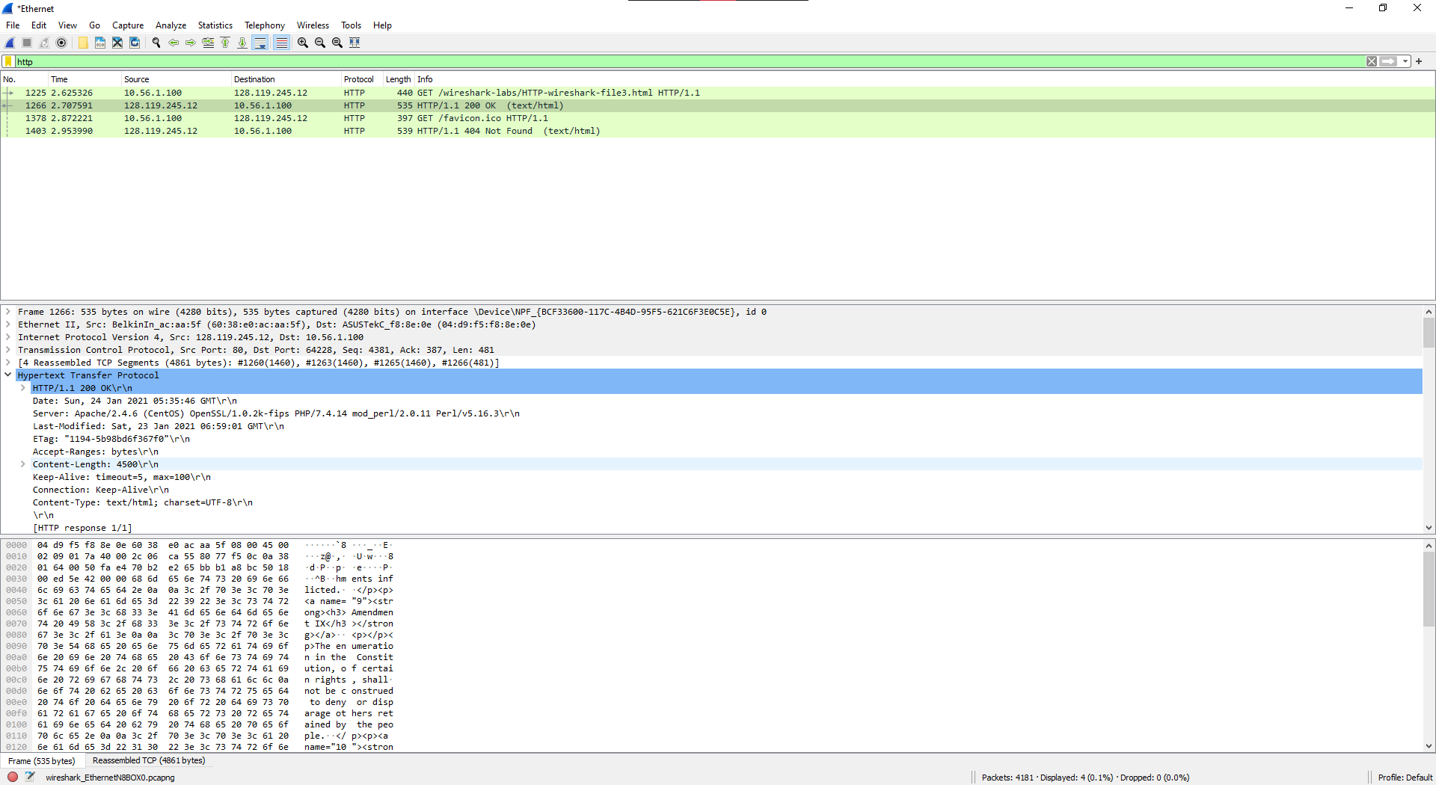

1. HTML documents with embedded objects
   1. How many HTTP GET request messages were sent by your browser? To which Internet addresses were these GET requests sent?
      1. 3 (excluding the favicon request). They were sent to relative paths of the site host where the files are supposedly located.
   2. Can you tell whether your browser downloaded the two images serially, or whether they were downloaded from the two web sites in parallel? Explain.
      1. They appear to have been downloaded serially as the icon of the website was requested in between the two GET messages for the images.
2. HTTP authentication
   1. What is the server’s response (status code and phrase) in response to the initial HTTP GET message from your browser?
      1. 401 Not Authorized
   2. When your browser’s sends the HTTP GET message for the second time, what new field is included in the HTTP GET message?
      1. “Authorization: Basic [long character string]=\r\n”