# Lab 0 – AWS Setup and Sniffing

Ian Kaiserman

## Screenshot of dockps command



## Screenshot of sniffer.py output (window 1) and ping command output (window 2)

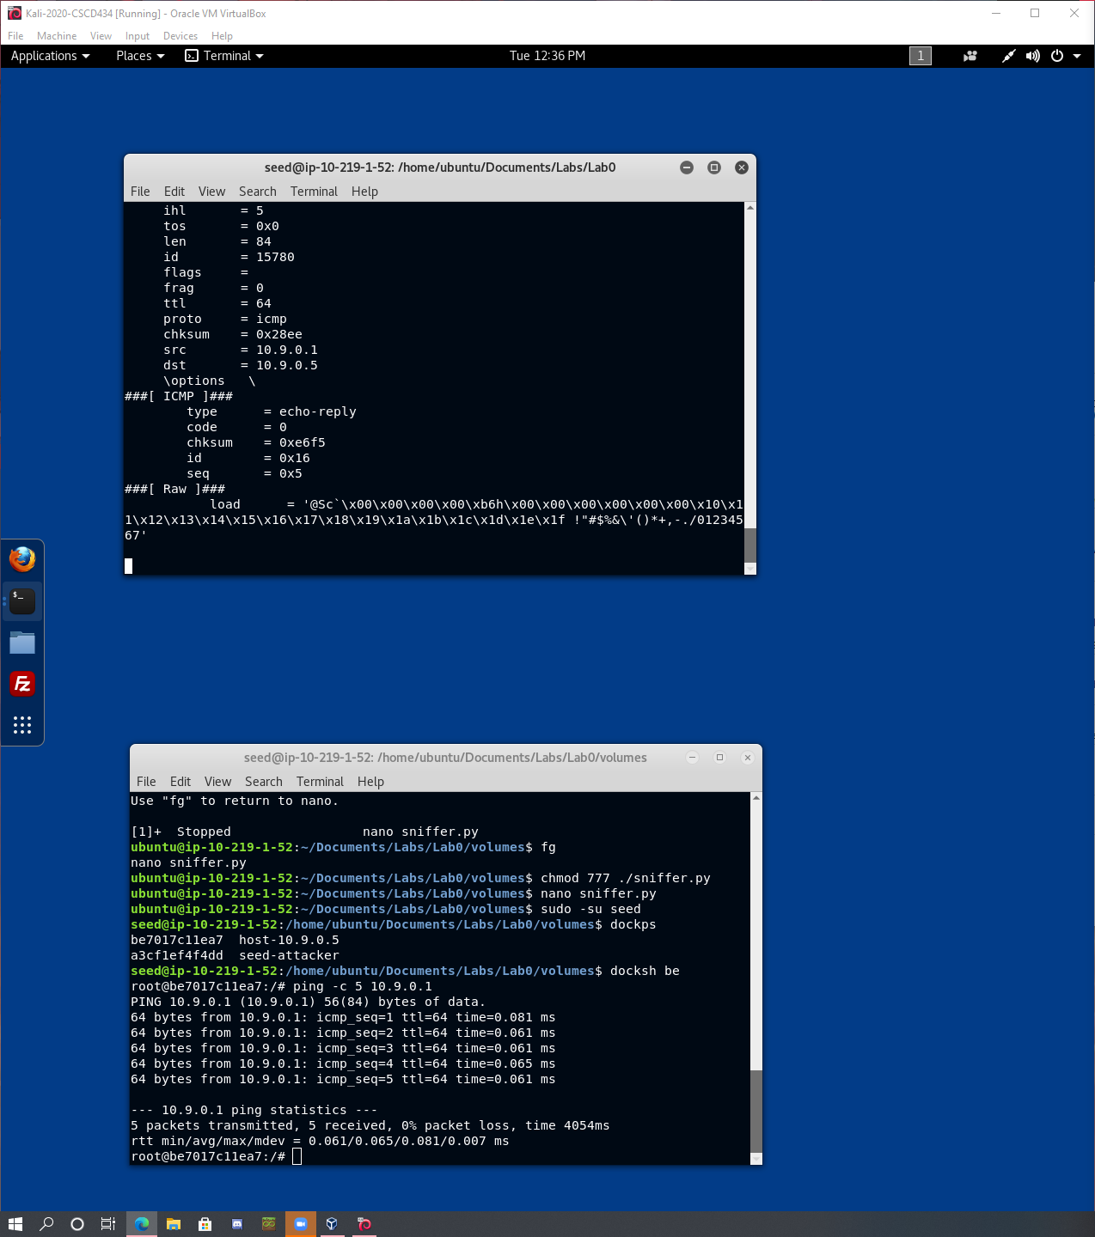

## Screenshot of cleanup

